SOLEWISE · FOOTWEAR INTELLIGENCE
Engineering Architecture, Failure Analysis & Technical Solution Whitepaper | Production Live
Executive Summary: Solewise was engineered to replace fragmented, error-prone spreadsheets in footwear manufacturing with an automated, dual-specification technical alternative matrix and batch yield optimizer. This report documents the critical engineering challenges encountered—including ephemeral cloud container data loss, Excel export encoding breakdown, and test fixture database pollution—alongside the architectural solutions deployed across database persistence, client ergonomics, and full-stack cloud infrastructure.
60.7%  Direct Cost Savings (Synthetic vs Leather) | 100%  Permanent ACID Sync (Render PostgreSQL) | 13 / 13  Automated Tests Passing (Zero DB Contamination) | 33.1 kB  Optimized CSS Bundle (Lightweight Mobile PWA)

1. System Data Flow & End-to-End Architecture
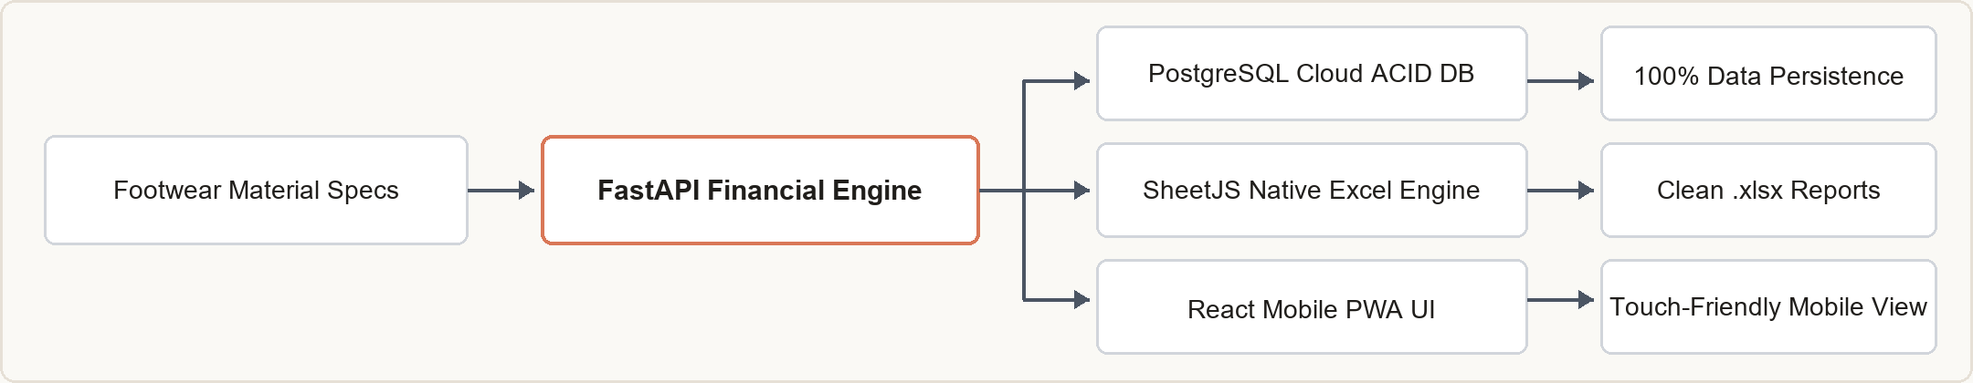
2. Identified Problems & Root Causes  • Ephemeral Cloud Data Loss (Render Sleep Cycle): On free-tier container hosting, storage is ephemeral. Inactivity after 15 min caused sleep/wake cycles that reset the local SQLite file to the initial Git commit, wiping all user-entered materials.  • Corrupted Excel & CSV File Exports: CSV exports lacked UTF-8 BOM headers, causing Indian Rupee currency symbols to render as corrupted text (â‚¹) and unformatted columns to overflow into ######## syntax in MS Excel.  • Production Database Test Pollution: Automated Pytest suites posted dummy test records ('Full Grain Bovine...') directly against the active production database, permanently corrupting the catalog with unwanted fixtures.  • Desktop-Biased Navigation & Mobile Breakage: Legacy views contained unneeded modules (Costing, Sequence, Suppliers) and wide tabular matrices that broke viewport bounds on smartphones with zero responsive touch targets. | 3. Technical Engineering Solutions  • Managed Cloud PostgreSQL Migration: Decoupled persistent storage from the container. Integrated psycopg2-binary with SQLAlchemy connection pooling (pool_pre_ping, pool_recycle=300) on Render PostgreSQL for 100% ACID durability.  • Native In-Browser SheetJS (.xlsx) Engine: Replaced broken CSV strings with client-side binary Excel generation (xlsx), applying dynamic column auto-fitting, typed numeric cells, and clean INR (₹) formatting.  • Isolated In-Memory Pytest Harness: Refactored the test suite using FastAPI dependency overrides and an isolated sqlite:///:memory: StaticPool, ensuring 100% test isolation without touching production files.  • Claude Design System & Mobile PWA: Redesigned with Anthropic Claude aesthetic (warm parchment #FAF9F5, terracotta #D97757), touch targets ≥ 44px, mobile drawer, and standalone PWA manifest with orange sneaker icons.

4. Production Stack & Deployment Architecture
Layer | Technology | Production Capabilities
Frontend UI | React 18 + Vite + Tailwind CSS | Claude Design tokens, SheetJS Excel engine, responsive mobile drawer, standalone PWA manifest.
Backend API | FastAPI (Python 3.14) + Uvicorn | ASGI asynchronous runtime, Pydantic v2 schemas, automated dual-specification alternative linkage.
Database | PostgreSQL (Render Cloud) | Permanent ACID cloud storage, connection pooling, automated schema creation, zero data loss.
Deployment | Render Cloud Web Service | Full-stack single container serving static React SPA and FastAPI endpoints under single SSL URL.
Solewise Footwear Intelligence Platform | Production Ready | Live URL: https://sole-wise.onrender.com

