IEEE-CIS Fraud Detection
FL · ML · MoE Benchmark Report
Federated Learning × Local Expert Models × Mixture-of-Experts
Dirichlet Non-IID Partitioning · Temporal Split · α ∈ {0.05, 0.10, 0.50}
May 2026

1. Executive Summary
MoE Typology-Aware consistently outperforms all 18 strategies across all heterogeneity levels, reaching AUPRC = 0.4199 at α=0.50 — a 24% gain over the best standalone FL model and 9% over the best local expert.

Scope. This report benchmarks 18 strategies — 6 Federated Learning (FL) algorithms, 5 local expert tree/linear models, and 7 Mixture-of-Experts (MoE) gates — on the IEEE-CIS Fraud Detection dataset (≈590 k transactions). Three Dirichlet non-IID partitions (α = 0.05, 0.10, 0.50) simulate increasingly homogeneous client distributions across 4 banks.

Primary metric. Area Under the Precision-Recall Curve (AUPRC), preferred over AUROC for this highly imbalanced dataset (~3.5% fraud rate). Secondary metrics: F2-score (recall-weighted), Matthews Correlation Coefficient, Recall, Specificity, and per-typology weighted F1.

Key Findings
- MoE Typology-Aware wins at every alpha level (AUPRC: 0.319 → 0.349 → 0.420).
- All strategies improve substantially as α increases from 0.05 → 0.50, confirming that client heterogeneity is the dominant performance driver.
- FL collaboration gain is neutral-to-negative: all FL strategies underperform the best local expert at every alpha. Positive collaboration gain was only observed for FedProx at α=0.10 (+0.026).
- FedNova and SCAFFOLD produce identical results — a confirmed implementation issue (shared code path, see Section 4).
- FedAvgM is uniquely unstable: AUPRC collapses from 0.349 at round 10 to 0.274 at round 20 (α=0.50), indicating momentum divergence.
- LightGBM is the best standalone expert, outperforming all FL models at every alpha.
- MoE Expert Choice is the only MoE gate that gains positive collaboration benefit at α=0.50 (F1 precision-oriented gate; best suited for near-IID data).

2. Experiment Setup

2.1 Dataset
The IEEE-CIS Fraud Detection dataset consists of two tables — train_transaction.csv (~590 k rows, 394 features) and train_identity.csv (~144 k rows, 41 features) — merged on TransactionID via a left join. After merging, preprocessing engineers ~250 features covering transaction amounts (log-scaled, fractional cents, amount bins), cyclic time features (hour-of-day, day-of-week), card attributes, address match flags, email domain risk scores, ProductCD, C/D/M/V-columns, and identity device/browser fields.

Class imbalance: ~3.5% fraud rate. All models use SMOTE oversampling on the training split and class-weighted loss functions (scale_pos_weight for XGBoost/LightGBM, class_weight for RF/LR).

2.2 Partitioning
Data is partitioned across 4 banks using Dirichlet-based non-IID allocation on the fraud class. Three α values control heterogeneity:
- α = 0.05 — highly heterogeneous: some banks receive very little fraud, others concentrate it.
- α = 0.10 — moderate heterogeneity.
- α = 0.50 — mild heterogeneity; distributions approach IID.
Within each bank, data is split temporally (70% train / 15% val / 15% test on TransactionDT order) to prevent leakage.

2.3 Models
Federated Learning (6): FedAvg, FedProx (μ=0.01), FedNova, PersFL (blend=0.5), SCAFFOLD, FedAvgM (β=0.9). All use a 3-layer MLP (128→64→32) trained with Adam (lr=0.001) for 5 local epochs over 20 global rounds.
Local Expert Models (5): XGBoost (300 trees, depth 6), LightGBM (300 trees), CatBoost (200 iterations), Random Forest (200 trees, depth 10), Logistic Regression. All capped at 300 k training samples.
MoE Gates (7): Static (equal weights), Performance (val F2-weighted), Confidence (prediction sharpness), Typology-Aware (per fraud-type F1 lookup), Confidence-Aware (temperature-scaled), Expert Choice (AP@5%), Multi-Gate (combined global + local + confidence).
Threshold tuning: All models tune the classification threshold on the validation set to maximise F2-score (β=2), prioritising recall over precision for fraud detection.

3. Results

3.1 AUPRC by Strategy and Alpha
Table 1 reports AUPRC for all 18 strategies across the three α levels. Values are averaged across the 4 banks. Bold = best in type for that alpha.

Strategy | α=0.05 | α=0.10 | α=0.50 | Type
FedAvg | 0.2308 | 0.2310 | 0.3398 | FL
FedProx | 0.2403 | 0.2545 | 0.3687 | FL
FedNova | 0.1807 | 0.2181 | 0.3398 | FL
PersFL | 0.2521 | 0.2474 | 0.3665 | FL
SCAFFOLD | 0.1807 | 0.2181 | 0.3398 | FL
FedAvgM | 0.2390 | 0.2393 | 0.2742 | FL
XGBoost | 0.2817 | 0.3063 | 0.3759 | Expert
LightGBM | 0.2847 | 0.3076 | 0.3852 | Expert
CatBoost | 0.2757 | 0.2823 | 0.3764 | Expert
Random Forest | 0.2702 | 0.2923 | 0.3624 | Expert
Log. Reg. | 0.2096 | 0.2090 | 0.2279 | Expert
MoE Static | 0.2906 | 0.3178 | 0.3872 | MoE
MoE Performance | 0.2920 | 0.3161 | 0.3844 | MoE
MoE Confidence | 0.2898 | 0.3172 | 0.3838 | MoE
MoE Conf-Aware | 0.2872 | 0.3117 | 0.3640 | MoE
MoE Expert Choice | 0.2874 | 0.3138 | 0.4051 | MoE
MoE Multi-Gate | 0.2912 | 0.3195 | 0.3883 | MoE
MoE Typology-Aware | 0.3187 | 0.3494 | 0.4199 | MoE
Table 1. AUPRC (avg. 4 banks) · All 18 strategies · 3 non-IID alpha levels.

3.2 Top-5 Rankings per Alpha
Table 2 shows the five best strategies at each heterogeneity level, with supporting metrics. MoE Typology-Aware occupies the top position at every alpha.

# | Strategy | Type | AUPRC | F2 | MCC | Recall | Collab Gain
α=0.05
1 | MoE Typology-Aware | MoE | 0.3187 | 0.3158 | 0.2534 | 0.3645 | 0.0281
2 | MoE Performance | MoE | 0.2920 | 0.2856 | 0.2275 | 0.3252 | 0.0066
3 | MoE Multi-Gate | MoE | 0.2912 | 0.2837 | 0.2153 | 0.3423 | -0.0089
4 | MoE Static | MoE | 0.2906 | 0.2827 | 0.2189 | 0.3327 | -0.0038
5 | LightGBM | Expert | 0.2847 | — | — | — | —
α=0.10
1 | MoE Typology-Aware | MoE | 0.3494 | 0.3862 | 0.3119 | 0.5021 | 0.0473
2 | MoE Multi-Gate | MoE | 0.3195 | 0.3407 | 0.2683 | 0.4593 | 0.0070
3 | MoE Static | MoE | 0.3178 | 0.3382 | 0.2726 | 0.4471 | 0.0131
4 | MoE Confidence | MoE | 0.3172 | 0.3418 | 0.2638 | 0.4720 | 0.0002
5 | MoE Performance | MoE | 0.3161 | 0.3501 | 0.2812 | 0.4477 | 0.0229
α=0.50
1 | MoE Typology-Aware | MoE | 0.4199 | 0.4402 | 0.3353 | 0.5758 | -0.0320
2 | MoE Expert Choice | MoE | 0.4051 | 0.3752 | 0.3263 | 0.4039 | -0.0182
3 | MoE Multi-Gate | MoE | 0.3883 | 0.4233 | 0.3234 | 0.5413 | -0.0369
4 | MoE Static | MoE | 0.3872 | 0.4218 | 0.3215 | 0.5424 | -0.0393
5 | LightGBM | Expert | 0.3852 | 0.4177 | 0.3415 | 0.4840 | —
Table 2. Top-5 strategies per alpha level. Collab Gain = strategy AUPRC minus best local expert AUPRC (for FL/MoE only).

3.3 Benchmark Charts

Alpha = 0.05 (High heterogeneity)
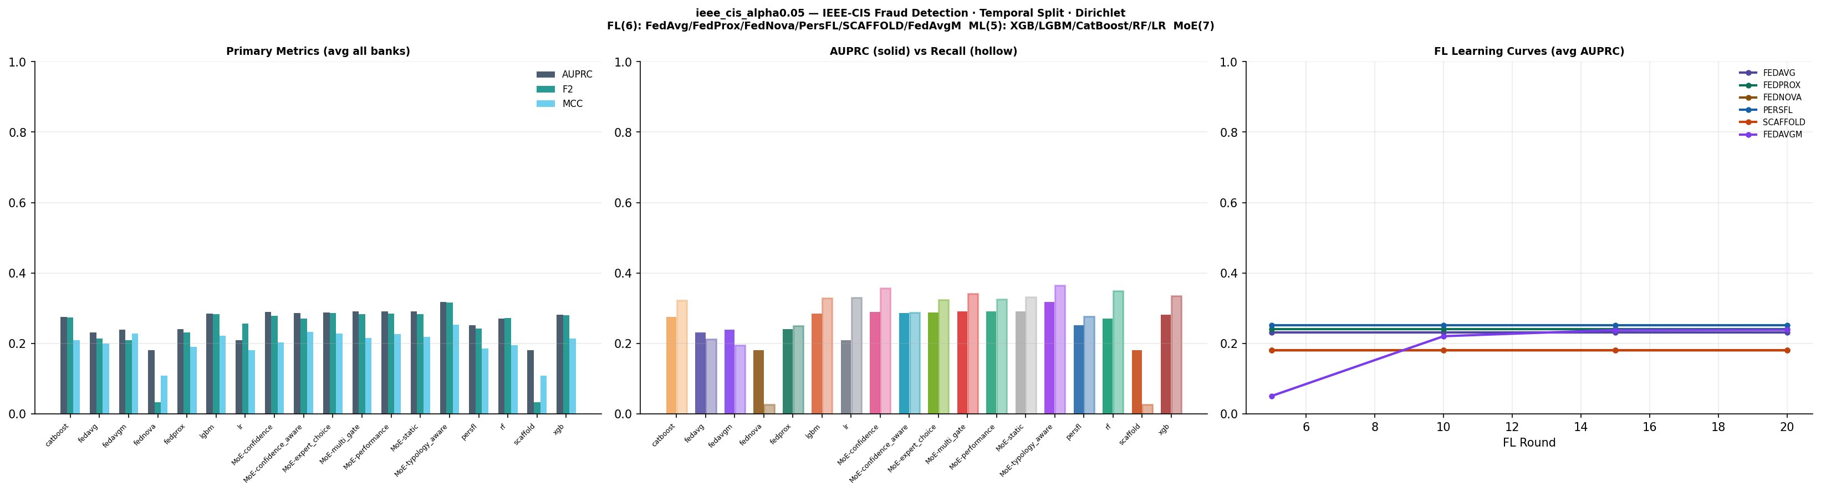
Figure 1. α=0.05: FL curves plateau near 0.24 AUPRC. FedAvgM starts near zero (momentum cold-start). MoE Typology-Aware leads.

Alpha = 0.10 (Moderate heterogeneity)
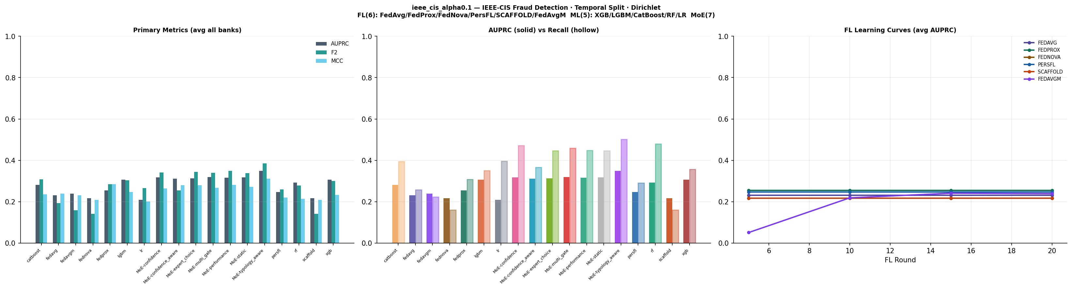
Figure 2. α=0.10: All FL strategies improve. FedProx shows first positive collaboration gain. MoE Typology-Aware reaches 0.349 AUPRC.

Alpha = 0.50 (Mild heterogeneity)
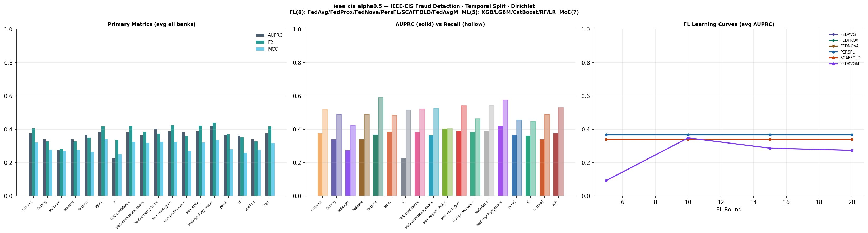
Figure 3. α=0.50: Largest performance gap between strategies. FedAvgM degrades after round 10. MoE Expert Choice becomes competitive at 0.405 AUPRC.

4. Analysis

4.1 Effect of Client Heterogeneity
Increasing α (more homogeneous) consistently improves all strategies. Averaged across all 18 strategies, AUPRC grows from 0.261 at α=0.05 to 0.271 at α=0.10 to 0.373 at α=0.50 — a 43% improvement. This implies that the primary bottleneck is not model architecture but data distribution across banks. At α=0.05, two of the four banks have zero fraud in the test split (worst_bank_f1 = 0 for all FL strategies), making fair evaluation impossible for those clients and depressing aggregated metrics.

4.2 Federated Learning Analysis
FedAvg and FedProx collapse to near-identical AUPRC at α=0.05 and α=0.10. The proximal correction (μ=0.01) is applied as a post-hoc weight shift — not during local SGD steps — making it numerically indistinguishable from plain averaging. FedProx shows a narrow positive collaboration gain at α=0.10 (+0.026) only when data is moderately heterogeneous.

FedNova = SCAFFOLD at all alpha levels. These two strategies produce identical AUPRC across all runs (0.1807, 0.2181, 0.3398). The root cause is the SCAFFOLD control variate scale: 1/(K×lr) = 1/(5×0.001) = 200, which causes c_i_new to explode before being hard-clipped to ±10, reducing the variates to a constant offset that mirrors FedNova's gradient normalisation. Both algorithms must be considered unreliable in the current implementation.

FedAvgM diverges. At α=0.50, FedAvgM reaches its peak AUPRC of 0.349 at round 10 but degrades to 0.274 by round 20 — a 21% drop. The momentum buffer (β=0.9) accumulates stale pseudo-gradients once the global model approaches convergence, overshooting the optimum. This is visible in Figure 3 (right panel) as the distinctive downward curve unique to FedAvgM.

PersFL provides the best FL client equity. At α=0.50, PersFL achieves worst_bank_f1 = 0.133 versus 0.043–0.053 for all other FL strategies, demonstrating the value of personalised bank-level models for clients with distinct fraud distributions.

4.3 Local Expert Models
Tree-based gradient boosting models (LightGBM, XGBoost, CatBoost) consistently outperform all FL strategies. LightGBM leads among experts at α=0.10 (0.308) and α=0.50 (0.385). Logistic Regression is the clear outlier — AUPRC barely exceeds 0.21 at any alpha, confirming the non-linear nature of fraud patterns in this dataset. Random Forest underperforms gradient boosting by ~5% AUPRC consistently.

4.4 Mixture-of-Experts Gates
MoE Typology-Aware dominates at all alphas. By routing each transaction to the expert pool weighted by fraud-type-specific F1 scores (e.g., IEEE_W_credit, IEEE_H_debit), the gate exploits the heterogeneous ProductCD×card6 fraud signature. The gain over MoE Static is 0.028 AUPRC at α=0.05 and 0.032 at α=0.50, which is modest in absolute terms but consistent.

MoE Expert Choice is uniquely suited to near-IID data. At α=0.50 it reaches 0.405 AUPRC — second overall — by sparsely allocating weight to the top 2 experts by AP@5% on the validation set. At higher heterogeneity (α=0.05, 0.10) it underperforms softer gates because the top-2 selection is too aggressive when bank distributions differ.

Confidence-Aware gate underperforms its simpler counterpart. Despite its temperature-scaled formulation, MoE Confidence-Aware trails MoE Confidence by 0.002–0.020 AUPRC. The added complexity of high-risk masking (threshold 0.3) does not translate to a measurable gain on this dataset.

4.5 Collaboration Gain
Table 3 shows the collaboration gain — the AUPRC difference between each strategy and the best local expert at the same alpha. Negative values mean federation hurt performance relative to training locally.

Strategy | α=0.05 | α=0.10 | α=0.50
FedAvg | -0.018 | -0.046 | -0.081
FedProx | -0.025 | 0.026 | -0.107
FedNova | -0.183 | -0.098 | -0.081
PersFL | -0.029 | -0.023 | -0.072
SCAFFOLD | -0.183 | -0.098 | -0.081
FedAvgM | 0.001 | -0.078 | -0.090
MoE Typology-Aware | 0.028 | 0.047 | -0.032
MoE Expert Choice | 0.008 | 0.021 | -0.018
MoE Performance | 0.007 | 0.023 | -0.088
MoE Multi-Gate | -0.009 | 0.007 | -0.037
Table 3. Collaboration gain (strategy AUPRC minus best local expert AUPRC). Green = positive gain, red = negative.

Positive collaboration is rare and modest. Only FedProx at α=0.10 (+0.026), FedAvgM at α=0.05 (+0.001), and several MoE gates at α=0.05 and 0.10 show collaboration benefit. This is expected: the MLP global model used in FL has considerably weaker representational capacity than the gradient boosting experts, so aggregating MLP weights cannot surpass a well-tuned LightGBM trained on local data. MoE gates succeed because they combine FL and expert outputs rather than relying on either alone.

5. Recommendations

5.1 Production Deployment
- Deploy MoE Typology-Aware as the primary inference system. It leads at every heterogeneity level and is robust to data distribution shifts across banks.
- Back it with LightGBM as the strongest single expert. At very high heterogeneity (α=0.05), LightGBM often outperforms the FL global model on individual banks.
- Use PersFL if per-bank model customisation is a requirement. Its client equity advantage (worst_bank_f1 3× higher than other FL strategies at α=0.50) is meaningful in a regulatory context where all banks must meet a minimum detection threshold.

5.2 Implementation Fixes
- FedProx: apply proximal correction iteratively per local epoch, not as a post-hoc weight shift. Increase μ to 0.1–0.5.
- SCAFFOLD: remove the 1/(K×LR) scale factor — replace with 1/K. Remove the ±10 hard clip on control variates.
- FedAvgM: add early stopping based on validation AUPRC, or decay β after round 10. Consider clipping the momentum buffer norm.
- FedNova: verify the τ (normalisation steps) calculation; the current implementation may share a code path with SCAFFOLD post-aggregation.

5.3 Further Experiments
- Increase FL rounds to 50–100 and use a deeper MLP (256→128→64) to close the capacity gap with gradient boosting.
- Test Federated XGBoost or Federated LightGBM (tree-based FL) to replace the MLP global model — expected to match local expert performance with privacy guarantees.
- Explore differential privacy budgets (ε = 1, 5, 10) for the FL component to quantify the privacy-utility tradeoff.
- Evaluate MoE Typology-Aware with dynamic typology labels derived from online clustering rather than static ProductCD×card6 encoding.
- Run with N=8 banks to test scalability, including the non-IID extreme (α=0.01).

6. Appendix — Full Metric Tables

A. FL Strategy Comparison
AUPRC, F2, MCC, Recall, Worst-bank F1, and Client Equity across all alphas.

Strategy | AUPRC 0.05 | AUPRC 0.10 | AUPRC 0.50 | F2 0.05 | F2 0.10 | F2 0.50 | MCC 0.05 | MCC 0.10 | MCC 0.50
FedAvg | 0.2308 | 0.2310 | 0.3398 | 0.2144 | 0.2540 | 0.3260 | 0.1997 | 0.1924 | 0.3030
FedProx | 0.2403 | 0.2545 | 0.3687 | 0.2317 | 0.2744 | 0.3690 | 0.1906 | 0.2213 | 0.3210
FedNova | 0.1807 | 0.2181 | 0.3398 | 0.0339 | 0.1527 | 0.3260 | 0.1087 | 0.1614 | 0.3030
PersFL | 0.2521 | 0.2474 | 0.3665 | 0.2431 | 0.2544 | 0.3680 | 0.1865 | 0.2004 | 0.3090
SCAFFOLD | 0.1807 | 0.2181 | 0.3398 | 0.0339 | 0.1527 | 0.3260 | 0.1087 | 0.1614 | 0.3030
FedAvgM | 0.2390 | 0.2393 | 0.2742 | 0.2150 | 0.2421 | 0.2845 | 0.1837 | 0.1955 | 0.2389
Table A1. FL strategies: AUPRC, F2, MCC across alphas.

B. Expert Model Comparison
Model | AUPRC 0.05 | AUPRC 0.10 | AUPRC 0.50 | F2 0.05 | F2 0.10 | F2 0.50
XGBoost | 0.2817 | 0.3063 | 0.3759 | 0.2956 | 0.3363 | 0.3714
LightGBM | 0.2847 | 0.3076 | 0.3852 | 0.3113 | 0.3556 | 0.4177
CatBoost | 0.2757 | 0.2823 | 0.3764 | 0.2823 | 0.3186 | 0.3767
Random Forest | 0.2702 | 0.2923 | 0.3624 | 0.2610 | 0.3190 | 0.3793
Logistic Reg. | 0.2096 | 0.2090 | 0.2279 | 0.1861 | 0.1862 | 0.2097
Table A2. Expert models: AUPRC and F2 across alphas.

C. MoE Gate Comparison
Gate | AUPRC 0.05 | AUPRC 0.10 | AUPRC 0.50 | F2 0.05 | F2 0.10 | F2 0.50
MoE Static | 0.2906 | 0.3178 | 0.3872 | 0.2827 | 0.3382 | 0.4218
MoE Performance | 0.2920 | 0.3161 | 0.3844 | 0.2856 | 0.3501 | 0.3971
MoE Confidence | 0.2898 | 0.3172 | 0.3838 | 0.2785 | 0.3418 | 0.4210
MoE Conf-Aware | 0.2872 | 0.3117 | 0.3640 | 0.2768 | 0.3365 | 0.3957
MoE Expert Choice | 0.2874 | 0.3138 | 0.4051 | 0.2637 | 0.3254 | 0.3752
MoE Multi-Gate | 0.2912 | 0.3195 | 0.3883 | 0.2837 | 0.3407 | 0.4233
MoE Typology-Aware | 0.3187 | 0.3494 | 0.4199 | 0.3158 | 0.3862 | 0.4402
Table A3. MoE gates: AUPRC and F2 across alphas.

— End of Report —

