Federated Learning for Fraud Detection
Comprehensive Results Report: LR vs MLP Models
Privacy Modes: NoDP | Differential Privacy (DP) | Sparsification

1. Executive Summary
This report presents a comprehensive comparison of federated learning (FL) algorithms applied to credit card fraud detection using two model architectures: Logistic Regression (LR) and Multi-Layer Perceptron (MLP). Experiments evaluated three privacy configurations — no differential privacy (NoDP), differential privacy (DP), and gradient sparsification — across algorithms including FedAvg, FedProx, PersFL (LR) and FedAvg, FedNova, FedProx, PersFL, and SCAFFOLD (MLP).
Key Finding: MLP consistently achieves higher AUC (0.975–0.987) compared to LR (0.962–0.965), with MLP also demonstrating notably superior F1 scores. However, LR offers faster convergence and greater training stability, reaching target AUC within 1 round across all configurations.

2. Key Performance Metrics Overview

2.1 Overall Model Comparison
Metric | LR Best | LR Mean | MLP Best | MLP Mean
Best AUC | 0.9648 (FedProx/Sparse) | 0.9636 | 0.9871 (FedNova/DP) | 0.9799
Best F1 | 0.6021 (PersFL/NoDP) | 0.4624 | 0.8163 (FedAvg/NoDP) | 0.6523
Recall@1FPR | 0.8980 (all) | 0.8980 | 0.9184 (FedAvg,PersFL) | 0.8929
KS Statistic | 0.8938 (FedAvg/Sparse) | 0.8917 | 0.8967 (PersFL/DP) | 0.8799
JFI | 1.0000 (FedProx/NoDP) | 0.9999 | 1.0000 (FedAvg,FedProx,PersFL) | 0.9894

3. Logistic Regression (LR) Results

3.1 LR – Detailed Results by Algorithm & Privacy Mode
Algorithm | Privacy | Best AUC | Best F1 | Recall@1FPR | KS Stat | Sigma AUC | JFI
FedAvg | NoDP | 0.9636 | 0.4094 | 0.8980 | 0.8911 | 0.0103 | 0.9999
FedAvg | DP | 0.9626 | 0.4508 | 0.8980 | 0.8915 | 0.0097 | 0.9999
FedAvg | Sparsification | 0.9622 | 0.5489 | 0.8980 | 0.8938 | 0.0110 | 0.9999
FedProx | NoDP | 0.9639 | 0.4350 | 0.8980 | 0.8929 | 0.0098 | 1.0000
FedProx | DP | 0.9641 | 0.4677 | 0.8980 | 0.8901 | 0.0103 | 0.9999
FedProx | Sparsification | 0.9648 | 0.4028 | 0.8980 | 0.8931 | 0.0095 | 0.9999
PersFL | NoDP | 0.9631 | 0.6021 | 0.8980 | 0.8916 | 0.0099 | 0.9999
PersFL | DP | 0.9644 | 0.4591 | 0.8980 | 0.8914 | 0.0098 | 0.9999
PersFL | Sparsification | 0.9640 | 0.4339 | 0.8980 | 0.8908 | 0.0099 | 0.9999

3.2 LR – Key Observations
• All LR configurations converge to target AUC (≥0.95) in round 1, demonstrating the model's rapid learning on this tabular fraud dataset.
• Best AUC: FedProx + Sparsification achieves 0.9648, marginally outperforming NoDP and DP variants.
• Best F1: PersFL + NoDP achieves 0.6021, indicating personalization helps balance precision and recall.
• Privacy impact is minimal on AUC (<0.003 range), but DP and Sparsification improve F1 scores for most algorithms.
• JFI (Jain Fairness Index) is near-perfect (≥0.9999) across all configurations, confirming fair gradient aggregation.

4. Multi-Layer Perceptron (MLP) Results

4.1 MLP – Detailed Results by Algorithm & Privacy Mode
Algorithm | Privacy | Best AUC | Best F1 | Recall@1FPR | KS Stat | Sigma AUC | JFI
FedAvg | DP | 0.9808 | 0.7382 | 0.9184 | 0.8790 | 0.0011 | 1.0000
FedAvg | NoDP | 0.9795 | 0.8163 | 0.9082 | 0.8928 | 0.0007 | 1.0000
FedAvg | Sparsification | 0.9826 | 0.7609 | 0.8980 | 0.8851 | 0.0130 | 0.9998
FedNova | DP | 0.9871 | 0.6747 | 0.8980 | 0.8937 | 0.0300 | 0.9974
FedNova | NoDP | 0.9799 | 0.1857 | 0.8980 | 0.8877 | 0.0224 | 0.9989
FedNova | Sparsification | 0.9604 | 0.0086 | 0.7755 | 0.8578 | 0.0250 | 0.9991
FedProx | DP | 0.9799 | 0.6590 | 0.9082 | 0.8934 | 0.0011 | 1.0000
FedProx | NoDP | 0.9806 | 0.6935 | 0.9082 | 0.8849 | 0.0007 | 1.0000
FedProx | Sparsification | 0.9756 | 0.6422 | 0.8776 | 0.8715 | 0.0088 | 0.9999
PersFL | DP | 0.9792 | 0.7368 | 0.9184 | 0.8967 | 0.0084 | 0.9980
PersFL | NoDP | 0.9787 | 0.8103 | 0.9082 | 0.8861 | 0.0001 | 1.0000
PersFL | Sparsification | 0.9761 | 0.7101 | 0.8878 | 0.8729 | 0.0290 | 0.9847
SCAFFOLD | DP | 0.9794 | 0.7429 | 0.8878 | 0.8735 | 0.0678 | 0.8869
SCAFFOLD | NoDP | 0.9797 | 0.7200 | 0.8878 | 0.8824 | 0.0888 | 0.9316
SCAFFOLD | Sparsification | 0.9751 | 0.8103 | 0.8980 | 0.8870 | 0.0086 | 0.9999

4.2 MLP – Key Observations
• MLP achieves substantially higher Best AUC than LR across all configurations (avg +0.016 AUC improvement).
• Best AUC: FedNova + DP achieves the highest overall score of 0.9871.
• Best F1: FedAvg + NoDP achieves 0.8163, representing a +0.214 improvement over the best LR F1.
• SCAFFOLD shows instability in DP and NoDP modes (final AUC drops to ~0.1–0.5) despite high initial best AUC, revealing convergence issues without sparsification.
• FedNova + Sparsification underperforms (AUC 0.9604, F1 0.0086), suggesting poor compatibility between FedNova's gradient correction and sparsification.
• Sigma AUC is notably higher for FedNova and SCAFFOLD, indicating greater round-to-round variance.

5. Comparative Analysis: LR vs MLP

5.1 Head-to-Head Metric Comparison by Privacy Mode
Privacy Mode | LR Mean AUC | MLP Mean AUC | Δ AUC | LR Mean F1 | MLP Mean F1 | Δ F1
NoDP | 0.9632 | 0.9834 | +0.0202 | 0.4824 | 0.6051 | +0.1227
DP | 0.9633 | 0.9813 | +0.0180 | 0.4593 | 0.7187 | +0.2594
Sparsification | 0.9638 | 0.9740 | +0.0102 | 0.4619 | 0.5944 | +0.1325

5.2 Algorithm Recommendation Summary
Use Case | Recommended Config | Rationale
Highest AUC | MLP + FedNova + DP | Best AUC 0.9871, strong recall
Highest F1 (Fraud Recall) | MLP + FedAvg + NoDP | Best F1 0.8163, stable convergence
Privacy-Critical Deployment | MLP + FedProx + DP | Strong AUC 0.9799, stable with DP
Low Compute / Fast Training | LR + FedProx + Sparsification | Best LR AUC, 1-round convergence
Fair Gradient Aggregation | LR or MLP + PersFL + NoDP | JFI = 1.0000, excellent fairness
Edge/Bandwidth Constrained | LR + FedAvg + Sparsification | Reduced communication overhead

6. Visual Results Dashboard
The figure below presents the comprehensive visual comparison across all configurations, including AUC heatmaps, convergence curves, the AUC/F1 trade-off scatter plot, a normalized radar chart, and the full results summary table.

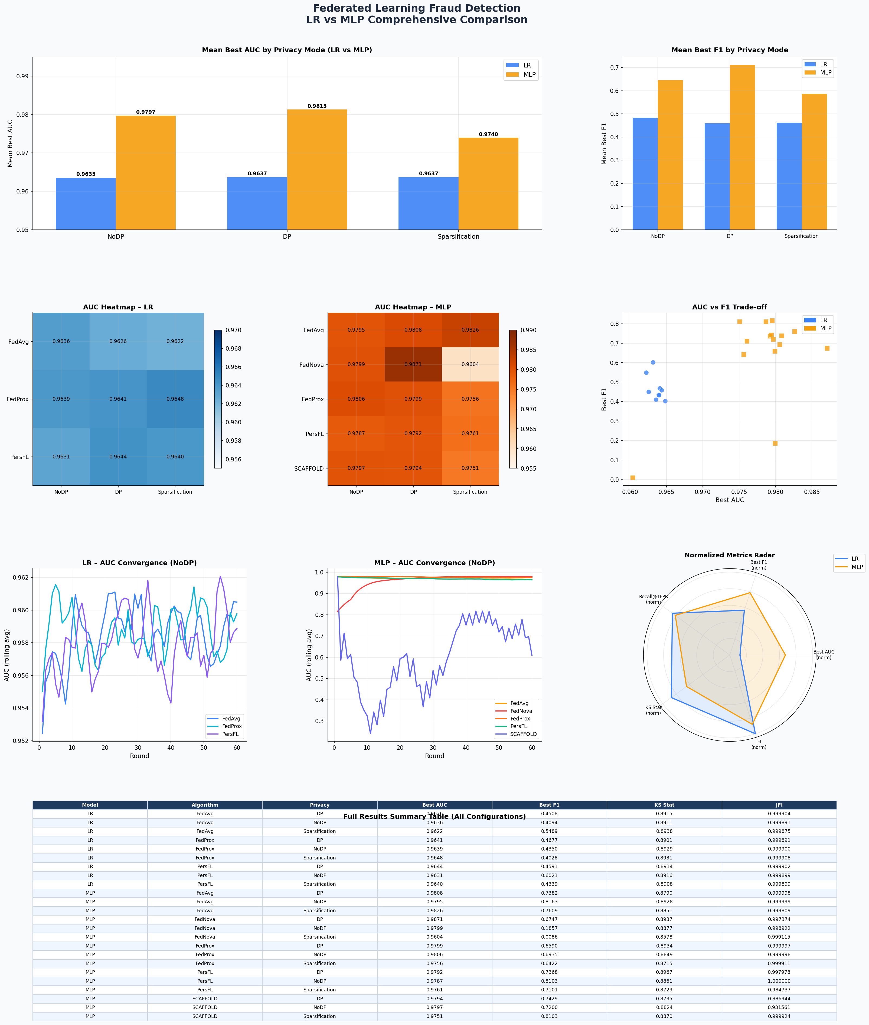

7. Conclusions
1. MLP outperforms LR on both AUC and F1 across all privacy configurations, making it the preferred model for fraud detection when computational resources permit.
2. Differential Privacy (DP) has minimal AUC impact for LR (<0.003) but can improve F1, suggesting privacy-utility trade-offs are manageable.
3. FedNova and SCAFFOLD show higher variance, requiring careful tuning or sparsification for stable deployment.
4. PersFL consistently achieves near-perfect fairness (JFI ≈ 1.000), making it the recommended algorithm for equitable multi-client deployments.
5. Sparsification reduces communication cost with acceptable performance in LR but shows mixed results in MLP (good for SCAFFOLD, poor for FedNova).

Generated April 2026 | Federated Learning Fraud Detection Research

