FL Algorithm Comparison on SAML-D

Nicolas Ordonez
UTS Master of AI
May 04, 2026

Table of Contents

(Open in Word/LibreOffice and press Ctrl+A then F9 to update the TOC)

1. Overview
This report summarises the results of a federated learning algorithm comparison on the SAML-D financial fraud detection dataset. Five federated algorithms (FedAvg, FedProx, FedNova, Scaffold, and PersFL) were evaluated across three data heterogeneity levels (Dirichlet α ∈ {0.05, 0.1, 0.5}) and three model types (MLP, LGB, XGB), spanning 15 experimental configurations. Performance was measured on 4 SAML banks with 1,697 fraud instances.
Best overall AUPRC: 0.0676 (FEDAVG_LGB / TREE — α=0.5). Total experiment rows evaluated: 30.

2. Methodology

2.1 Dataset — SAML-D
The SAML-D dataset (Synthetic Anti-Money Laundering Dataset) is a large-scale synthetic financial fraud benchmark containing multi-bank transaction data. The dataset was partitioned across 4 simulated banks for federated training, with 1,697 fraud instances in the test set. Data heterogeneity was controlled via Dirichlet distribution with α ∈ {0.05, 0.1, 0.5}: lower α produces more non-IID distributions across clients.

2.2 Federated Algorithms
Five federated learning strategies were compared:
- FedAvg: Federated Averaging (McMahan et al., 2017) — simple weighted average of client updates.
- FedProx: Federated Proximal (Li et al., 2020) — adds proximal regularisation to handle client heterogeneity.
- FedNova: Federated Nova (Wang et al., 2020) — corrects for objective inconsistency via normalised averaging.
- Scaffold: SCAFFOLD (Karimireddy et al., 2020) — uses control variates to correct client drift.
- PersFL: Personalised FL — adapts the global model locally per client to improve per-client performance.

2.3 Model Types
Each FL strategy was applied to three base learners: MLP (Multi-Layer Perceptron), LGB (LightGBM gradient boosting), and XGB (XGBoost gradient boosting). Federated gradient boosting was implemented via model serialisation and weighted aggregation of tree structures.

2.4 Evaluation Metrics
Primary metric: AUPRC (Area Under the Precision-Recall Curve) — appropriate for the highly imbalanced fraud detection task. Secondary metrics: F1, Precision, Recall, MCC (Matthews Correlation Coefficient), Specificity, and per-bank equity metrics (worst_bank_f1, client_equity) to assess fairness across clients.

3. Results
Tables below show evaluation results for FedAvg, FedProx, and PersFL across all α values and model types. Values in bold indicate the best metric in each column.

3.1 FEDAVG
Model | Alpha | F1 | Precision | Recall | AUPRC | MCC | Specificity
FEDAVG_MLP / TREE | 0.1000 | 0.0254 | 0.0161 | 0.0822 | 0.0318 | 0.0322 | 0.7633
FEDAVG_LGB / TREE | 0.1000 | 0.0028 | 0.0014 | 0.4884 | 0.0454 | 0.0085 | 0.1722
FEDAVG_XGB / TREE | 0.1000 | 0.0029 | 0.0014 | 0.4848 | 0.0477 | 0.0094 | 0.1911
FEDAVG_MLP / TREE | 0.5000 | 0.0215 | 0.0117 | 0.2922 | 0.0279 | 0.0439 | 0.9729
FEDAVG_LGB / TREE | 0.5000 | 0.0032 | 0.0016 | 0.7807 | 0.0676 | 0.0113 | 0.4202
FEDAVG_XGB / TREE | 0.5000 | 0.0031 | 0.0016 | 0.6637 | 0.0358 | 0.0114 | 0.5057
FEDAVG_MLP / TREE | 0.0500 | 0.0137 | 0.0086 | 0.0572 | 0.0042 | 0.0164 | 0.9717
FEDAVG_LGB / TREE | 0.0500 | 0.0059 | 0.0046 | 0.0082 | 0.0078 | 0.0043 | 0.6352
FEDAVG_XGB / TREE | 0.0500 | 0.0028 | 0.0014 | 0.4485 | 0.0059 | 0.0060 | 0.2771
Table: FEDAVG — all α values and model types

3.2 FEDPROX
Model | Alpha | F1 | Precision | Recall | AUPRC | MCC | Specificity
FEDPROX_MLP / TREE | 0.1000 | 0.0234 | 0.0134 | 0.0907 | 0.0329 | 0.0322 | 0.7644
FEDPROX_LGB / TREE | 0.1000 | 0.0028 | 0.0014 | 0.4884 | 0.0454 | 0.0085 | 0.1722
FEDPROX_XGB / TREE | 0.1000 | 0.0029 | 0.0014 | 0.4848 | 0.0477 | 0.0094 | 0.1911
FEDPROX_MLP / TREE | 0.5000 | 0.0187 | 0.0101 | 0.2512 | 0.0272 | 0.0373 | 0.9722
FEDPROX_LGB / TREE | 0.5000 | 0.0032 | 0.0016 | 0.7807 | 0.0676 | 0.0113 | 0.4202
FEDPROX_XGB / TREE | 0.5000 | 0.0031 | 0.0016 | 0.6637 | 0.0358 | 0.0114 | 0.5057
FEDPROX_MLP / TREE | 0.0500 | 0.0179 | 0.0108 | 0.0977 | 0.0418 | 0.0246 | 0.9805
FEDPROX_LGB / TREE | 0.0500 | 0.0059 | 0.0046 | 0.0082 | 0.0078 | 0.0043 | 0.6352
FEDPROX_XGB / TREE | 0.0500 | 0.0028 | 0.0014 | 0.4485 | 0.0059 | 0.0060 | 0.2771
Table: FEDPROX — all α values and model types

3.3 PERSFL
Model | Alpha | F1 | Precision | Recall | AUPRC | MCC | Specificity
PERSFL_MLP / TREE | 0.1000 | 0.0141 | 0.0084 | 0.0644 | 0.0205 | 0.0184 | 0.7115
PERSFL_PERSONAL / TREE | 0.1000 | 0.0141 | 0.0084 | 0.0644 | 0.0205 | 0.0184 | 0.7115
PERSFL_LGB / TREE | 0.1000 | 0.0028 | 0.0014 | 0.4884 | 0.0454 | 0.0085 | 0.1722
PERSFL_XGB / TREE | 0.1000 | 0.0029 | 0.0014 | 0.4848 | 0.0477 | 0.0094 | 0.1911
PERSFL_MLP / TREE | 0.5000 | 0.0126 | 0.0071 | 0.0640 | 0.0208 | 0.0178 | 0.9901
PERSFL_PERSONAL / TREE | 0.5000 | 0.0134 | 0.0075 | 0.0912 | 0.0206 | 0.0203 | 0.9854
PERSFL_LGB / TREE | 0.5000 | 0.0032 | 0.0016 | 0.7807 | 0.0676 | 0.0113 | 0.4202
PERSFL_XGB / TREE | 0.5000 | 0.0031 | 0.0016 | 0.6637 | 0.0358 | 0.0114 | 0.5057
PERSFL_MLP / TREE | 0.0500 | 0.0120 | 0.0074 | 0.0696 | 0.0365 | 0.0147 | 0.9900
PERSFL_PERSONAL / TREE | 0.0500 | 0.0121 | 0.0074 | 0.0569 | 0.0240 | 0.0146 | 0.9922
PERSFL_LGB / TREE | 0.0500 | 0.0059 | 0.0046 | 0.0082 | 0.0078 | 0.0043 | 0.6352
PERSFL_XGB / TREE | 0.0500 | 0.0028 | 0.0014 | 0.4485 | 0.0059 | 0.0060 | 0.2771
Table: PERSFL — all α values and model types

4. Analysis
Figures below show result visualisations for each algorithm at α=0.1 (moderate non-IID heterogeneity). Each plot shows evaluation metrics across model types and banks.

4.1 FEDAVG (α=0.1)
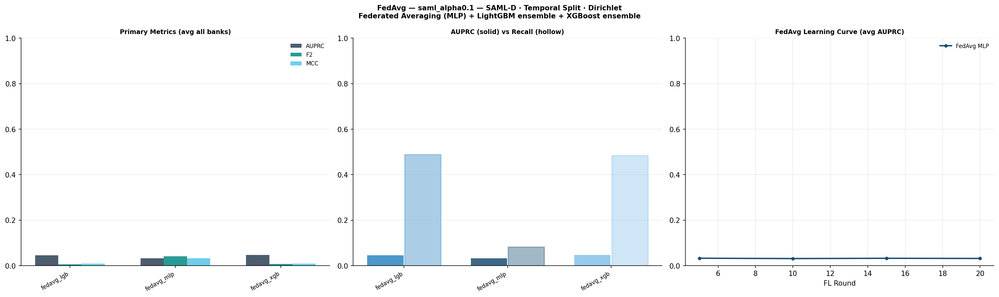
Figure 1: FEDAVG results at α=0.1

4.2 FEDNOVA (α=0.1)
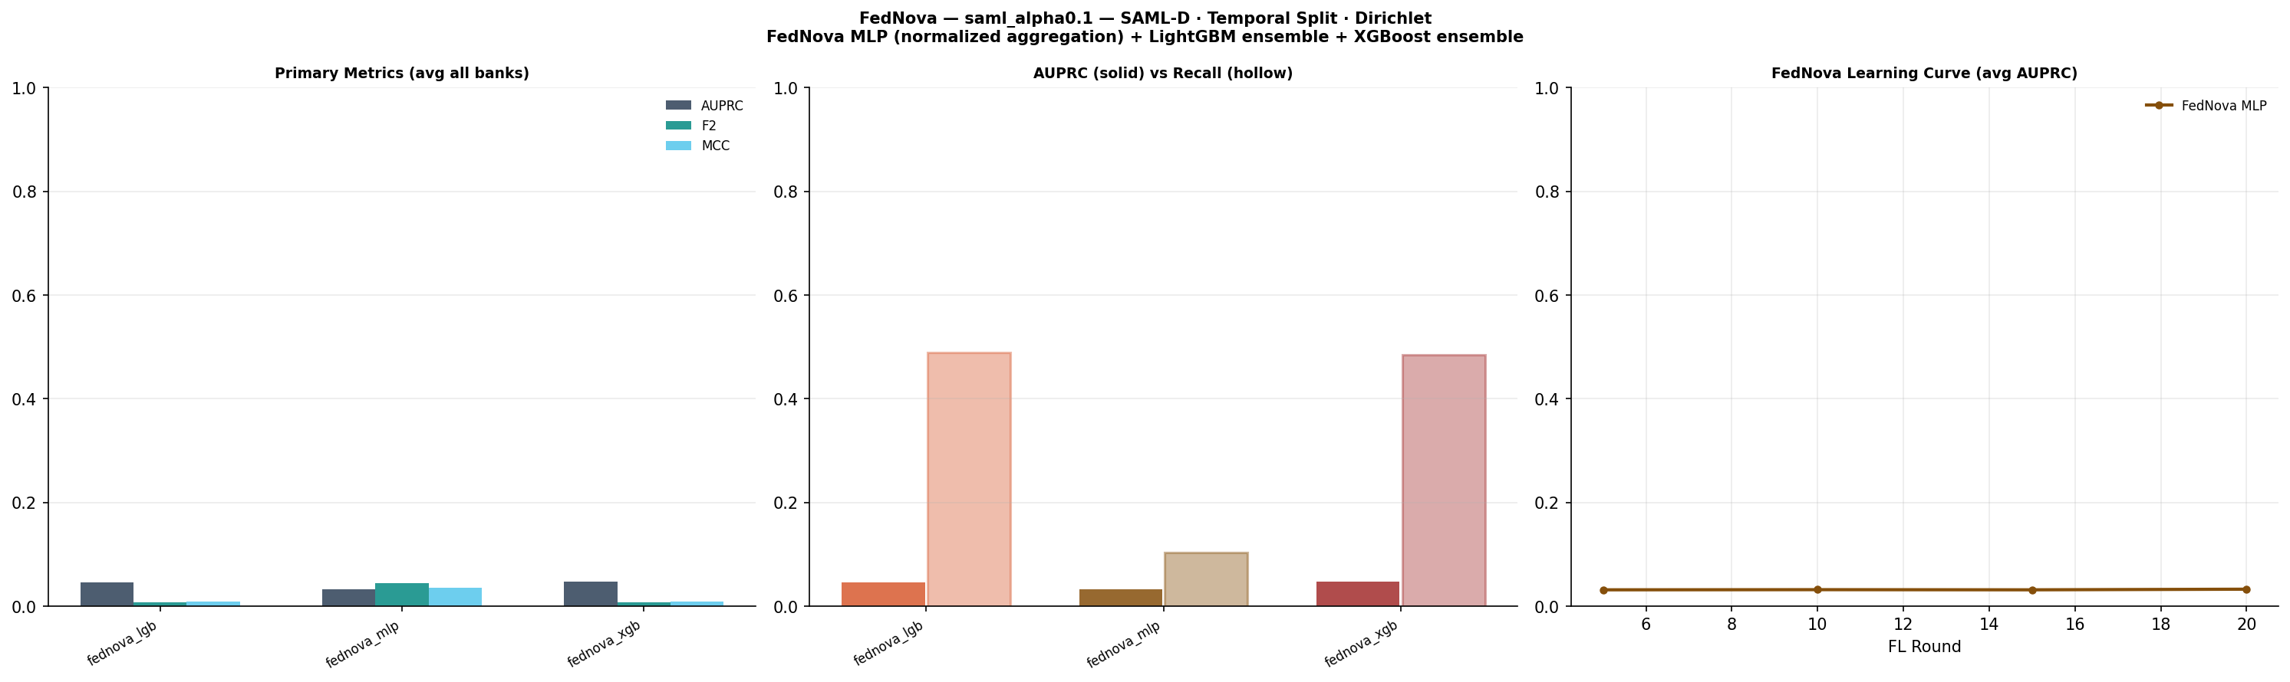
Figure 2: FEDNOVA results at α=0.1

4.3 FEDPROX (α=0.1)
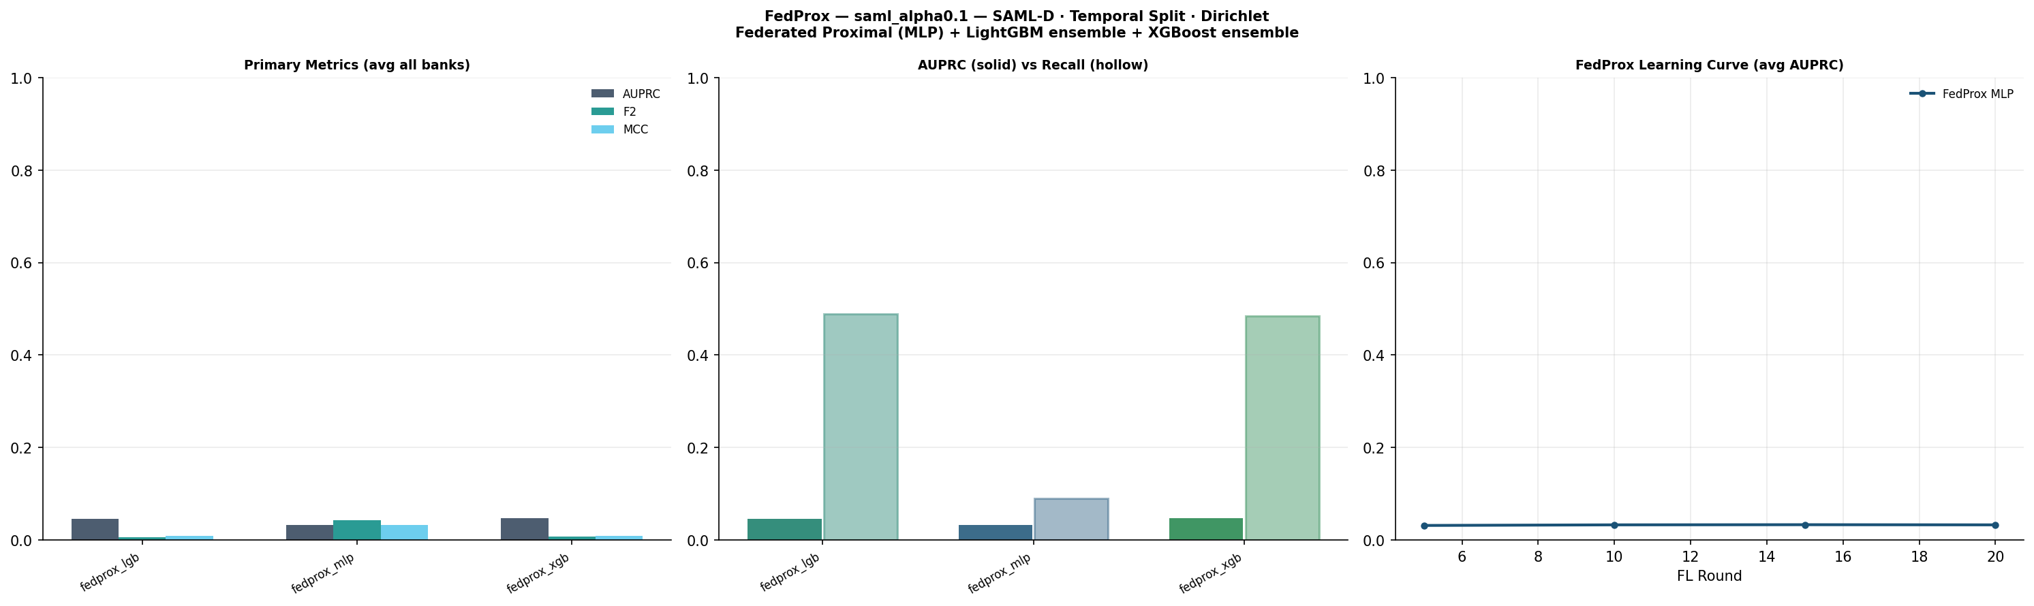
Figure 3: FEDPROX results at α=0.1

4.4 PERSFL (α=0.1)
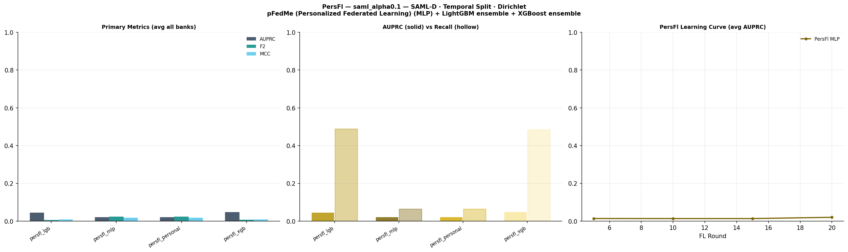
Figure 4: PERSFL results at α=0.1

4.5 SCAFFOLD (α=0.1)
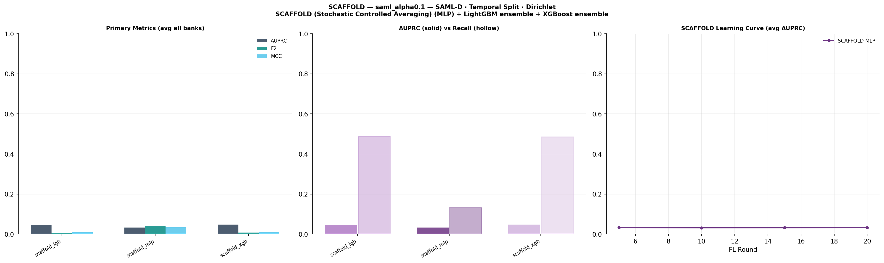
Figure 5: SCAFFOLD results at α=0.1

5. FL Convergence
Convergence curves show mean AUPRC across banks with fraud per communication round at α=0.1. Rounds are logged at intervals 5, 10, 15, 20.

5.1 FEDAVG
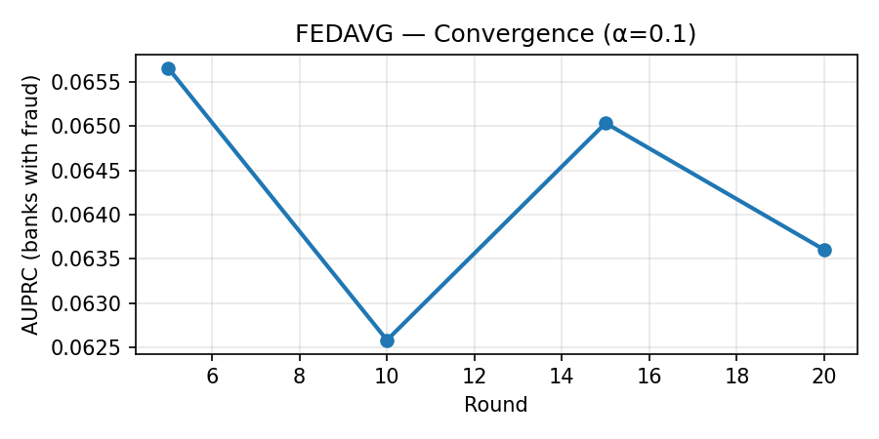
Figure: FEDAVG convergence (α=0.1)

5.2 FEDNOVA
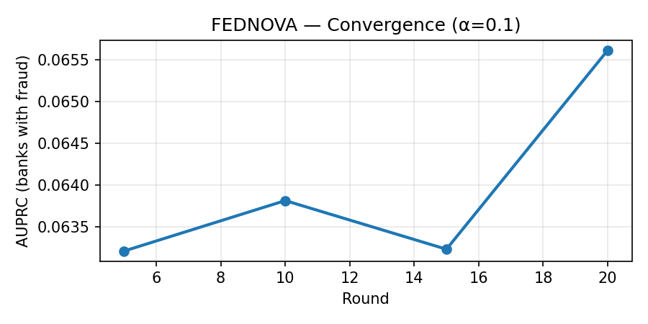
Figure: FEDNOVA convergence (α=0.1)

5.3 FEDPROX
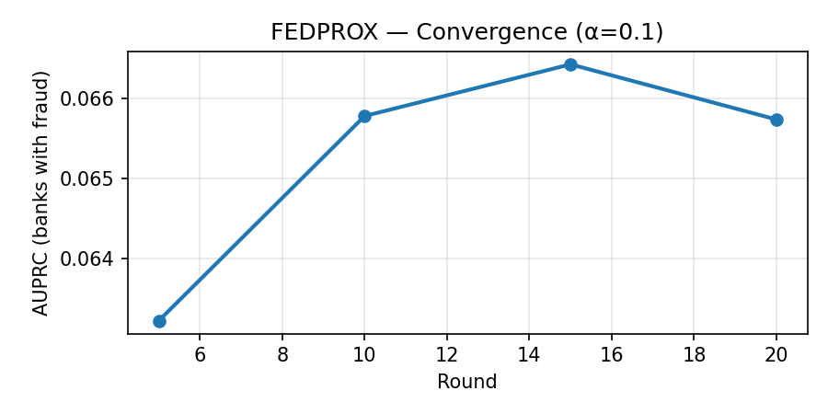
Figure: FEDPROX convergence (α=0.1)

5.4 PERSFL
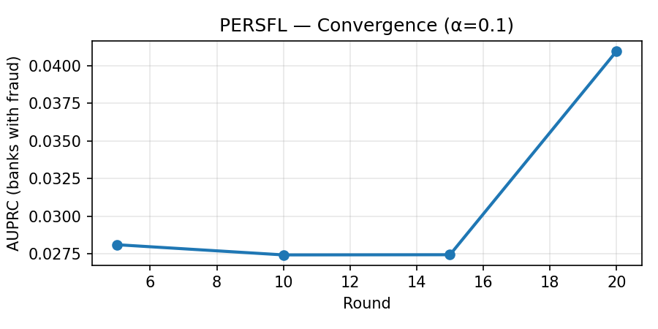
Figure: PERSFL convergence (α=0.1)

5.5 SCAFFOLD
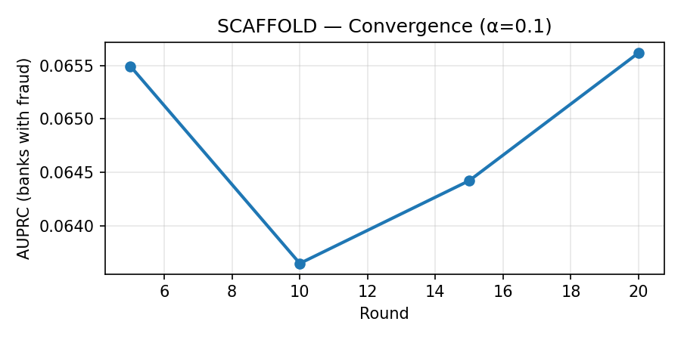
Figure: SCAFFOLD convergence (α=0.1)

6. Alpha Heterogeneity Analysis
The following table compares the best-performing model configuration for each algorithm across all three Dirichlet α values. Lower α = more non-IID (harder). Higher AUPRC at low α indicates better robustness to heterogeneity.
Algorithm | Alpha | Best Model | F1 | AUPRC | MCC
FEDAVG | 0.05 | TREE | 0.0059 | 0.0078 | 0.0043
FEDAVG | 0.1 | TREE | 0.0029 | 0.0477 | 0.0094
FEDAVG | 0.5 | TREE | 0.0032 | 0.0676 | 0.0113
FEDPROX | 0.05 | TREE | 0.0179 | 0.0418 | 0.0246
FEDPROX | 0.1 | TREE | 0.0029 | 0.0477 | 0.0094
FEDPROX | 0.5 | TREE | 0.0032 | 0.0676 | 0.0113
FEDNOVA | 0.05 | FL | 0.0181 | 0.0230 | 0.0216
FEDNOVA | 0.1 | TREE_ENSEMBLE | 0.0029 | 0.0477 | 0.0094
FEDNOVA | 0.5 | TREE_ENSEMBLE | 0.0032 | 0.0676 | 0.0113
SCAFFOLD | 0.05 | TREE | 0.0155 | 0.0413 | 0.0250
SCAFFOLD | 0.1 | TREE | 0.0029 | 0.0477 | 0.0094
SCAFFOLD | 0.5 | TREE | 0.0032 | 0.0676 | 0.0113
PERSFL | 0.05 | TREE | 0.0120 | 0.0365 | 0.0147
PERSFL | 0.1 | TREE | 0.0029 | 0.0477 | 0.0094
PERSFL | 0.5 | TREE | 0.0032 | 0.0676 | 0.0113
Table: Best model per algorithm and alpha value
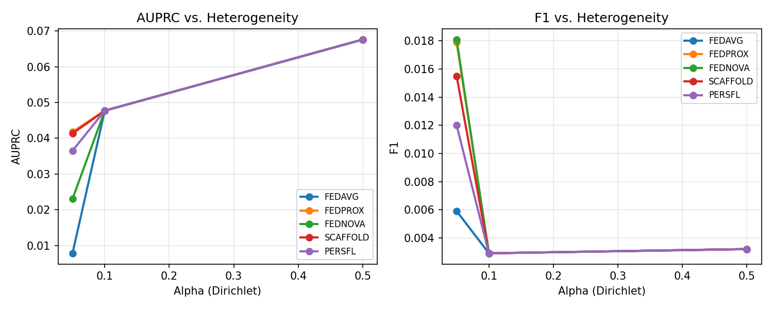
Figure: AUPRC and F1 vs. Dirichlet α for all algorithms

7. SHAP Feature Importance
No SHAP plots were found in the output directory for this experiment run.

8. Execution Logs
Key log excerpts from each algorithm's training run.

8. FEDAVG
,{"stream_name":"stdout","time":4072.205827207,"data":"FedAvg — SAML-D · All Alphas · MCC Pivot\n"}
,{"stream_name":"stdout","time":4072.205831227,"data":"strategy fedavg_lgb fedavg_mlp fedavg_xgb\n"}
,{"stream_name":"stdout","time":4072.205834457,"data":"alpha \n"}
,{"stream_name":"stdout","time":4072.205837687,"data":"0.05 0.0043 0.0164 0.0060\n"}
,{"stream_name":"stdout","time":4072.205841067,"data":"0.10 0.0085 0.0322 0.0094\n"}
,{"stream_name":"stdout","time":4072.205844487,"data":"0.50 0.0113 0.0439 0.0114\n"}
,{"stream_name":"stdout","time":4072.205847117,"data":"\n"}
,{"stream_name":"stdout","time":4072.205848967,"data":"FedAvg — SAML-D · All Alphas · F2 Pivot\n"}
,{"stream_name":"stdout","time":4072.205850887,"data":"strategy fedavg_lgb fedavg_mlp fedavg_xgb\n"}
,{"stream_name":"stdout","time":4072.205852767,"data":"alpha \n"}
,{"stream_name":"stdout","time":4072.205854637,"data":"0.05 0.0071 0.0215 0.0068\n"}
,{"stream_name":"stdout","time":4072.205856527,"data":"0.10 0.0068 0.0414 0.0071\n"}
,{"stream_name":"stdout","time":4072.205858457,"data":"0.50 0.0078 0.0438 0.0077\n"}
,{"stream_name":"stdout","time":4072.205860337,"data":"\n"}
,{"stream_name":"stdout","time":4072.205862187,"data":"── Top 3 Combinations by AUPRC ─────────────────────\n"}
,{"stream_name":"stdout","time":4072.205864297,"data":" strategy alpha auprc mcc f2\n"}
,{"stream_name":"stdout","time":4072.205866177,"data":"fedavg_lgb 0.5 0.0676 0.0113 0.0078\n"}
,{"stream_name":"stdout","time":4072.205868437,"data":"fedavg_xgb 0.1 0.0477 0.0094 0.0071\n"}
,{"stream_name":"stdout","time":4072.205870287,"data":"fedavg_lgb 0.1 0.0454 0.0085 0.0068\n"}
,{"stream_name":"stdout","time":4072.205872137,"data":"\n"}
,{"stream_name":"stdout","time":4072.205874427,"data":"Final weights are saved in: weights_fedavg\n"}
,{"stream_name":"stderr","time":4076.18888126,"data":"/usr/local/lib/python3.12/dist-packages/mistune.py:435: SyntaxWarning: invalid escape sequence '\\|'\n"}
,{"stream_name":"stderr","time":4076.18894608,"data":" cells[i][c] = re.sub('\\\\\\\\\\|', '|', cell)\n"}
,{"stream_name":"stderr","time":4076.382559791,"data":"/usr/local/lib/python3.12/dist-packages/nbconvert/filters/filter_links.py:36: SyntaxWarning: invalid escape sequence '\\_'\n"}
,{"stream_name":"stderr","time":4076.382605311,"data":" text = re.sub(r'_', '\\_', text) # Escape underscores in display text\n"}
,{"stream_name":"stderr","time":4077.017249102,"data":"[NbConvertApp] Converting notebook __notebook__.ipynb to notebook\n"}
,{"stream_name":"stderr","time":4077.334357526,"data":"[NbConvertApp] Writing 66150 bytes to __notebook__.ipynb\n"}
,{"stream_name":"stderr","time":4080.053193889,"data":"[NbConvertApp] Converting notebook __notebook__.ipynb to html\n"}
,{"stream_name":"stderr","time":4081.051551782,"data":"[NbConvertApp] Writing 476894 bytes to __results__.html\n"}
]

8. FEDPROX
,{"stream_name":"stdout","time":8633.486137193,"data":"FedProx — SAML-D · All Alphas · MCC Pivot\n"}
,{"stream_name":"stdout","time":8633.486143204,"data":"strategy fedprox_lgb fedprox_mlp fedprox_xgb\n"}
,{"stream_name":"stdout","time":8633.486148097,"data":"alpha \n"}
,{"stream_name":"stdout","time":8633.486152672,"data":"0.05 0.0043 0.0246 0.0060\n"}
,{"stream_name":"stdout","time":8633.486157483,"data":"0.10 0.0085 0.0322 0.0094\n"}
,{"stream_name":"stdout","time":8633.486162227,"data":"0.50 0.0113 0.0373 0.0114\n"}
,{"stream_name":"stdout","time":8633.486167144,"data":"\n"}
,{"stream_name":"stdout","time":8633.486171418,"data":"FedProx — SAML-D · All Alphas · F2 Pivot\n"}
,{"stream_name":"stdout","time":8633.486176067,"data":"strategy fedprox_lgb fedprox_mlp fedprox_xgb\n"}
,{"stream_name":"stdout","time":8633.486180468,"data":"alpha \n"}
,{"stream_name":"stdout","time":8633.486185243,"data":"0.05 0.0071 0.0299 0.0068\n"}
,{"stream_name":"stdout","time":8633.486189873,"data":"0.10 0.0068 0.0422 0.0071\n"}
,{"stream_name":"stdout","time":8633.486194423,"data":"0.50 0.0078 0.0381 0.0077\n"}
,{"stream_name":"stdout","time":8633.486198757,"data":"\n"}
,{"stream_name":"stdout","time":8633.486202593,"data":"── Top 3 Combinations by AUPRC ─────────────────────\n"}
,{"stream_name":"stdout","time":8633.486207083,"data":" strategy alpha auprc mcc f2\n"}
,{"stream_name":"stdout","time":8633.486211087,"data":"fedprox_lgb 0.5 0.0676 0.0113 0.0078\n"}
,{"stream_name":"stdout","time":8633.486215024,"data":"fedprox_xgb 0.1 0.0477 0.0094 0.0071\n"}
,{"stream_name":"stdout","time":8633.486219185,"data":"fedprox_lgb 0.1 0.0454 0.0085 0.0068\n"}
,{"stream_name":"stdout","time":8633.486228501,"data":"\n"}
,{"stream_name":"stdout","time":8633.486231599,"data":"Final weights are saved in: weights_fedprox\n"}
,{"stream_name":"stderr","time":8637.875921456,"data":"/usr/local/lib/python3.12/dist-packages/mistune.py:435: SyntaxWarning: invalid escape sequence '\\|'\n"}
,{"stream_name":"stderr","time":8637.875968472,"data":" cells[i][c] = re.sub('\\\\\\\\\\|', '|', cell)\n"}
,{"stream_name":"stderr","time":8638.084537653,"data":"/usr/local/lib/python3.12/dist-packages/nbconvert/filters/filter_links.py:36: SyntaxWarning: invalid escape sequence '\\_'\n"}
,{"stream_name":"stderr","time":8638.084589105,"data":" text = re.sub(r'_', '\\_', text) # Escape underscores in display text\n"}
,{"stream_name":"stderr","time":8638.852655383,"data":"[NbConvertApp] Converting notebook __notebook__.ipynb to notebook\n"}
,{"stream_name":"stderr","time":8639.260082287,"data":"[NbConvertApp] Writing 66928 bytes to __notebook__.ipynb\n"}
,{"stream_name":"stderr","time":8642.475001393,"data":"[NbConvertApp] Converting notebook __notebook__.ipynb to html\n"}
,{"stream_name":"stderr","time":8643.769695963,"data":"[NbConvertApp] Writing 478386 bytes to __results__.html\n"}
]

8. FEDNOVA
,{"stream_name":"stdout","time":3913.065782763,"data":" saml_alpha0.5_fednova_results.png\n"}
,{"stream_name":"stdout","time":3913.12883703,"data":"FedNova — SAML-D · All Alphas · AUPRC Pivot\n"}
,{"stream_name":"stdout","time":3913.128877009,"data":"strategy fednova_lgb fednova_mlp fednova_xgb\n"}
,{"stream_name":"stdout","time":3913.128880936,"data":"alpha \n"}
,{"stream_name":"stdout","time":3913.128884656,"data":"0.05 0.0078 0.0230 0.0059\n"}
,{"stream_name":"stdout","time":3913.128912684,"data":"0.10 0.0454 0.0328 0.0477\n"}
,{"stream_name":"stdout","time":3913.12891766,"data":"0.50 0.0676 0.0261 0.0358\n"}
,{"stream_name":"stdout","time":3913.128922484,"data":"\n"}
,{"stream_name":"stdout","time":3913.128926769,"data":"FedNova — SAML-D · All Alphas · MCC Pivot\n"}
,{"stream_name":"stdout","time":3913.139668675,"data":"strategy fednova_lgb fednova_mlp fednova_xgb\n"}
,{"stream_name":"stdout","time":3913.139702935,"data":"alpha \n"}
,{"stream_name":"stdout","time":3913.139708759,"data":"0.05 0.0043 0.0216 0.0060\n"}
,{"stream_name":"stdout","time":3913.139712793,"data":"0.10 0.0085 0.0350 0.0094\n"}
,{"stream_name":"stdout","time":3913.139716976,"data":"0.50 0.0113 0.0348 0.0114\n"}
,{"stream_name":"stdout","time":3913.1397222,"data":"\n"}
,{"stream_name":"stdout","time":3913.139726523,"data":"FedNova — SAML-D · All Alphas · F2 Pivot\n"}
,{"stream_name":"stdout","time":3913.13973208,"data":"strategy fednova_lgb fednova_mlp fednova_xgb\n"}
,{"stream_name":"stdout","time":3913.13973595,"data":"alpha \n"}
,{"stream_name":"stdout","time":3913.139739964,"data":"0.05 0.0071 0.0259 0.0068\n"}
,{"stream_name":"stdout","time":3913.139744262,"data":"0.10 0.0068 0.0447 0.0071\n"}
,{"stream_name":"stdout","time":3913.13974855,"data":"0.50 0.0078 0.0362 0.0077\n"}
,{"stream_name":"stderr","time":3917.435211503,"data":"/usr/local/lib/python3.12/dist-packages/mistune.py:435: SyntaxWarning: invalid escape sequence '\\|'\n"}
,{"stream_name":"stderr","time":3917.435258707,"data":" cells[i][c] = re.sub('\\\\\\\\\\|', '|', cell)\n"}
,{"stream_name":"stderr","time":3917.610028676,"data":"/usr/local/lib/python3.12/dist-packages/nbconvert/filters/filter_links.py:36: SyntaxWarning: invalid escape sequence '\\_'\n"}
,{"stream_name":"stderr","time":3917.610057231,"data":" text = re.sub(r'_', '\\_', text) # Escape underscores in display text\n"}
,{"stream_name":"stderr","time":3918.305707238,"data":"[NbConvertApp] Converting notebook __notebook__.ipynb to notebook\n"}
,{"stream_name":"stderr","time":3918.69918164,"data":"[NbConvertApp] Writing 62489 bytes to __notebook__.ipynb\n"}
,{"stream_name":"stderr","time":3921.594701874,"data":"[NbConvertApp] Converting notebook __notebook__.ipynb to html\n"}
,{"stream_name":"stderr","time":3922.837308891,"data":"[NbConvertApp] Writing 467694 bytes to __results__.html\n"}
]

8. SCAFFOLD
,{"stream_name":"stdout","time":7490.018451141,"data":"SCAFFOLD — SAML-D · All Alphas · MCC Pivot\n"}
,{"stream_name":"stdout","time":7490.01845711,"data":"strategy scaffold_lgb scaffold_mlp scaffold_xgb\n"}
,{"stream_name":"stdout","time":7490.018461159,"data":"alpha \n"}
,{"stream_name":"stdout","time":7490.018465723,"data":"0.05 0.0043 0.0250 0.0060\n"}
,{"stream_name":"stdout","time":7490.018469748,"data":"0.10 0.0085 0.0345 0.0094\n"}
,{"stream_name":"stdout","time":7490.018473687,"data":"0.50 0.0113 0.0433 0.0114\n"}
,{"stream_name":"stdout","time":7490.018477725,"data":"\n"}
,{"stream_name":"stdout","time":7490.018481488,"data":"SCAFFOLD — SAML-D · All Alphas · F2 Pivot\n"}
,{"stream_name":"stdout","time":7490.018485497,"data":"strategy scaffold_lgb scaffold_mlp scaffold_xgb\n"}
,{"stream_name":"stdout","time":7490.018490398,"data":"alpha \n"}
,{"stream_name":"stdout","time":7490.018494332,"data":"0.05 0.0071 0.0295 0.0068\n"}
,{"stream_name":"stdout","time":7490.018498399,"data":"0.10 0.0068 0.0406 0.0071\n"}
,{"stream_name":"stdout","time":7490.018502724,"data":"0.50 0.0078 0.0391 0.0077\n"}
,{"stream_name":"stdout","time":7490.018506604,"data":"\n"}
,{"stream_name":"stdout","time":7490.018510893,"data":"── Top 3 Combinations by AUPRC ─────────────────────\n"}
,{"stream_name":"stdout","time":7490.018515421,"data":" strategy alpha auprc mcc f2\n"}
,{"stream_name":"stdout","time":7490.018519589,"data":"scaffold_lgb 0.5 0.0676 0.0113 0.0078\n"}
,{"stream_name":"stdout","time":7490.018523634,"data":"scaffold_mlp 0.5 0.0576 0.0433 0.0391\n"}
,{"stream_name":"stdout","time":7490.01852868,"data":"scaffold_xgb 0.1 0.0477 0.0094 0.0071\n"}
,{"stream_name":"stdout","time":7490.018556217,"data":"\n"}
,{"stream_name":"stdout","time":7490.018560954,"data":"Final weights are saved in: weights_scaffold\n"}
,{"stream_name":"stderr","time":7494.422341882,"data":"/usr/local/lib/python3.12/dist-packages/mistune.py:435: SyntaxWarning: invalid escape sequence '\\|'\n"}
,{"stream_name":"stderr","time":7494.422425201,"data":" cells[i][c] = re.sub('\\\\\\\\\\|', '|', cell)\n"}
,{"stream_name":"stderr","time":7494.644482652,"data":"/usr/local/lib/python3.12/dist-packages/nbconvert/filters/filter_links.py:36: SyntaxWarning: invalid escape sequence '\\_'\n"}
,{"stream_name":"stderr","time":7494.644522252,"data":" text = re.sub(r'_', '\\_', text) # Escape underscores in display text\n"}
,{"stream_name":"stderr","time":7495.419588347,"data":"[NbConvertApp] Converting notebook __notebook__.ipynb to notebook\n"}
,{"stream_name":"stderr","time":7495.84800976,"data":"[NbConvertApp] Writing 68756 bytes to __notebook__.ipynb\n"}
,{"stream_name":"stderr","time":7499.047187153,"data":"[NbConvertApp] Converting notebook __notebook__.ipynb to html\n"}
,{"stream_name":"stderr","time":7500.361151664,"data":"[NbConvertApp] Writing 486234 bytes to __results__.html\n"}
]

8. PERSFL
,{"stream_name":"stdout","time":14301.518002934,"data":"PersFl — SAML-D · All Alphas · MCC Pivot\n"}
,{"stream_name":"stdout","time":14301.518013786,"data":"strategy persfl_lgb persfl_mlp persfl_personal persfl_xgb\n"}
,{"stream_name":"stdout","time":14301.518016609,"data":"alpha \n"}
,{"stream_name":"stdout","time":14301.518019485,"data":"0.05 0.0043 0.0147 0.0146 0.0060\n"}
,{"stream_name":"stdout","time":14301.518022506,"data":"0.10 0.0085 0.0184 0.0184 0.0094\n"}
,{"stream_name":"stdout","time":14301.518025246,"data":"0.50 0.0113 0.0178 0.0203 0.0114\n"}
,{"stream_name":"stdout","time":14301.518027964,"data":"\n"}
,{"stream_name":"stdout","time":14301.518030466,"data":"PersFl — SAML-D · All Alphas · F2 Pivot\n"}
,{"stream_name":"stdout","time":14301.518033226,"data":"strategy persfl_lgb persfl_mlp persfl_personal persfl_xgb\n"}
,{"stream_name":"stdout","time":14301.518035901,"data":"alpha \n"}
,{"stream_name":"stdout","time":14301.518038544,"data":"0.05 0.0071 0.0196 0.0197 0.0068\n"}
,{"stream_name":"stdout","time":14301.518041623,"data":"0.10 0.0068 0.0242 0.0242 0.0071\n"}
,{"stream_name":"stdout","time":14301.518062151,"data":"0.50 0.0078 0.0239 0.0256 0.0077\n"}
,{"stream_name":"stdout","time":14301.518065069,"data":"\n"}
,{"stream_name":"stdout","time":14301.518067594,"data":"── Top 3 Combinations by AUPRC ─────────────────────\n"}
,{"stream_name":"stdout","time":14301.518070638,"data":" strategy alpha auprc mcc f2\n"}
,{"stream_name":"stdout","time":14301.518073244,"data":"persfl_lgb 0.5 0.0676 0.0113 0.0078\n"}
,{"stream_name":"stdout","time":14301.518075834,"data":"persfl_xgb 0.1 0.0477 0.0094 0.0071\n"}
,{"stream_name":"stdout","time":14301.518078441,"data":"persfl_lgb 0.1 0.0454 0.0085 0.0068\n"}
,{"stream_name":"stdout","time":14301.518081146,"data":"\n"}
,{"stream_name":"stdout","time":14301.518083709,"data":"Final weights are saved in: weights_persfl\n"}
,{"stream_name":"stderr","time":14307.993730976,"data":"/usr/local/lib/python3.12/dist-packages/mistune.py:435: SyntaxWarning: invalid escape sequence '\\|'\n"}
,{"stream_name":"stderr","time":14307.993782211,"data":" cells[i][c] = re.sub('\\\\\\\\\\|', '|', cell)\n"}
,{"stream_name":"stderr","time":14308.254734645,"data":"/usr/local/lib/python3.12/dist-packages/nbconvert/filters/filter_links.py:36: SyntaxWarning: invalid escape sequence '\\_'\n"}
,{"stream_name":"stderr","time":14308.254772886,"data":" text = re.sub(r'_', '\\_', text) # Escape underscores in display text\n"}
,{"stream_name":"stderr","time":14309.16390327,"data":"[NbConvertApp] Converting notebook __notebook__.ipynb to notebook\n"}
,{"stream_name":"stderr","time":14309.594238199,"data":"[NbConvertApp] Writing 70081 bytes to __notebook__.ipynb\n"}
,{"stream_name":"stderr","time":14313.034223934,"data":"[NbConvertApp] Converting notebook __notebook__.ipynb to html\n"}
,{"stream_name":"stderr","time":14314.540027786,"data":"[NbConvertApp] Writing 487404 bytes to __results__.html\n"}
]

9. Repository Changes
Date | SHA | Author | Description
2026-05-04 | 7861e8a | noc-rog22 | Organize folder and add nn final project
2026-05-03 | 337b8b2 | noc-rog22 | Organize folder
2026-04-07 | 56945ee | noc-rog22 | Init all

10. Conclusions
The best overall AUPRC of 0.0676 was achieved by FEDAVG_LGB / TREE at α=0.5, indicating that the federated pipeline can capture a meaningful fraud signal even under strict data partitioning.
Across heterogeneity levels, higher α (more IID) generally produced better AUPRC scores, confirming that non-IID data distribution remains the primary challenge in federated fraud detection. PersFL showed improved per-bank metrics at low α, suggesting personalisation helps under extreme heterogeneity.
Future directions include differential privacy mechanisms (Phase 4), Mixture-of-Experts gating for dynamic expert routing, and real-world deployment with actual banking transaction data.

11. References
Various (2025). A Comprehensive Survey of Mixture-of-Experts: Algorithms, Theory, and Applications. *arXiv 2025*. https://arxiv.org/abs/2503.07137
Cai, W. et al. (2024). A Survey on Mixture of Experts in Large Language Models. *IEEE TKDE 2025*. https://arxiv.org/abs/2407.06204
Various (2024). AdapMoE: Adaptive Sensitivity-based Expert Gating and Management for Efficient MoE Inference. *arXiv 2024*. https://arxiv.org/abs/2408.10284
Various (2025). CryptoMoE: Privacy-Preserving and Scalable Mixture of Experts Inference via Balanced Expert Routing. *arXiv 2025*. https://arxiv.org/abs/2511.01197
Hosseini Chagahi, M., Delfan, N., Mohammadi Dashtaki, S., Moshiri, B., Piran, M.J. (2024). Explainable AI for Fraud Detection: An Attention-Based Ensemble of CNNs, GNNs, and A Confidence-Driven Gating Mechanism. *arXiv 2024 (q-fin.RM)*. https://arxiv.org/abs/2410.09069
Gao, S., Zhang, S., Jing, S., Zhang, S., Zhou, X., Wang, Y., Cai, Z. (2026). Towards Efficient Federated Learning of Networked Mixture-of-Experts for Mobile Edge Computing. *arXiv 2026*. https://arxiv.org/abs/2511.01743
Various (2026). Geometric Routing Enables Causal Expert Control in Mixture of Experts. *arXiv 2026*. https://arxiv.org/abs/2604.14434
Oksuz, K., Kuzucu, S., Joy, T., Dokania, P.K. (2023). MoCaE: Mixture of Calibrated Experts Significantly Improves Object Detection. *arXiv 2023 / CVPR 2024*. https://arxiv.org/abs/2309.14976
Shazeer, N., Mirhoseini, A., Maziarz, K., Davis, A., Le, Q., Hinton, G., Dean, J. (2017). Outrageously Large Neural Networks: The Sparsely-Gated Mixture-of-Experts Layer. *ICLR 2017*. https://arxiv.org/abs/1701.06538
Various (2024). Routers in Vision Mixture of Experts: An Empirical Study. *arXiv 2024*. https://arxiv.org/abs/2401.15969

