**DEVOPS**

DAY 1 : JENKINS(Installing and setting up Jenkins on Linux machine)

#ip addr

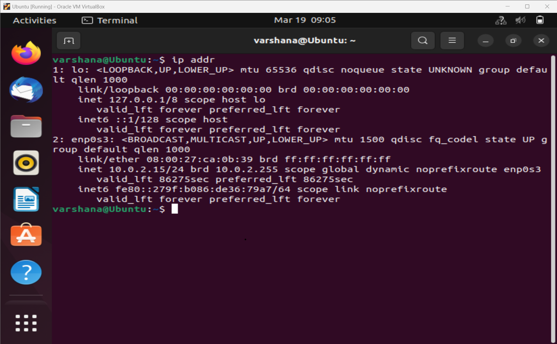

#Execute Shell(Commands)

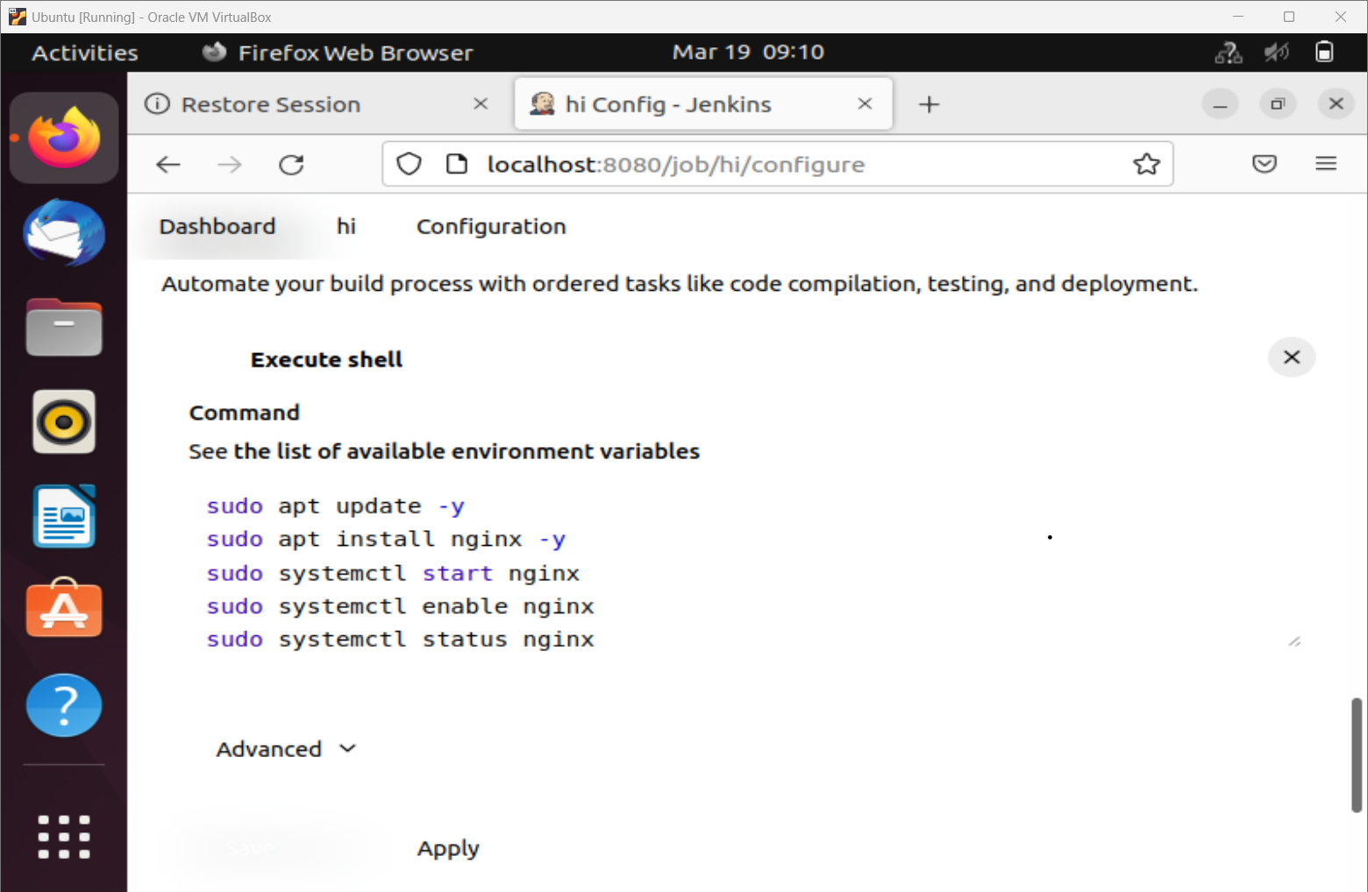

#Console Output

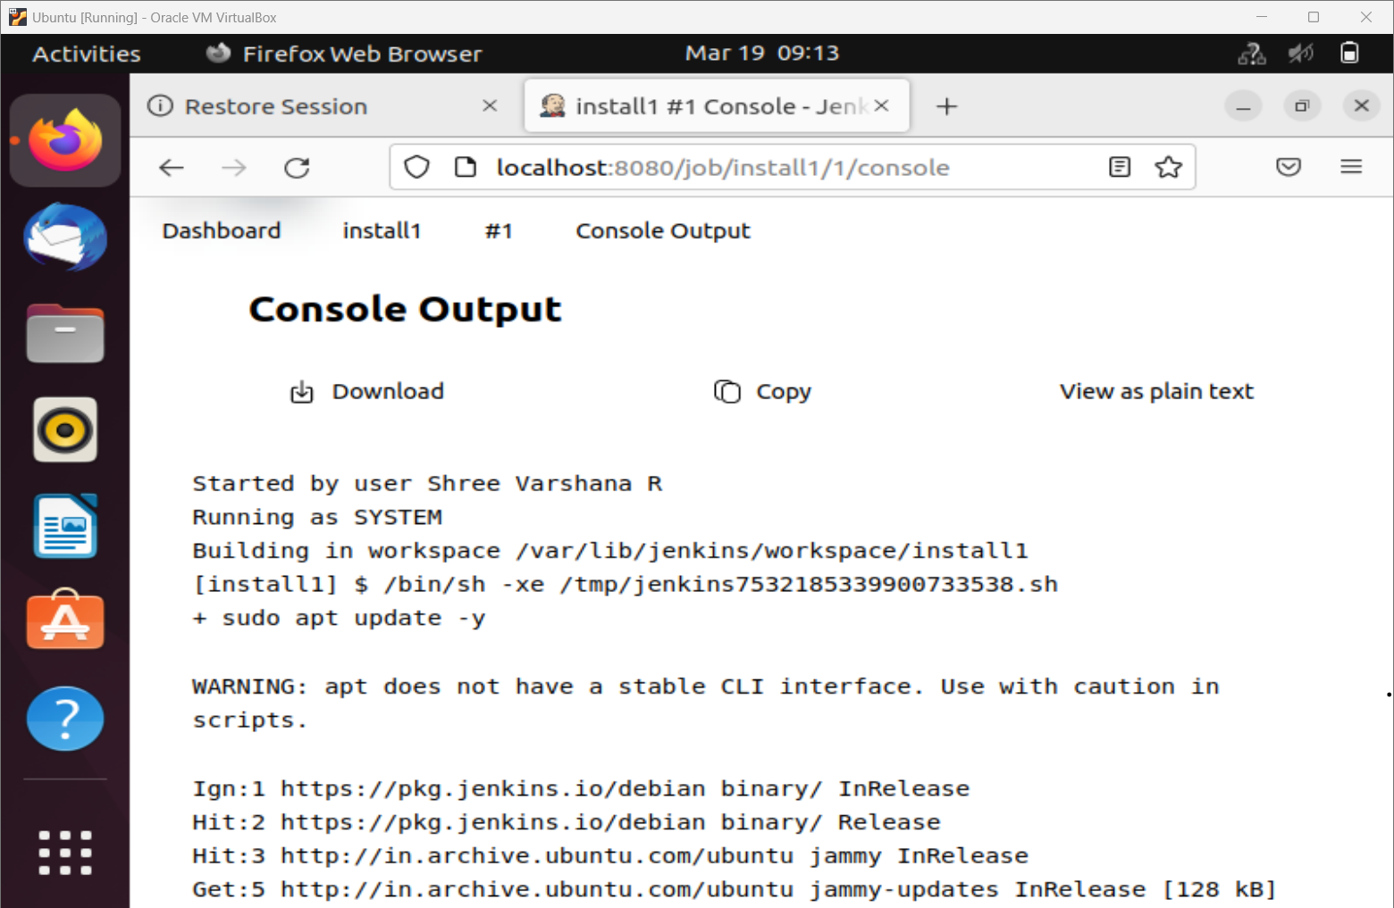

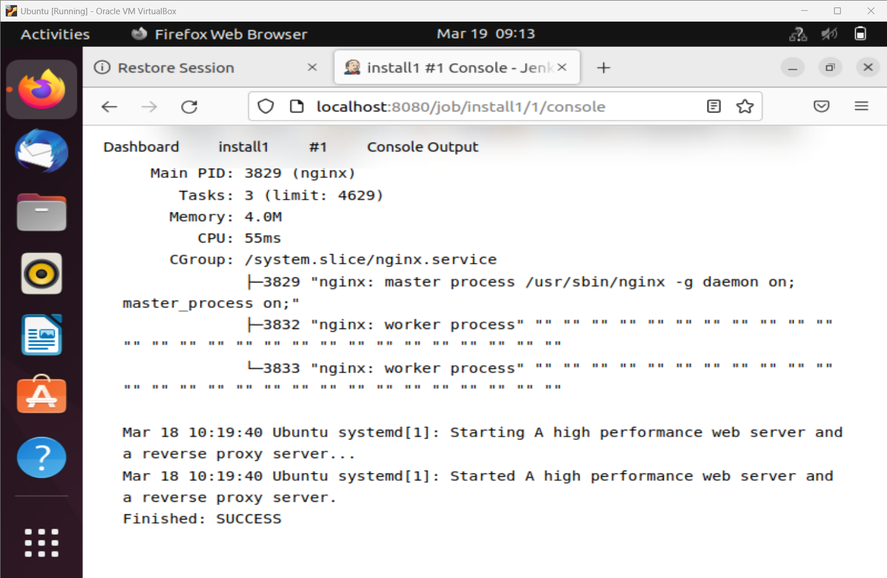

#Welcome Page

