**CREATE A S3 BUCKET WITH NO PUBLIC ACCESS**

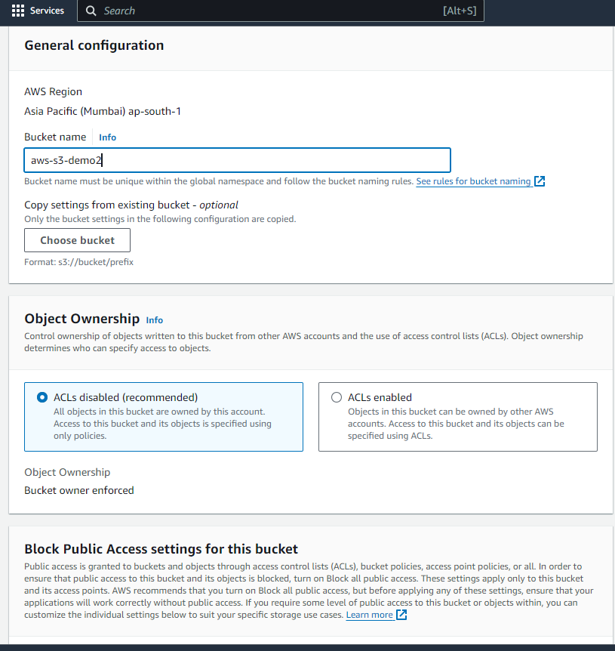

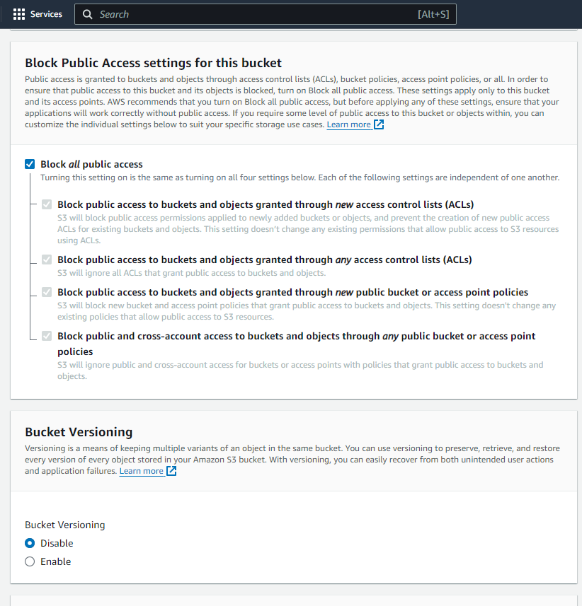

**UPLOAD ANY FILES TO THE BUCKET**

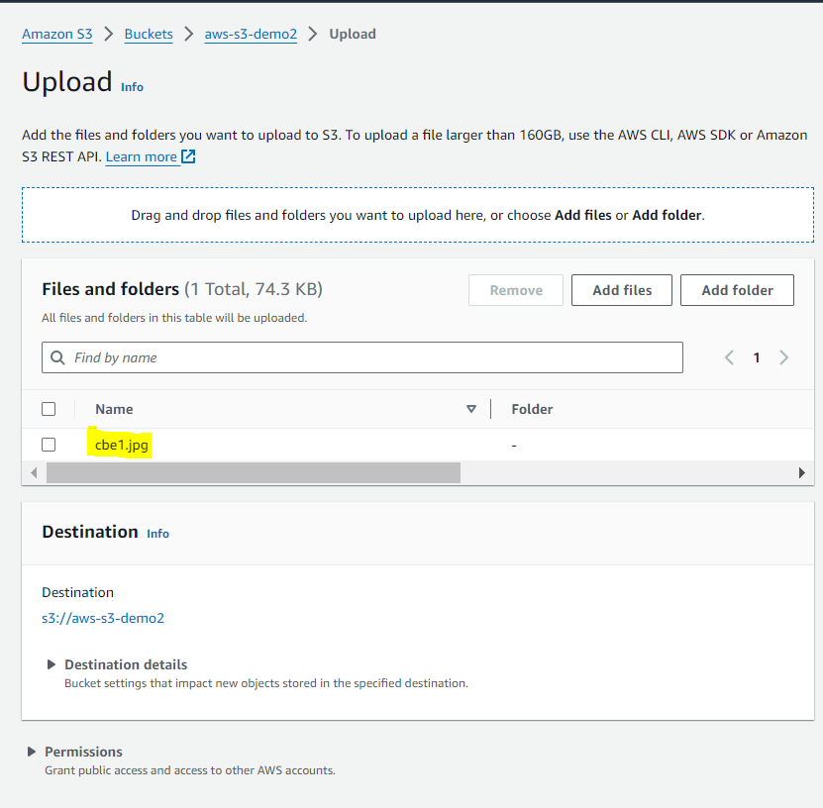

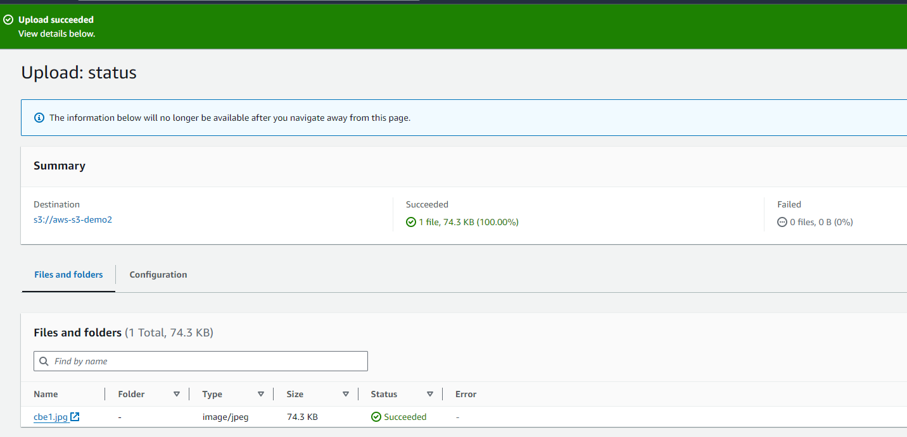

**NOW ENABLE LOGS FOR THE BUCKET**

**NAVIGATE TO PROPERTIES IN THE BUCKET AND ENABLE SERVER ACCESS LOGGING**

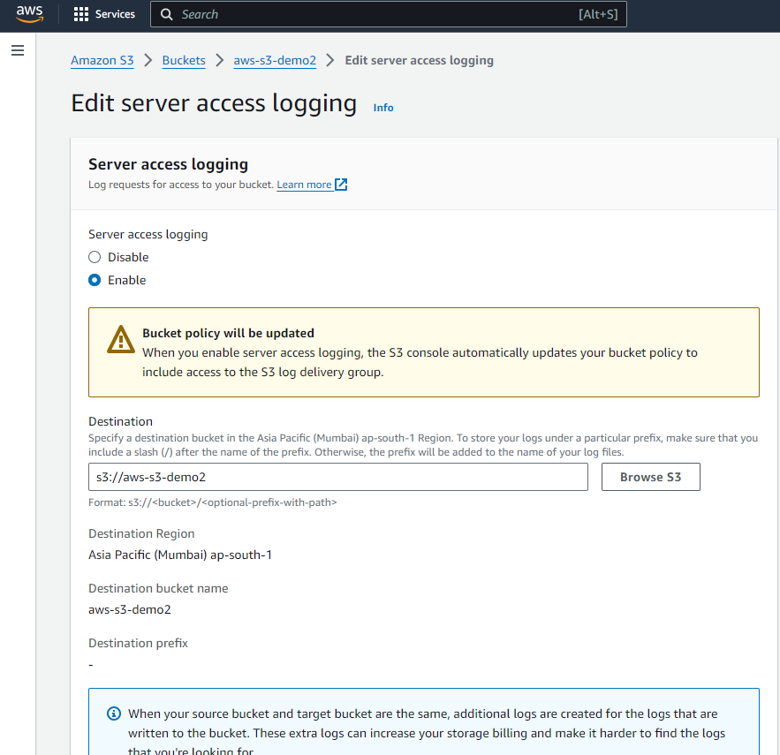

**IN DESTINATION SELECT THE BUCKET THAT WE CREATED**

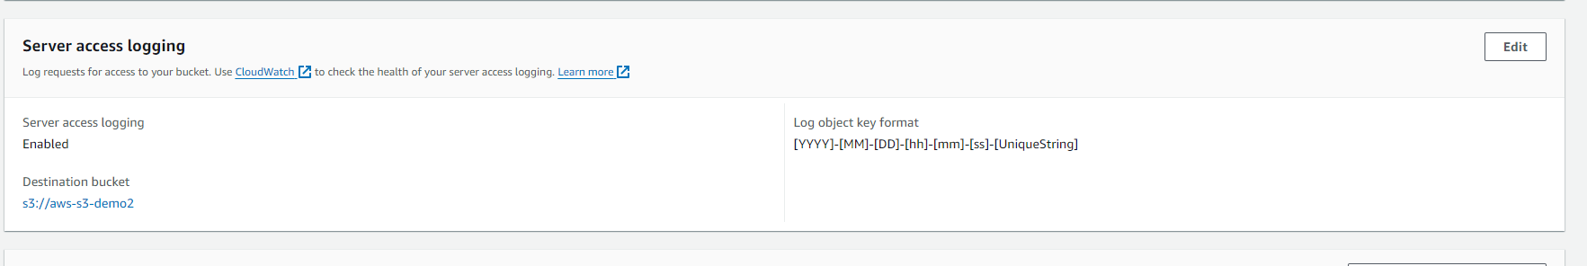

**LOGS**

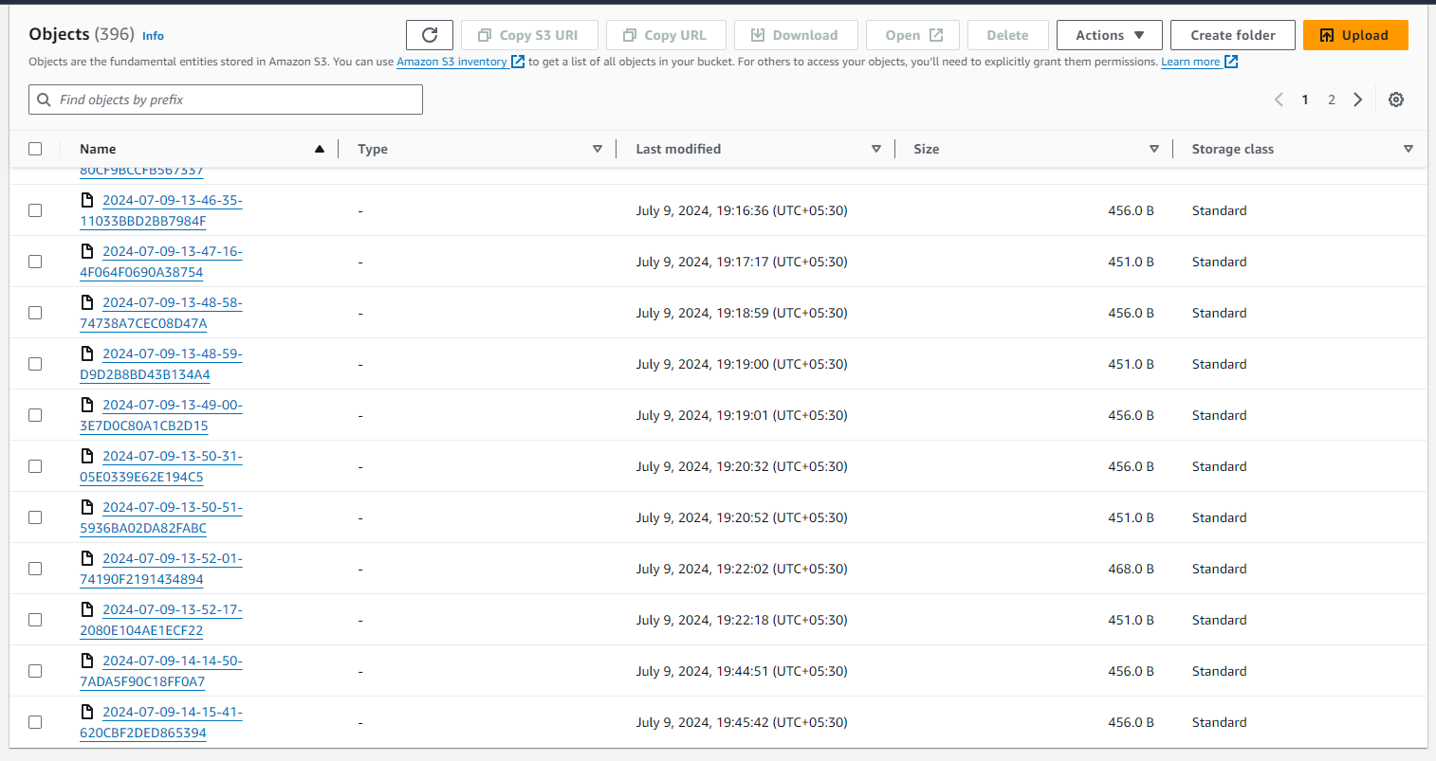

**NOW CREATE 2 EC2 INSTANCE**

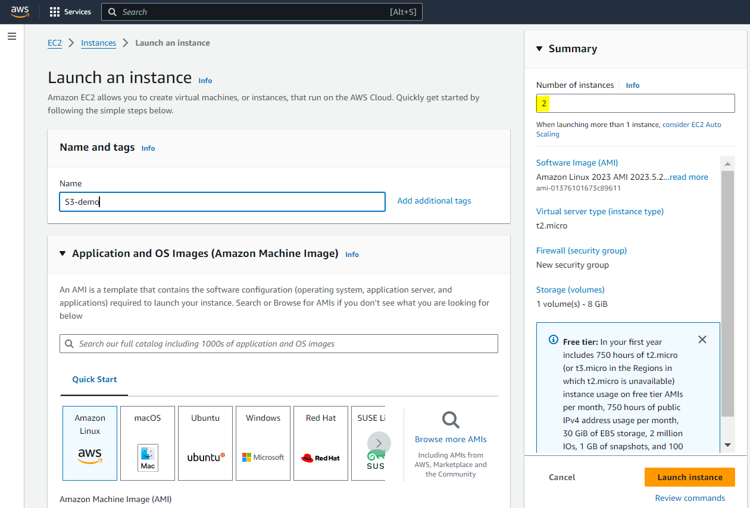

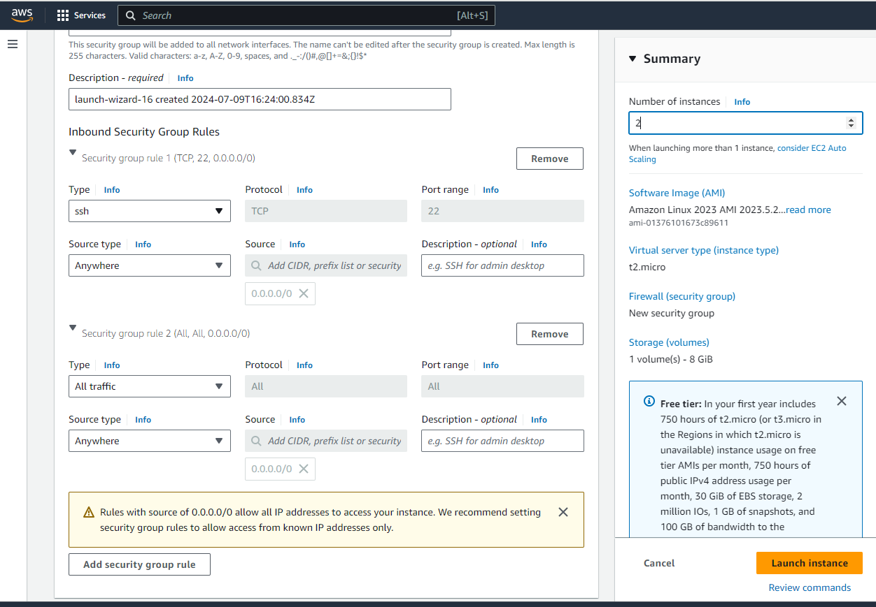

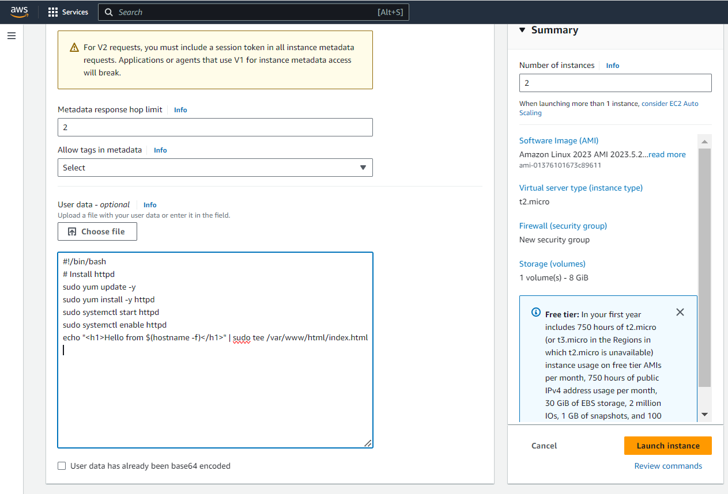

**OPEN PORT 80 IN SECURITY GROUP**

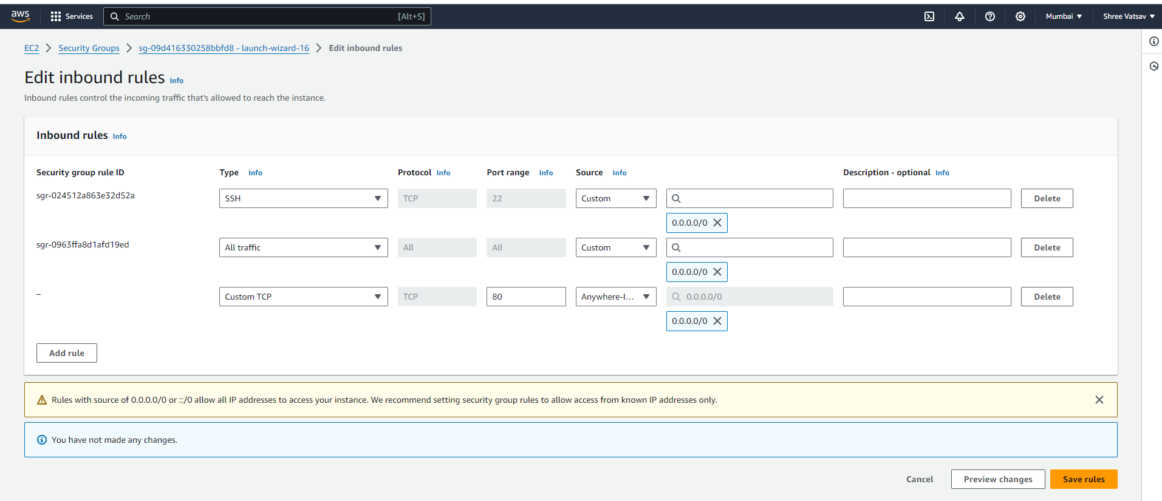

**OUTPUT WHEN WE ACCESS THE IP ADDRESS IN WEB**



**NOW CREATE A APPLICATION LOAD BALANCER**

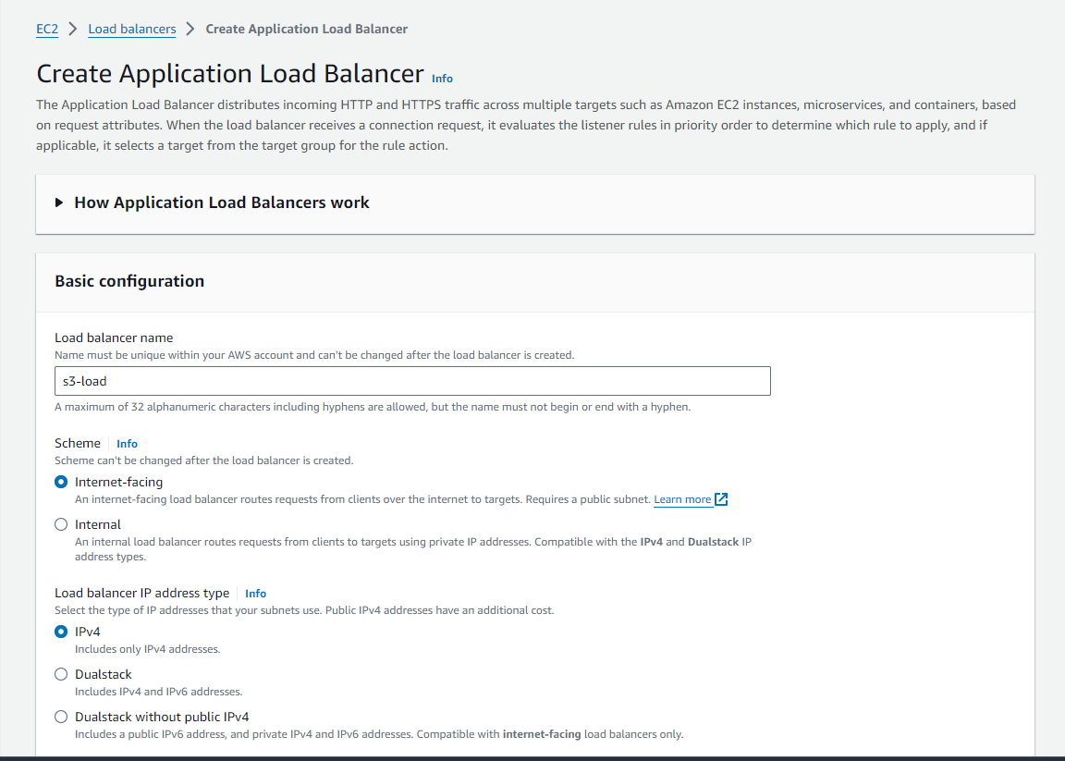

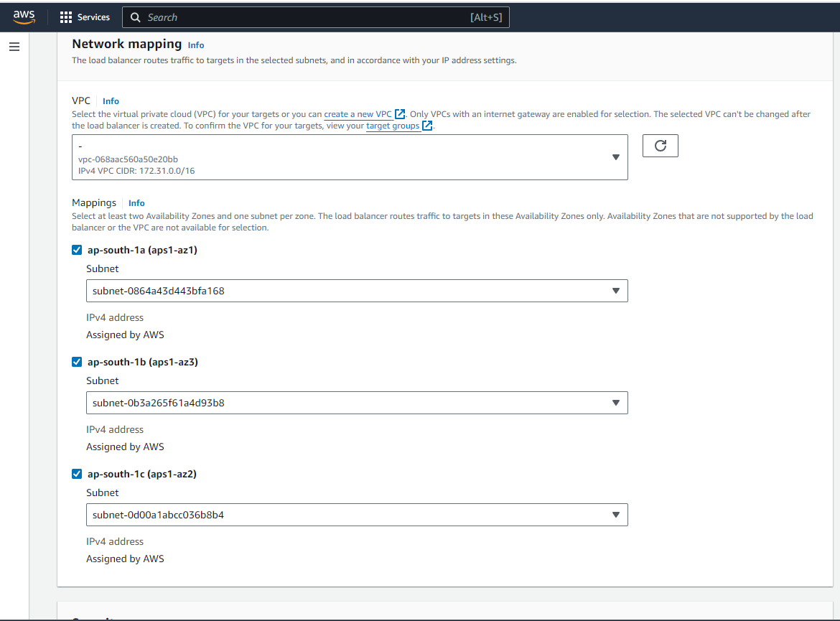

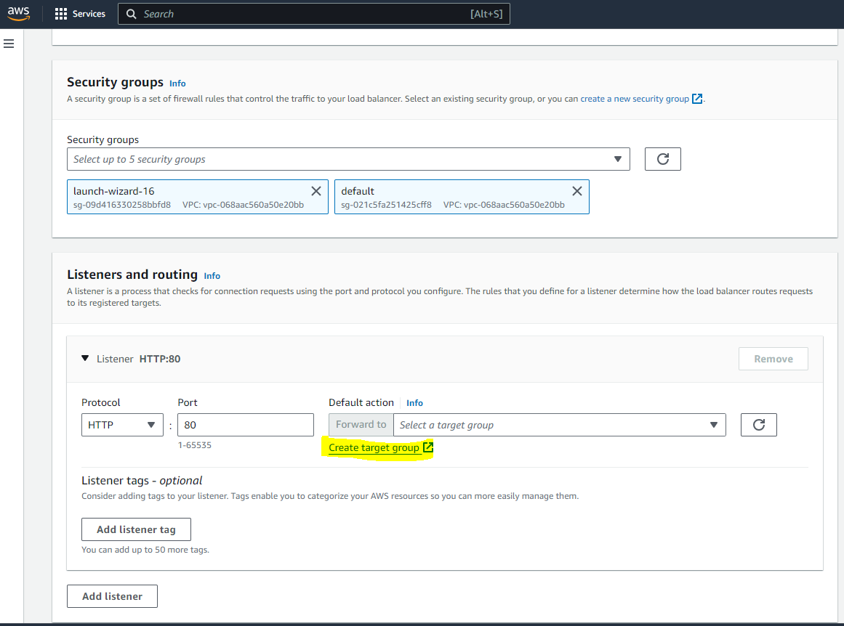

**NOW CREATE A TARGET GROUP**

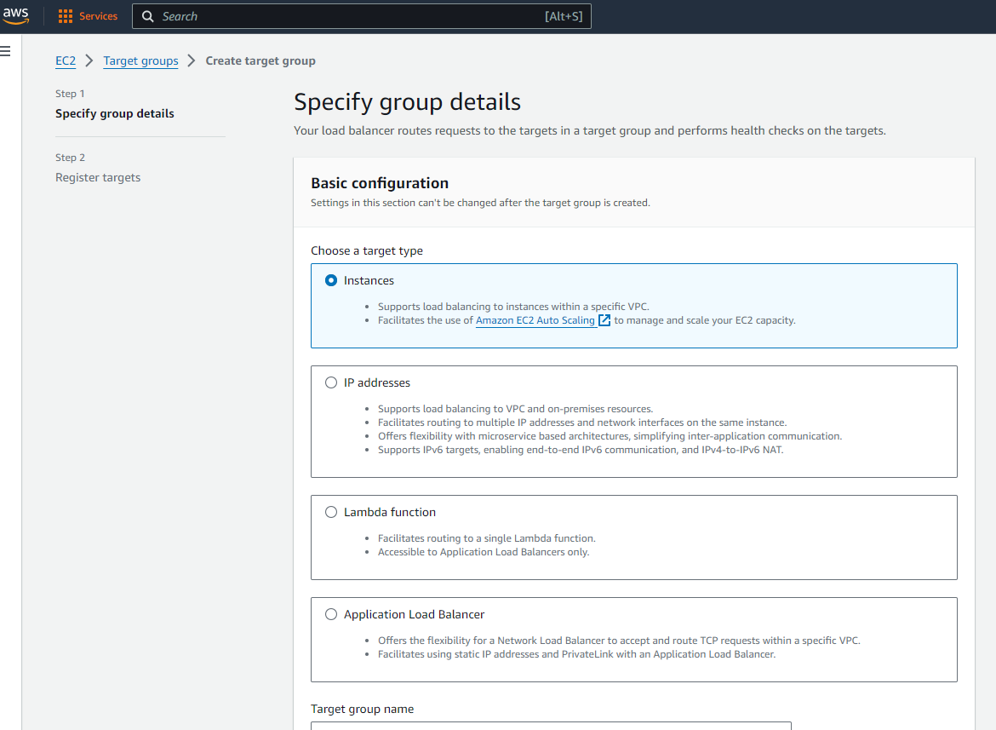

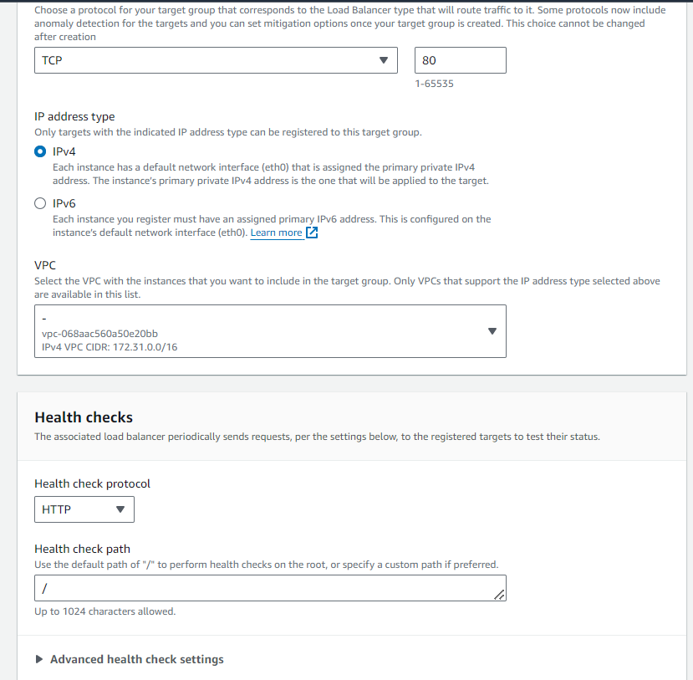

**SELECT THE INSTANCE AND GIVE INCLUDE AS PENDING BELOW AND CREATE TARGET GROUP**

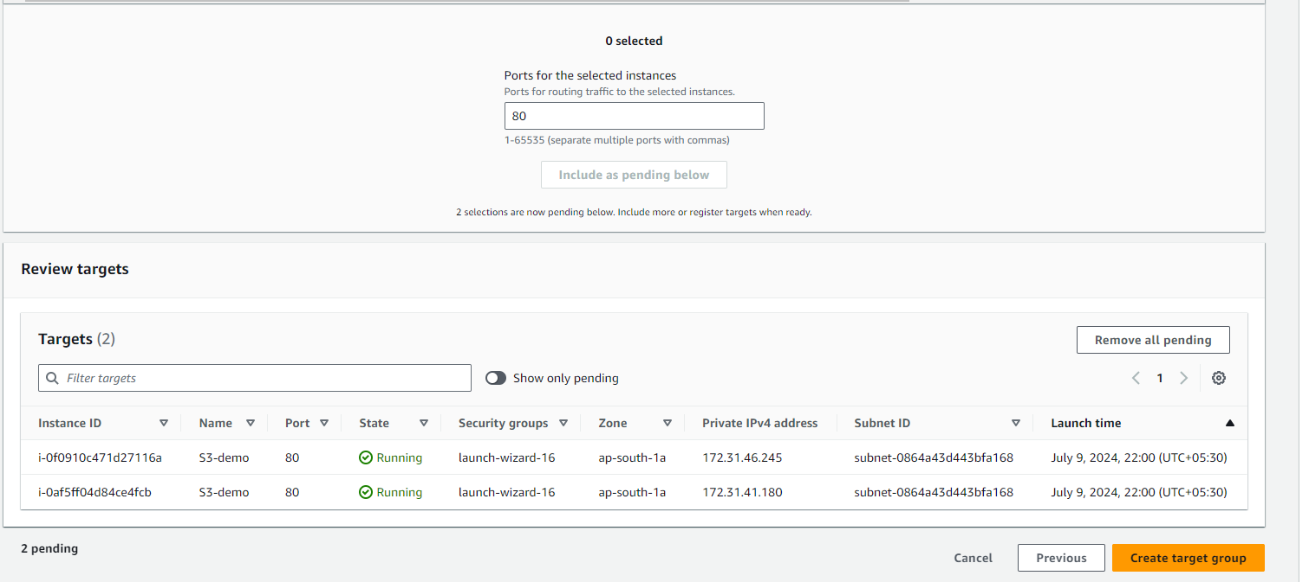

**NOW SELECT THE CREATED TARGET GROUP WHILE CREATING THE LOAD BALANCER**

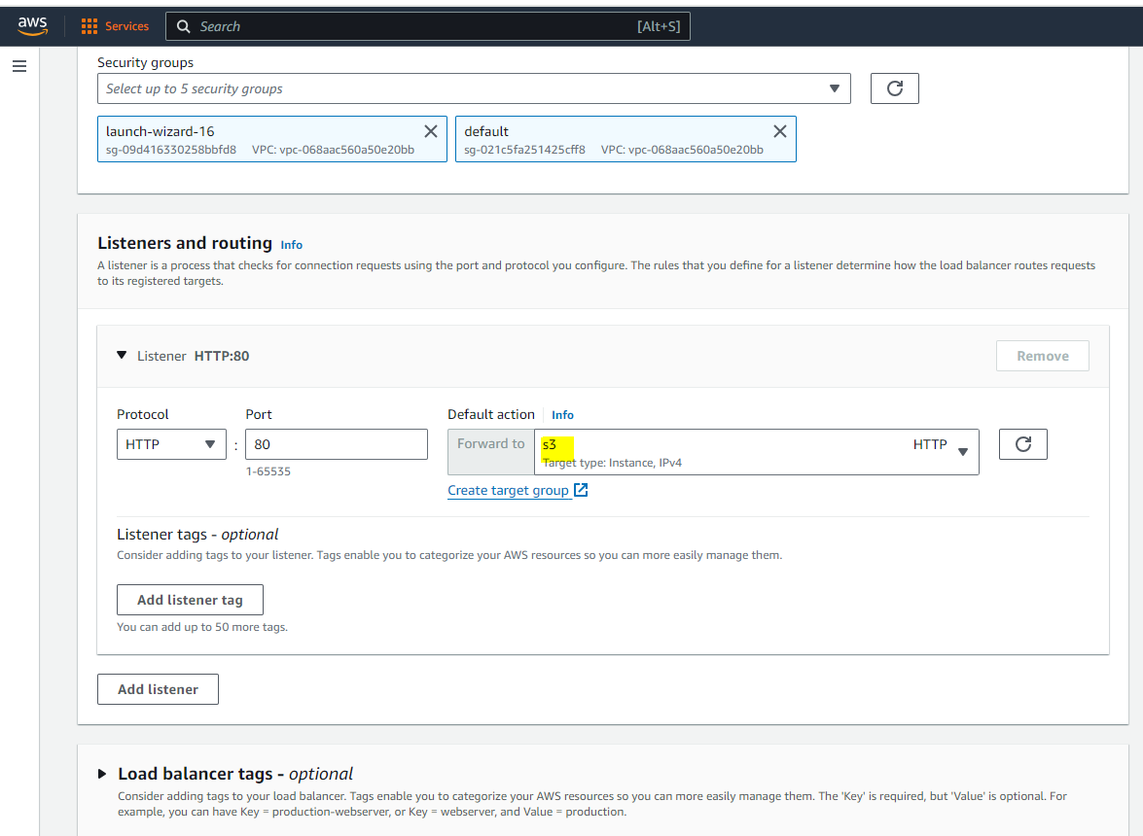

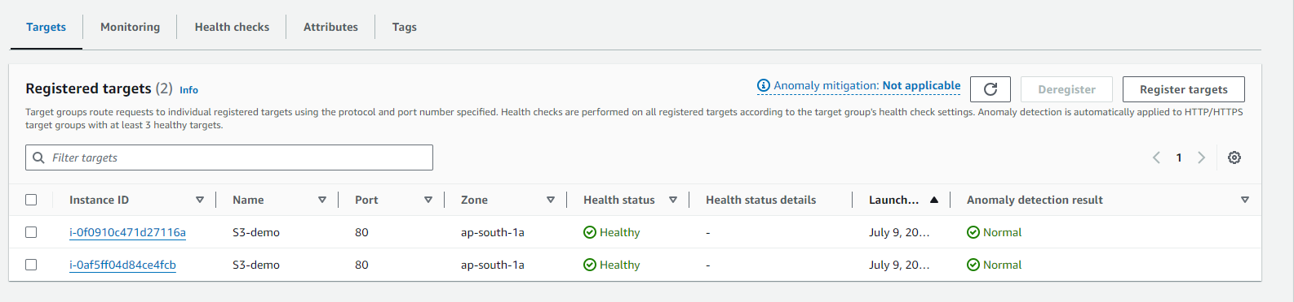

**NOW ACCESS THE LOAD BALANCERS DNS**

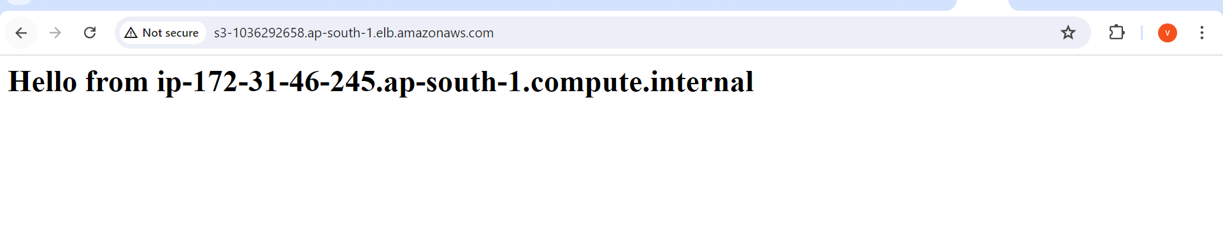

**AND IF WE REFRESH THE IP ADDRESS WILL CHANGE**

