**CREATE A VPC**

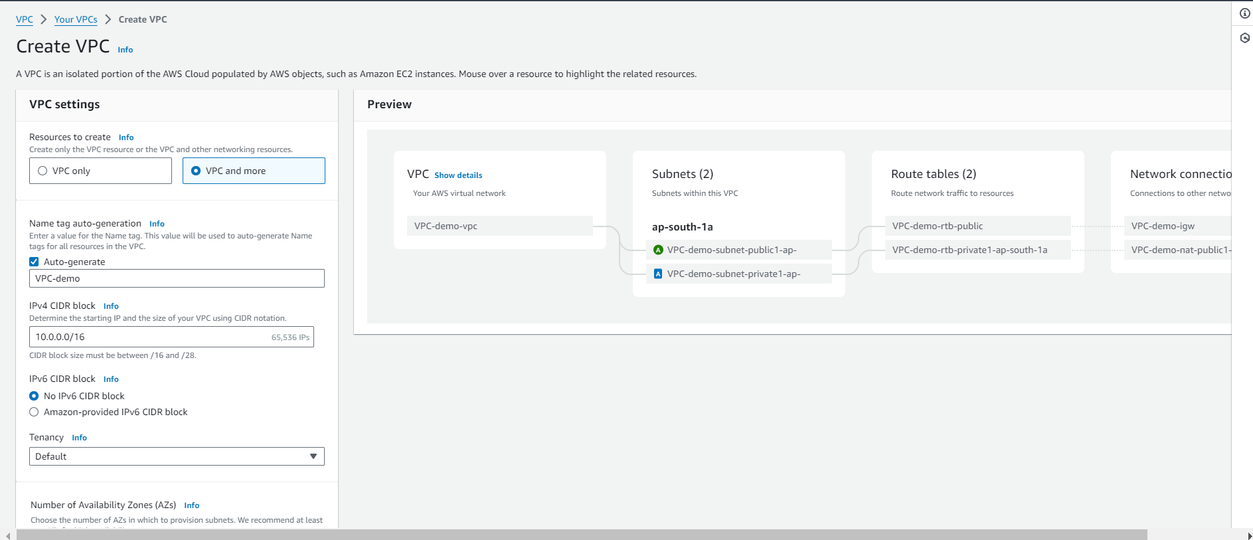

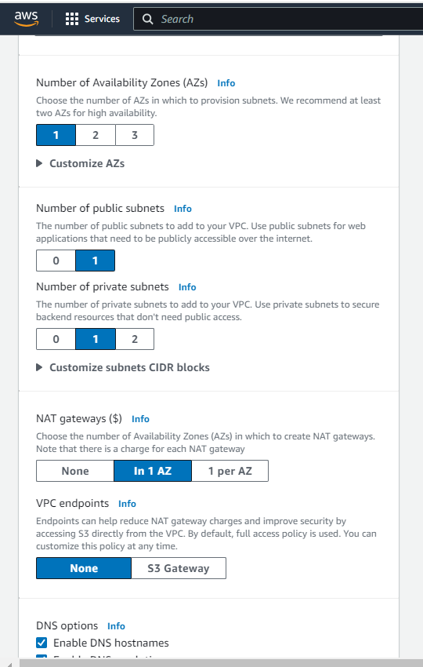

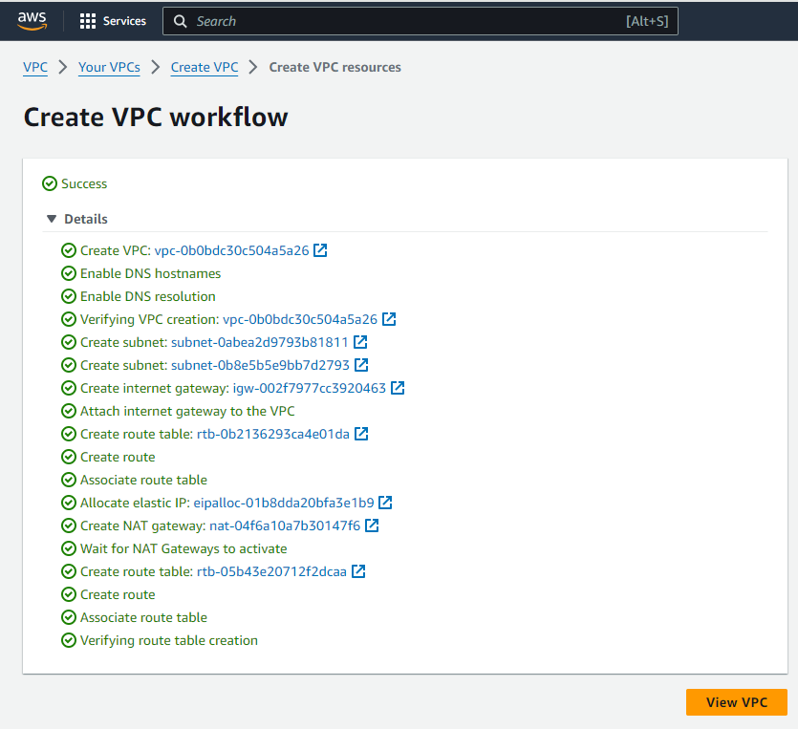

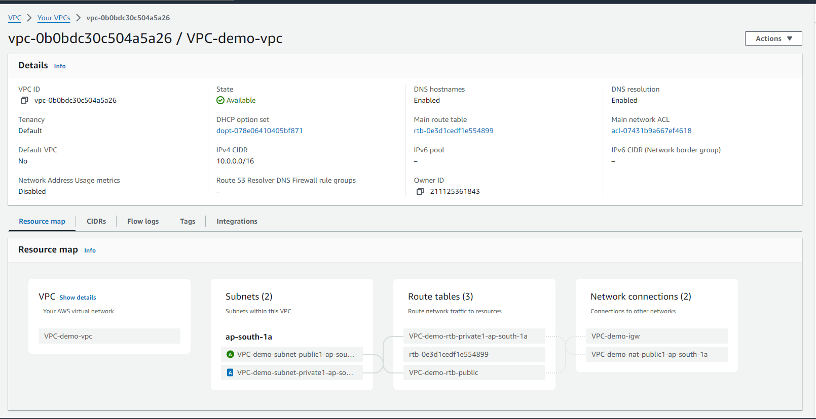

**CREATE A ROUTE TABLE**

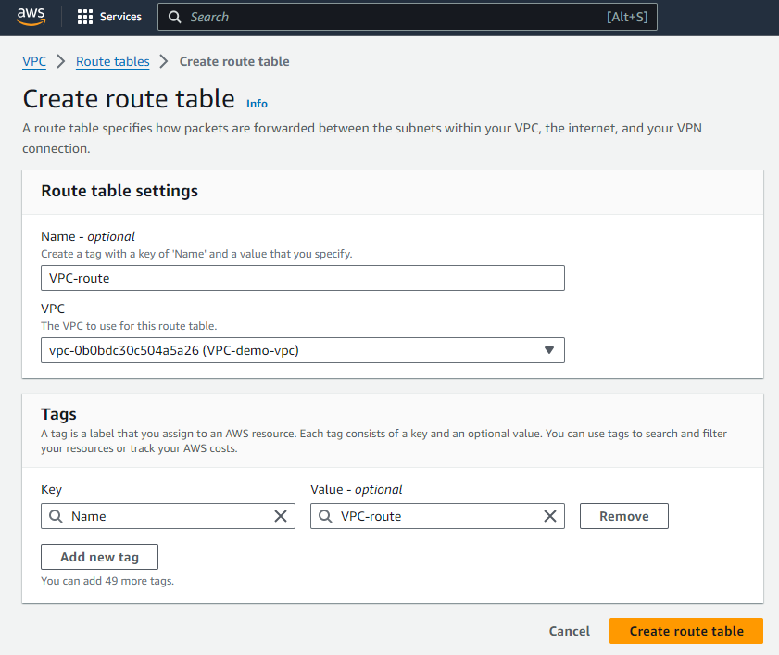

**NOW ASSOCIATE THE SUBNET WITH ROUTE TABLE**

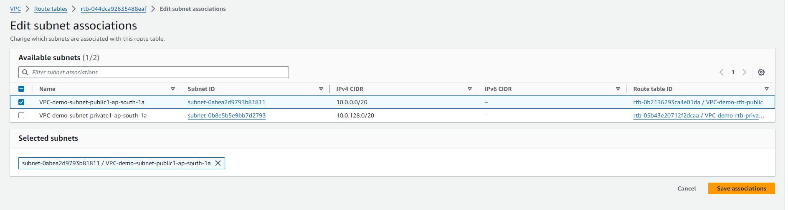

**INTERNET GATEWAY**

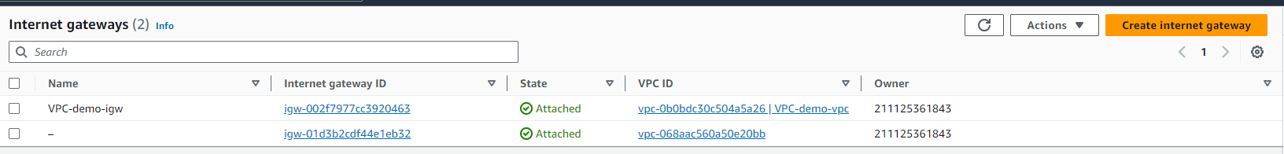

**NATGATEWAY**

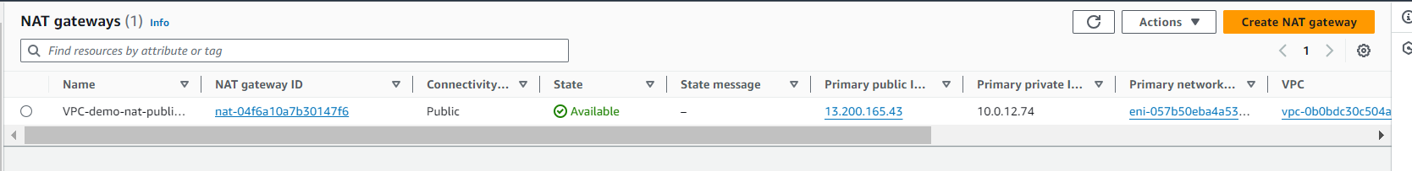

**CREATE A LINUX EC2 INSTANCE WITH CREATED VPC AND SUBNET**

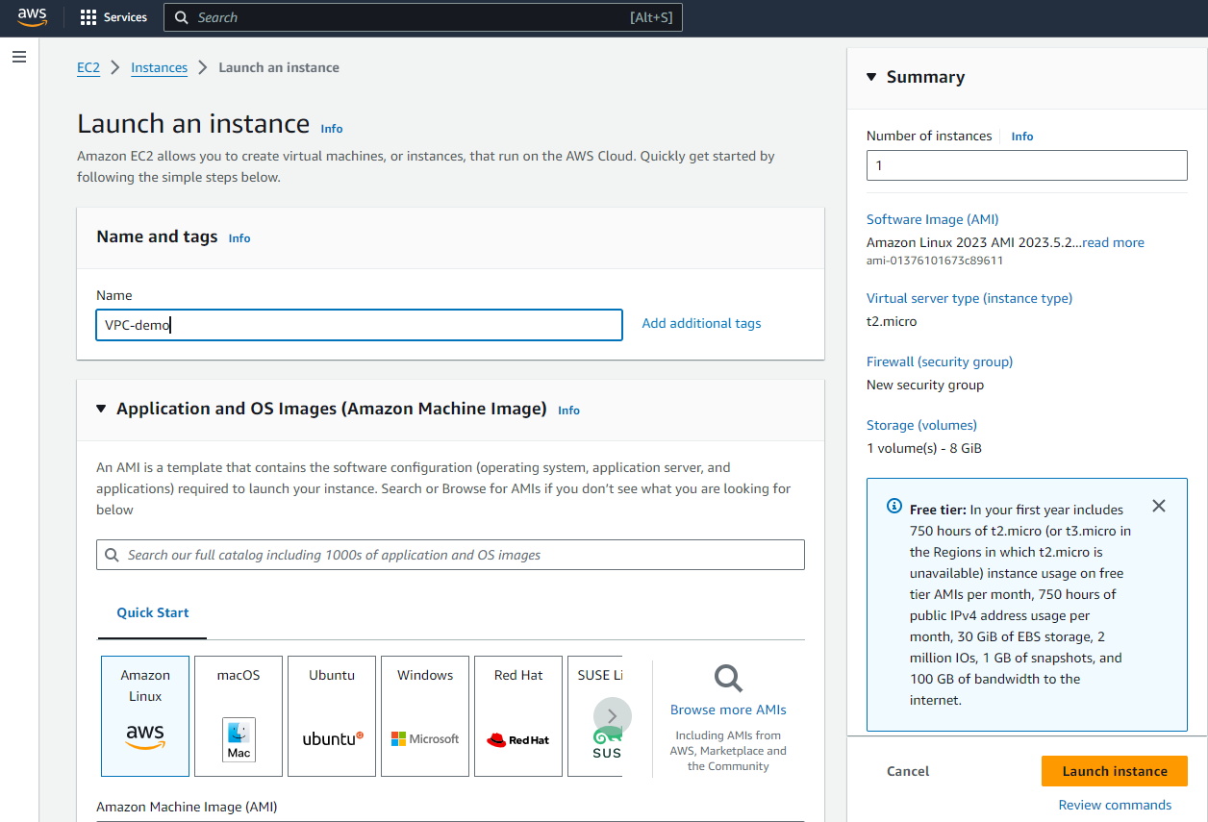

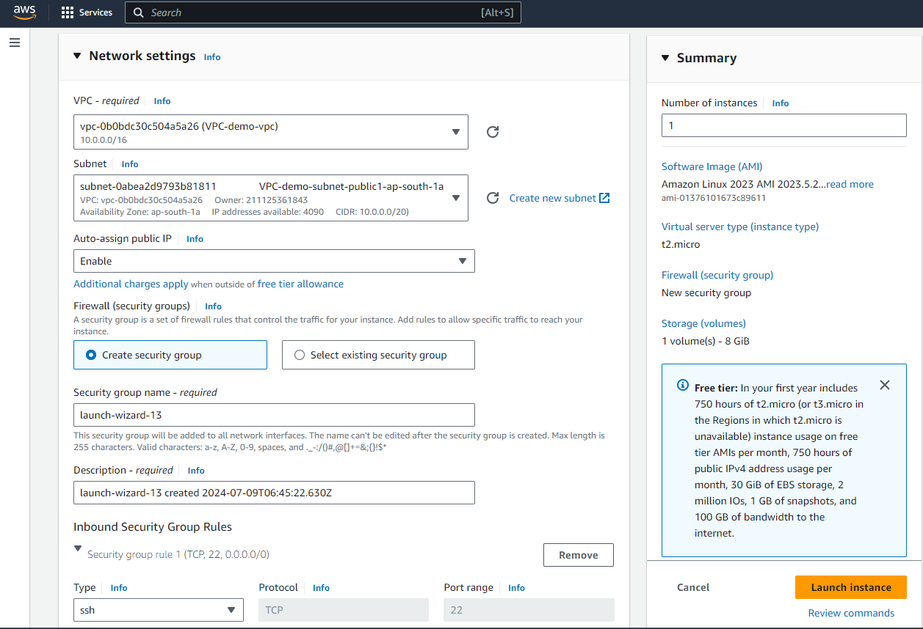



**NOW LAUNCH THE INSTANCE**