**CREATE A REPOSITORY**

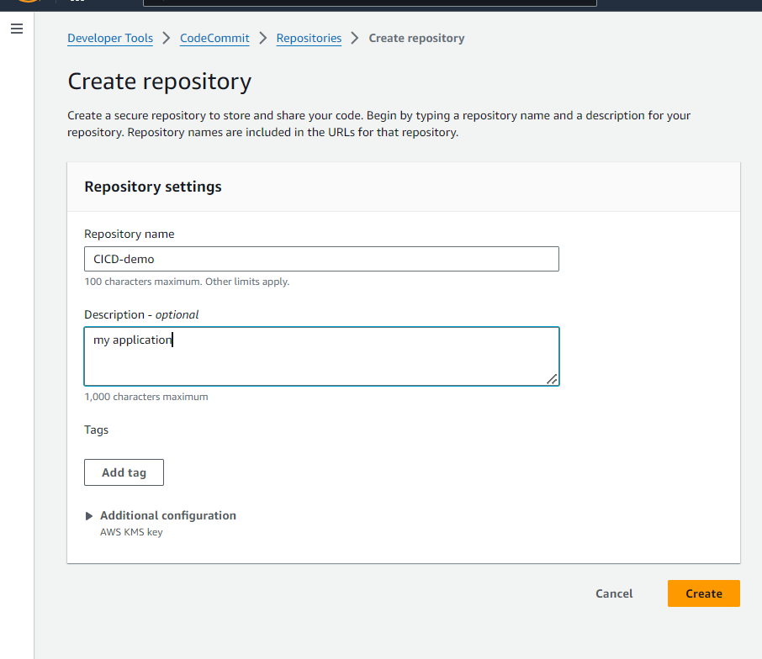

**CLONE HTTPS URL**

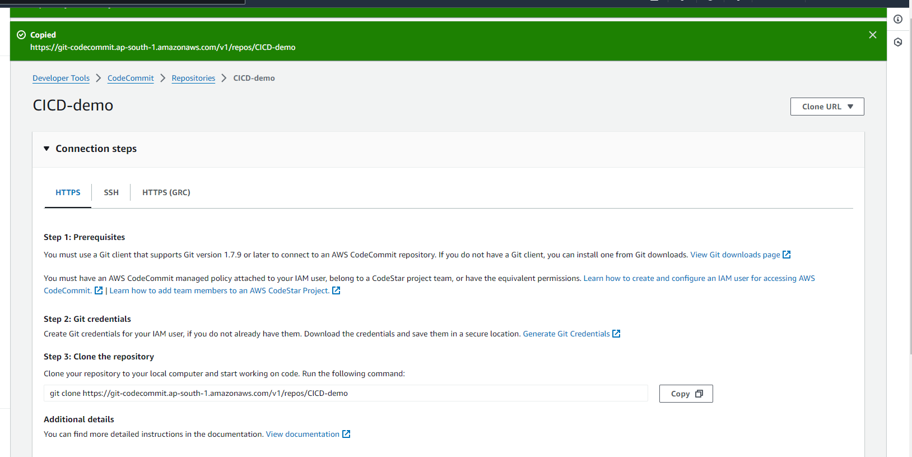

**LAUNCH AND CONNECT TO A EC2 MACHINE**

**NOW INSTALL GIT AND CLONE THE REPOSITORY CREATED**

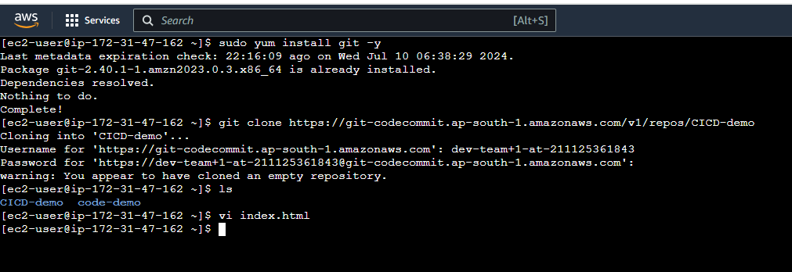

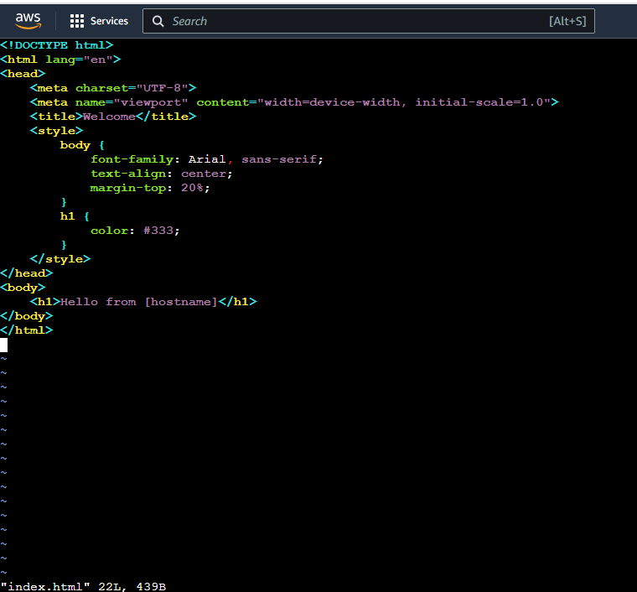

**NOW MOVE INDEX.HTML FILE TO THE CODE COMMIT REPOSITORY**

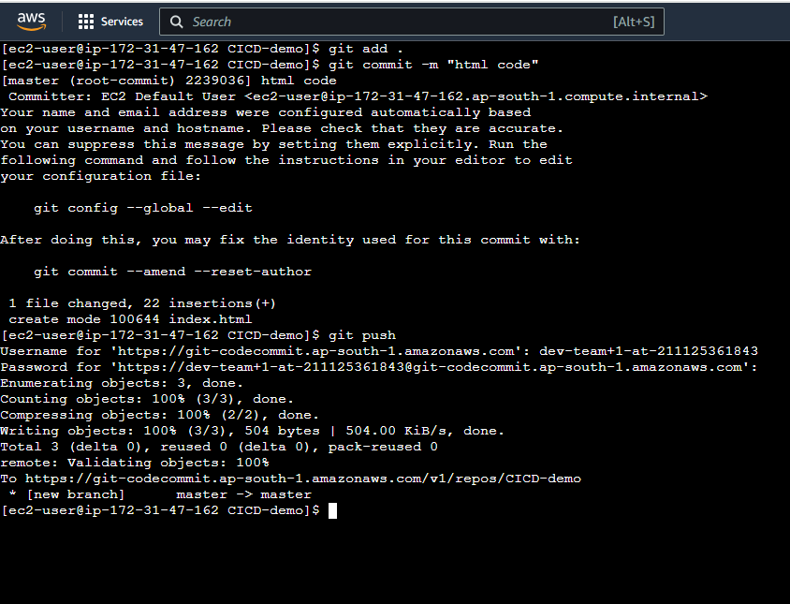

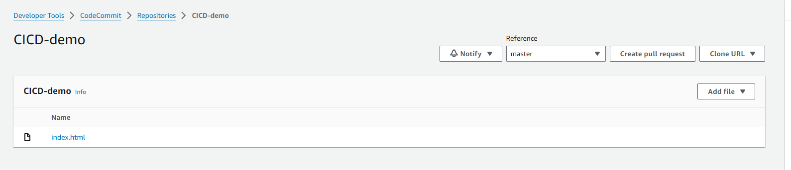

**NOW WRITE A BUILDSPEC.YAML FILE FOR BUILDING**

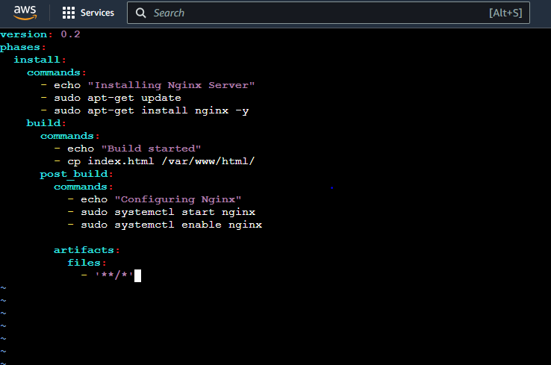

**NOW MOVE THE BUILDSPEC FILE TO REPOSITORY**

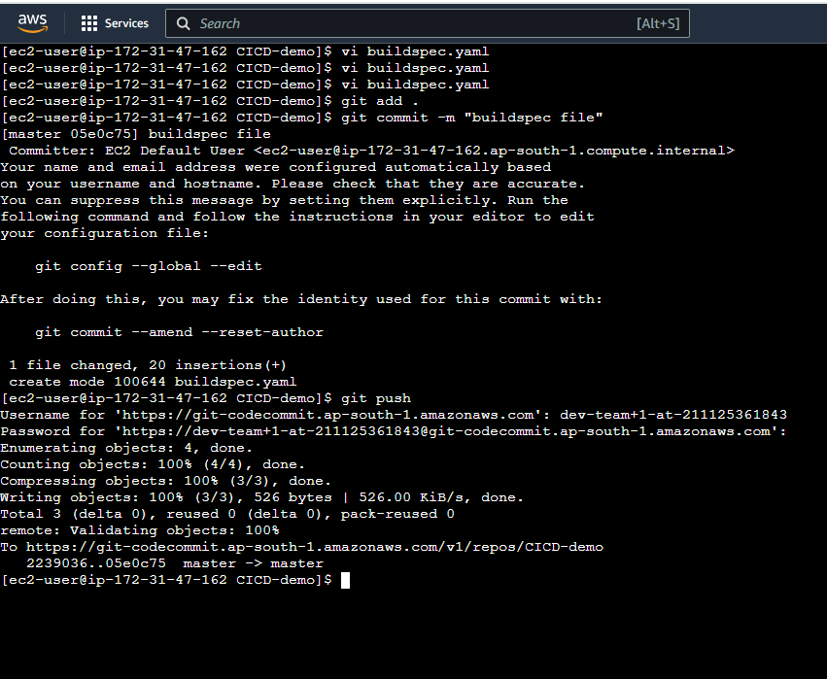

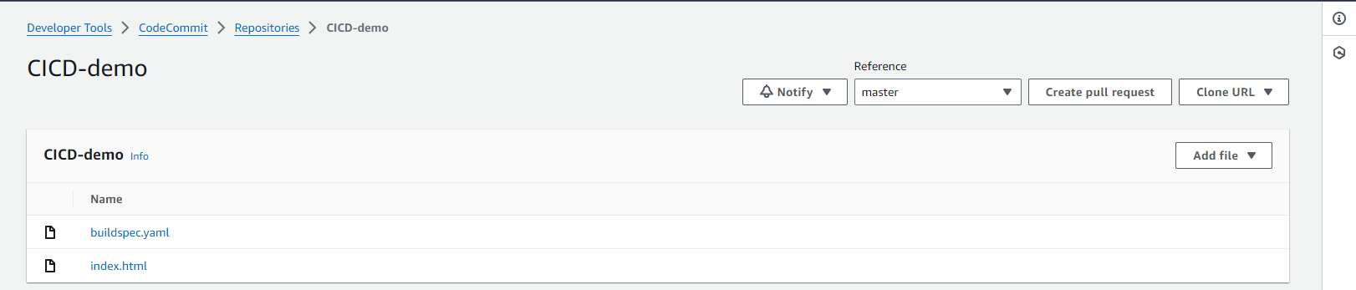

**BUILD THE PROJECT**

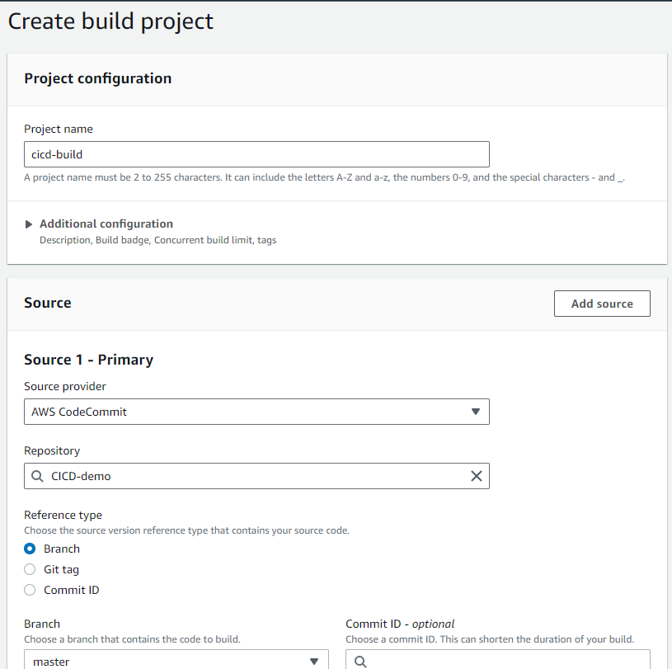

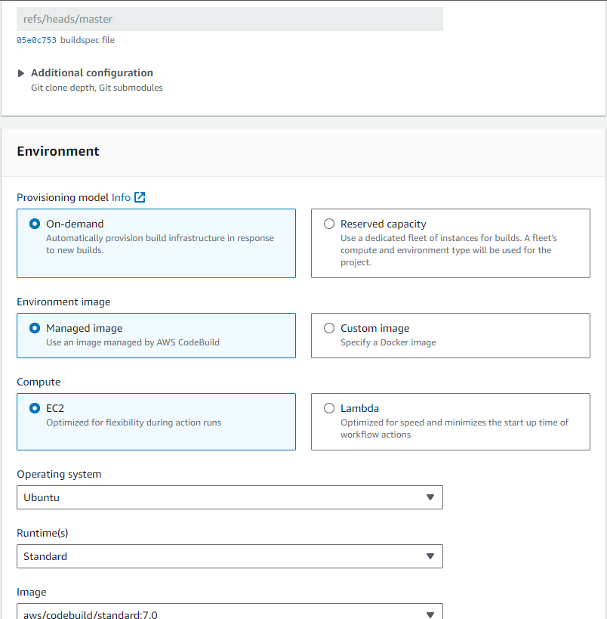

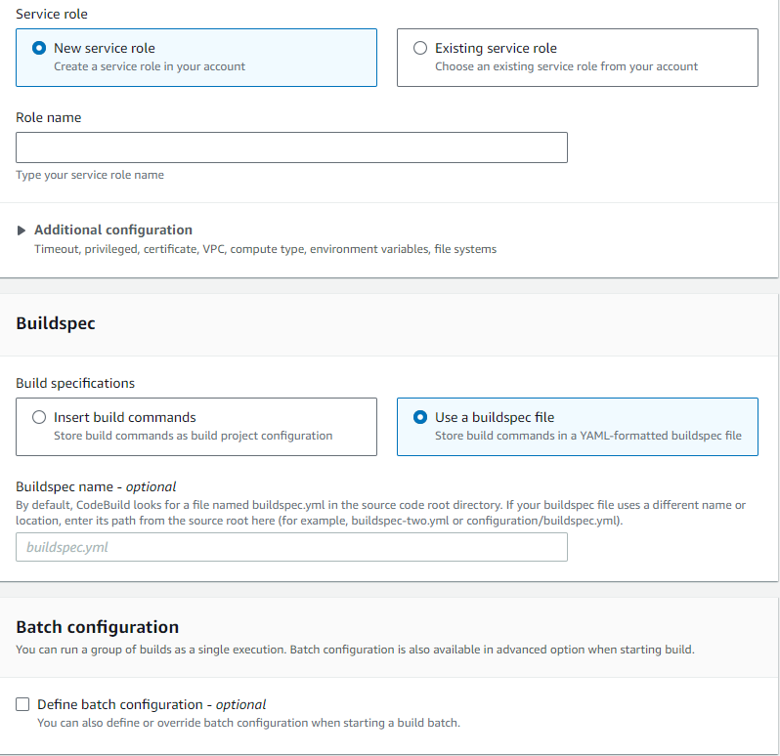

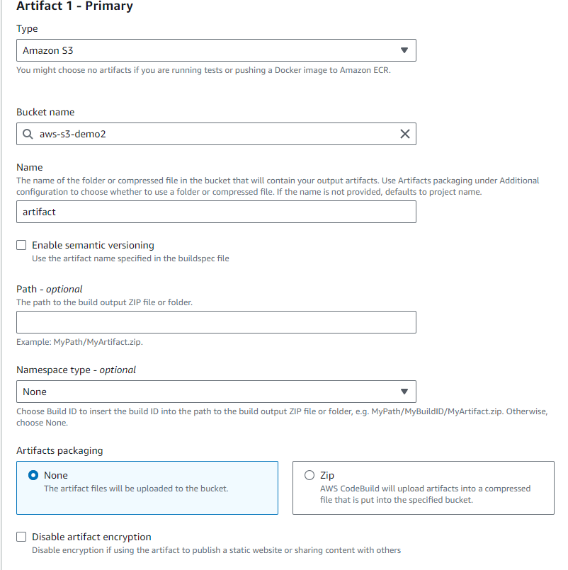

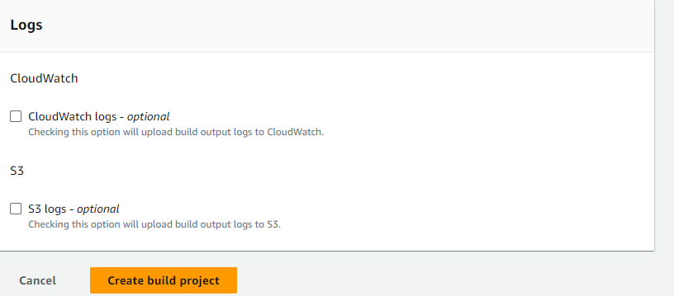

**AFTER CREATING THE PROJECT , BUILD THE PROJECT**

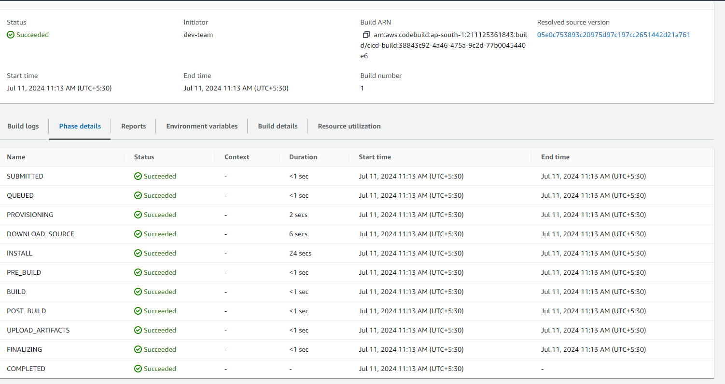

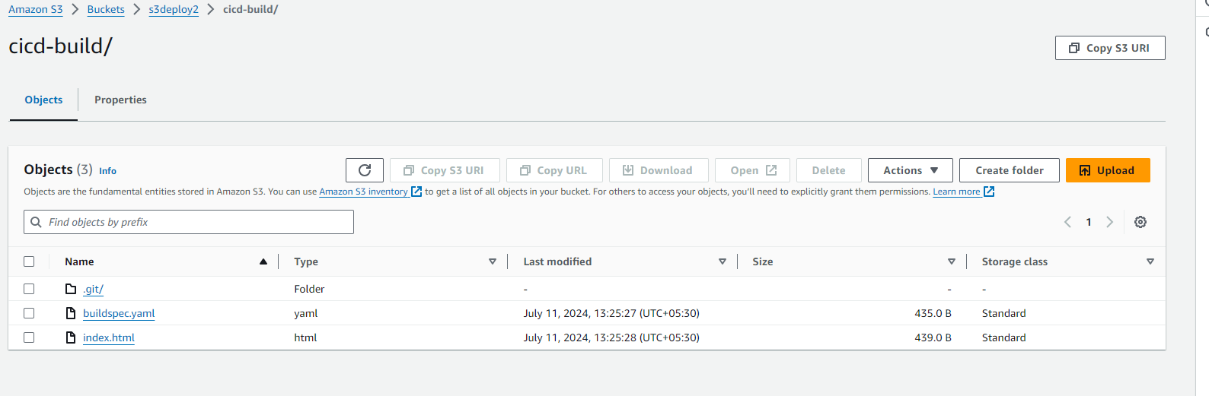

**BUILD SUCCESS**

**NOW DEPLOY THE APPLICATION**

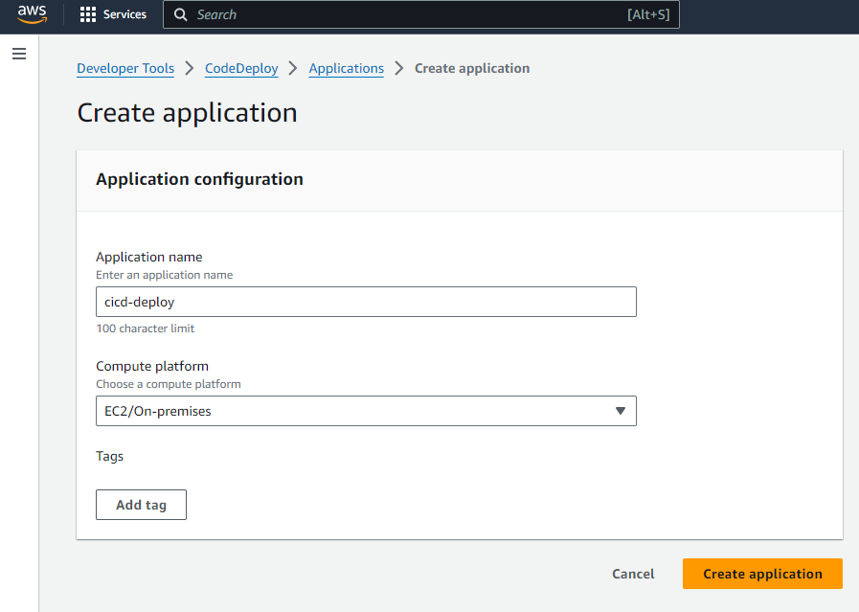

**CREATE DEPLOYMET GROUP**

**CREATE A SERVICE ROLE BEFORE**

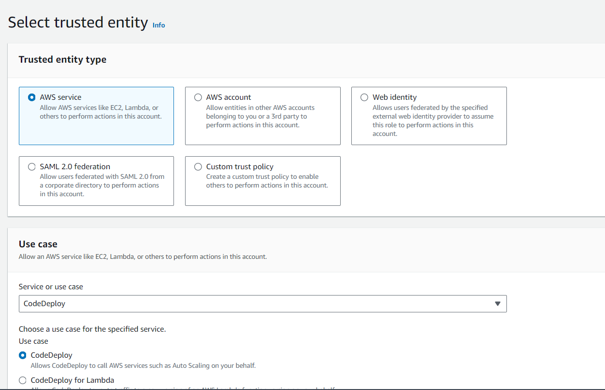

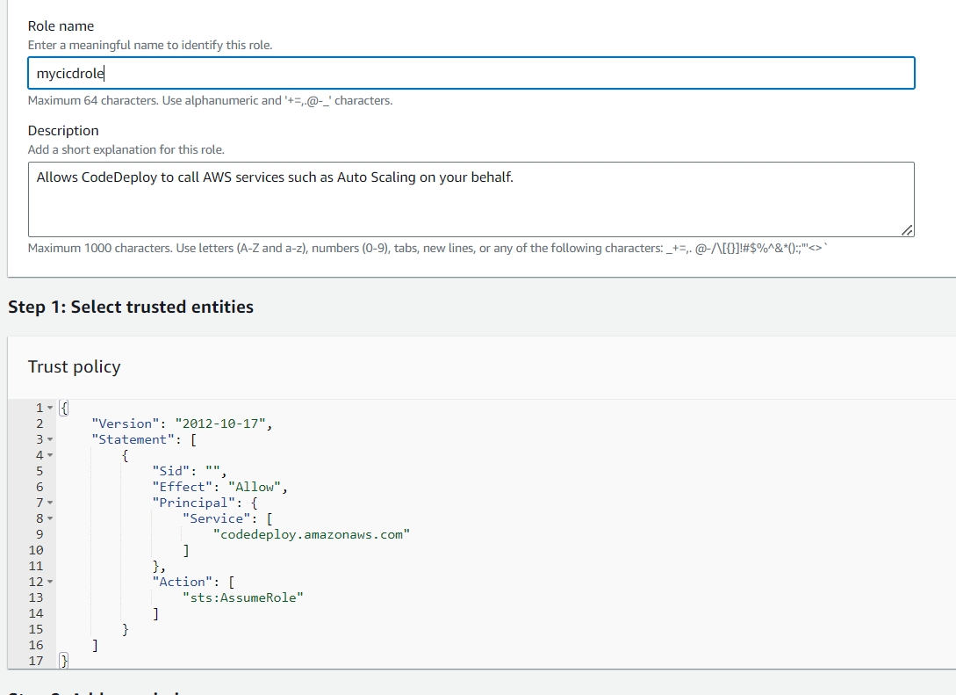

**ADD THE BELOW PERMISSIONS FOR THE ROLE**

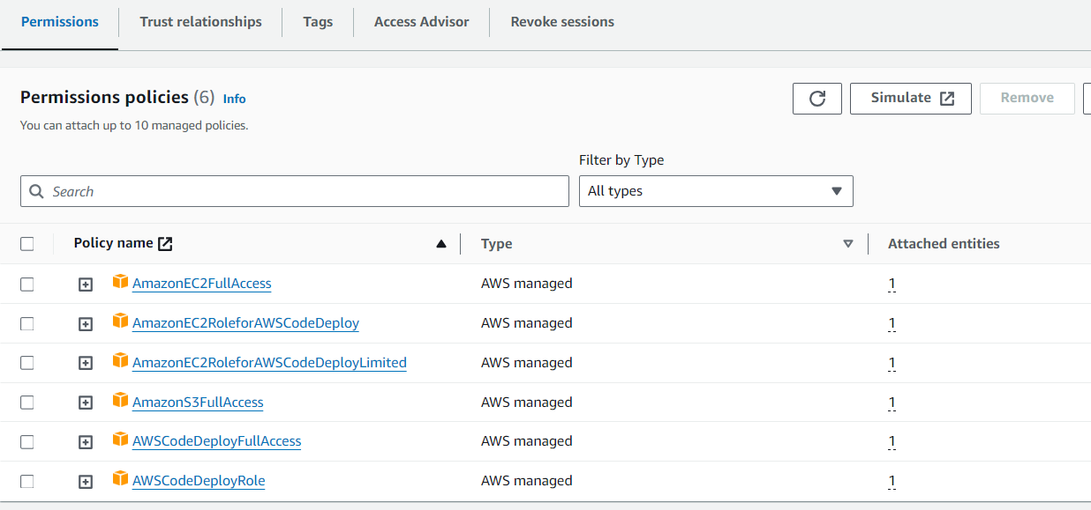

**CREATE A EC2 INSTANCE AND CONNECT**

**INSTALL CODE DEPLOY AGENT**

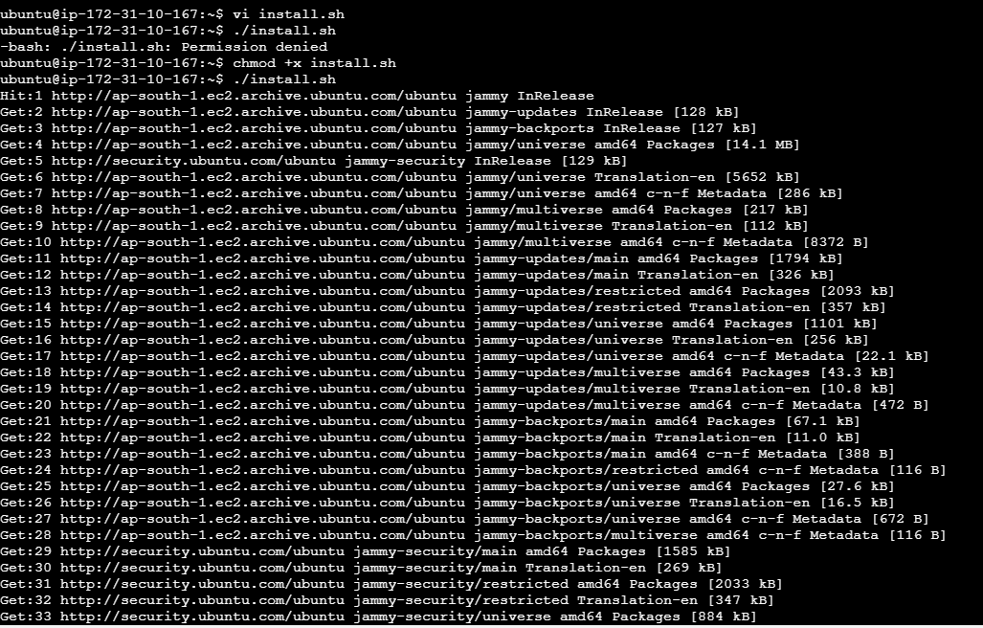

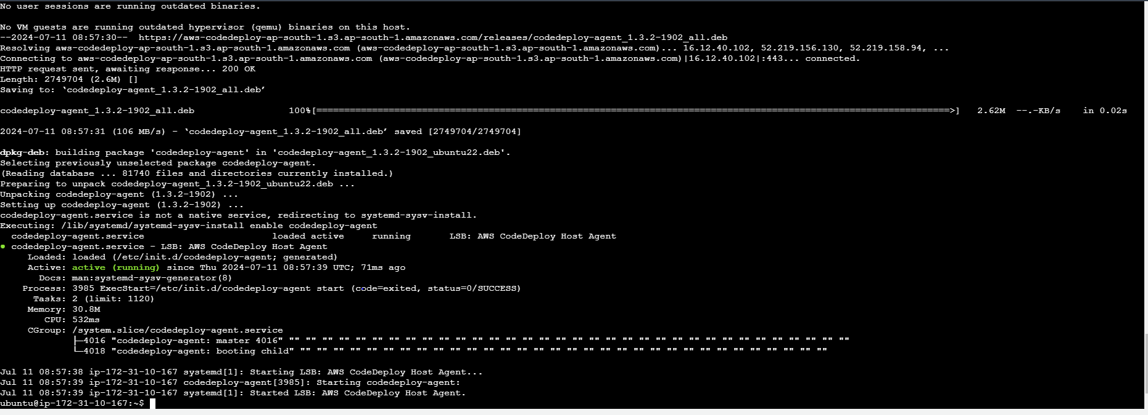

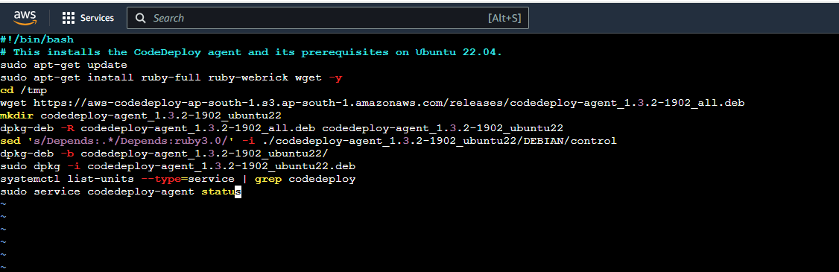

**CREATE A ROLE FOR EC2 AND ADD THE BELOW PERMISSIONS**

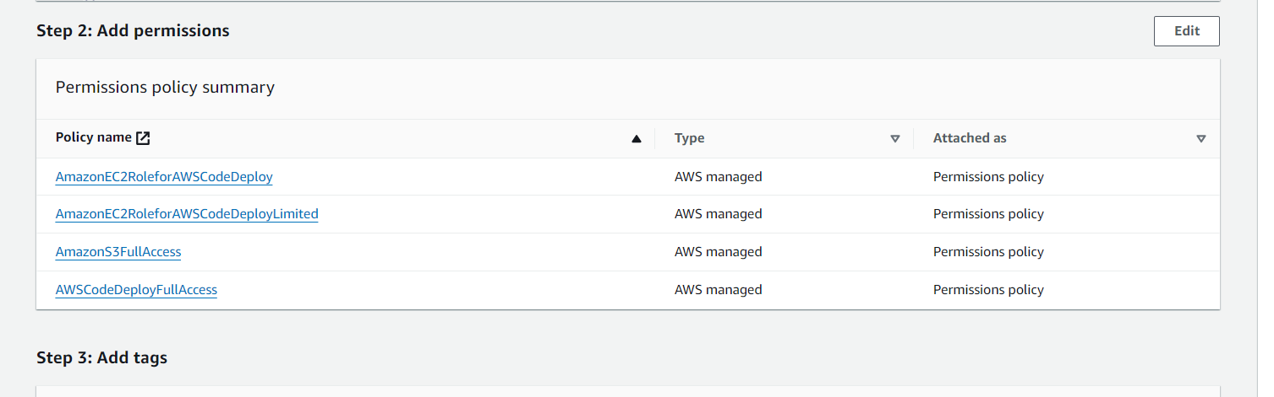

**ATTACH THE ROLE TO THE EC2 MACHINE**

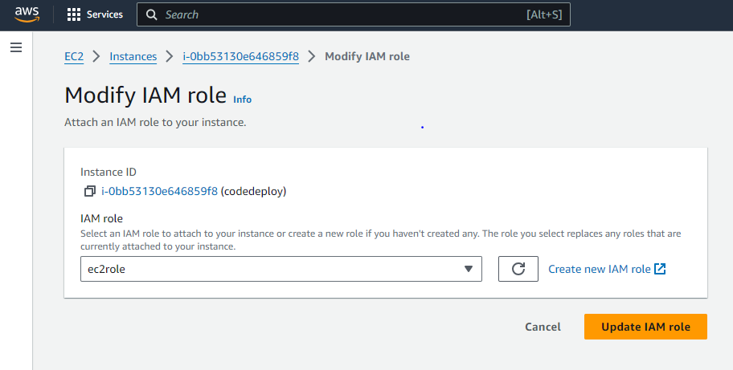

**NOW RESTART THE CODE DEPLOY AGENT**

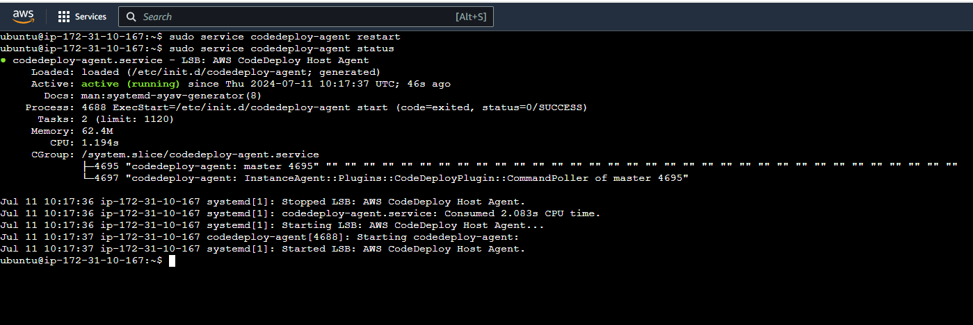

**NOW CONNECT TO THE LINUX EC2 MACHINE**

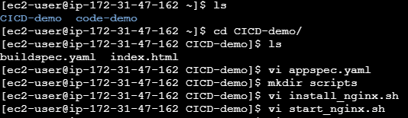

**APPSPEC.YAML**

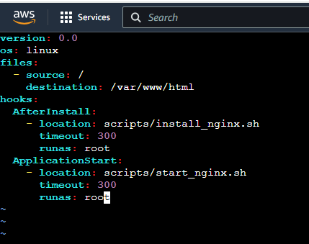

**INSTALL NGINX**

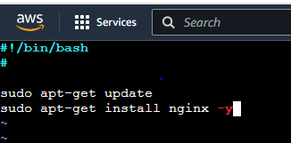

**START NGINX**

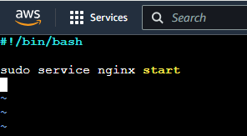

**NOW PUSH THESE SCRIPT FILES TO REPOSITORY**

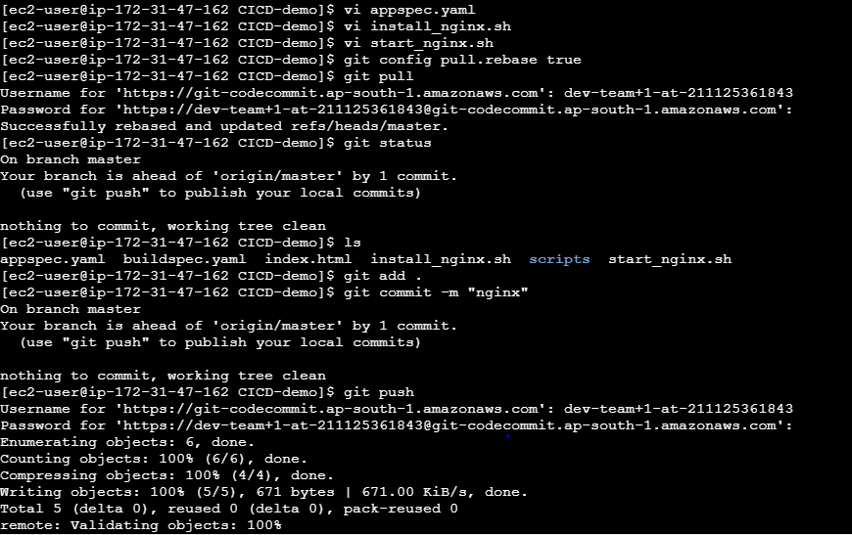

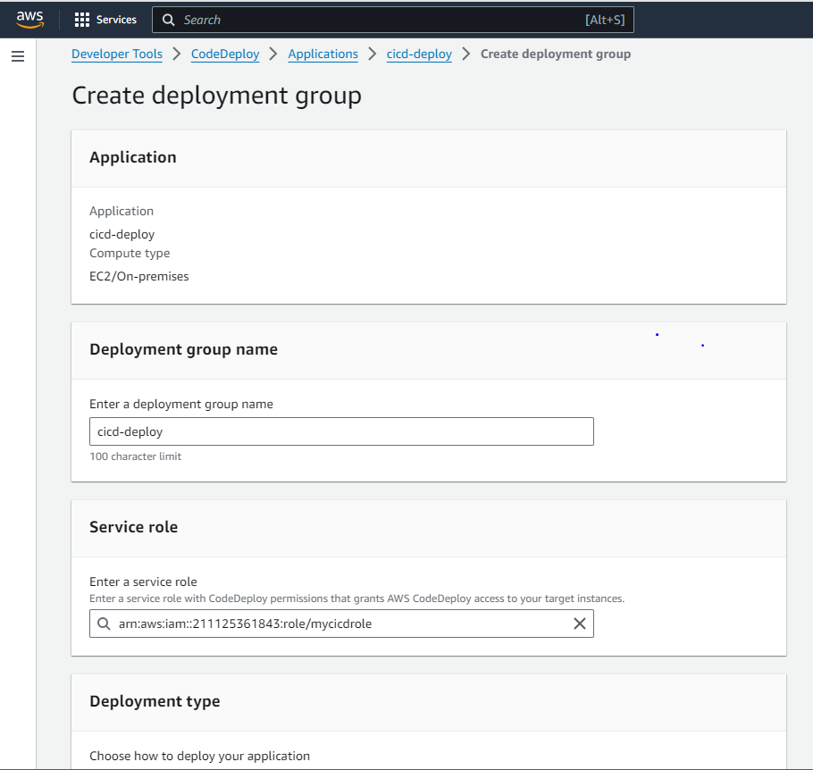

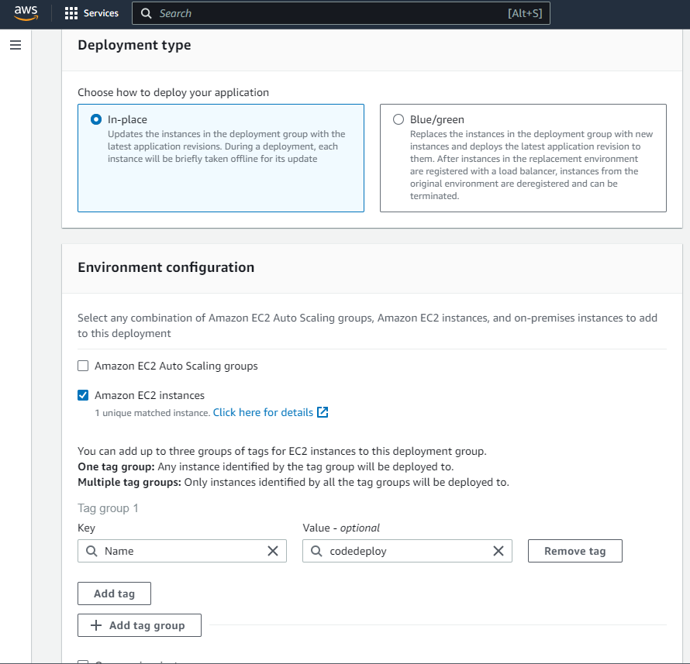

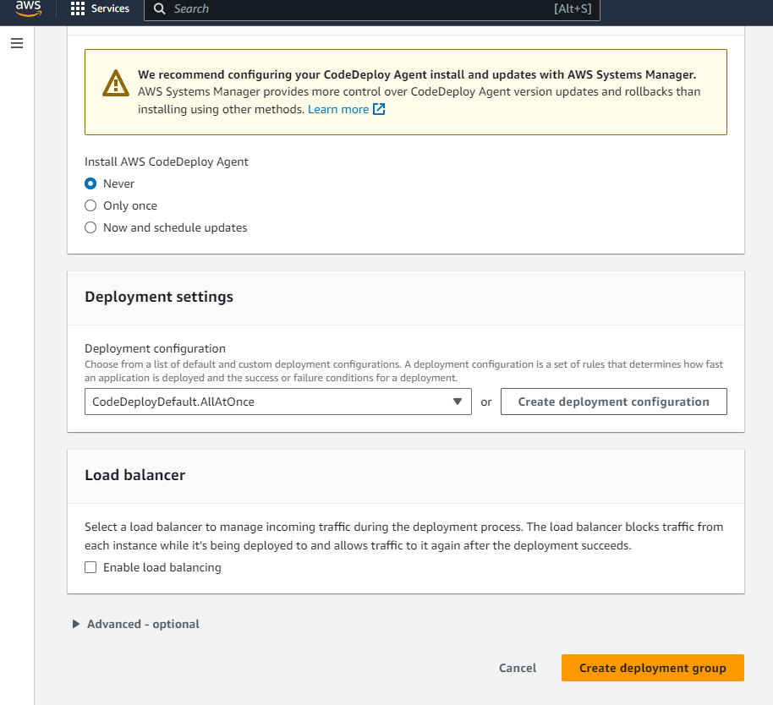

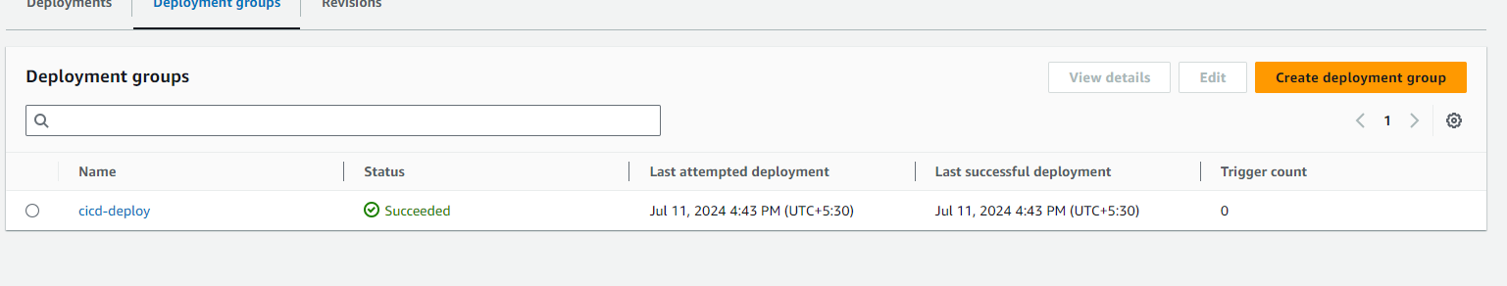

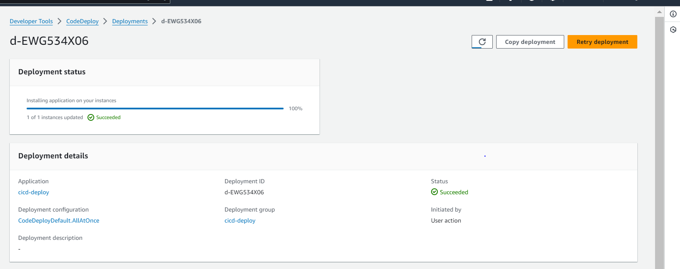

**ANOTHER METHOD WE CAN CREATE PIPELINE AND ALSO TRY IT LIKE SHOWN BELOW**

**CREATE A PIPELINE**

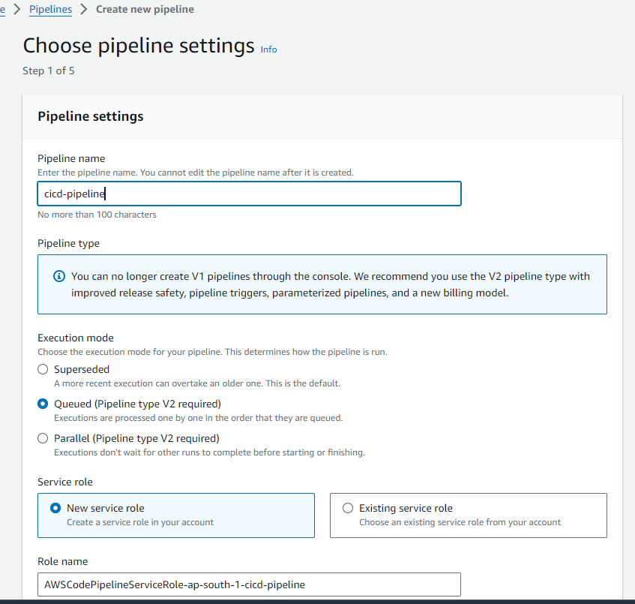

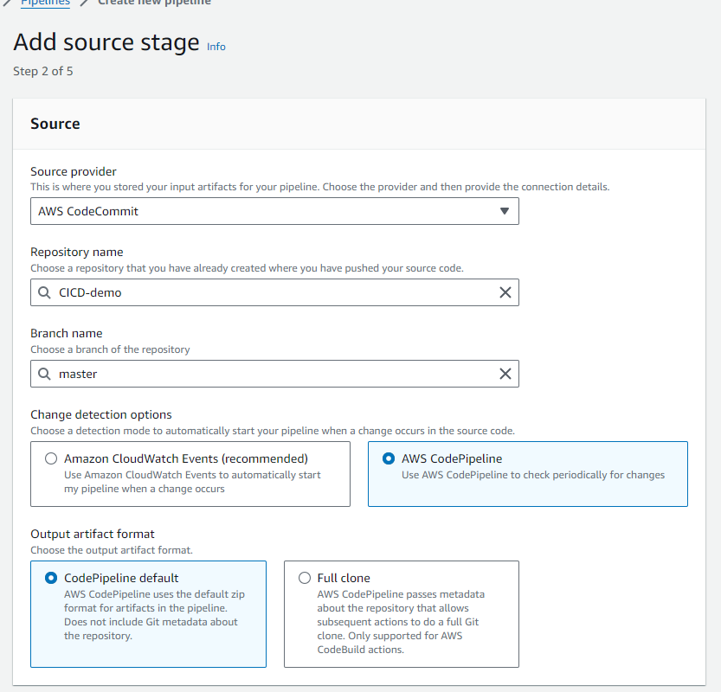

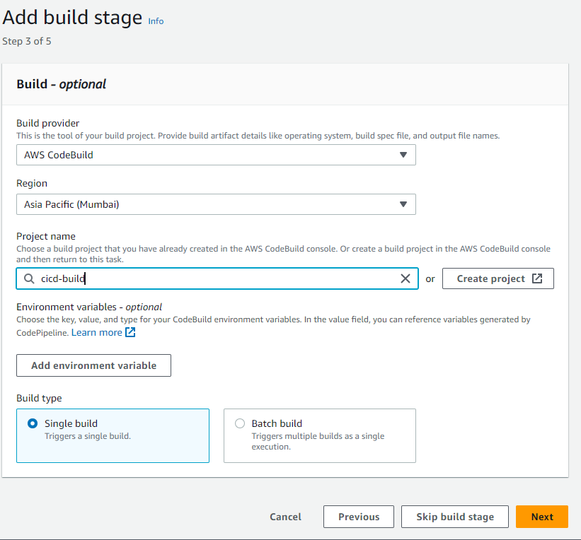

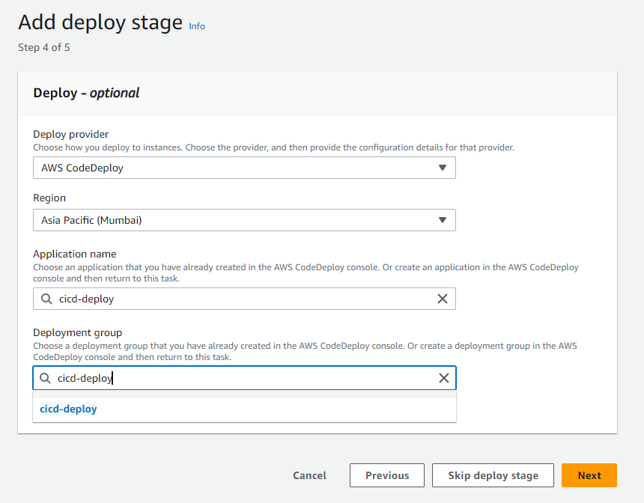

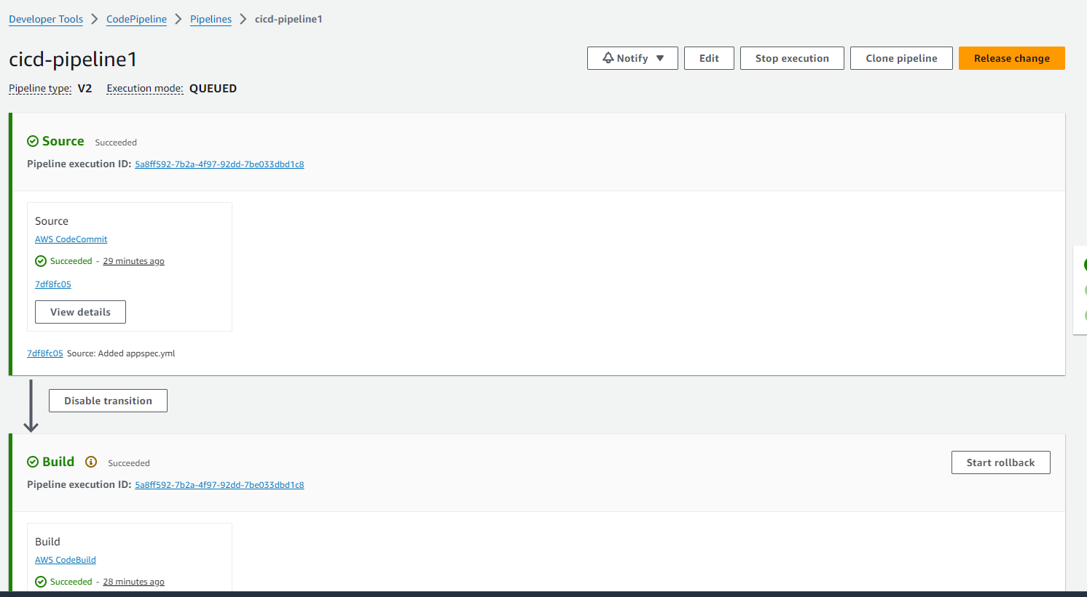

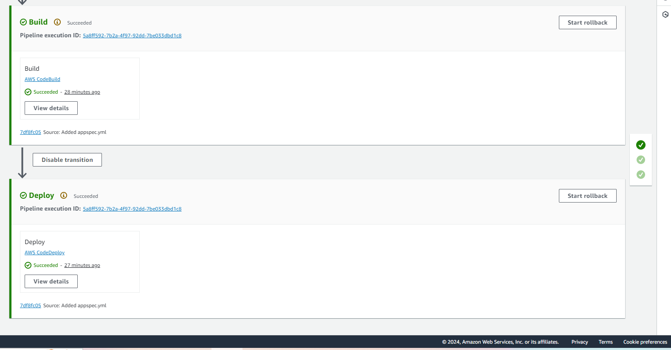

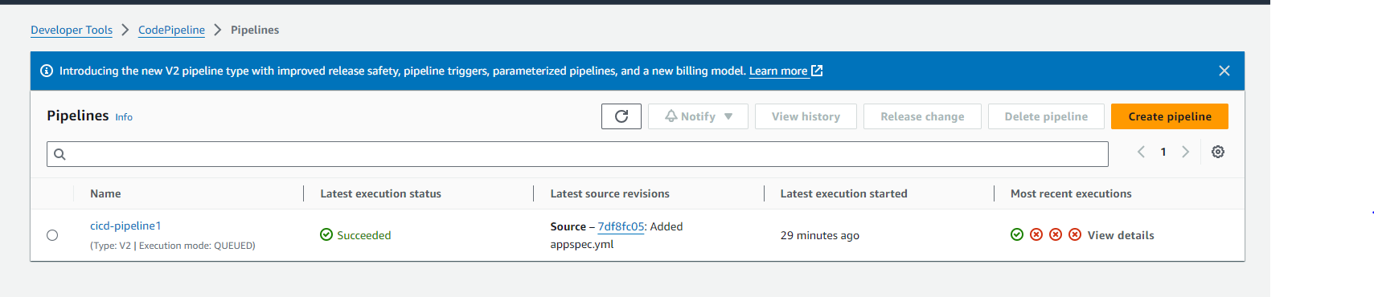

**NOW OPEN PORT NO 80 UNDER SECURITY GROUP AND ACCESS THE IP ADDRESS**

