Launch an EC2 instance (Linux and Windows) along with a web server. Then, create an EBS volume of 5 GB, attach it to an EC2 machine (Linux and Windows), and take a snapshot. Finally, create an EBS volume using the taken snapshot.

**EBS-LINUX**

**CREATE A VOLUME (5GB)**

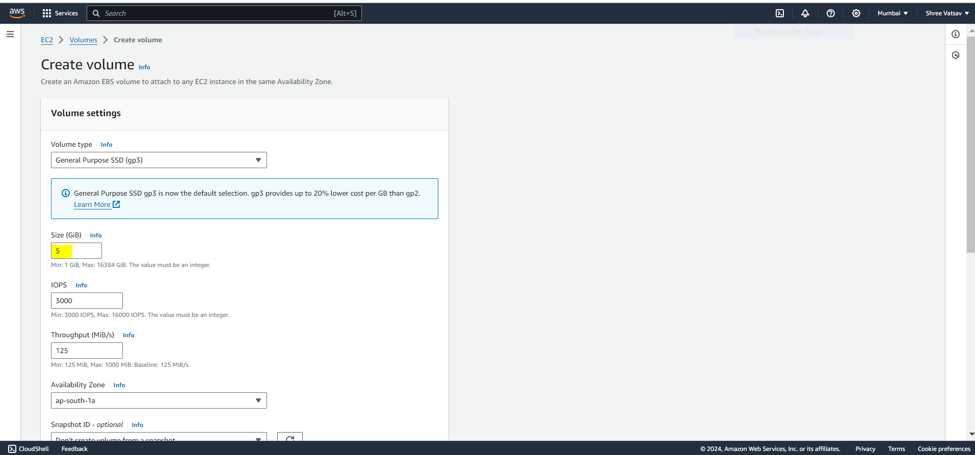

**VOLUME CREATED**

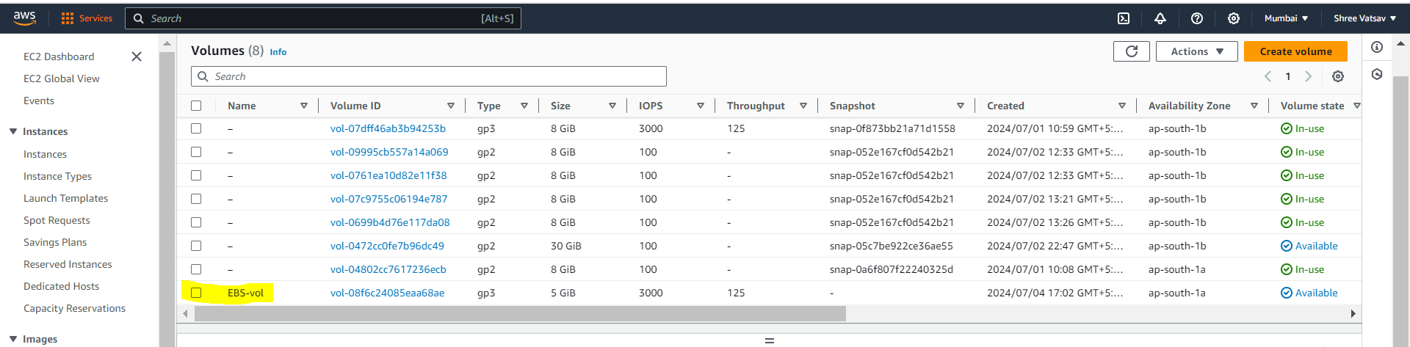

**LAUNCH AN EC2 INSTANCE (LINUX)**

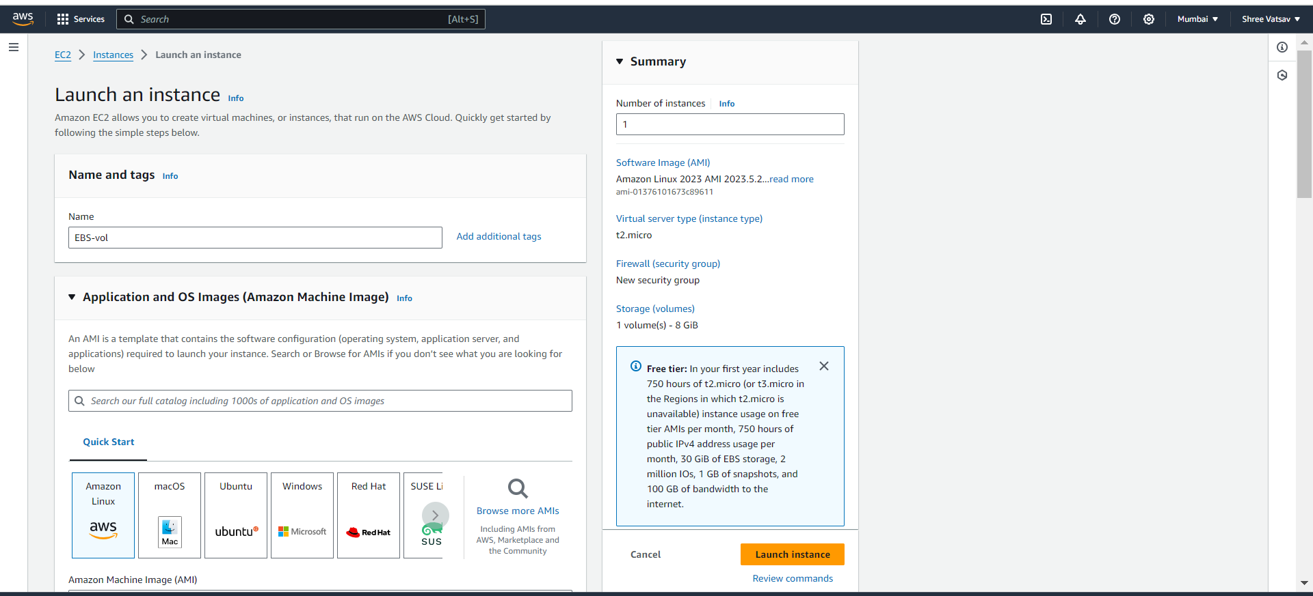

**NOW ATTACH THE CREATED VOLUME TO THE EC2 MACHINE**

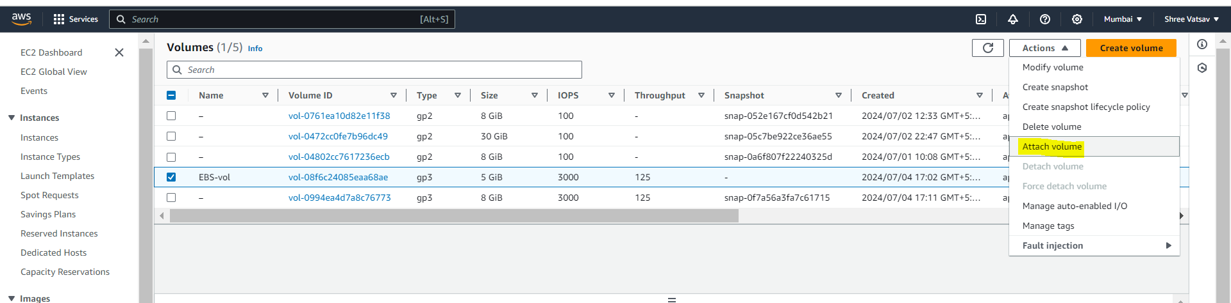

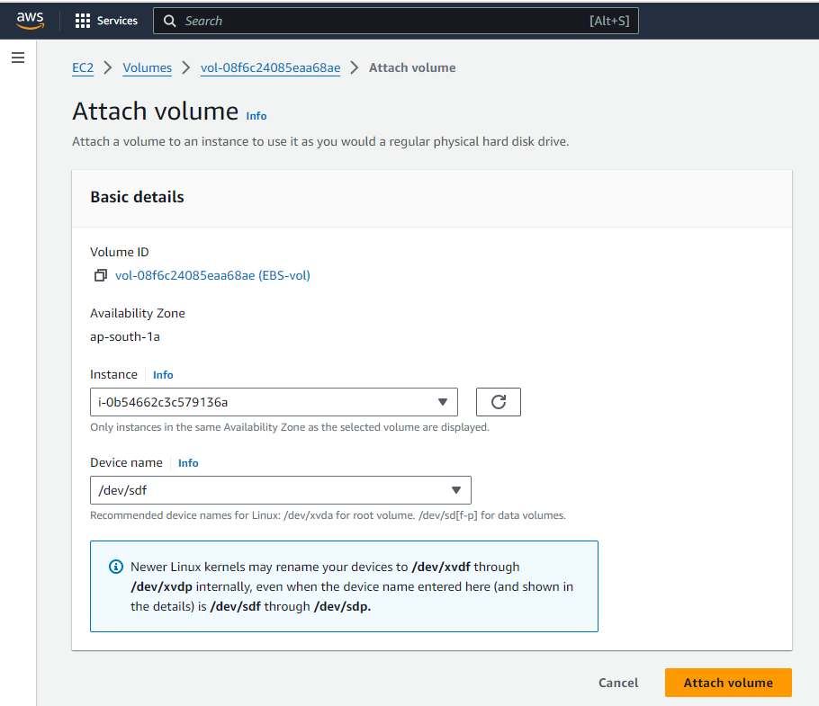

**NOW WE HAVE ATTACHED THE VOLUME TO EC2 MACHINE , TO ACCESS IT WE HAVE TO MOUNT THE VOLUME. GET INTO THE EC2 MACHINE (CONNECT)**

**CHECK WHETHER THE VOLUME HAS BEEN ATTACHED TO THE EC2 MACHINE**

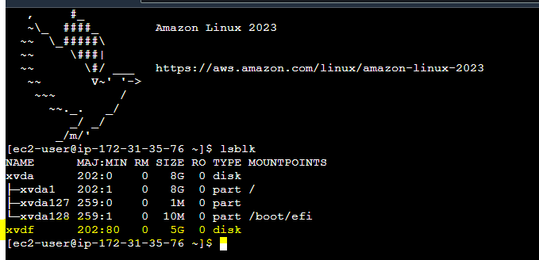

**NOW WE ARE FORMATING OUR DISK ANJD CREATING OUR MOUNT PATH AND ATTACHING IT AND UPDATING THE CONFIGURATION OF THE EC2 MACHINE**

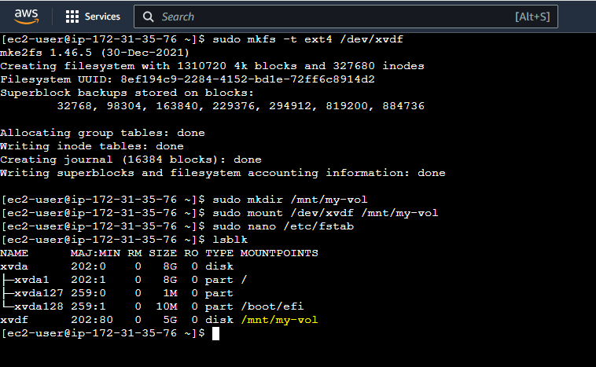

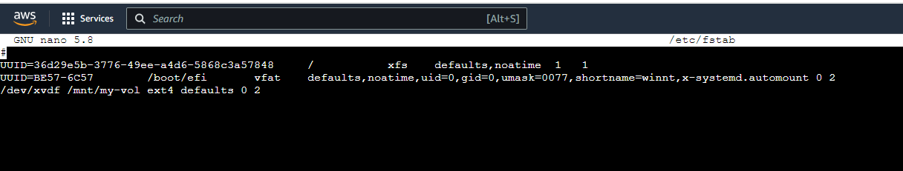

**CREATE A SNAPSHOT FOR THE VOLUME CREATED**

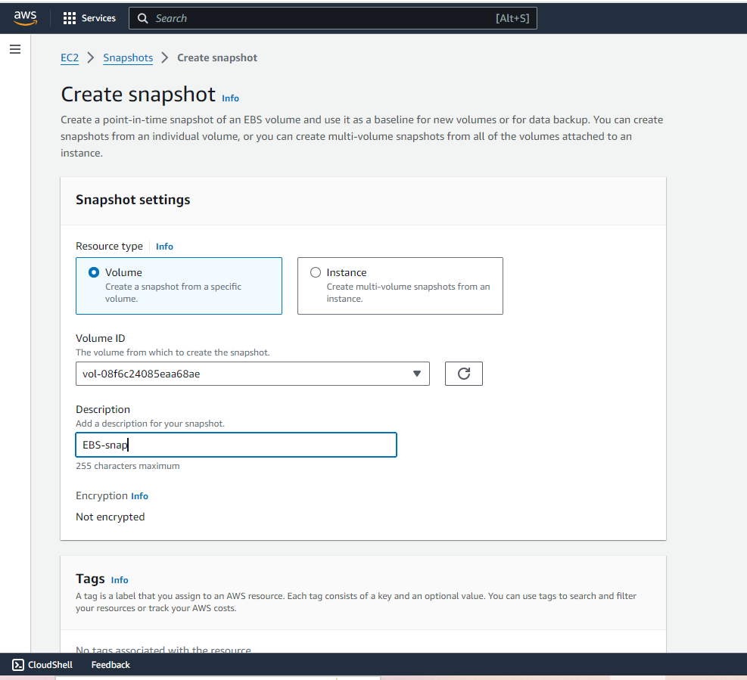

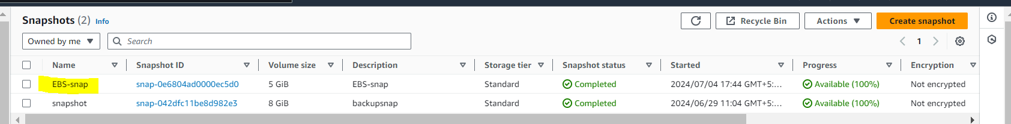

**NOW CREATE A NEW EBS VOLUME AND ATTACH THE SNAPSHOT WITH DIFFERENT AVALIABILITY ZONE**

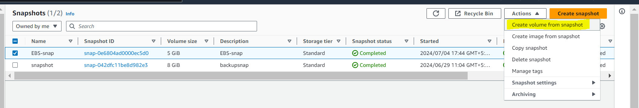

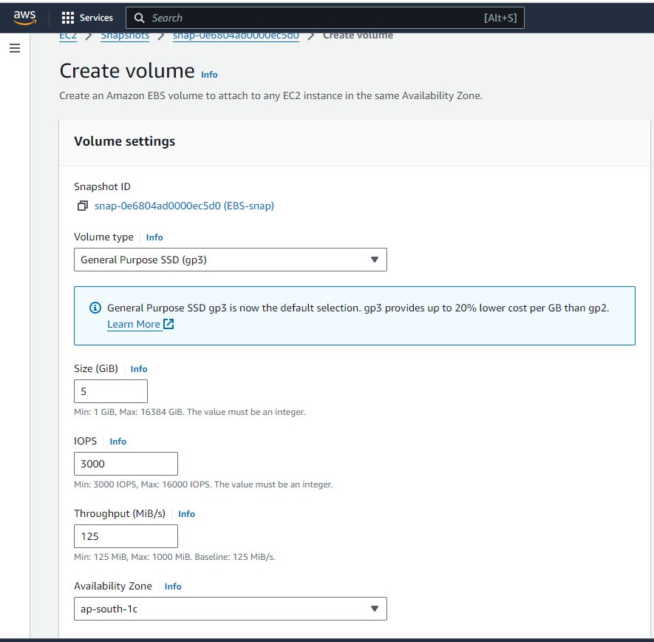

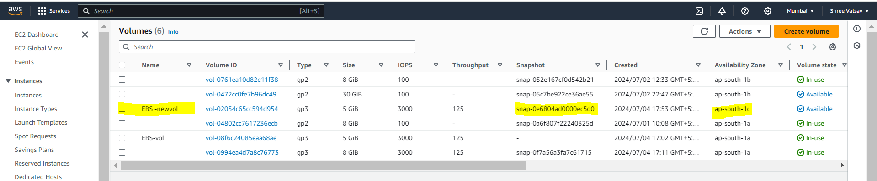

**ADDING WEB SERVER (NGINX) TO EC2**

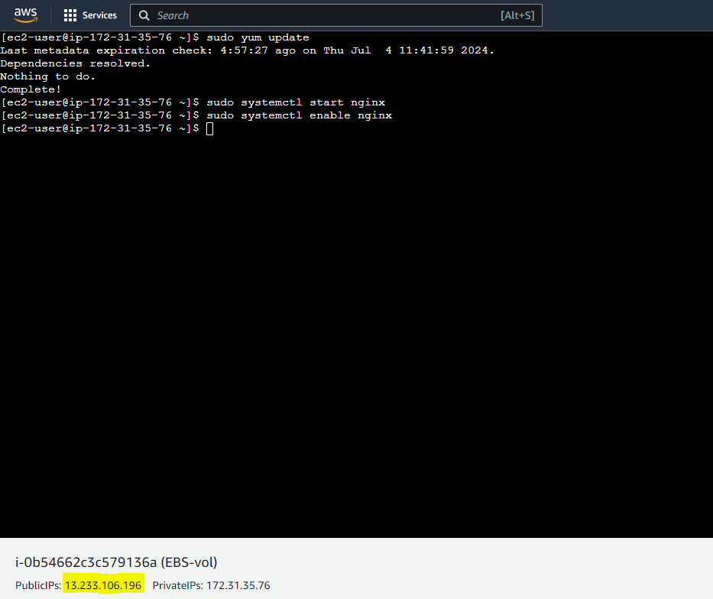

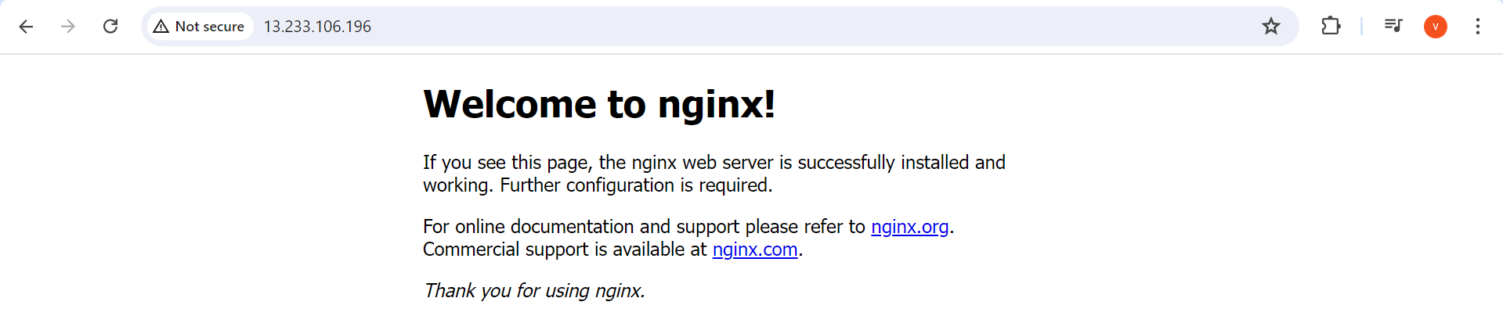

**WINDOWS**

**NOW FOR WINDOWS , CREATE A SEPARATE VOLUME**

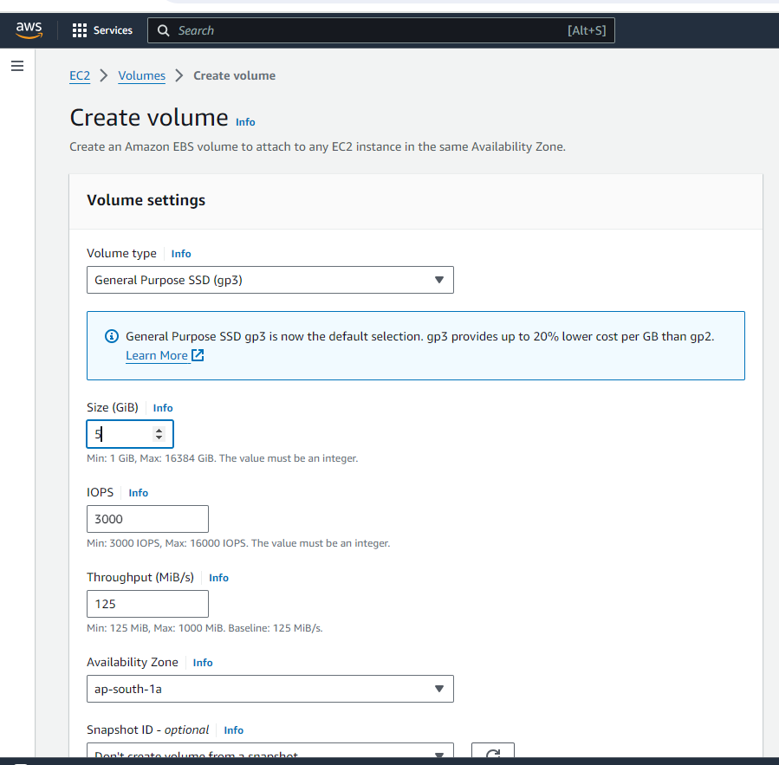

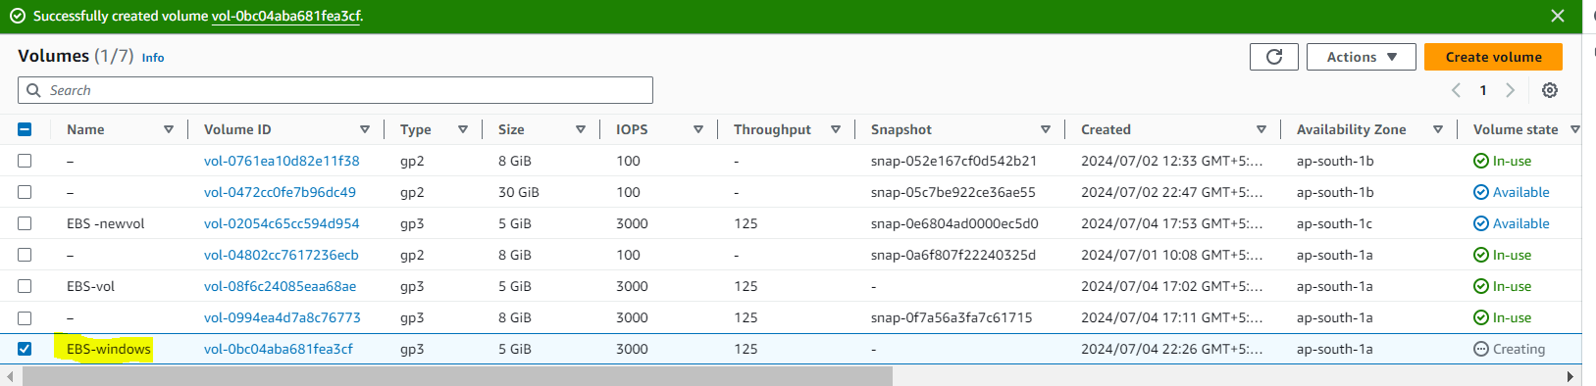

**CREATE A EC2 INSTANCE (WINDOWS)**

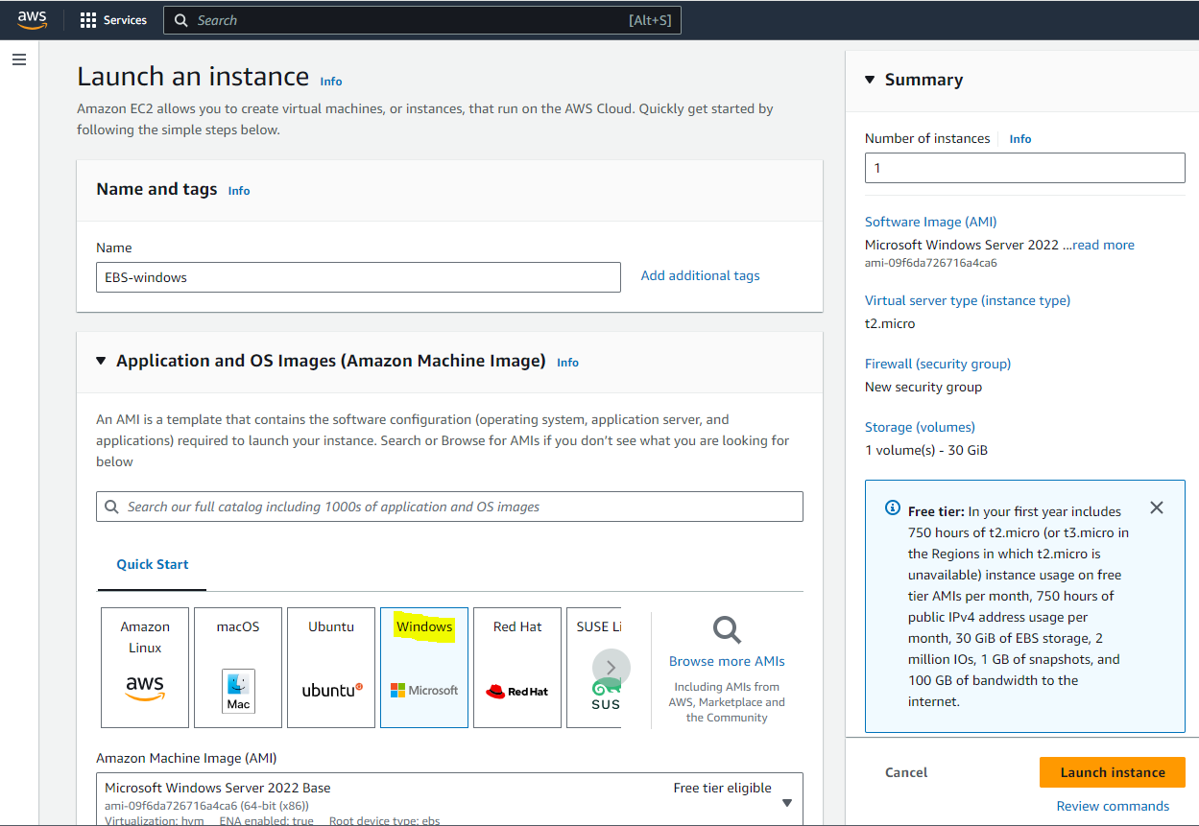

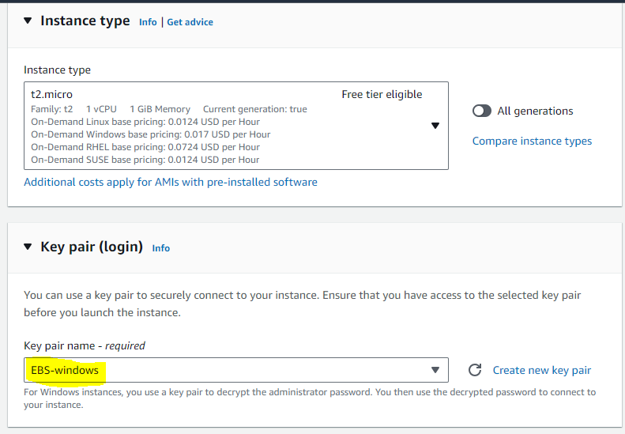

**ADD PORT 3389 OF TYPE RDP IN SECURITY GROUP**

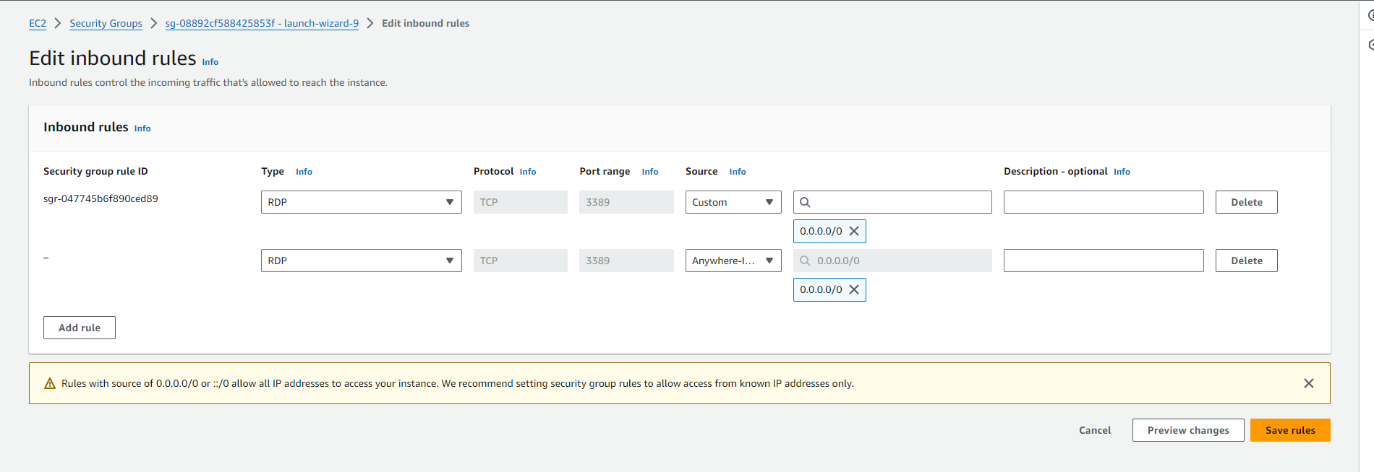

**NOW CONNECT TO THE EC2 INSTANCE AND DOWNLOAD THE REMOTE DESKTOP FILE IN RDP CLIENT AND GENERATE THE PASSWORD BY USING GET PASSWORD BY UPLOADING .PEM FILE**

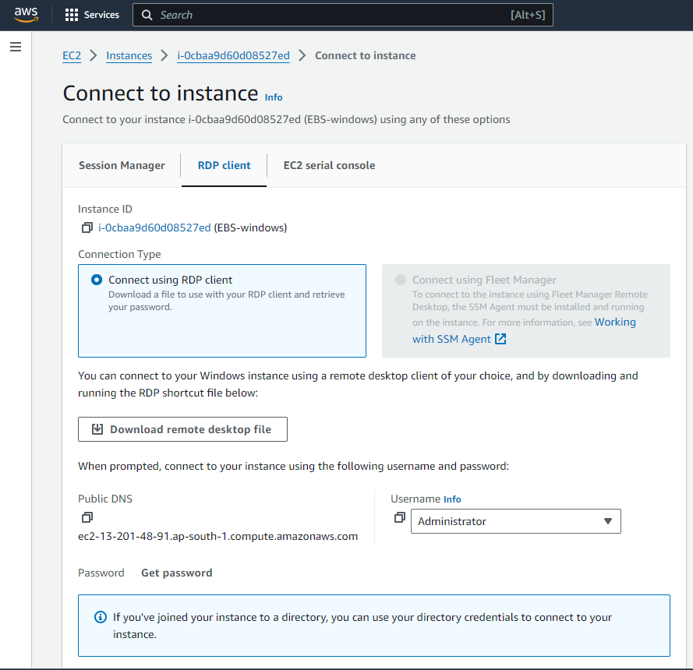

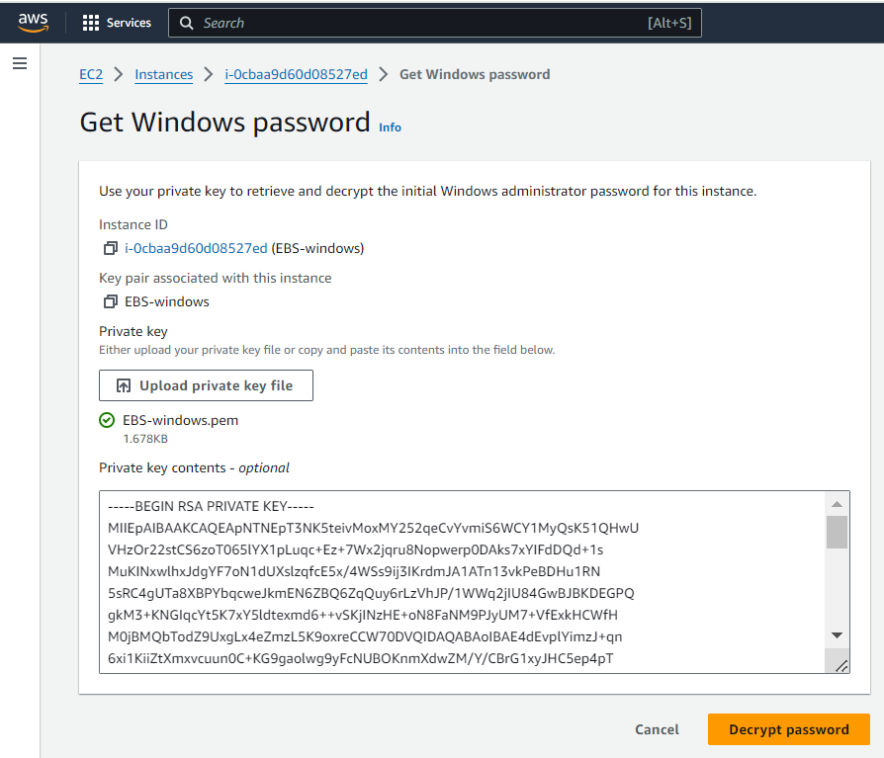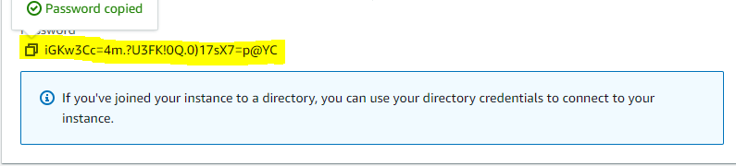

**ENTER THE PASSWORD AND CONNECT TO WINDOWS VM**

**NOW OPEN SERVER MANAGER AND CLICK ON “ADD ROLES AND FEATURES”**

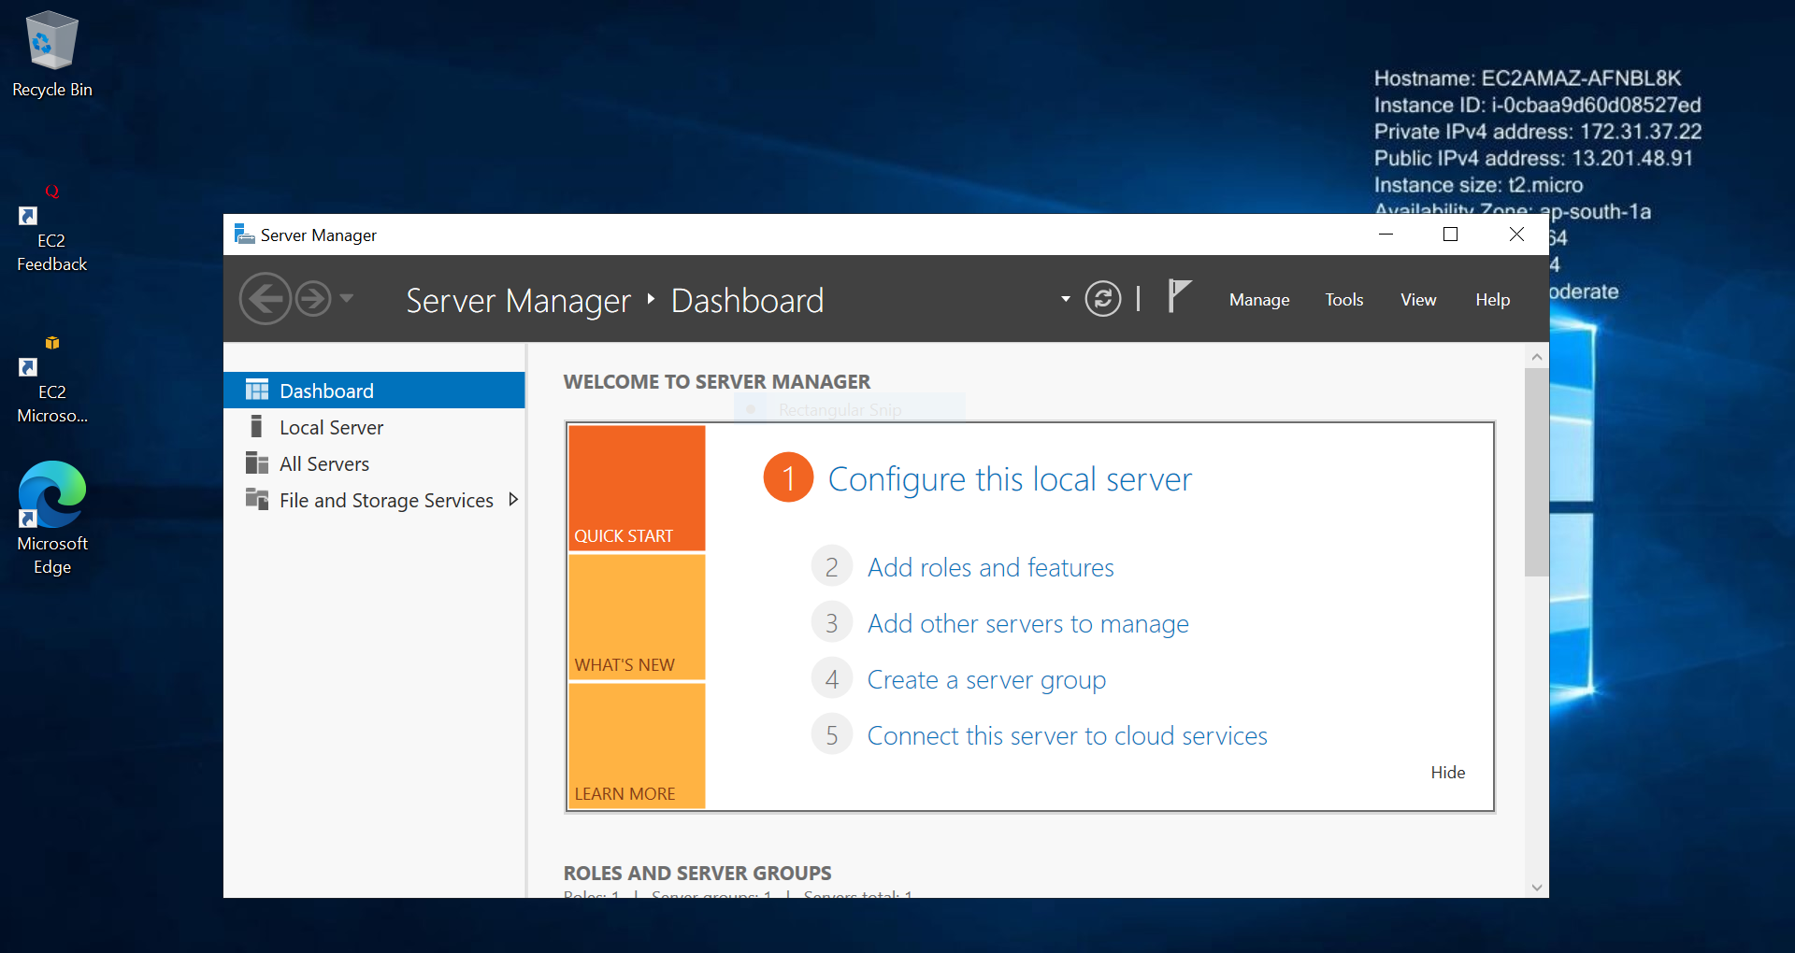

**ENABLE WEB SERVER (IIS)** 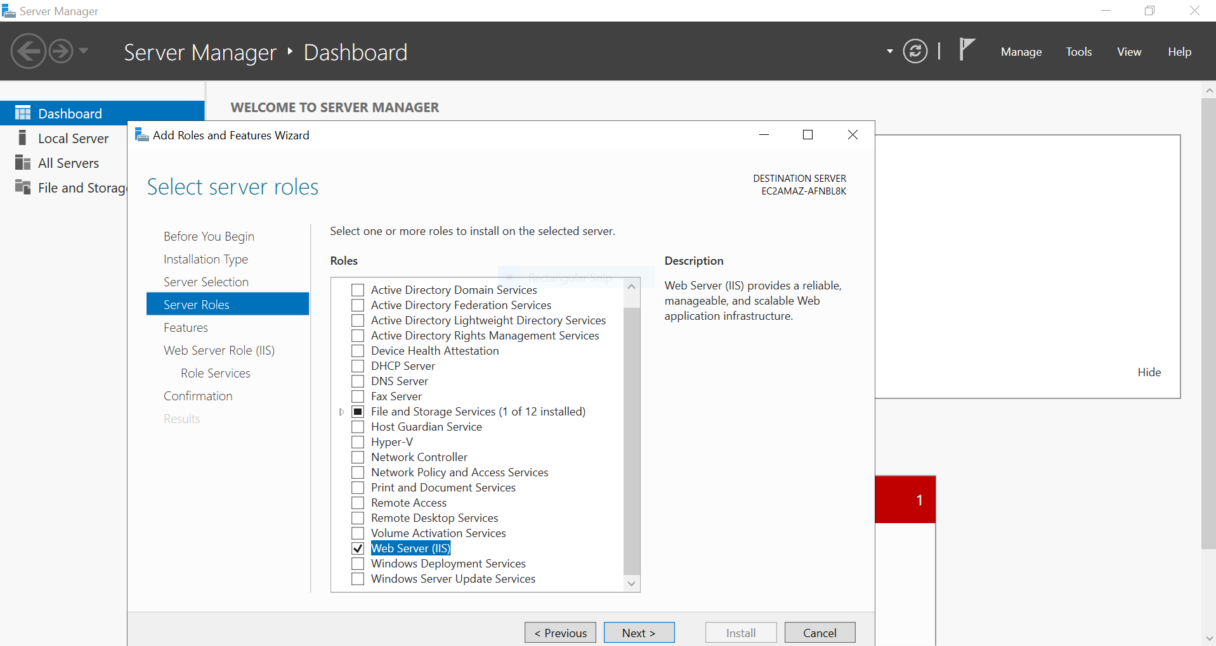

**NOW COMPLETE THE INSTALLATION AND ACCESS THE IP ADDRESS (WINDOWS WEB SERVER)**

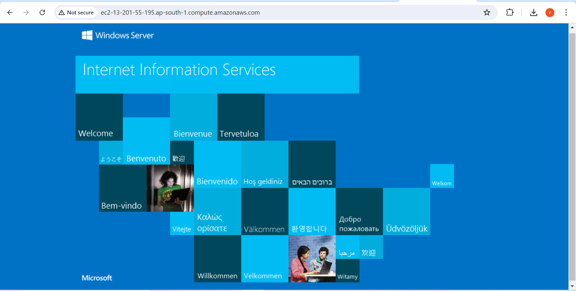

**NOW ATTACH THE VOLUME TO THE EC2**

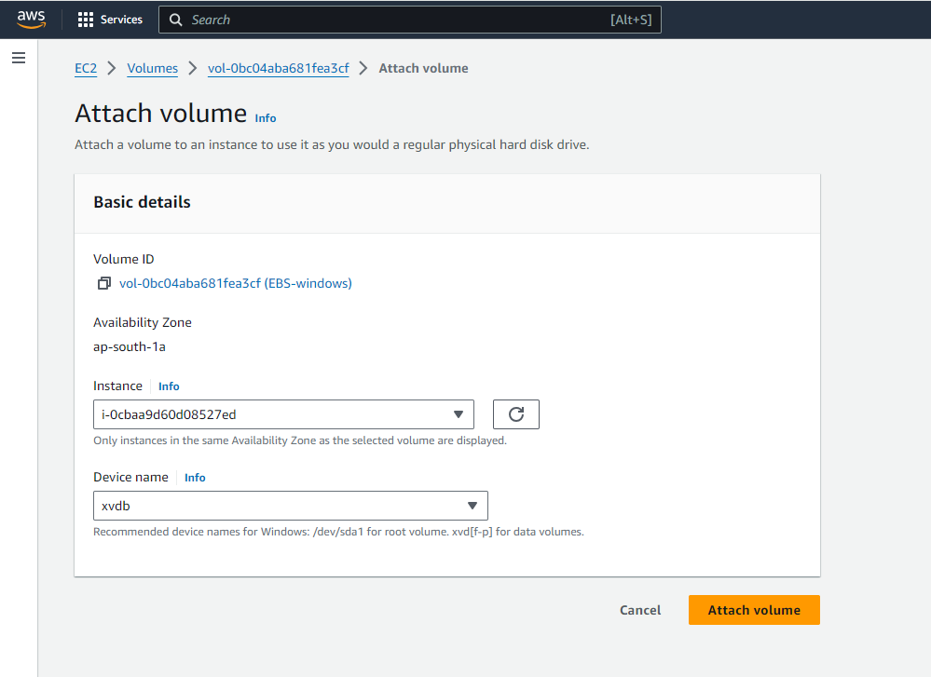

**AFTER ATTACHING THE VOLUME , CHECK IN WINDOWS WHETHER IT IS ATTACHED OR NOT**

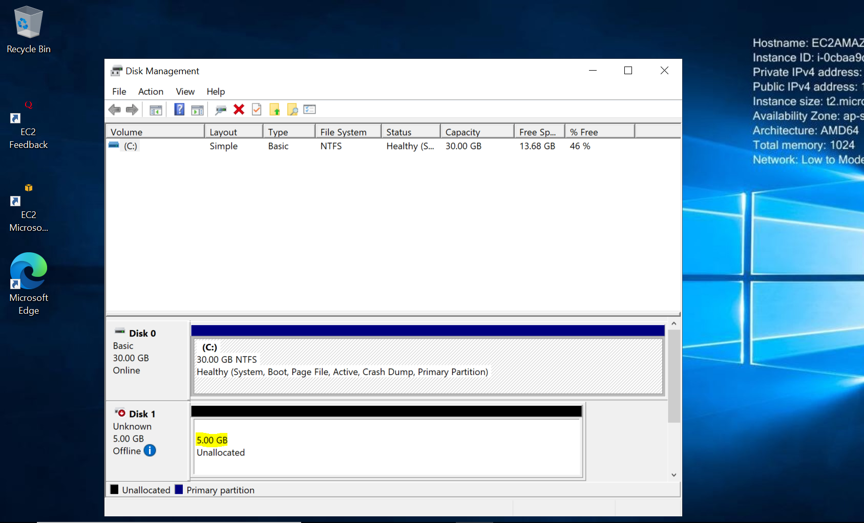

**NOW CREATE A NEW SNAPSHOT(WINDOWS)**

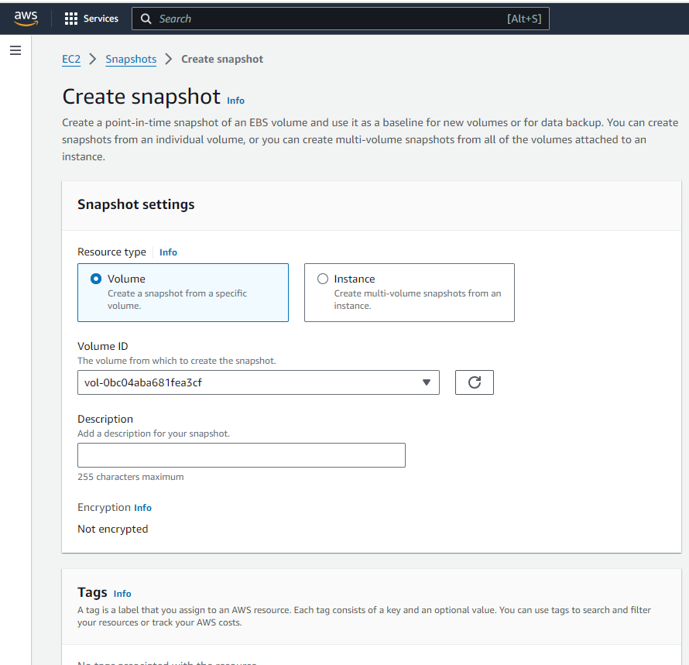

**CREATE A EBS VOLUME USING TAKEN SNAPSHOT**

