PROJECT REPORT

1. Project Details

Project Title: Hospital Management System

Problem Statement:
To build a Hospital Management System (HMS) web application that allows Admins, Doctors, and Patients to interact with the system based on their roles.

Approach:
The app was built using Flask as the backend framework with a modular structure. It allows admin to add, edit, delete, blacklist doctors and patients along with viewing appointments. Doctors can know their patient’s history and provide availability. The patient can check for all doctors and book appointment.

2. AI/LLM Declaration
I used ChatGPT (GPT-5) to assist in writing some part of the frontend(HTML, CSS), routing and improving some of the functionalities.
The extent of AI/LLM usage is around 15–20%, limited to code suggestions and documentation formatting.
All final implementation logic, debugging, and integration were done manually.

3. Technologies and Frameworks Used
Technology / Library | Purpose
Flask | Core backend web framework
SQLAlchemy | Object Relational Mapper for SQLite database
Jinja2 | Template engine for rendering dynamic HTML pages
Bootstrap 5 | Frontend styling and responsive design
Flask-Login | User authentication and session management
SQLite | Lightweight local database for storing user data
Javascript | Very less use. Ex: inline confirm() and toggling

4. Database Schema / ER Diagram
Tables:
- User — stores login and profile details
(id, name, email, password, role, active)
- Doctor — stores doctor-specific information
(id, user_id, specialization, department_id, experience, phone, address)
- Patient — stores patient-specific details
(id, user_id, age, gender, phone, address)
- Appointment — stores appointment bookings between doctor and patient
(id, patient_id, doctor_id, date, time, status)
- Treatment — stores medical diagnosis and prescriptions for each appointment
(id, appointment_id, diagnosis, prescription, notes, visit_type, tests_done, followup_required)
- Availability — stores doctor availability time slots
(id, doctor_id, date, time_slot, status)
- Department — stores hospital departments
(id, name, description)
Relationships:
● One-to-One → User → Doctor
● One-to-One → User → Patient
● One-to-Many → Doctor → Appointment
● One-to-Many → Patient → Appointment
● One-to-One → Appointment → Treatment
● One-to-Many → Doctor → Availability
● One-to-Many → Department → Doctor

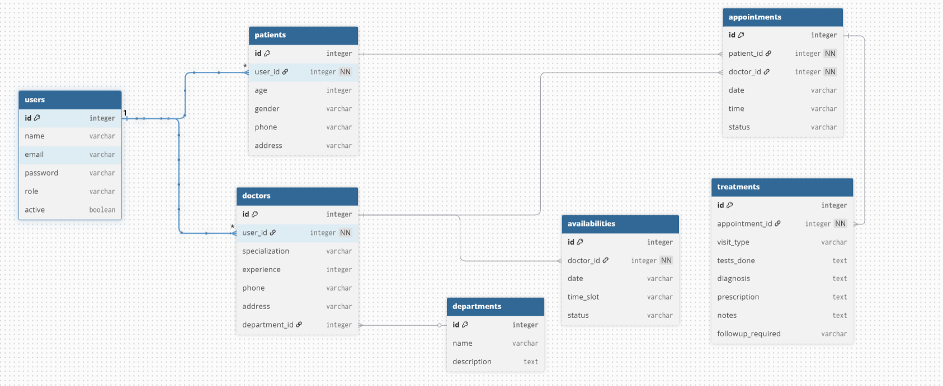

5. Architecture and Features

Architecture Overview:

● app.py – main Flask application entry point
● /models – database models using SQLAlchemy (User, Doctor, Patient, Appointment, Treatment, Availability, Department)
● /routes – Flask Blueprints for admin, doctor, patient, and authentication modules
● /templates – Jinja2 HTML templates for all dashboards and UI pages
● /static – CSS styling files and images used across the application
● config.py – central configuration for database and secret key

Implemented Features:
User registration and login
Role-based access control (Admin, Doctor, Patient)
Doctor availability management with automatic expiry of past slots
Patient appointment booking and cancellation
Doctor-side completion of appointment history and treatment notes
Admin dashboard for managing doctors, patients, and appointments
Flash-based alerts for all operations
Responsive UI using HTML and CSS (Jinja2 templating)
Additional Features:
● Prevents back-button access after logout
● Automatic cleanup of expired availability
● Dedicated patient and doctor detail views for admin

