**Website basic Content**

**Home Page**

* **Slide Show Photos –** photos will be provided by committee
* **About SnC –** small description about committee it will be provided

**Counting display**

Clubs Member Participants

Eg:-



* **After Movie video**
* **Meet the Team**

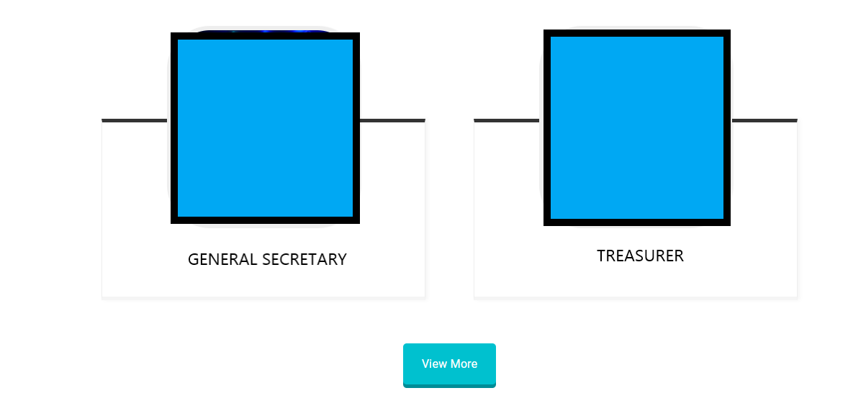

**Here we will have only two photos and clicking view more it will redirect to about us page in which we will have whole team**

* **Contact us**

1. Social Media
2. Name, Number

**2th Tab**

**About Us page**

**SnC description – all content will be provided**

**SnC Team :-**

**Eg:-**

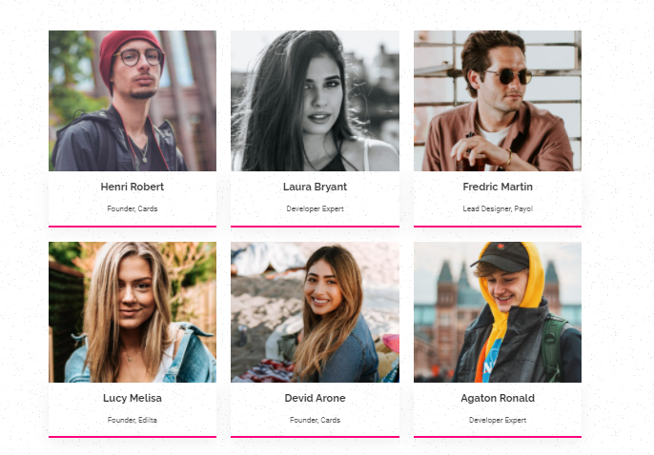

**3Nd Tab**

* **Clubs**

1. LOGO’s
2. 17 Clubs name & details

**4rd Tab**

* **Current Events**

1. Rangtaal – description about rangtaal(provided)
2. Photos gallery

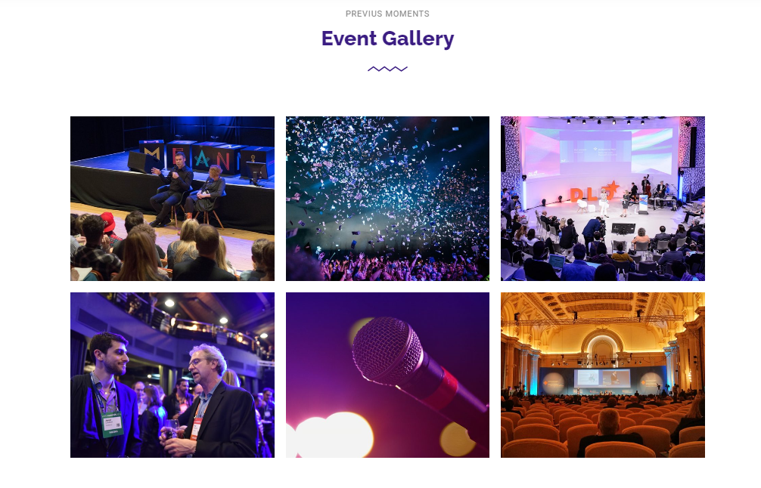

Schedule Events

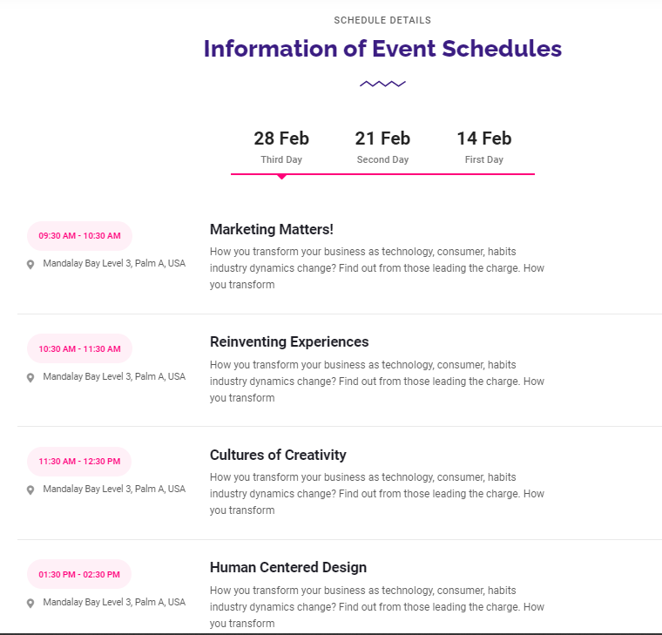

Note:- Link should be provided to join event as button

**5th Tab**

* **Past year events**

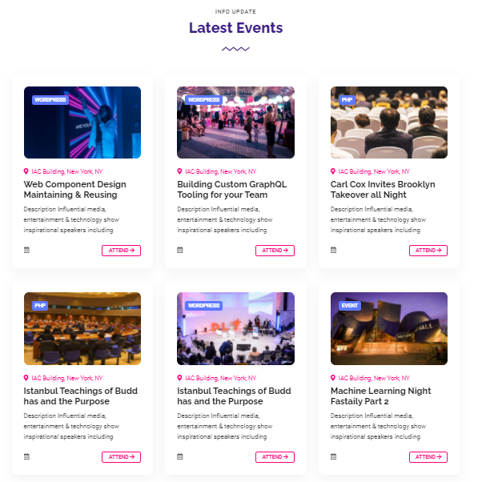

* **Glimpse (Photo Gallery)**



**6Th Tab**

**FEEDBACK form**

**Fest of other Colleges**

[**http://synapse.daiict.ac.in**](http://synapse.daiict.ac.in)

[**https://moodi.org**](https://moodi.org)

[**http://ieee.daiict.ac.in/ifest/#aboutus**](http://ieee.daiict.ac.in/ifest/#aboutus)

[**http://www.msu-paramarsh.org/**](http://www.msu-paramarsh.org/)

[**http://www.sympulsefest.com/**](http://www.sympulsefest.com/)

[**https://springfest.in/**](https://springfest.in/)

[**https://www.anwesha.info/**](https://www.anwesha.info/)

[**https://bitswaves.org/**](https://bitswaves.org/)