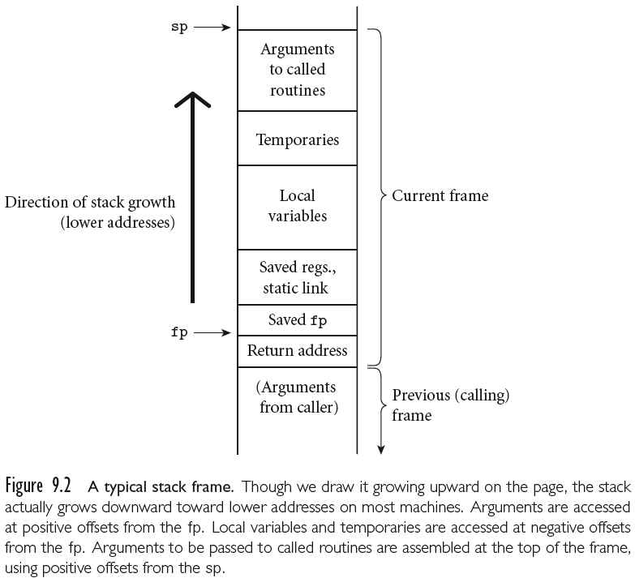

**A Typical Calling Sequence**

Exact details are system dependent, what follows is a reasonable approximation.

The calling sequence begins with the caller: A()

1. Pushes some registers on to the stack (modifying sp).
2. Pushes arguments.
3. Computes and pushes the static link.
4. Executes a call machine instruction and pushes the return address.

Next the callee:B()

1. Pushes the old frame ptr and calculates the new one.
2. Pushes some registers.
3. Allocates space for temporaries and local variables.
4. Begins execution of the subroutine.

When the subroutine completes, the callee:

1. Stores the return value (perhaps on the stack).
2. Restores some registers.
3. Restores the sp.
4. Restores the fp.
5. Jumps to the return address, resuming the caller.

Finally, the caller:

1. Restores some registers.
2. Moves the return value to its destination.

