Assignment: Create a job to deploy index.html to Apache httpd.

Step 1: Create a EC2 as Jenkins-master in Aws
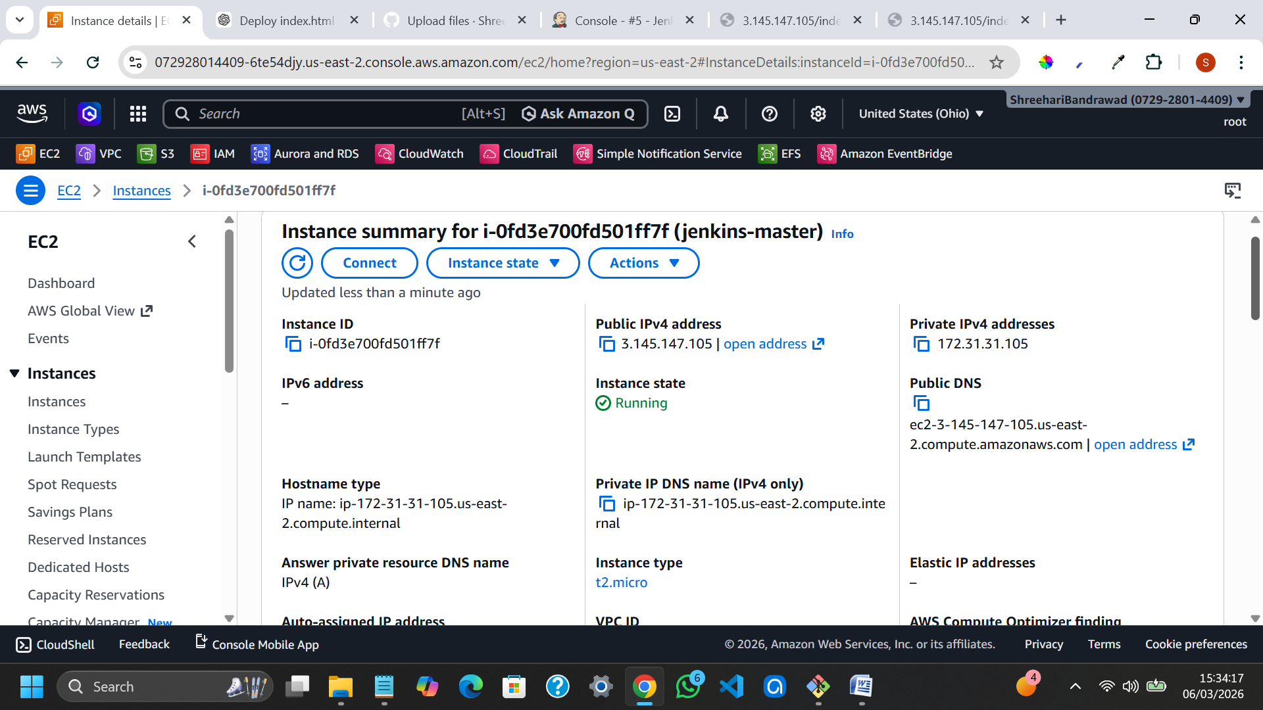

Step 2 : install java-17 and Jenkins.
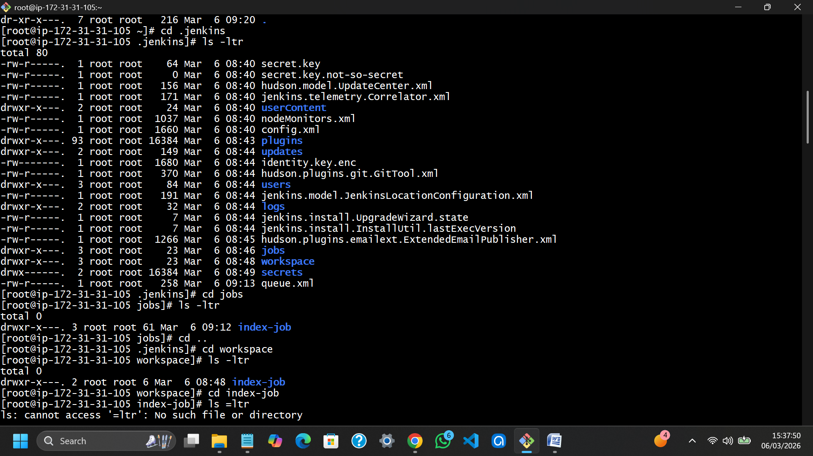

Step 3 : create a job in Jenkins dashboard

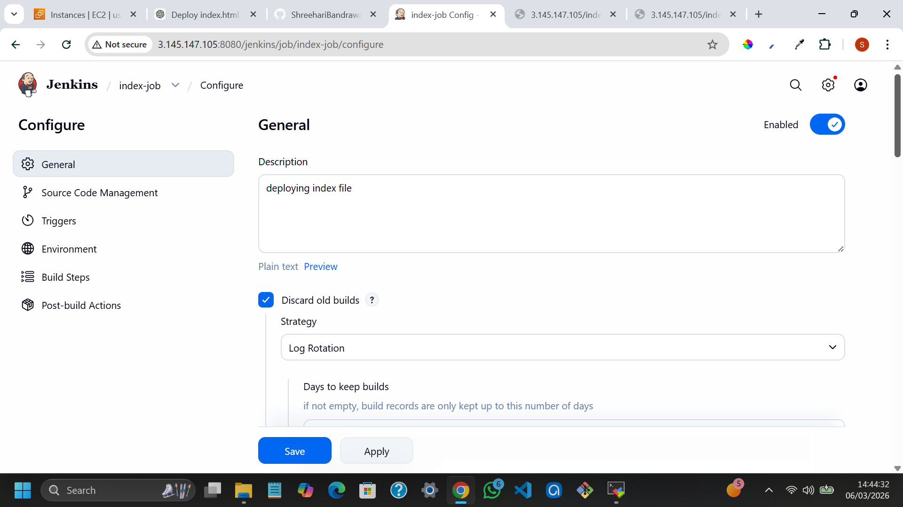

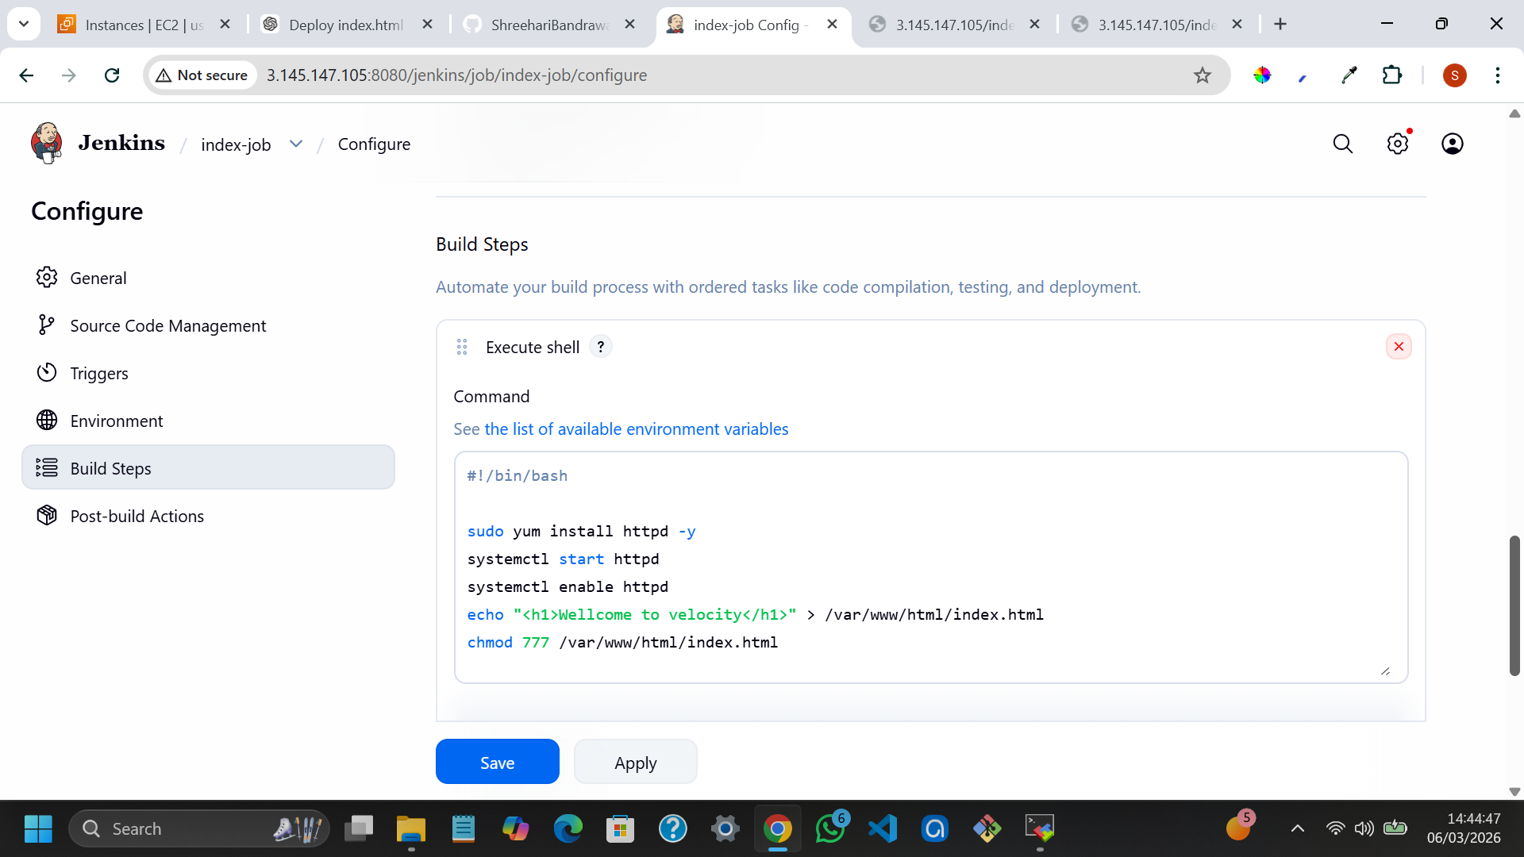

Step 4 : Build job
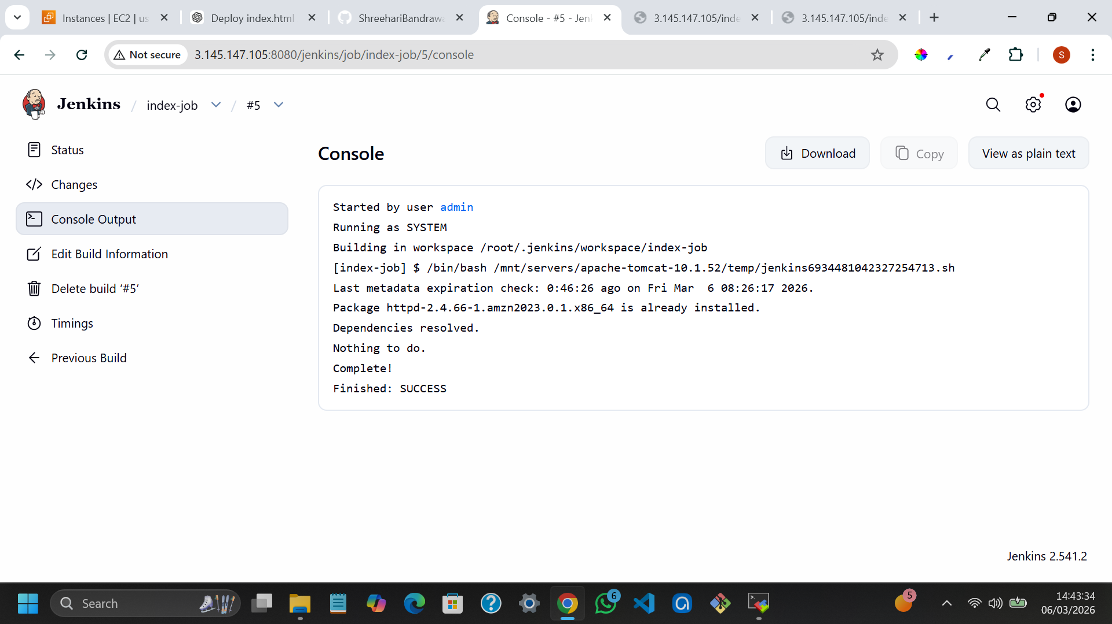

Step 5: Index file
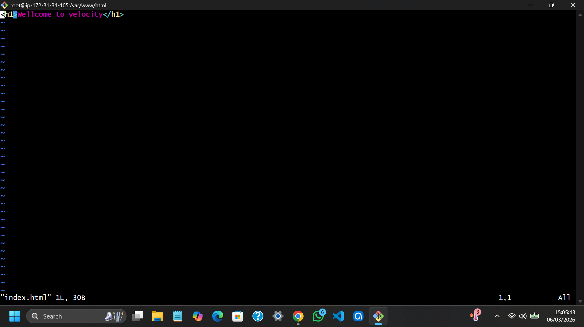

Step 6: result
