# # Question 1:

## Code screenshot

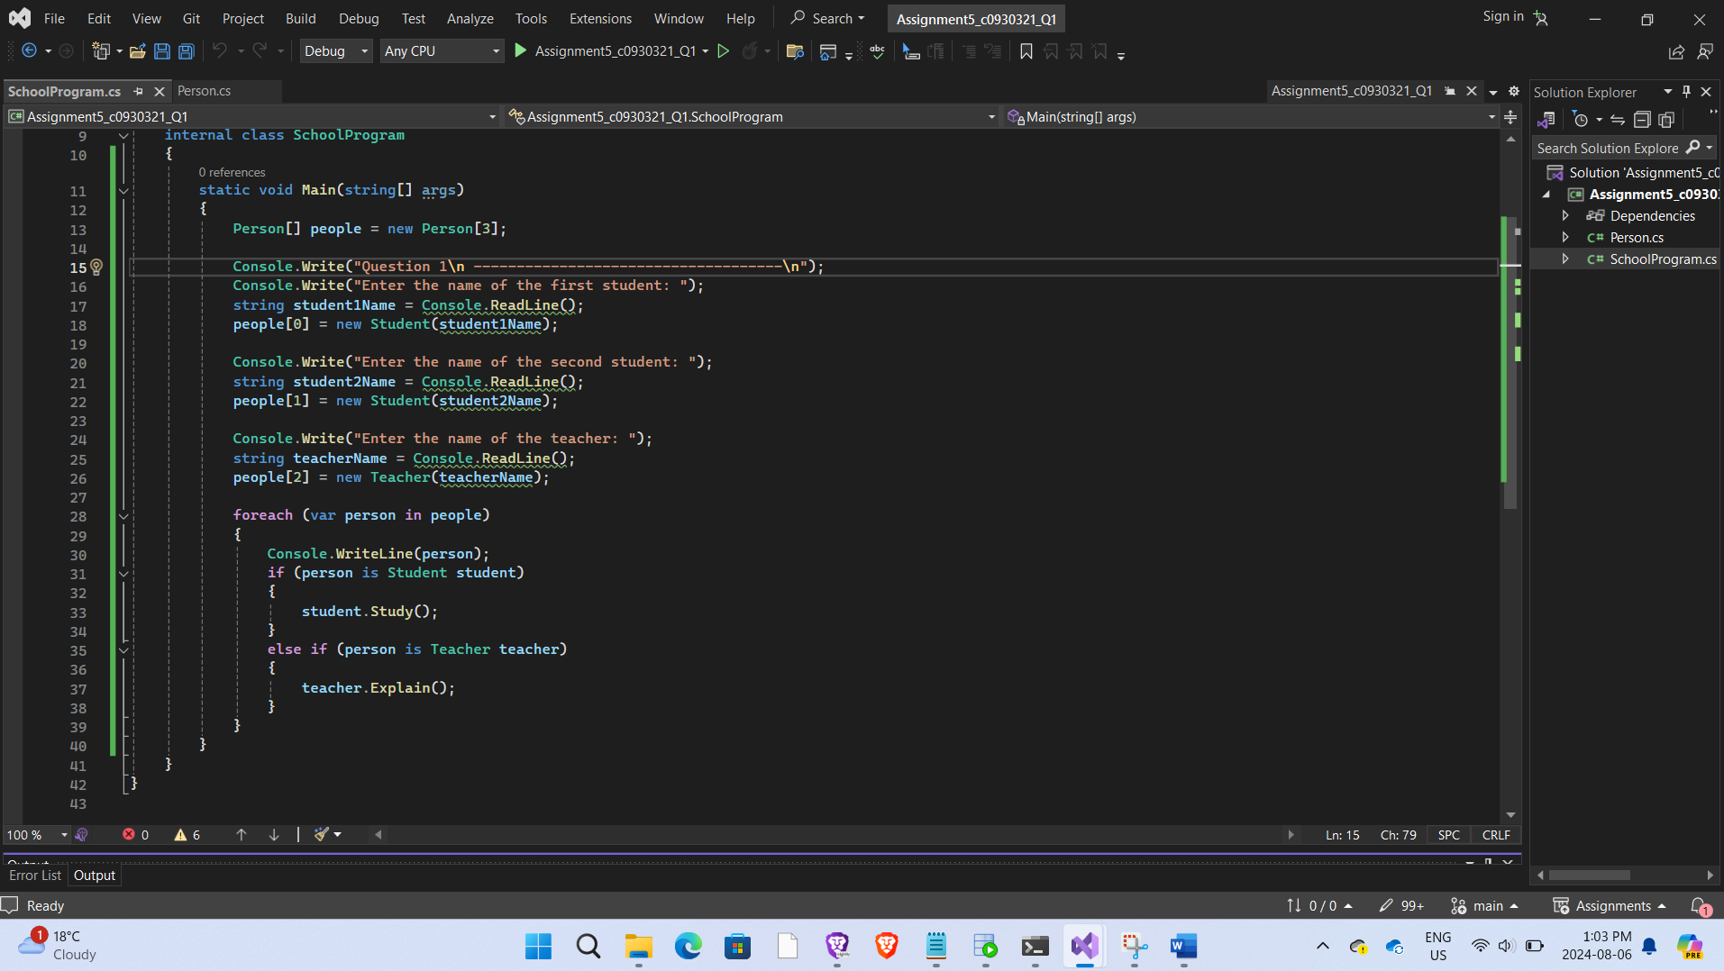

## Code

using System;

namespace Assignment5_c0930321_Q1

{

internal class Person

{

public string Name { get; private set; }

public Person(string name)

{

Name = name;

}

public override string ToString()

{

return Name;

}

}

internal class Student : Person

{

public Student(string name) : base(name)

{

}

public void Study()

{

Console.WriteLine($"{Name} is studying.");

}

}

internal class Teacher : Person

{

public Teacher(string name) : base(name)

{

}

public void Explain()

{

Console.WriteLine($"{Name} is explaining.");

}

}

}

using System;

namespace Assignment5_c0930321_Q1

{

internal class SchoolProgram

{

static void Main(string[] args)

{

Person[] people = new Person[3];

Console.Write("Question 1\n ------------------------------------\n");

Console.Write("Enter the name of the first student: ");

string student1Name = Console.ReadLine();

people[0] = new Student(student1Name);

Console.Write("Enter the name of the second student: ");

string student2Name = Console.ReadLine();

people[1] = new Student(student2Name);

Console.Write("Enter the name of the teacher: ");

string teacherName = Console.ReadLine();

people[2] = new Teacher(teacherName);

foreach (var person in people)

{

Console.WriteLine(person);

if (person is Student student)

{

student.Study();

}

else if (person is Teacher teacher)

{

teacher.Explain();

}

}

}

}

}

## Output Screenshot

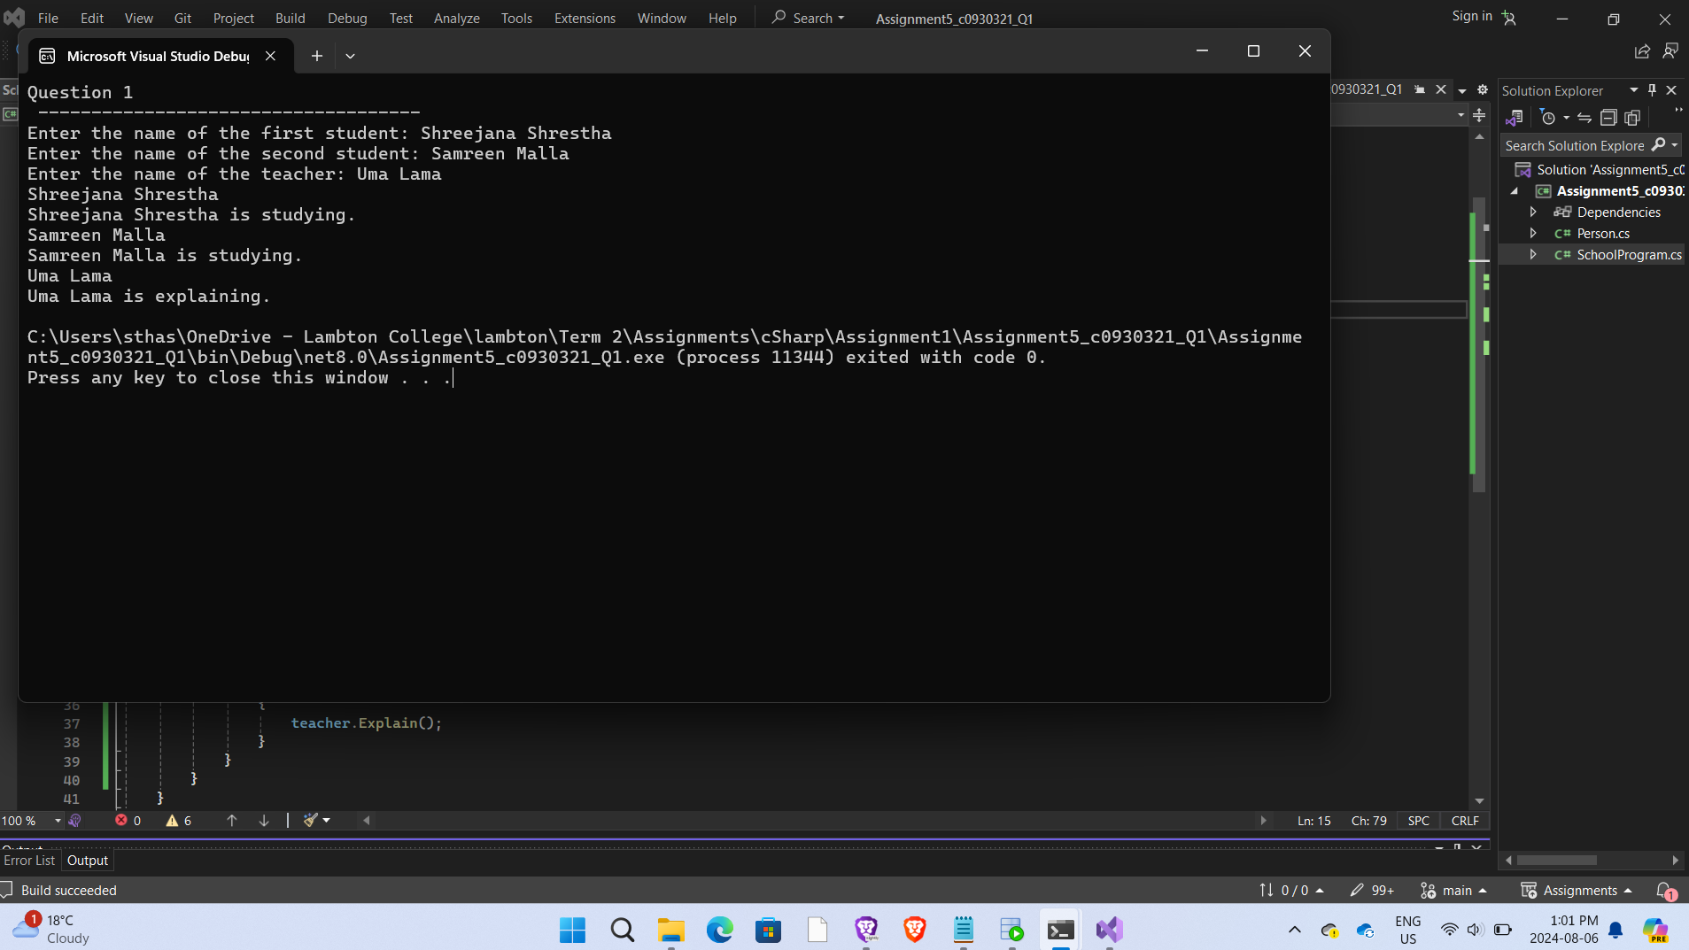

# Question 2:

## Code:

using System;

namespace Assignment5_Q2_c0930321

{

public abstract class Shape

{

protected Location c;

public Shape(Location c)

{

this.c = c;

}

public abstract double Area();

public abstract double Perimeter();

public override string ToString()

{

return $"Shape at location ({c.x}, {c.y})\n";

}

}

public class Rectangle : Shape

{

private double side1;

private double side2;

public Rectangle(Location c, double side1, double side2) : base(c)

{

this.side1 = side1;

this.side2 = side2;

}

public override double Area()

{

return side1 * side2;

}

public override double Perimeter()

{

return 2 * (side1 + side2);

}

public override string ToString()

{

return $"Rectangle at location ({c.x}, {c.y}) with sides {side1} and {side2}\n";

}

}

public class Circle : Shape

{

private double radius;

public Circle(Location c, double radius) : base(c)

{

this.radius = radius;

}

public override double Area()

{

return Math.PI * radius * radius;

}

public override double Perimeter()

{

return 2 * Math.PI * radius;

}

public override string ToString()

{

return $"Circle at location ({c.x}, {c.y}) with radius {radius}\n";

}

}

}

using System;

namespace Assignment5_Q2_c0930321

{

public class Location

{

public double x { get; set; }

public double y { get; set; }

public Location(double x, double y)

{

this.x = x;

this.y = y;

}

}

}

using System;

namespace Assignment5_Q2_c0930321

{

internal class GeometryProgram

{

static void Main(string[] args)

{

Console.WriteLine("Question 2\nGeometry Program\n-------------------------------\n");

Location location1 = new Location(4.0, 3.0);

Console.WriteLine("Rectangle\n--------------\n");

Shape rect = new Rectangle(location1, 6.0, 2.0);

Console.WriteLine(rect.ToString());

Console.WriteLine($"Area: {rect.Area()}");

Console.WriteLine($"Perimeter: {rect.Perimeter()}\n");

Location location2 = new Location(5.0, 6.0);

Console.WriteLine("Circle\n--------------\n");

Shape circle = new Circle(location2, 2.5);

Console.WriteLine(circle.ToString());

Console.WriteLine($"Area: {circle.Area()}");

Console.WriteLine($"Perimeter: {circle.Perimeter()}");

}

}

}

## Output Screenshot

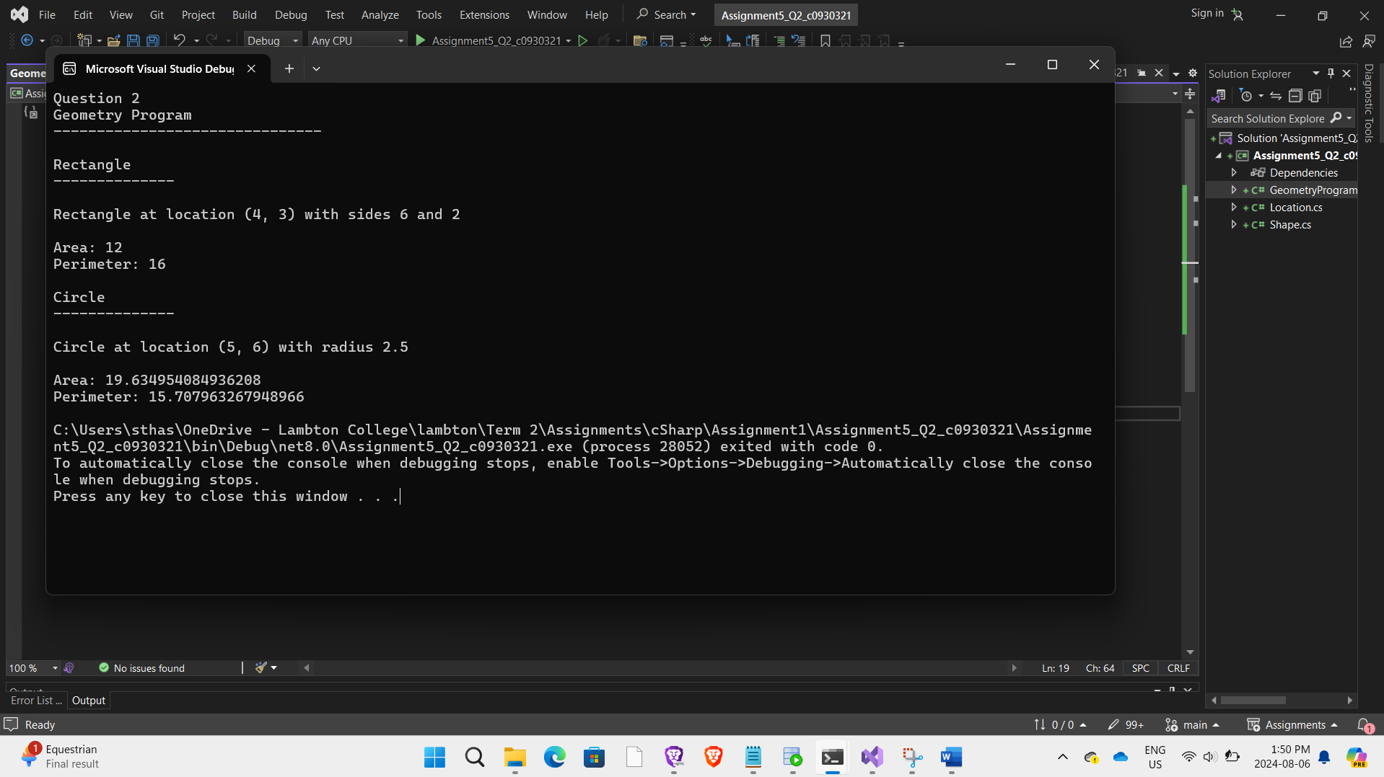

# Question 3:

## # Code screenshot

## Code

using System;

namespace Assigmnent_Q3_c0930321

{

internal class VehicleProgram

{

static void Main(string[] args)

{

Car car = new Car(0);

Console.WriteLine("Question 3 \n----------------------------- \n");

Console.WriteLine("Enter the amount of gasoline to refuel:");

if (int.TryParse(Console.ReadLine(), out int amount))

{

car.Refuel(amount);

}

else

{

Console.WriteLine("Invalid input. Please enter a valid integer.");

}

car.Drive();

Console.WriteLine($"Remaining gasoline: {car.GetGasoline()} units.");

}

}

}

using System;

namespace Assigmnent_Q3_c0930321

{

public class Car : IVehiculo

{

private int gasoline;

public Car(int initialGasoline)

{

gasoline = initialGasoline;

}

public void Drive()

{

if (gasoline > 0)

{

Console.WriteLine("The car is driving.");

gasoline--;

}

else

{

Console.WriteLine("Cannot drive, the car is out of gasoline.");

}

}

public bool Refuel(int amount)

{

if (amount > 0)

{

gasoline += amount;

Console.WriteLine($"Car refueled with {amount} units of gasoline.");

return true;

}

else

{

Console.WriteLine("Invalid amount of gasoline to refuel.");

return false;

}

}

public int GetGasoline()

{

return gasoline;

}

}

}

using System;

namespace Assigmnent_Q3_c0930321

{

internal interface IVehiculo

{

void Drive();

bool Refuel(int amount);

}

}

## # Output Screenshot

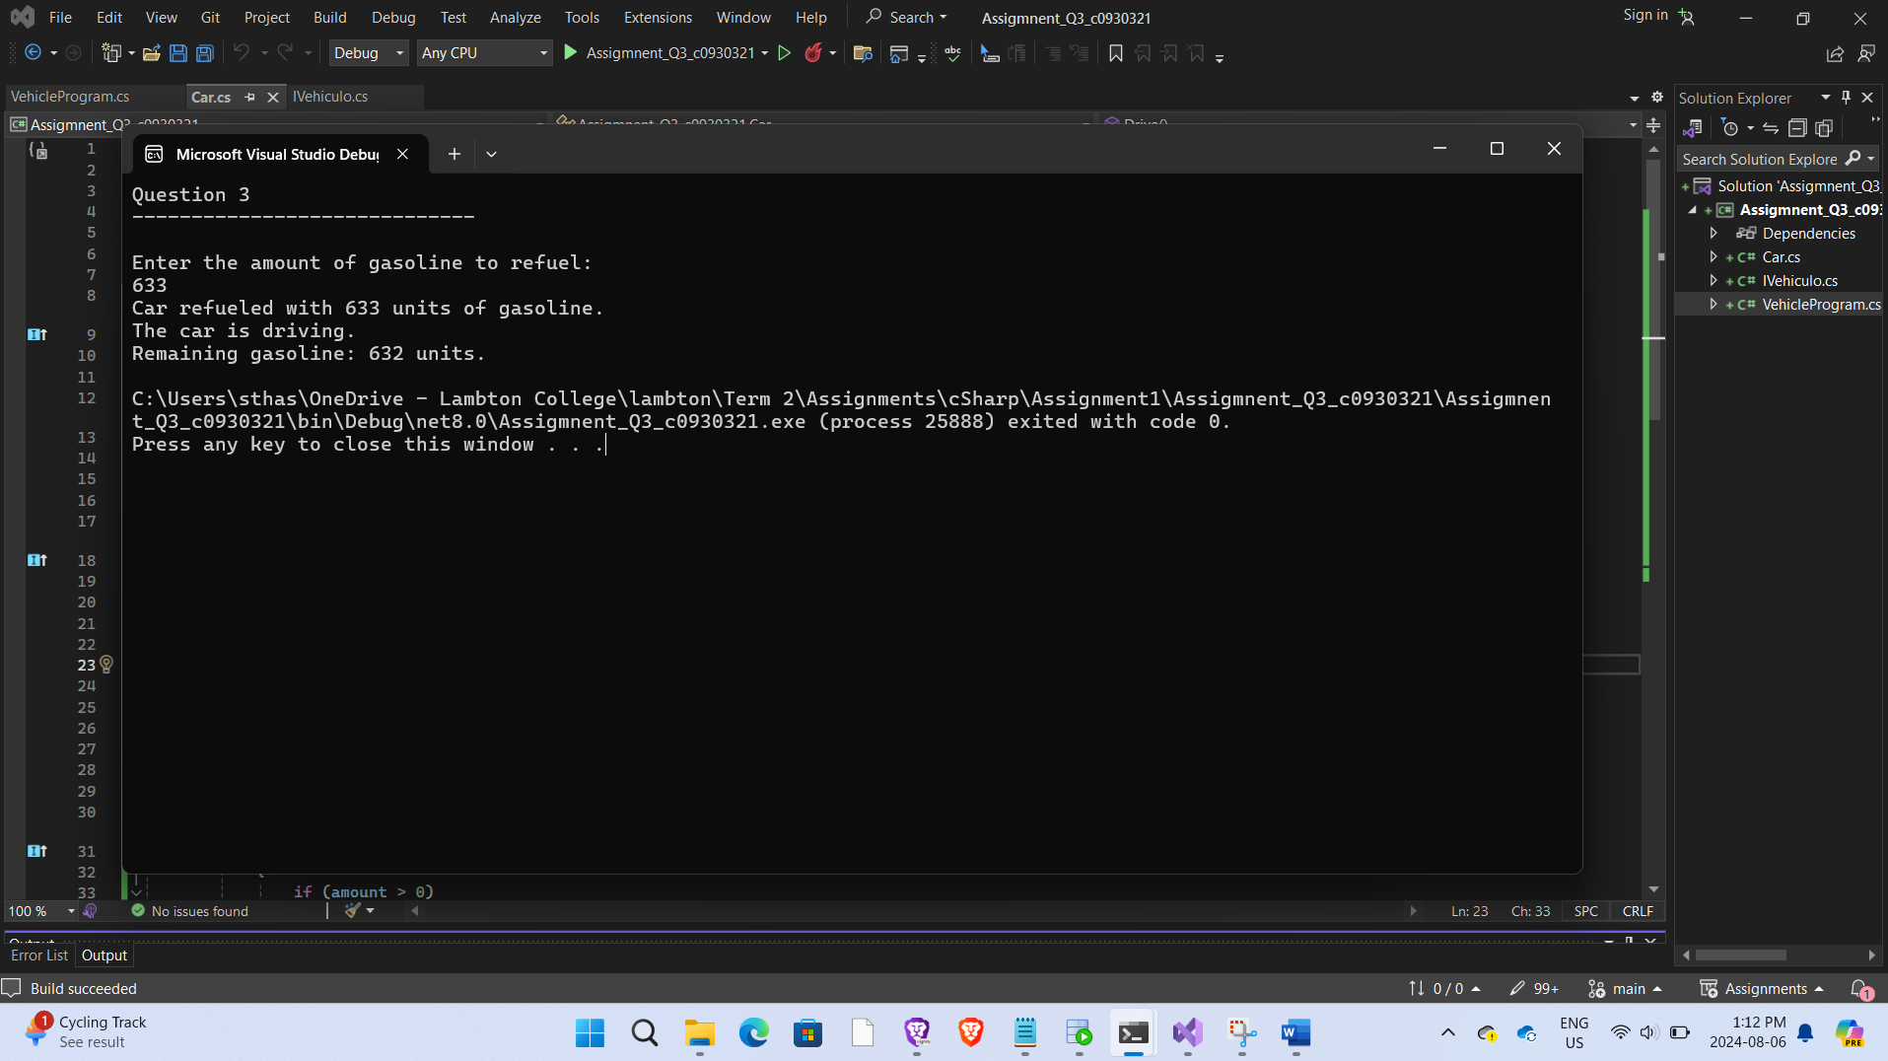

# Question 4:

## # Code screenshot

## Code

using System;

namespace Assignment5_Q4_c0930321

{

internal class AnimalWorld

{

static void Main(string[] args)

{

Console.WriteLine("Question 4\n-----------------------------\n");

Console.WriteLine("Enter the dog's name:");

string dogName = Console.ReadLine();

Dog dog = new Dog();

dog.SetName(dogName);

Console.WriteLine($"The dog's name is: {dog.GetName()}");

dog.Eat();

}

}

}

using System;

namespace Assignment5_Q4_c0930321

{

public abstract class Animal

{

public string Name { get; private set; }

public void SetName(string name)

{

Name = name;

}

public string GetName()

{

return Name;

}

public abstract void Eat();

}

public class Dog : Animal

{

public override void Eat()

{

Console.WriteLine($"{GetName()} is eating.");

}

}

}

## # Output Screenshot

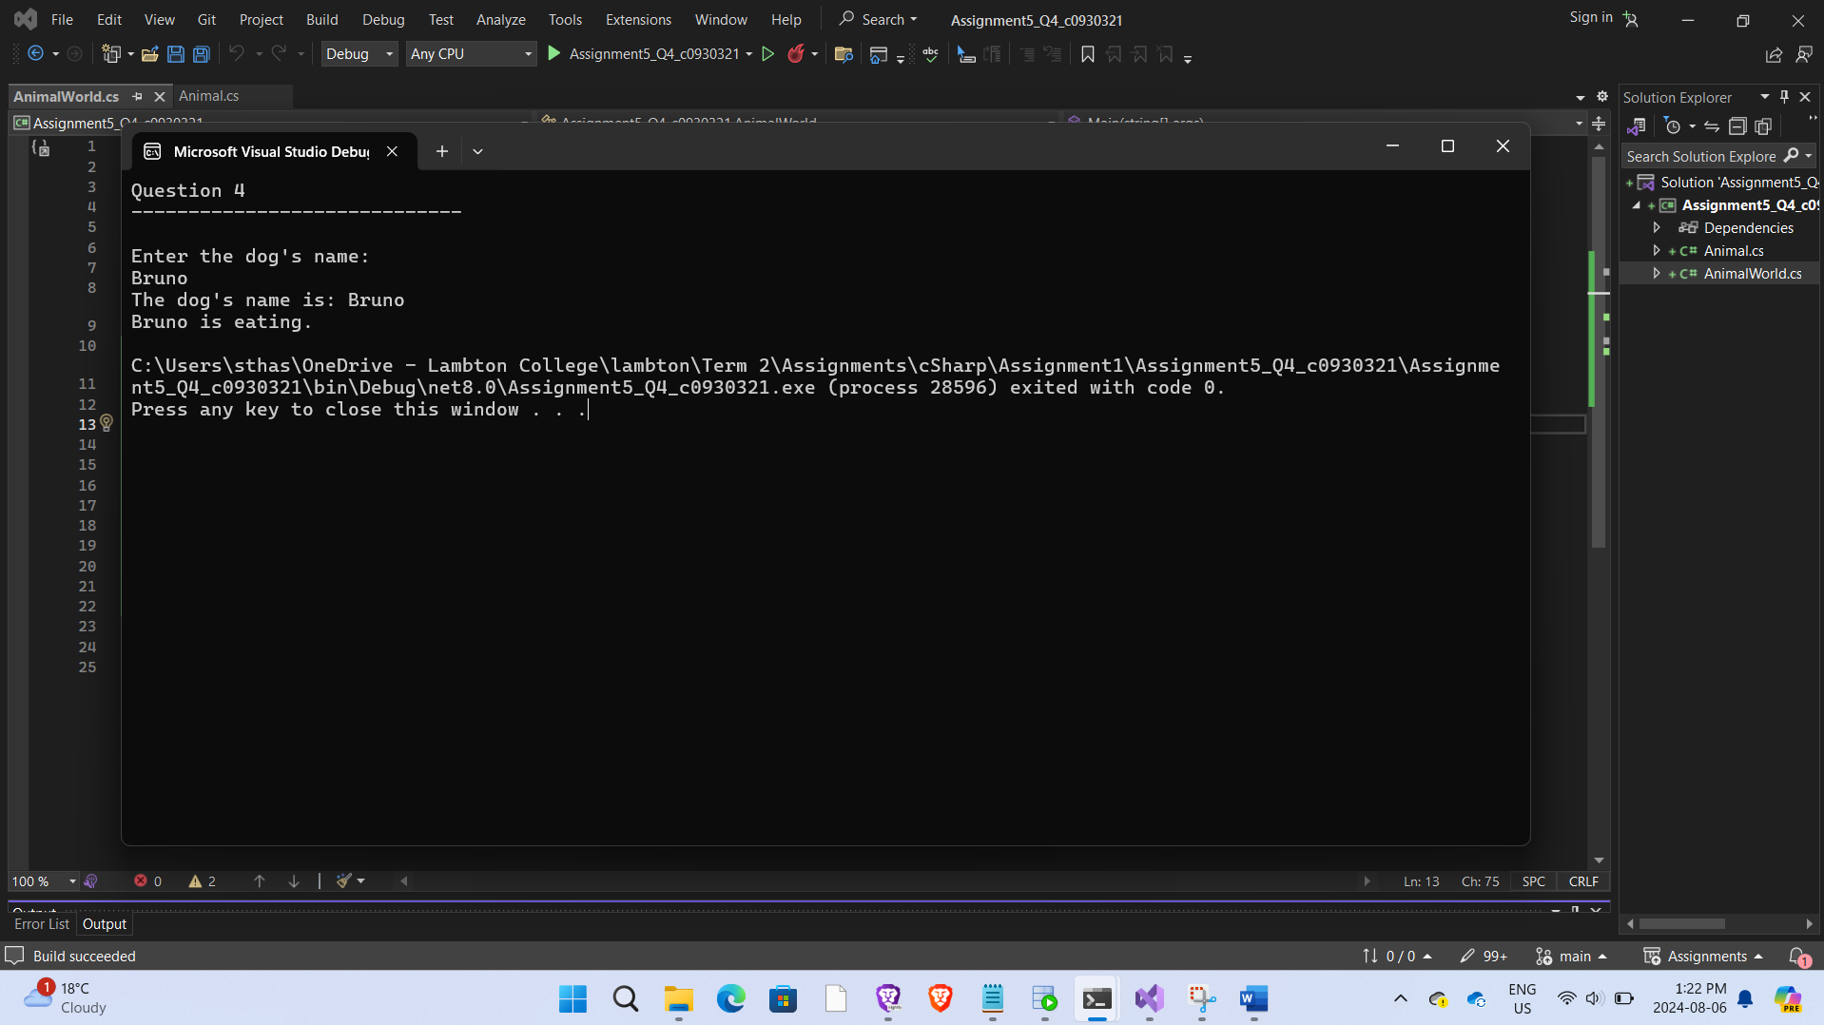

# Question 5:

## # Code:

using System;

namespace Assignment5_Q5_c0930321

{

internal class Student

{

private static double serviceTax = 12.3;

public static double ServiceTax

{

get { return serviceTax; }

set { serviceTax = value; }

}

public int RollNo { get; private set; }

public string Name { get; private set; }

public Course CourseJoined { get; private set; }

public double FeePaid { get; private set; }

public Student(int rollNo, string name, Course course)

{

RollNo = rollNo;

Name = name;

CourseJoined = course;

FeePaid = 0;

}

public void Payment(double amount)

{

FeePaid += amount;

}

public double DueAmount

{

get { return TotalFee - FeePaid; }

}

public double TotalFee

{

get { return CourseJoined.GetTotalFee() * (1 + ServiceTax / 100); }

}

public void Print()

{

Console.WriteLine($"Roll No: {RollNo}\n, Name: {Name}\n, Course: {CourseJoined.Name}\n, Fee Paid: {FeePaid:C}\n, Due Amount: {DueAmount:C}\n");

}

}

}

using System;

namespace Assignment5_Q5_c0930321

{

public abstract class Course

{

public string Name { get; private set; }

public int Duration { get; private set; }

public double CourseFee { get; private set; }

public Course(string name, int duration, double courseFee)

{

Name = name;

Duration = duration;

CourseFee = courseFee;

}

public abstract double GetTotalFee();

public virtual void Print()

{

Console.WriteLine($"Course: {Name}, Duration: {Duration} months, Course Fee: {CourseFee:C}\n");

}

}

class PartTimeCourse : Course

{

public string Timing { get; private set; }

public PartTimeCourse(string name, int duration, double courseFee, string timing)

: base(name, duration, courseFee)

{

Timing = timing;

}

public override double GetTotalFee()

{

return CourseFee * 0.9;

}

public override void Print()

{

base.Print();

Console.WriteLine($"Timing: {Timing}");

}

}

class OnsiteCourse : Course

{

public string CompanyName { get; private set; }

public int NumberOfCandidates { get; private set; }

public OnsiteCourse(string name, int duration, double courseFee, string companyName, int numberOfCandidates)

: base(name, duration, courseFee)

{

CompanyName = companyName;

NumberOfCandidates = numberOfCandidates;

}

public override double GetTotalFee()

{

return CourseFee * 1.1;

}

public override void Print()

{

base.Print();

Console.WriteLine($"Company: {CompanyName},\n Number of Candidates: {NumberOfCandidates}\n");

}

}

}

using System;

namespace Assignment5_Q5_c0930321

{

internal class StudentCourseMgmt

{

static void Main(string[] args)

{

Console.WriteLine("Question 5\n Student Course Management\n-----------------------------------\n");

// Creating courses

Course csharpCourse = new PartTimeCourse("C#", 6, 2000, "Evening");

Course aspNetCourse = new OnsiteCourse("ASP.NET", 4, 3000, "ABC Corp", 10);

Course pythonCourse = new PartTimeCourse("Python", 5, 1500, "Morning");

// Creating students

Student student1 = new Student(1, "Alish", csharpCourse);

Student student2 = new Student(2, "Alishma", aspNetCourse);

Student student3 = new Student(3, "Karishma", pythonCourse);

// Simulate payments flow

student1.Payment(500);

student2.Payment(1000);

student3.Payment(1500);

// Printing student details

student1.Print();

student2.Print();

student3.Print();

// Printing course details

csharpCourse.Print();

aspNetCourse.Print();

pythonCourse.Print();

}

}

}

## # Output Screenshot:

