**Database Programming - CSD 4203**

**Practical Exercise #1 – 2024S**

**Student ID : C0930321**

**Student Name : Shreejana Shrestha**

**----------------------------------------------------------------------------------------------------------------**

1. Create a copy of the table employee (New table name is employees_copy)

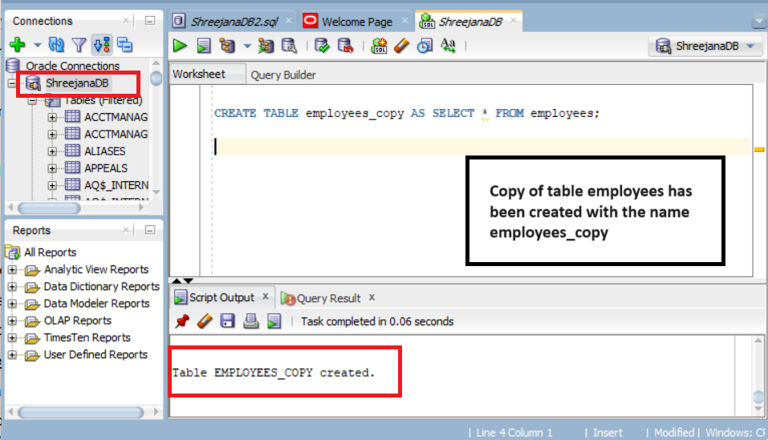

2. Write anonymous block to display FirstName and Salary of employee number 110 (use %TYPE)

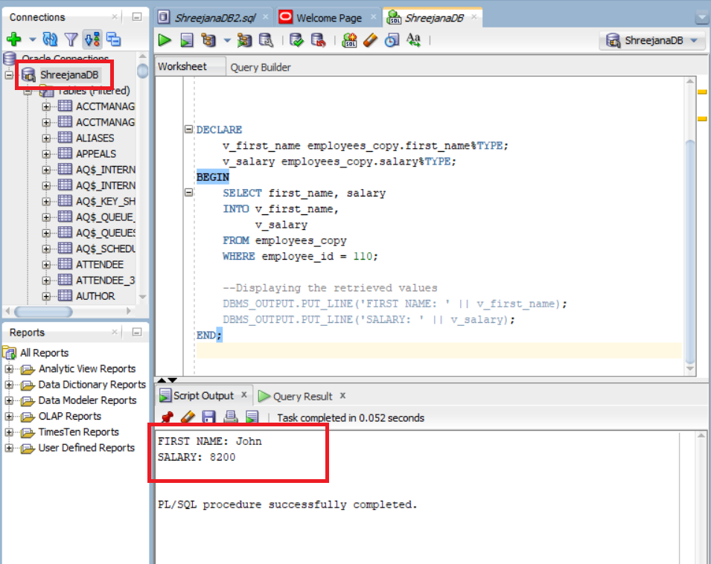

3.Write anonymous block to display average salary of all employees (use %TYPE)

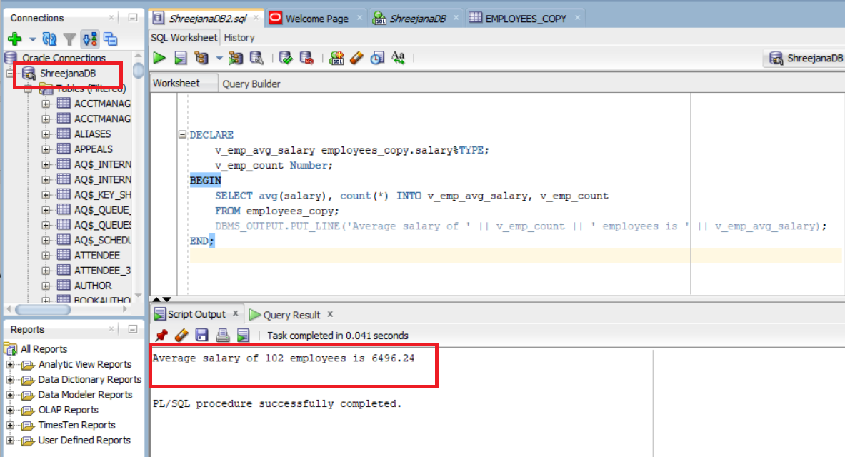

4.What is the difference between %ROWTYPE and %TYPE?

%TYPE and %ROWTYPE are the attributes in oracle PL/SQL. They are used to declare variables that inherit the data types of existing database objects. These attributes help to enhance code consistency and flexibility. Some of the differences between these attributes are given below:

|  |  |  |
| --- | --- | --- |
| S.N | %TYPE | %ROWTYPE |
| 1. | It declares a variable with the same data type and size that represents a database column | It declares a variable of type record that represents either a full or partial row of a database or view. |
| 2. | It focuses on single columns | It focuses on complete rows |
| 3. | It is best used for procedures and functions where individual column values are processed. | It is best used for cursors where entire roes are fetched and processed. |
| 4. | It automatically adapts to changes in the data type of the referenced column. | It automatically adapts to changes in the structure of the referenced table or cursor. |