**Web Technologies II**

**Student ID : c0930321**

**Student Name : Shreejana Shrestha**

**Assignment # 10**

**---------------------------------------------------------------------------------------------------------------------**

# # LocalStorage in JavaScript

# #Screehshots of the output

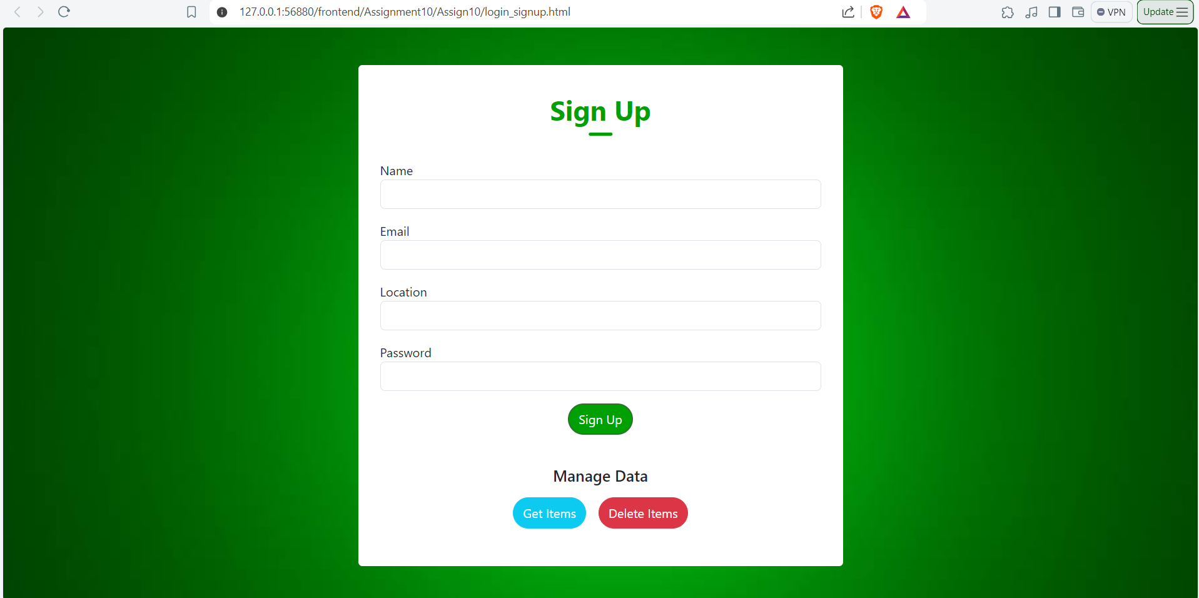

## # Before adding to localStorage

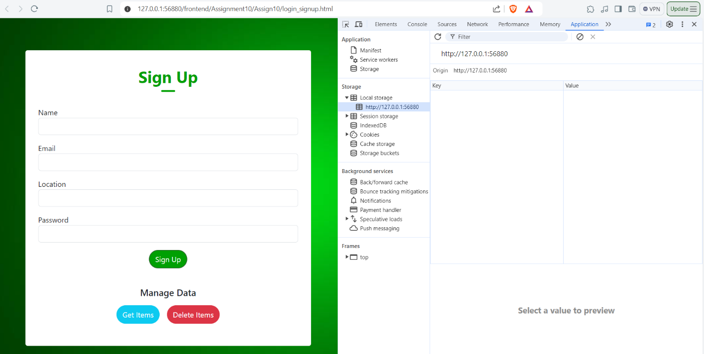

## # Form data stored in localStorage

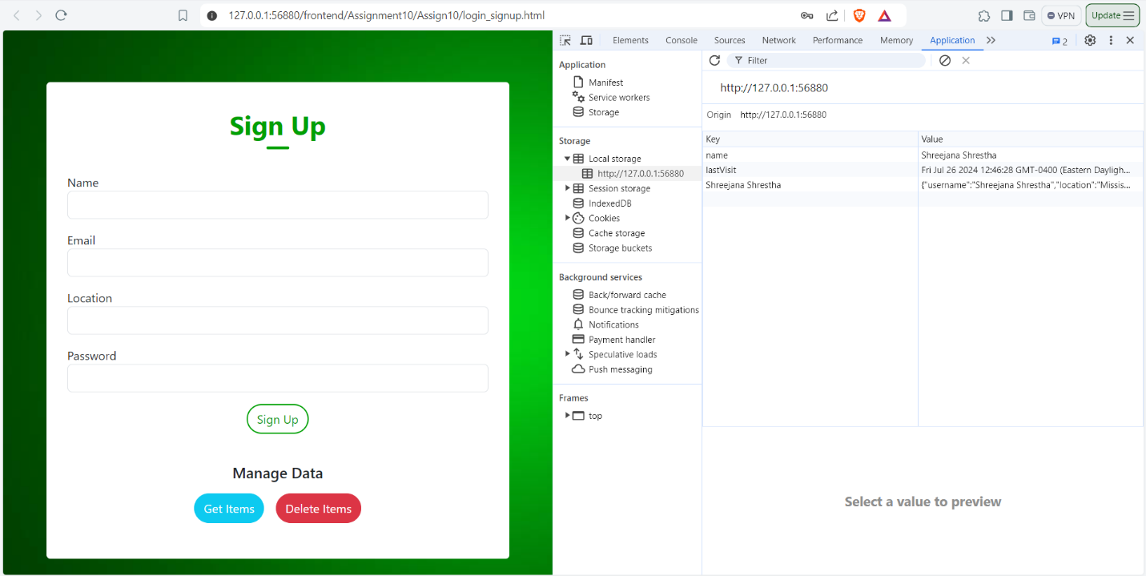

## # Getting the items from localStorage

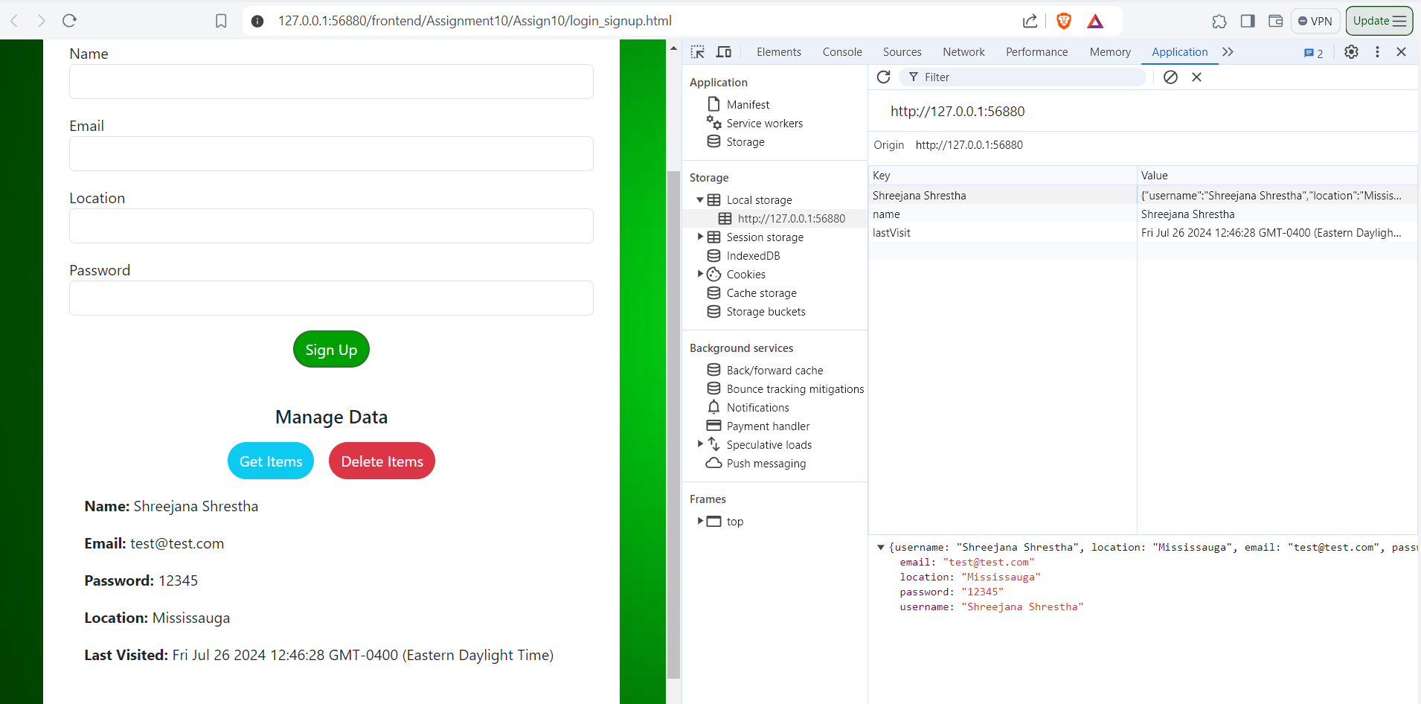

## # Removing the items from localStorage

