**Assignment: 04**

**Student Name : Shreejana Shrestha**

**Student Id : C0930321**

**---------------------------------------------------------------------------------------------------------------------**

# **SECTION – A (writing the statement/s only)**



* **int[] numbers;**



***// ArrayList provides dynamic resizing capabilities, so we are using an array to store exactly 10 Rectangle objects.***

* **Rectangle[] boxes = new Rectangle[10];**



* **double[] grades = {44, 55, 66, 77, 88};**

OR, we can explicitly use decimal points to show the array has double values

* **double[] grades = {44.0, 55.0, 66.0, 77.0, 88.0};**



*// fifth position is denoted by the index no. 4 in array*

* **numbers[4] = 13;**



* **System.out.println("Value of the third position of array ” + numbers[2]);**



* **System.out.println(“The total number of elements is ” + numbers.length);**



* **grades[grades.length - 1] = 99;**



* **for(int i = 0; i<10; i++) {**

**scores[i] = i + 1;**

**}**

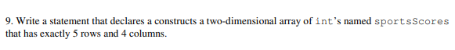

* **int[][] sportsScores = new int[5][4];**

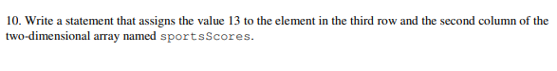

* **sportsScores[2][1] = 13;**

# **SECTION – B (Implement the program and upload the screenshots here with each program)**

1. Test if an array contains a specific value.

1. Find the maximum and minimum value of an array.

1. Copy one array into other array.

