Class Activity:

Reflection on Basic commands:

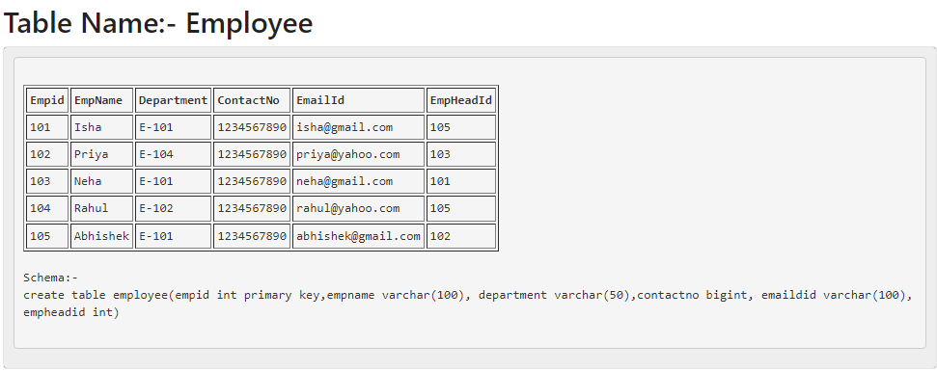

Schema:-

create table employee(empid int primary key,empname varchar(100), department varchar(50),contactno bigint, emaildid varchar(100), empheadid int)

insert into employee values('3','priya', ‘IT’, 6398763456, [priya@gmail.com](mailto:priya@gmail.com), 1005);

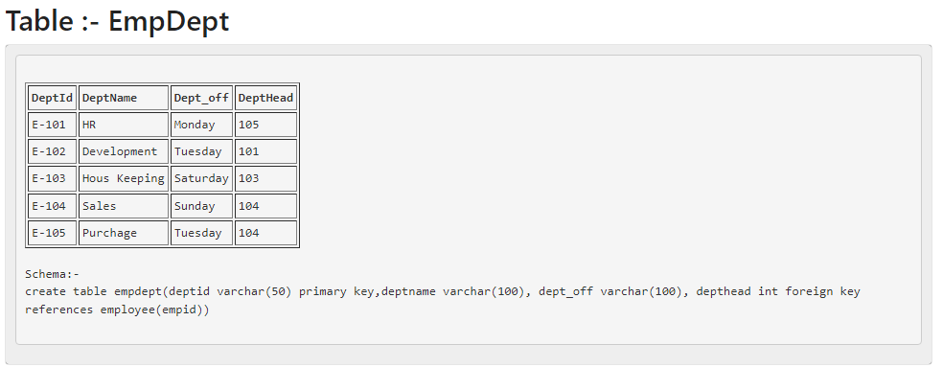

Schema:-

create table empdept(deptid varchar(50) primary key,deptname varchar(100), dept_off varchar(100), depthead int foreign key references employee(empid))

insert into empdept values(101, ‘IT’, ‘Monday’,101)

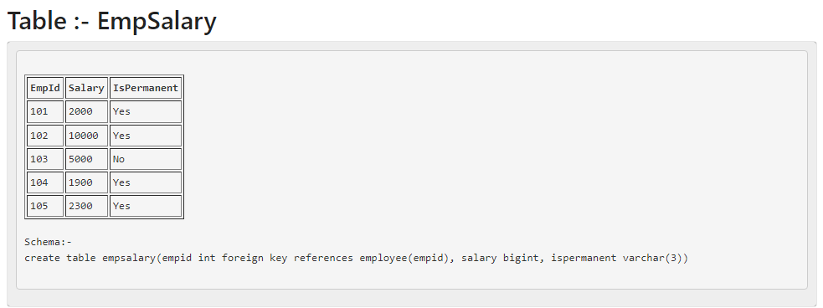

Schema:-

create table empsalary(empid int foreign key references employee(empid), salary bigint, ispermanent varchar(3))

insert into empsalary values(101, 80000, ‘No’)

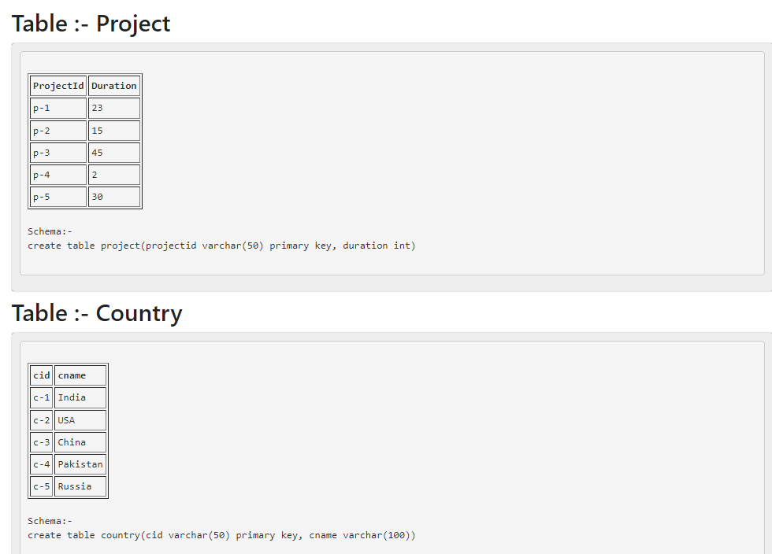

Schema:-

create table project(projectid varchar(50) primary key, duration int)

insert into project values(‘p-12’, 25)

Schema:-

create table country(cid varchar(50) primary key, cname varchar(100))

insert into country values(19, ‘India’)

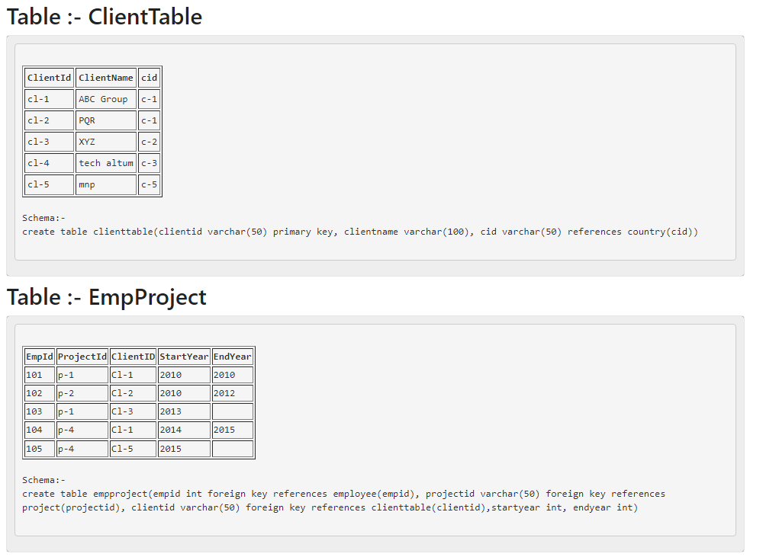

Schema:-

create table clienttable(clientid varchar(50) primary key, clientname varchar(100), cid varchar(50) references country(cid))

insert into clienttable values(102, ‘ABC Group’, ‘c-12’)

Schema:-

create table empproject(empid int foreign key references employee(empid), projectid varchar(50) foreign key references project(projectid), clientid varchar(50) foreign key references clienttable(clientid),startyear int, endyear int)

insert into empproject values(105, ‘p-12’, ‘c-12’,2010,2015)

Queries:-

Simple Queries

1.   Select the detail of the employee whose name start with P.

### 2.   How many permanent candidate take salary more than 5000.

### 3.   Select the detail of employee whose emailId is in gmail.

### 4.   Select the details of the employee who work either for department E-104 or E-102.

### 5.   What is the department name for DeptID E-102?

### 6.  What is total salarythat is paid to permanent employees?

### 7.  List name of all employees whose name ends with a.

### 8.  List the number of department of employees in each project.

### 9.  How many project started in year 2010.

### 10.  How many project started and finished in the same year.

### 11.  select the name of the employee whose name's 3rd charactor is 'h'.

### Nested Queries

### 1.   Select the department name of the company which is assigned to the employee whose employee id is grater 103.

### 2.   Select the name of the employee who is working under Abhishek.

### 3.   Select the name of the employee who is department head of HR.

### 4.   Select the name of the employee head who is permanent.

### 5.   Select the name and email of the Dept Head who is not Permanent.