**CSD 4203 – Database Programming**

**Term : 2023S**

**Student ID : C0930321**

**Student Name : Shreejana Shrestha**

**Assignment # 10**

**----------------------------------------------------------------------------------------------------------------**

# Inventory Management Functions

## Task 1: Table creation and data insertion

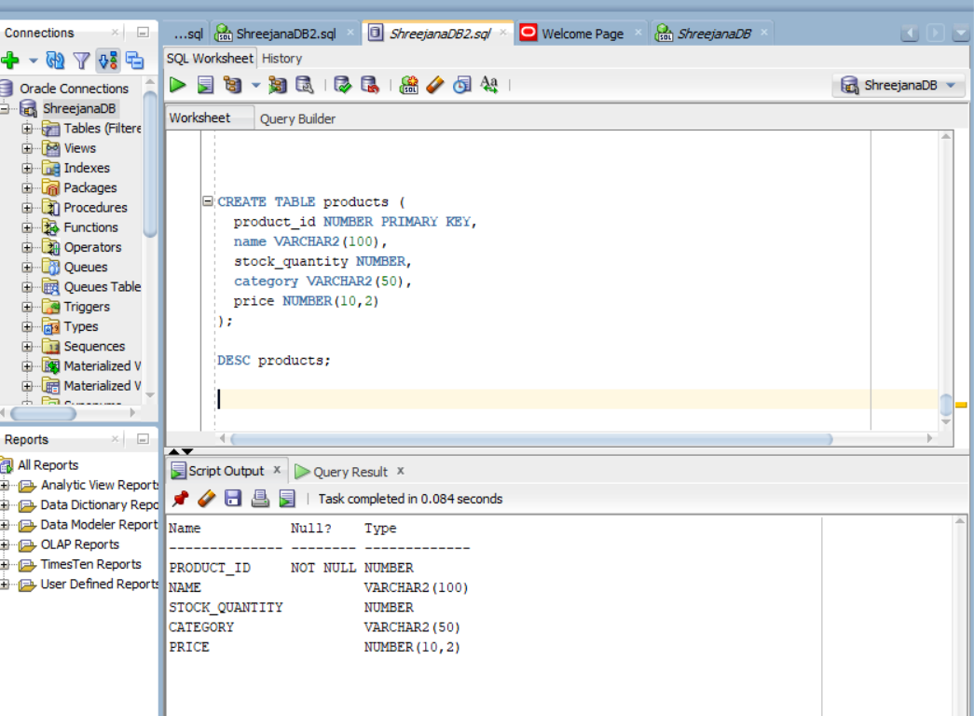

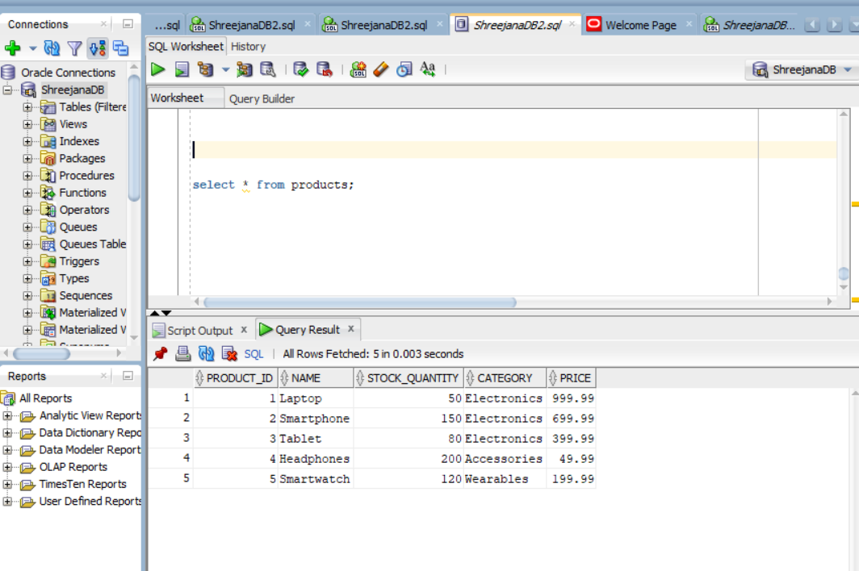

## Task 2: Functions creation

### # check_stock

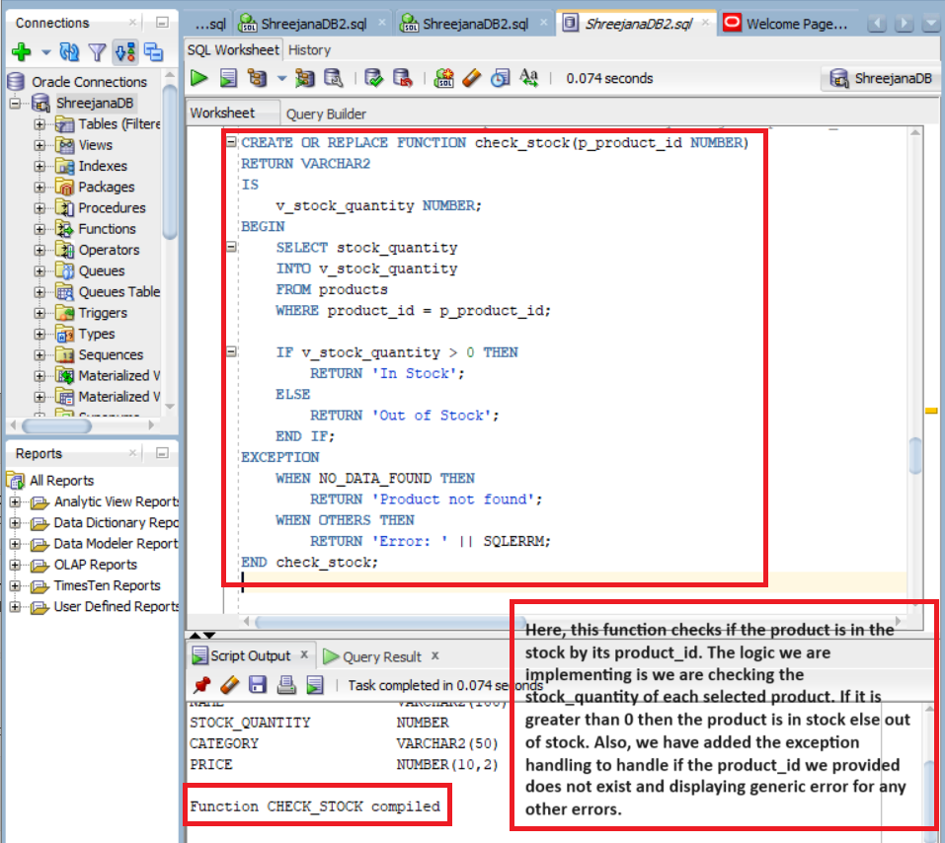

### # reorder_level

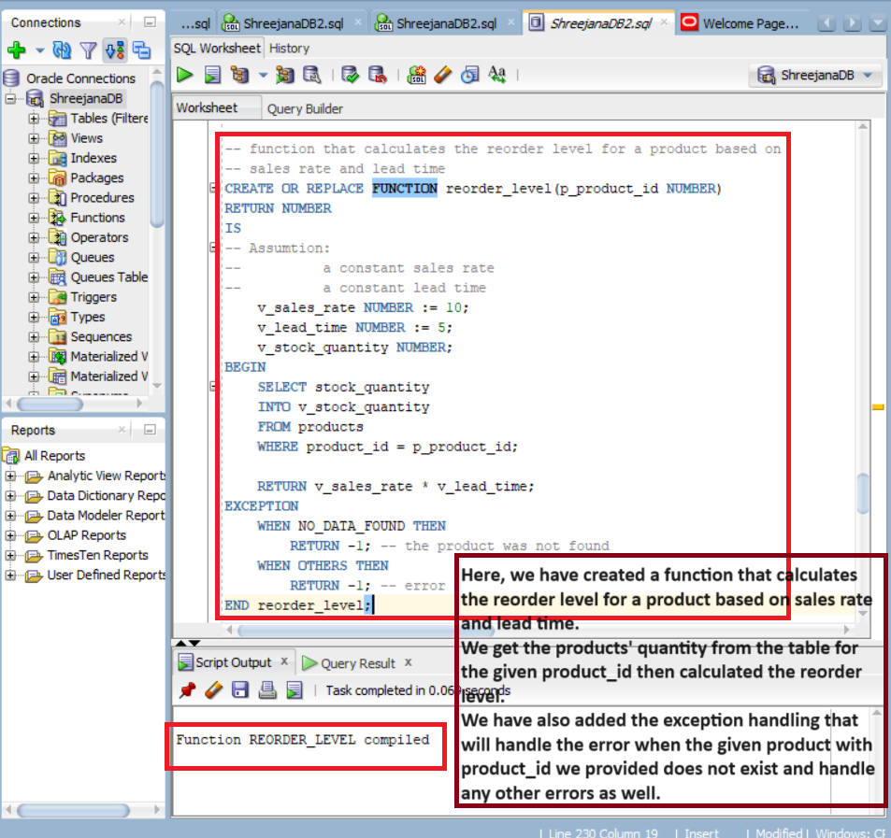

### # format_product_info

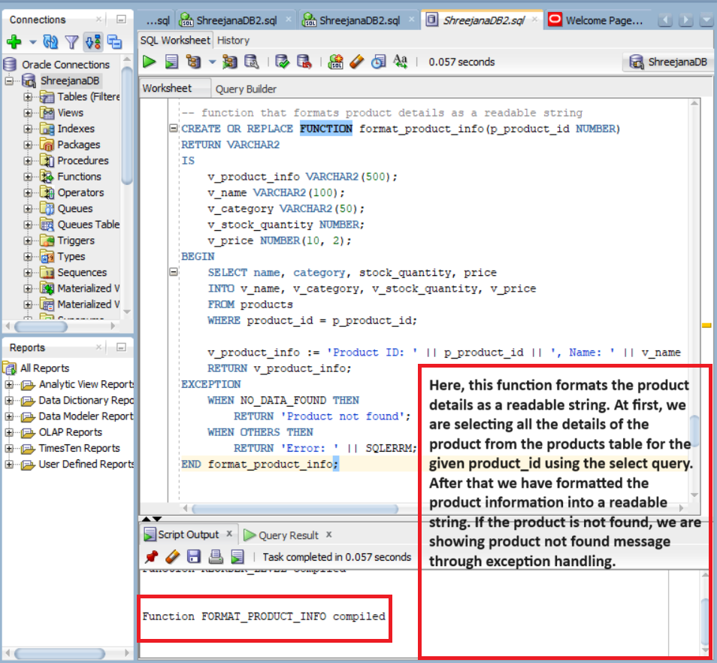

## Task 3: Implementation

### # implementation of check_stock function

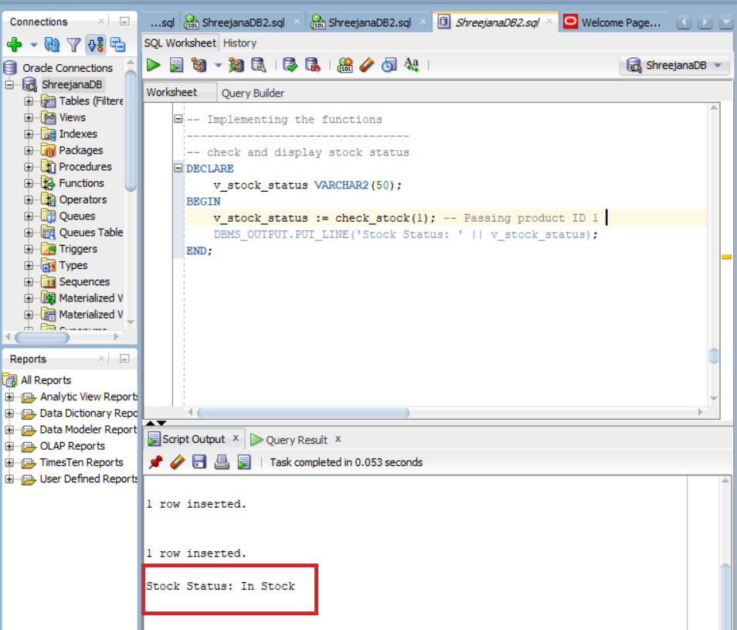

### # Implementation of reorder_level function

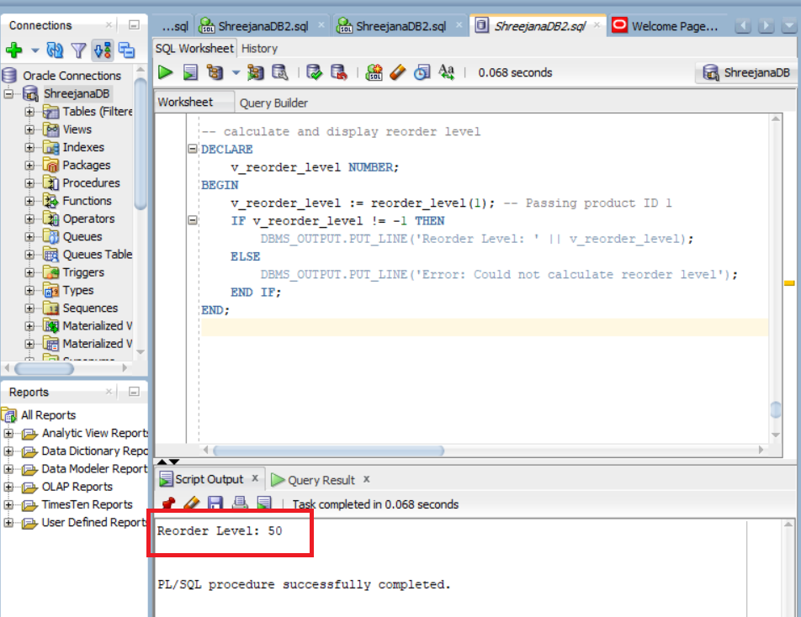

### # Implementation of format_product_info function

