**Database Programming**

**Practical Exercise #5**

**Student Name : Shreejana Shrestha**

**Student Id : C0930321**

**---------------------------------------------------------------------------------------------------------------------**

# # Question 1

# Table Creation

# # Question 2

# Stored Procedure

# Inserting data invoking stored procedure

# # Question 3

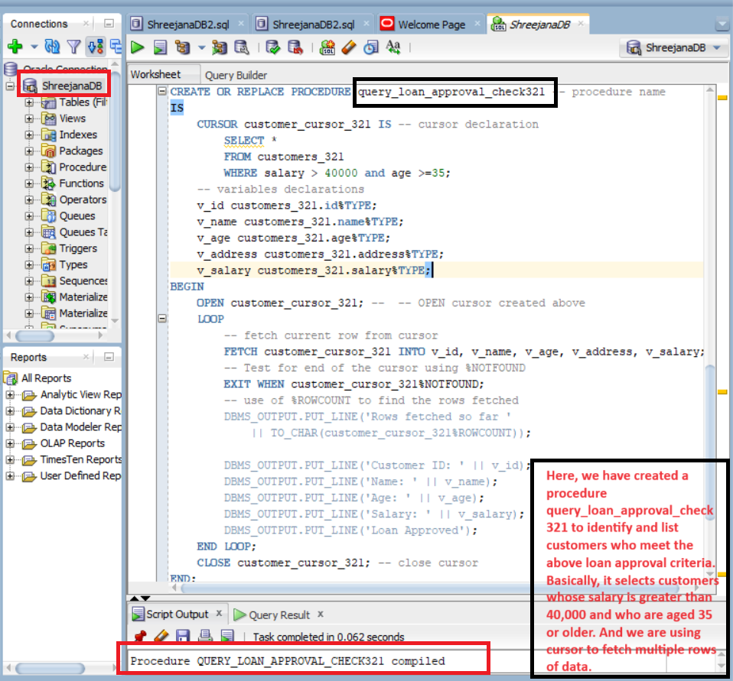

# # execution of loan approval check procedure invoking it

