**Web Technologies II**

**Student ID : C0930321**

**Student Name : Shreejana Shrestha**

**Assignment # 9**

---------------------------------------------------------------------------------------------------------------------

# # Screenshots of the output

Assignment 9

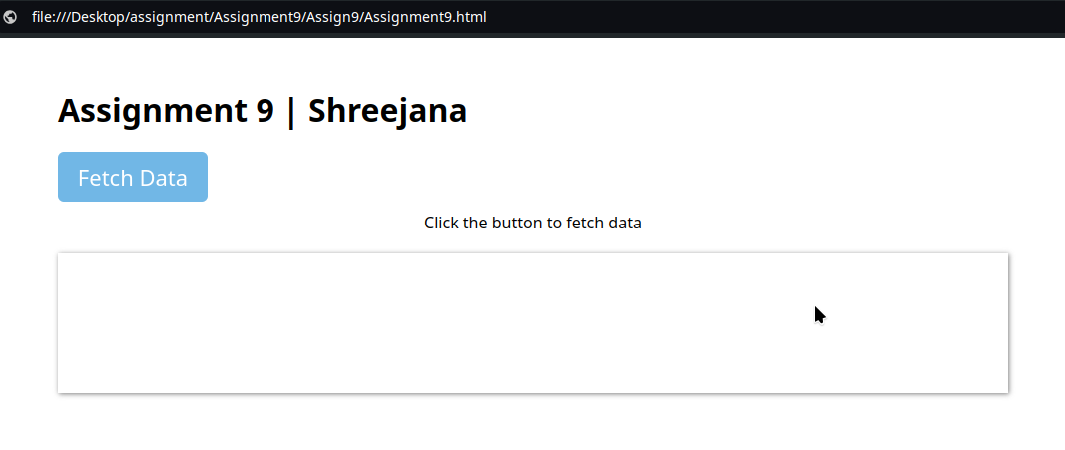

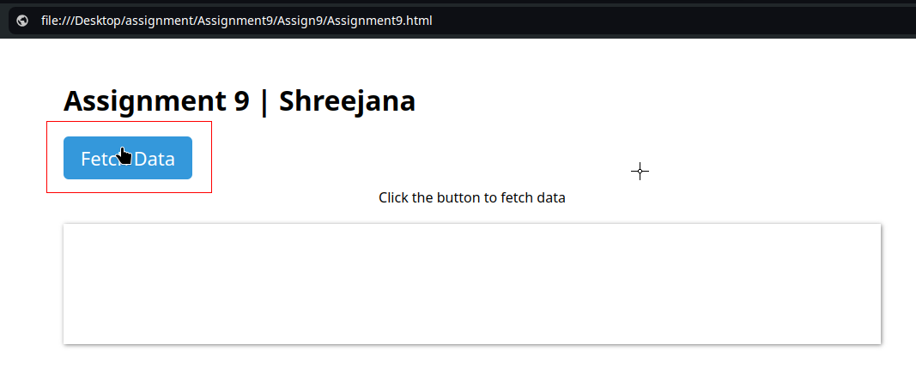

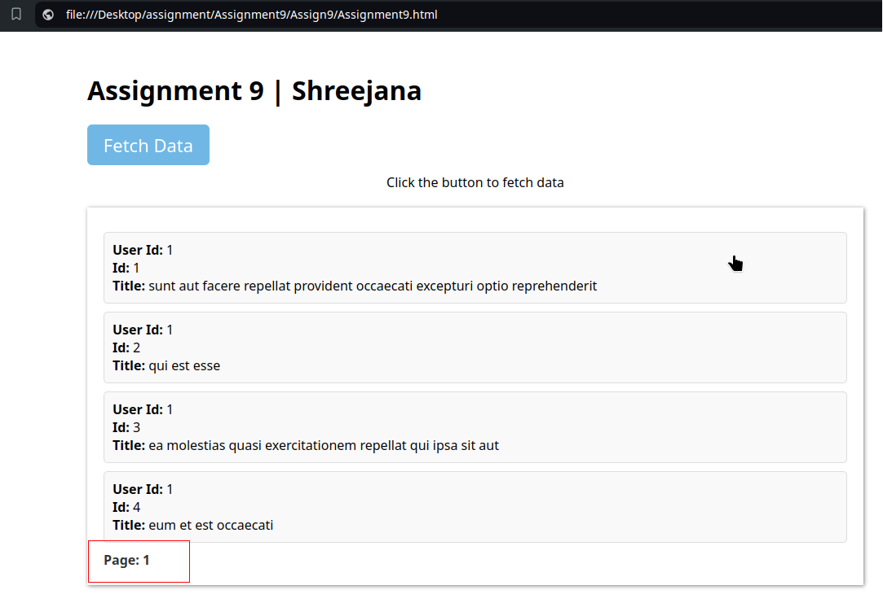

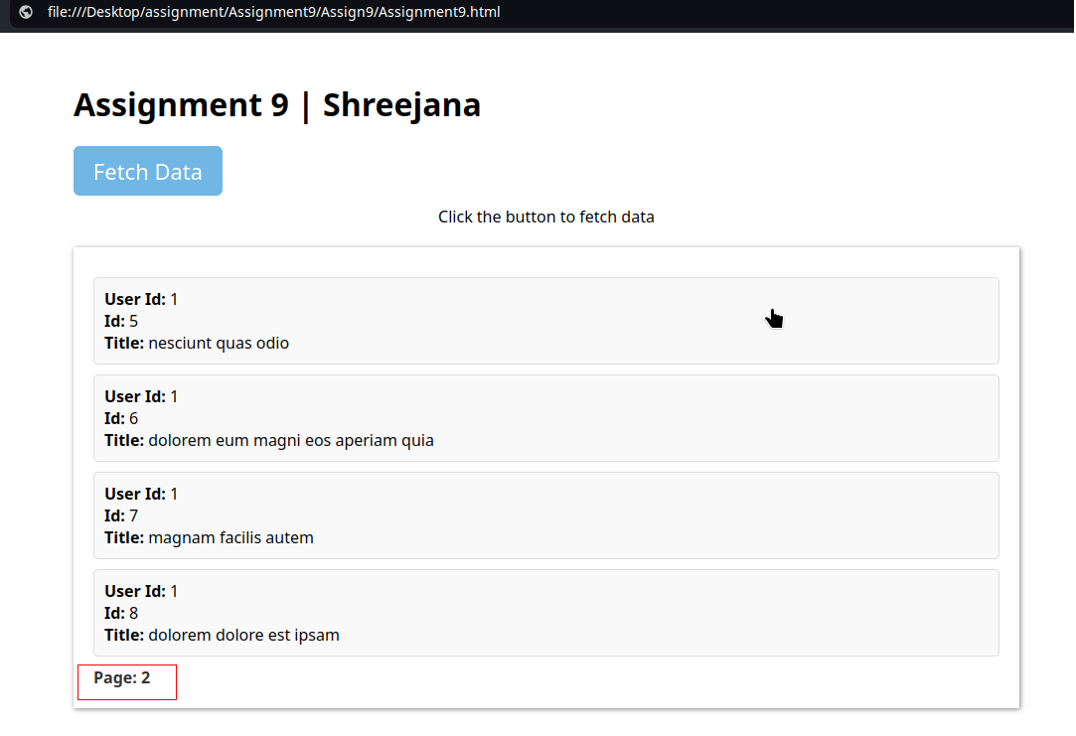

**How Ajax call works**

1. There is a Fetch Data button with the ID `**btnAjaxCall**`. It triggers the `**click`** event handle and the function `**fetchDataAndDisplay`** is called.
2. In the function **fetchDataAndDisplay,** there is a loading indicator. Before making Ajax request, the loading indicator is shown to inform the user that the data is being fetched.
3. The **`$.ajax()`** function is used to make the HTTP request. Inside it, the URL and Method is used.

* URL => https://jsonplaceholder.typicode.com/posts is the endpoint from which data is fetched
* Method => HTTP GET method is used to fetch data which means the data is requested from the server without sending any data to it.

1. Once the data is fetched, the response that has been received is handled. The response has been handled using **Success Callback(`done`).** Once the server responds with data, the **`done`** function is executed.

* Calculate Range: The variables `start` and `end` has been used to determine which records to fetch for the current page.
* Build HTML: The fetched data has been processed and converted into HTML strings, which are them added to the **`display-data`** div.
* Page number: The number is displayed
* Hide Loading Indicator: After the data has been processed, the loading indicator is hidden
* Show Display Data: The display area has been made visible again to show the newly fetched data

1. While fetching the data, if an error with request (e.g network issues) is occurred, the **`fail`** function is executed. An error message will be displayed in the `display-data` area hiding the loading indicator.