**Assignment: 01**

**Student Name : Shreejana Shrestha**

**Student Id : C0930321**

**---------------------------------------------------------------------------------------------------------------------**

# # Question 1

## Source code Screenshot

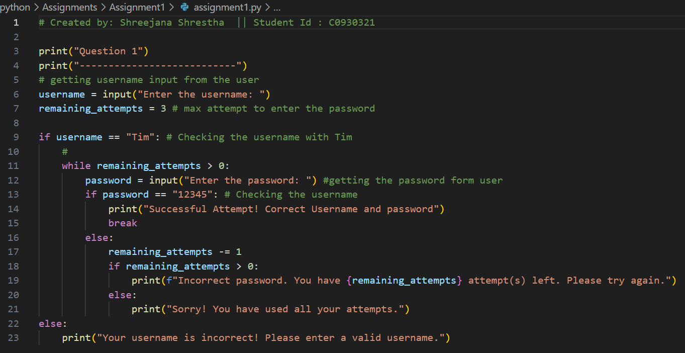

## # output

# # Question 2

## Source code Screenshot

## # Output

