**Course Name: Programming JAVA**

**Course Code: CSD 4464**

**Assignment-1**

**Group A**

**---------------------------------------------------------------------------------------------------------------------**

**1. Dynamic Web Project [GroupAAssignment1] creation with the index.jsp**

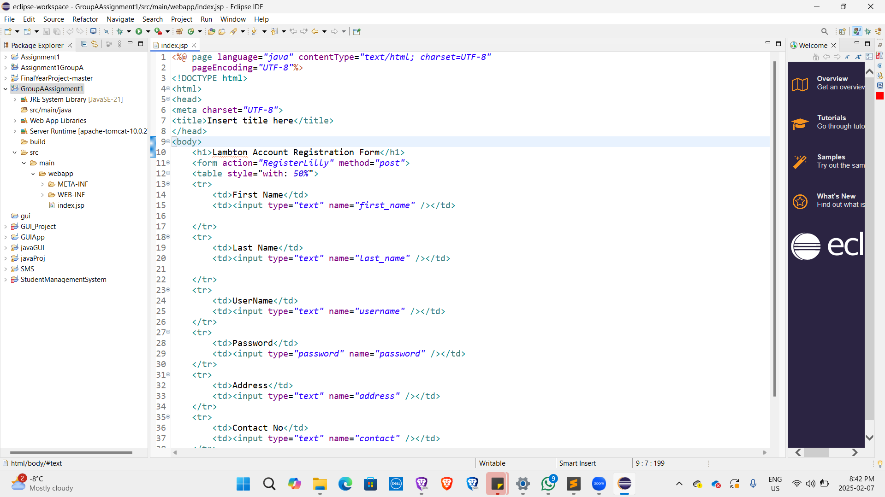

**2. Package Creation [GroupA]**

**3. Servlet Creation [RegisterGroupA] under the package GroupA**

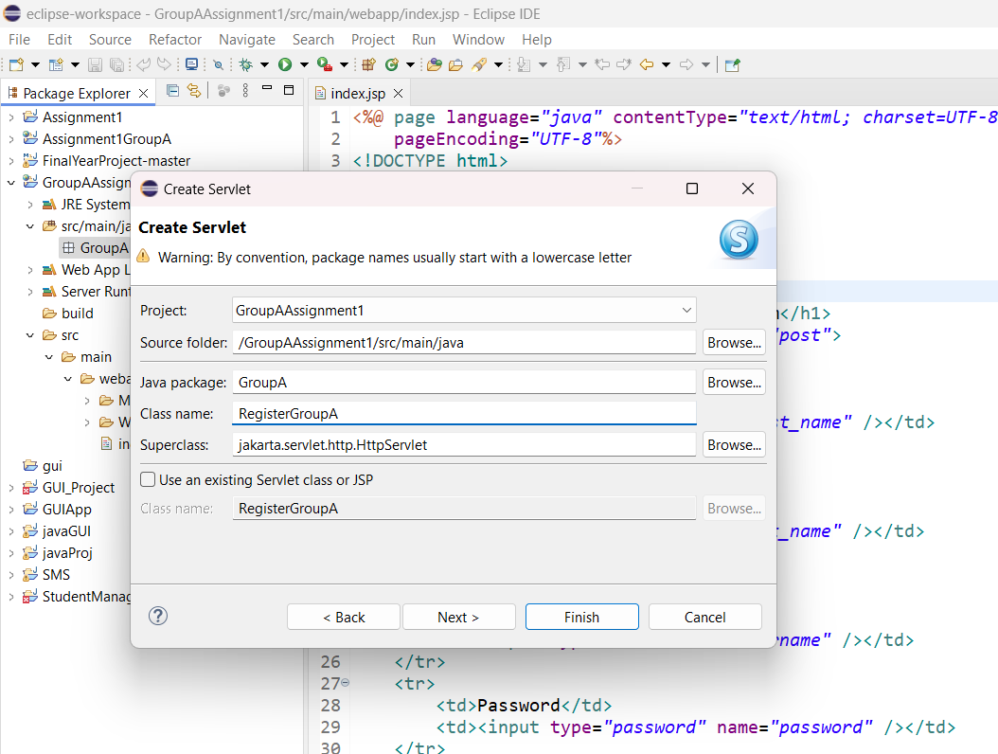

**4. Updated doPost() method in RegisterGroupA servlet**

Here, we imported **RequestDispatcher** from jakarta.servlet

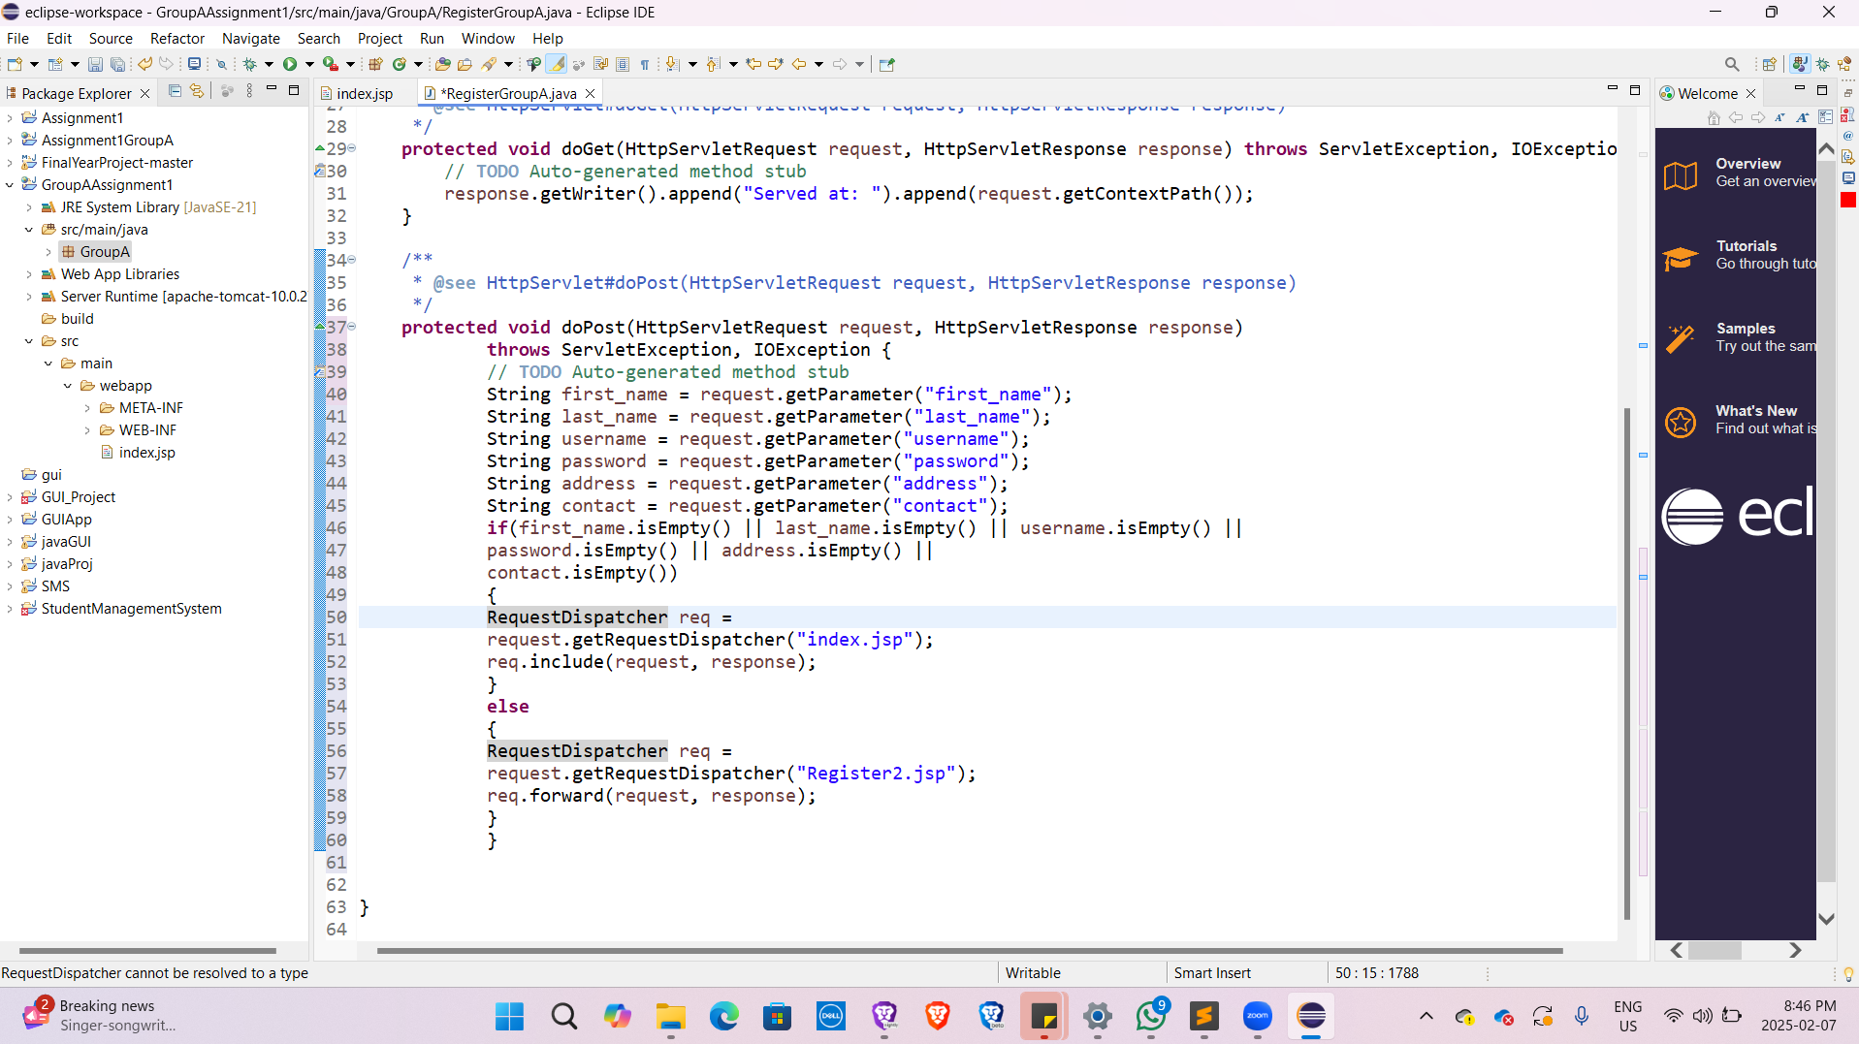

**5. Created Register2.jsp file**

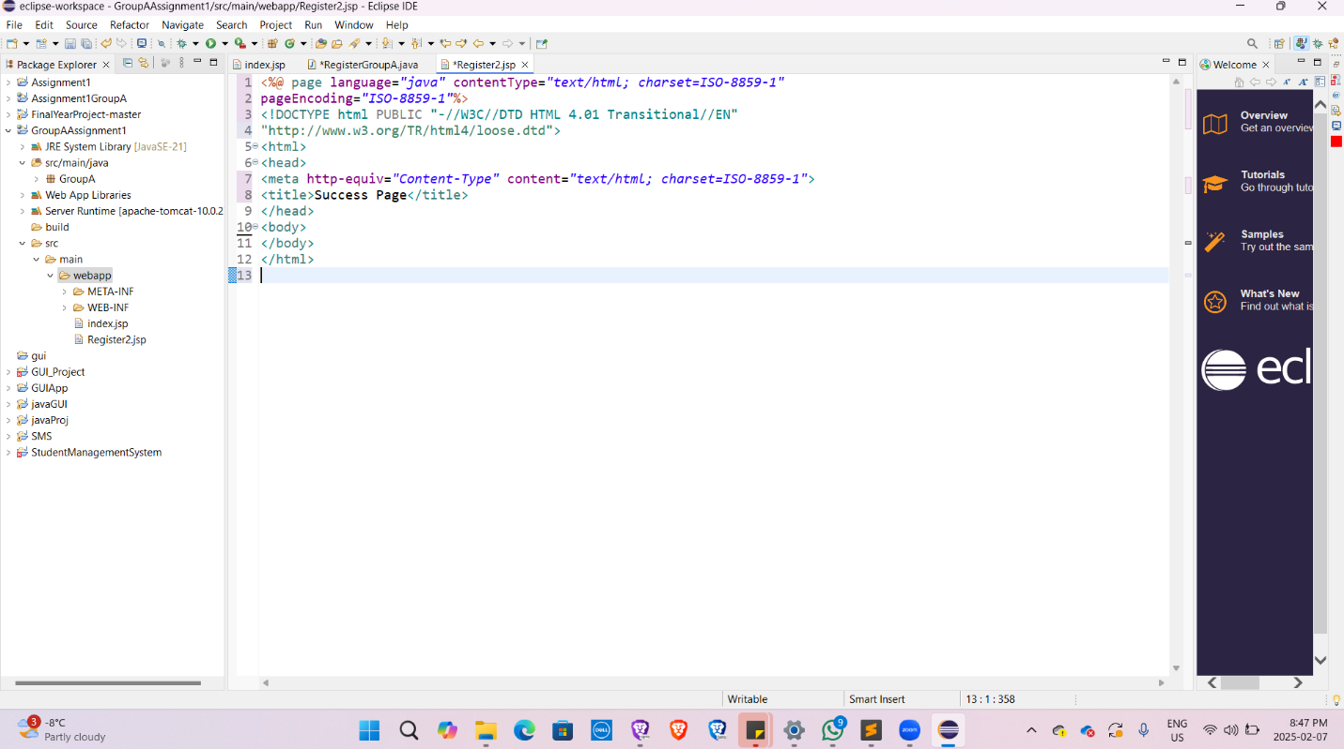

**6. Created Register3.jsp file**

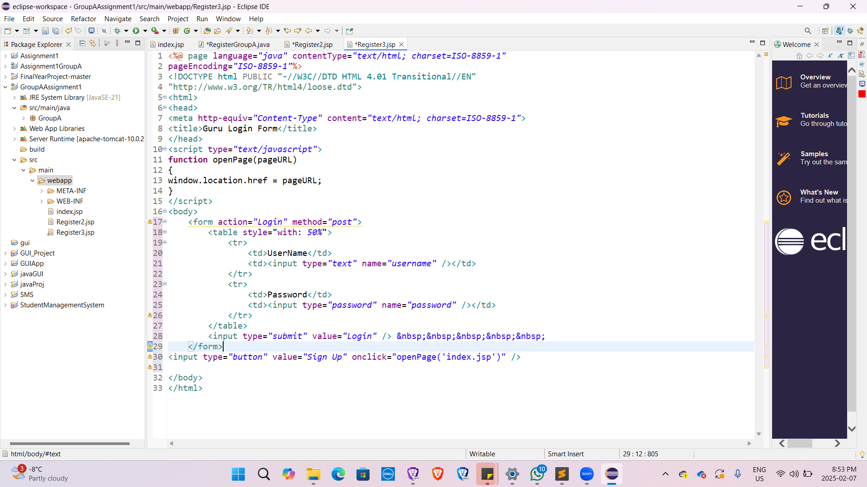

**7. Created Register4.jsp file**

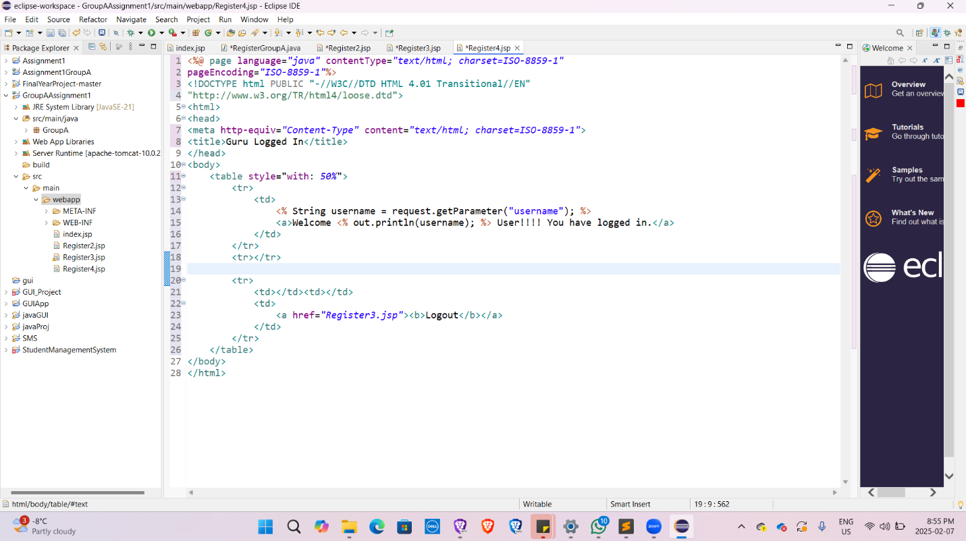

**8. Created Login Servlet and updated the doPost() method and imported RequestDispatcher library**

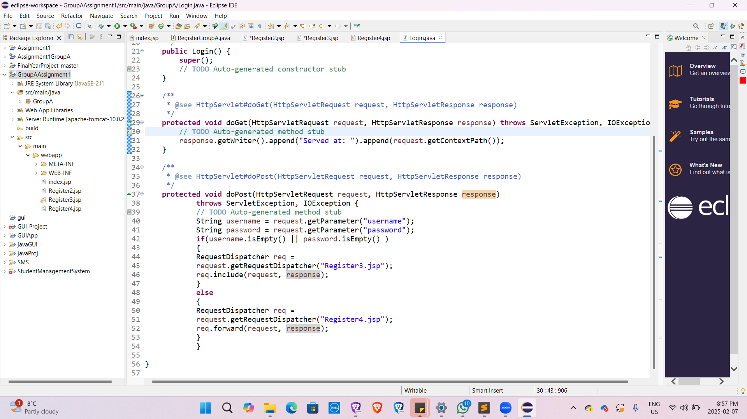

**9. Output after running the Register3.jsp**

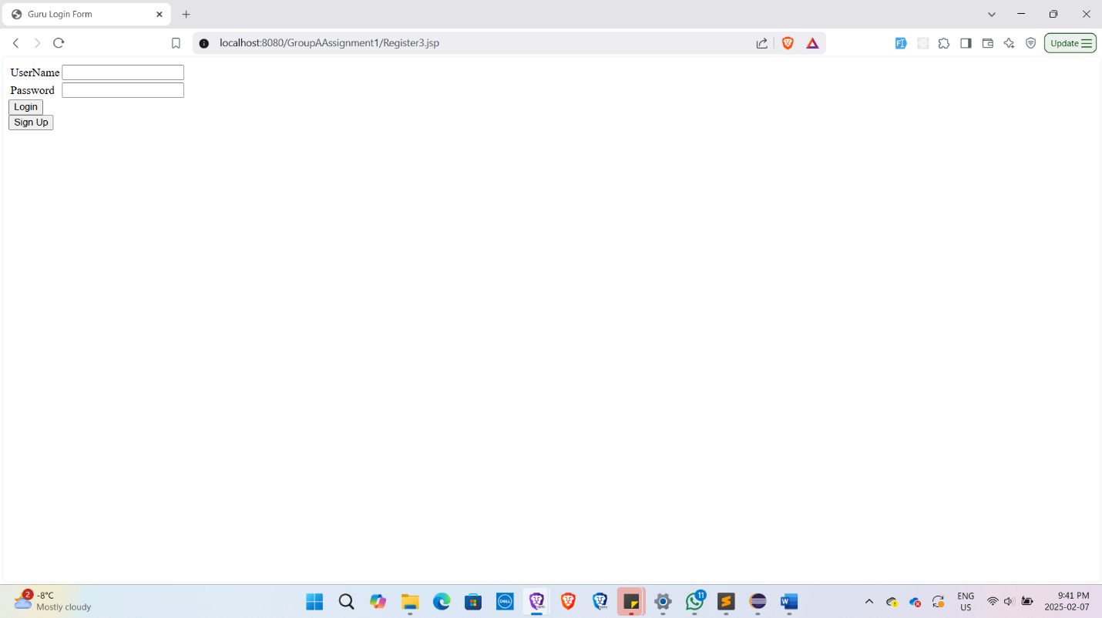

**10. Sign up form**

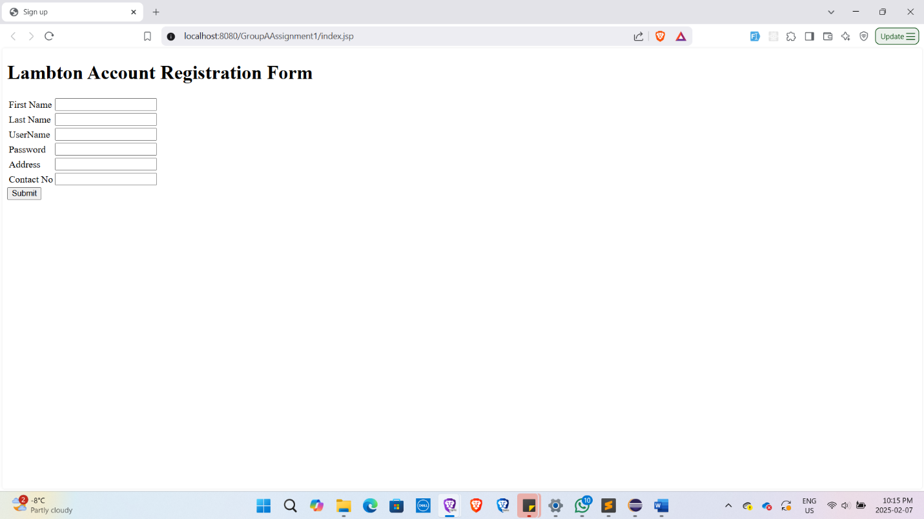

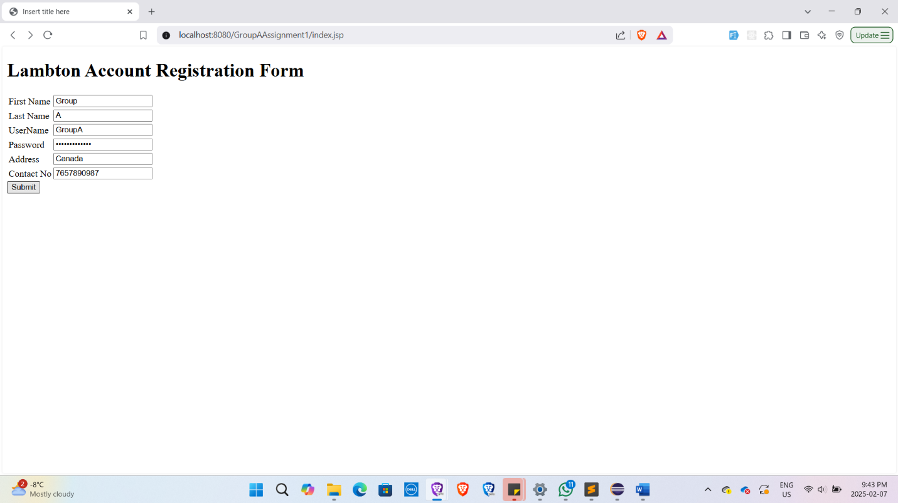

While signing up, we were getting this error at first. In the form action of the sign up form of index.jsp file, it was calling the RegisterLilly, which was not found. We had RegisterGroupA servlet in our project, so we updated the form’s action attribute so that it called RegisterGroupA on click of submit button.

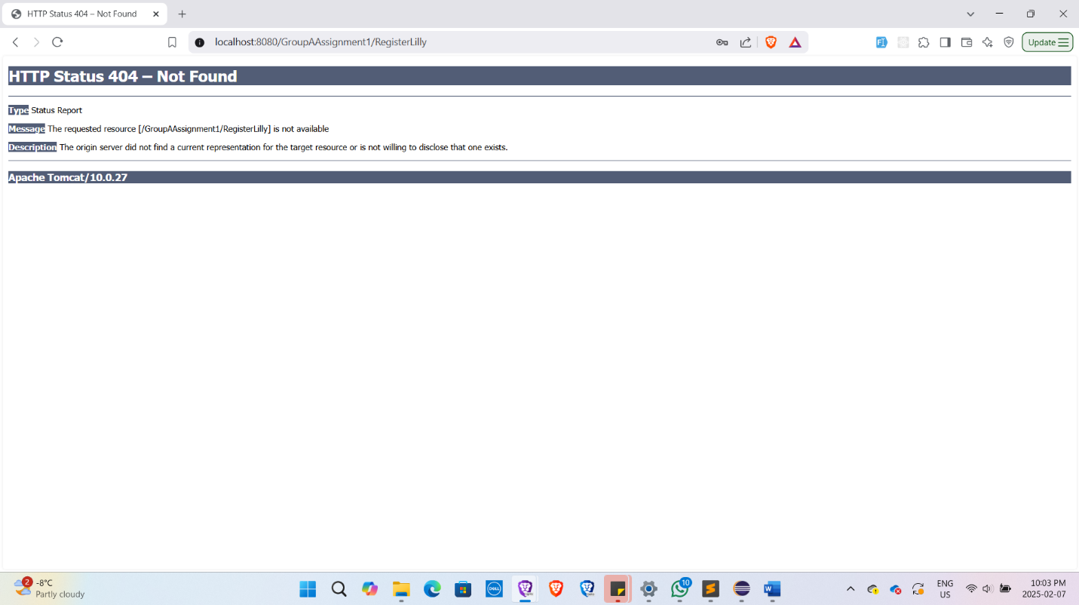

When the sign up was succeed, there was not any message showing up. So, we added a success message after successful sign up.

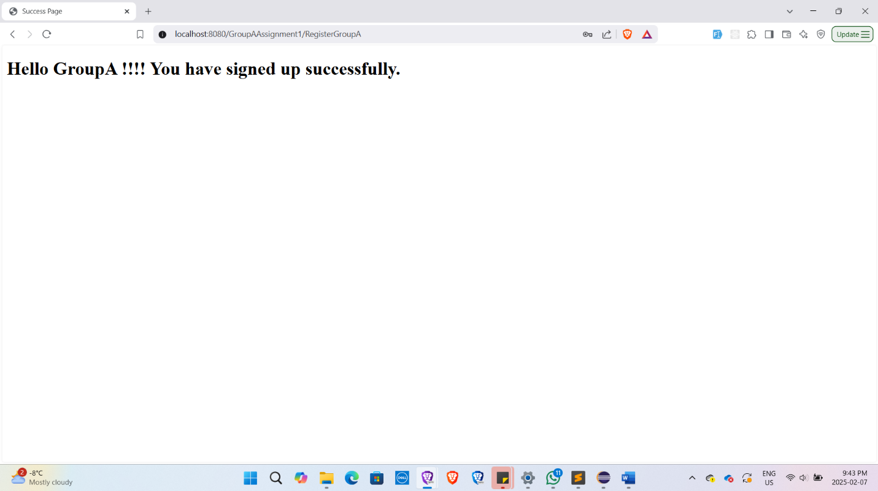

**11. Login form**

