**Term: 2024S FSDM**

**Course: Database Programming**

**Practical Exercise #2**

**Student Name: C0930321**

**Student Number: Shreejana Shrestha**

**---------------------------------------------------------------------------------------------------------------------**

**1. Customer Table creation**

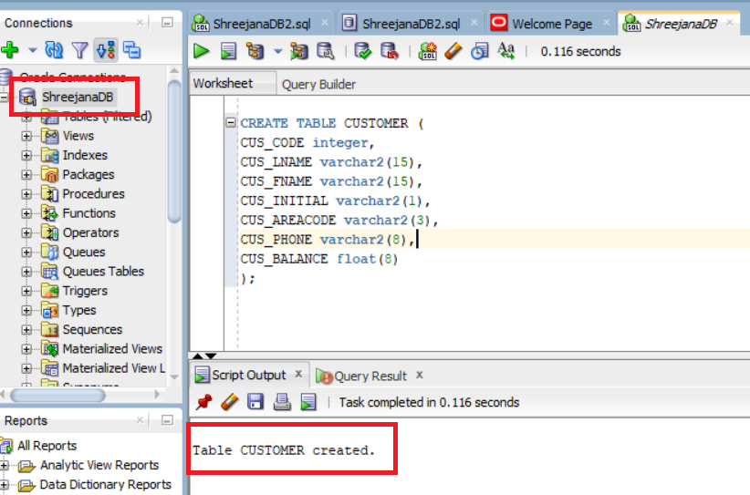

**2. Table data insertion**

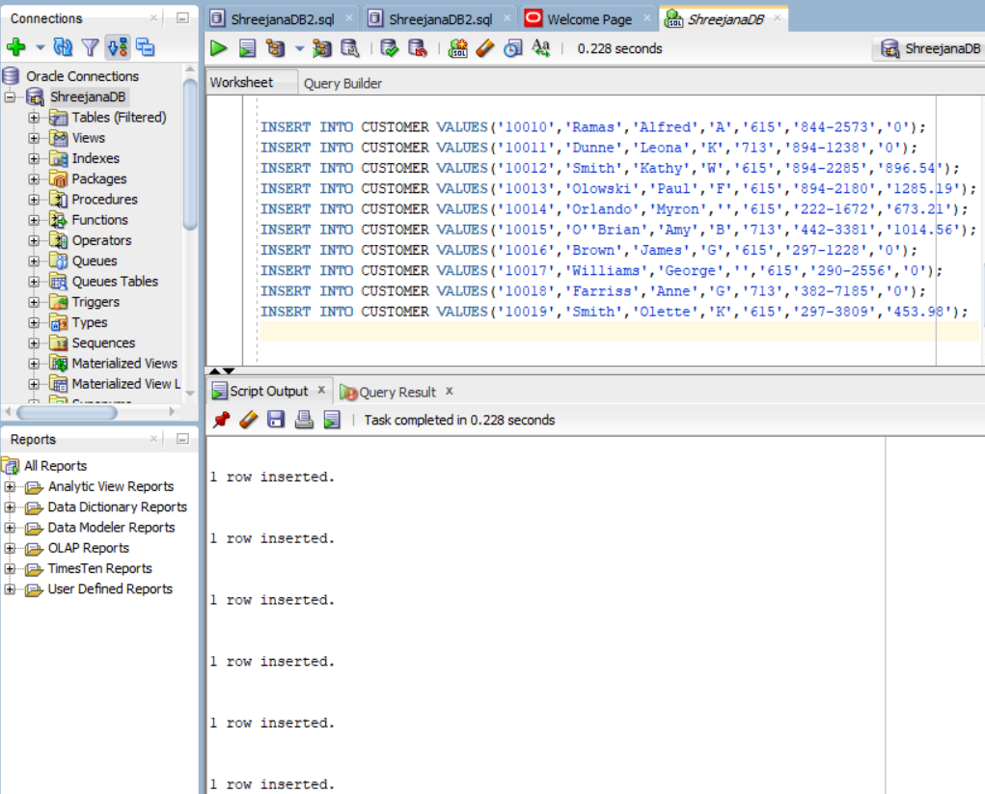

**3. Making copy of CUSTOMER table**

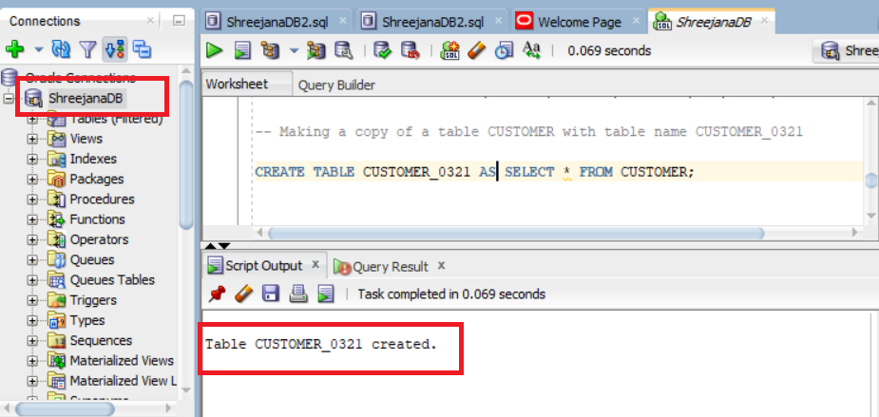

**4. Write a PL/SQL script to demonstrate the use of %TYPE, SELECT INTO using where clause, and display output.**

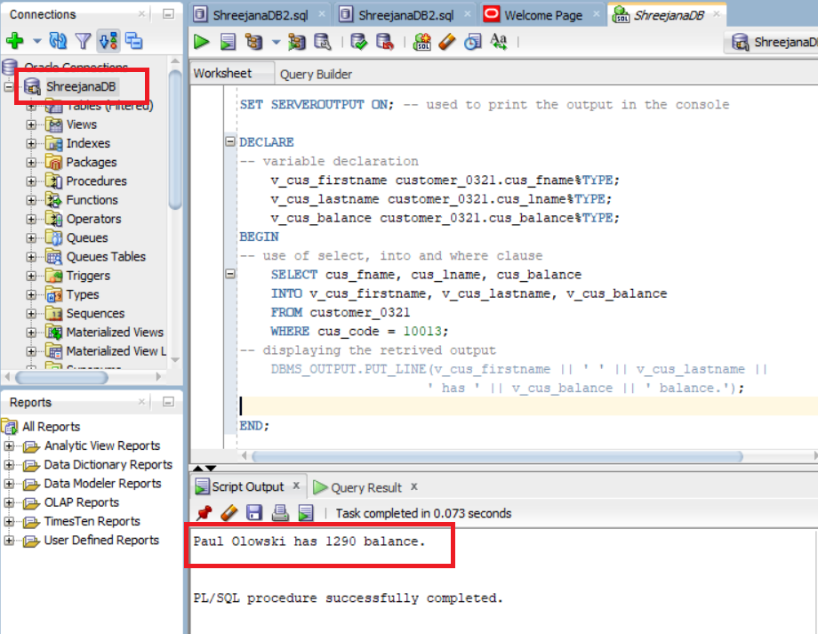

**5. Write a PL/SQL script to demonstrate the error “ no data found”.**

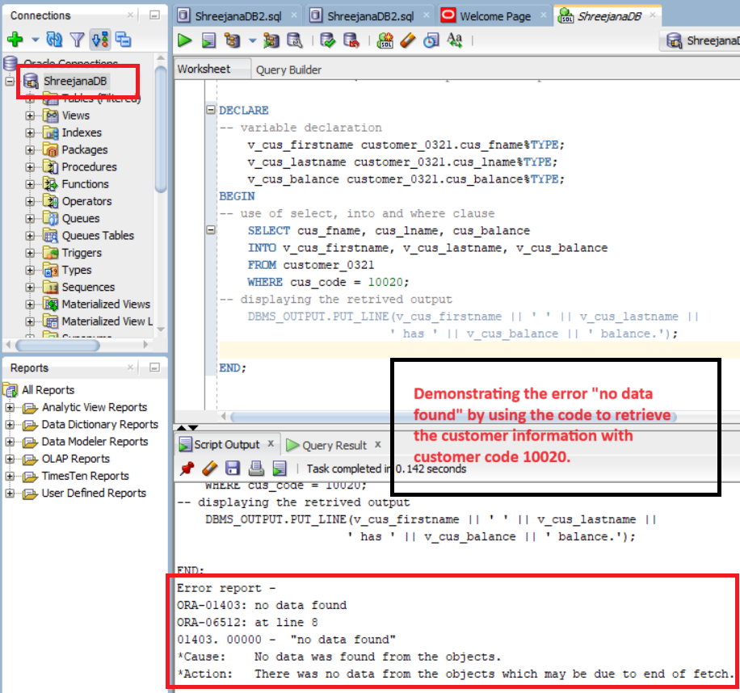

**6. Write a PL/SQL script to demonstrate the error “ multiple rows returned”.**

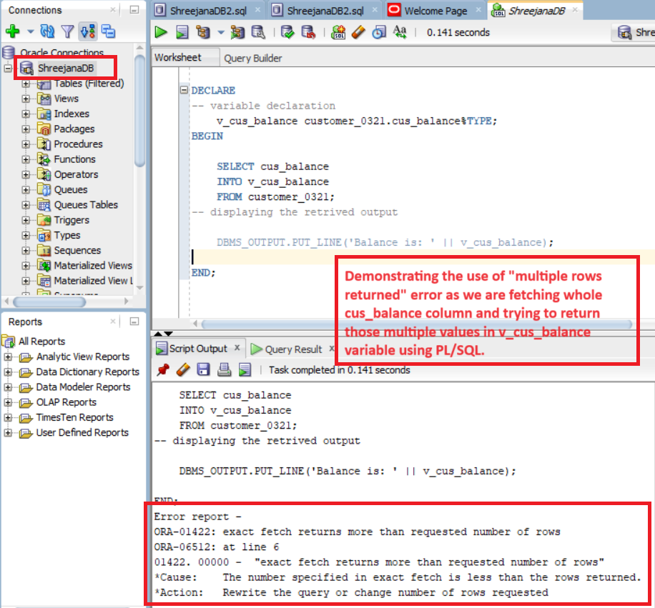

**7. Write a PL/SQL script to demonstrate the use of group function.**

