# # Table creation

# # Inserting the data to the table

# # Question 1: Implicit cursor

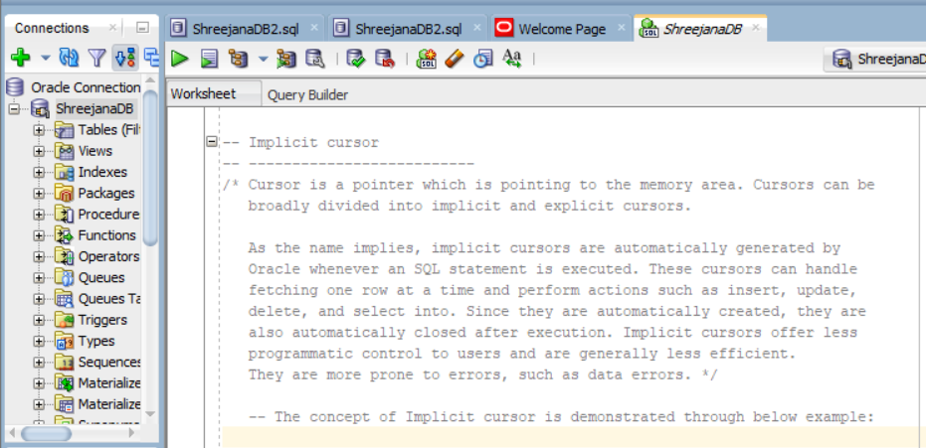

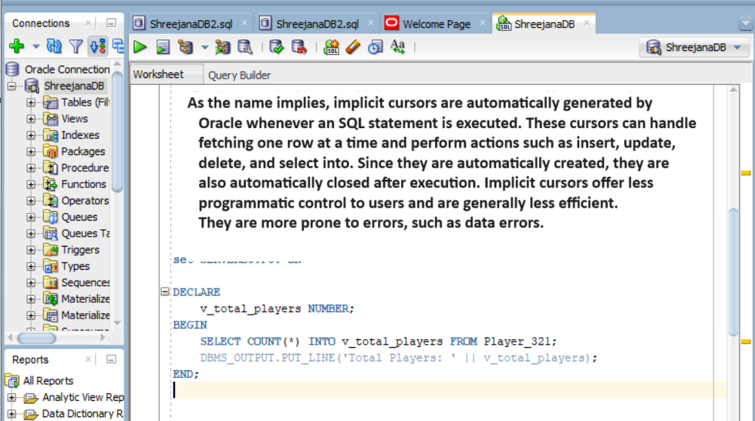

## # code and output

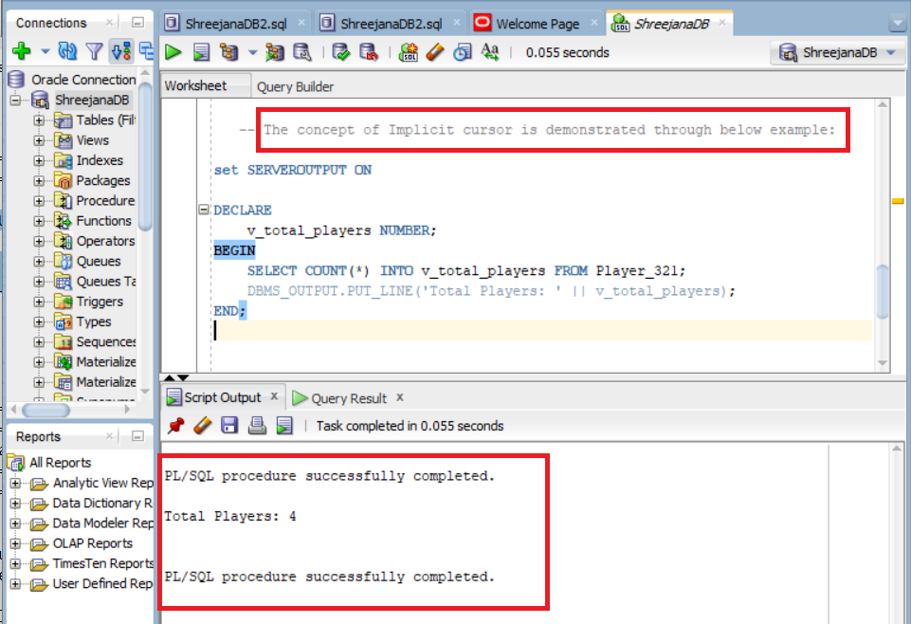

# # Question 2: Explicit Cursor

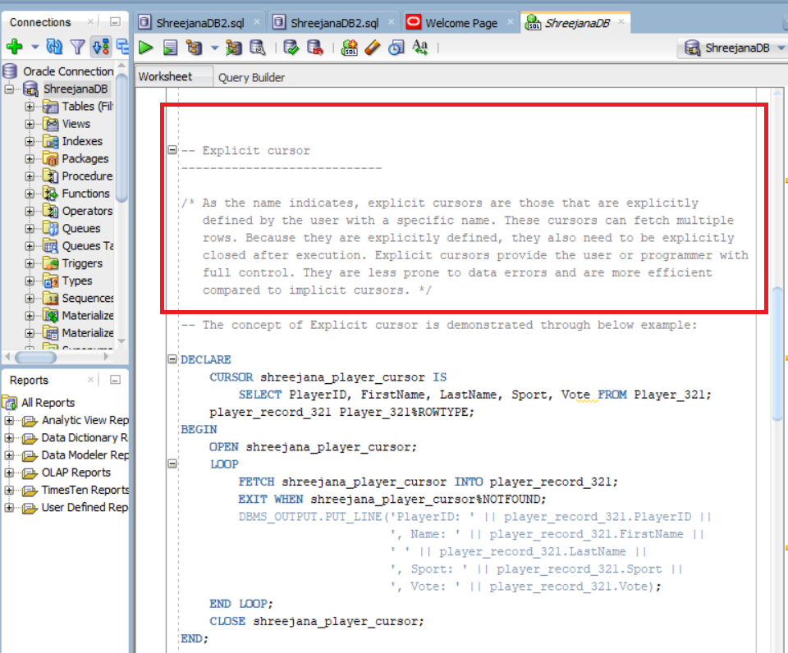

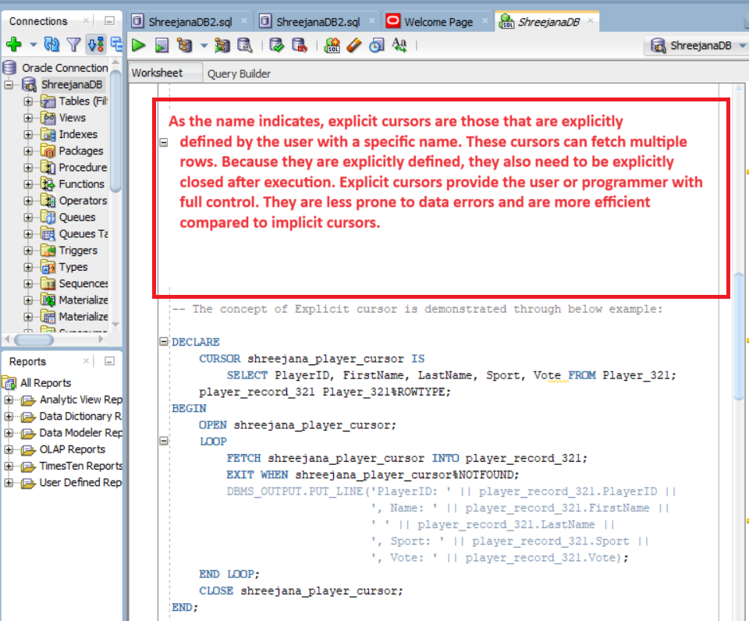

## # code and output

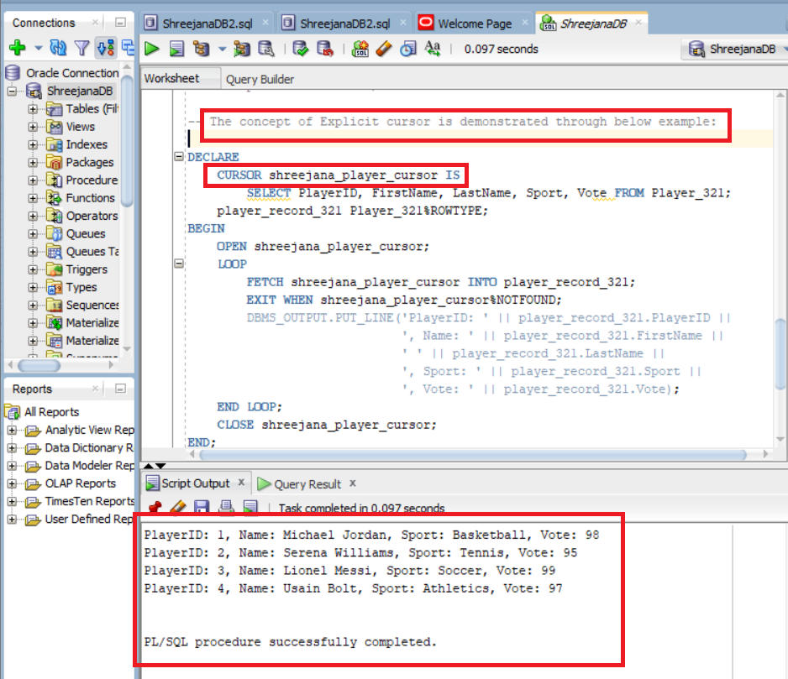

# # Question 3: Cursor Attributes

## # code

## # Output

