**Database Programming**

**Practical Exercise #7**

**Student Name : Shreejana Shrestha**

**Student Id : C0930321**

**---------------------------------------------------------------------------------------------------------------------**

# # Question 1: nested skill_list creation

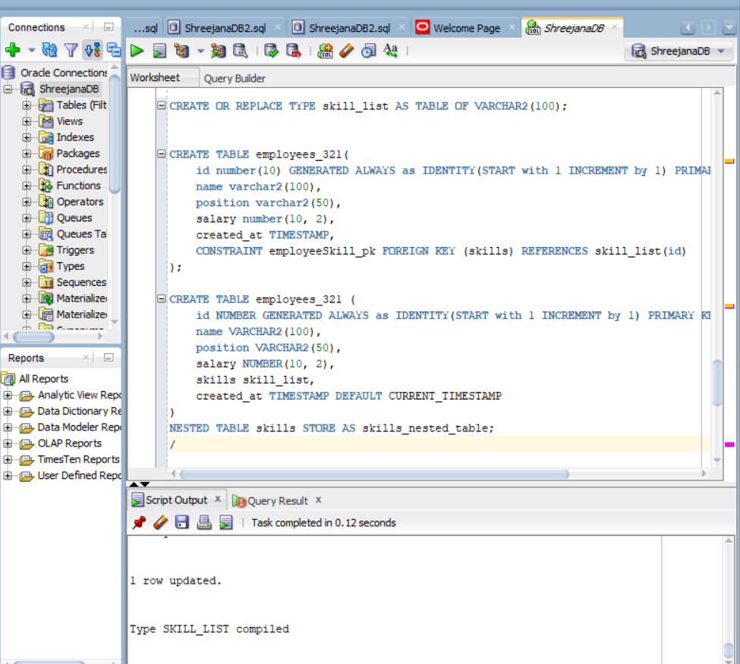

# # Question 2: employees_321 table creation

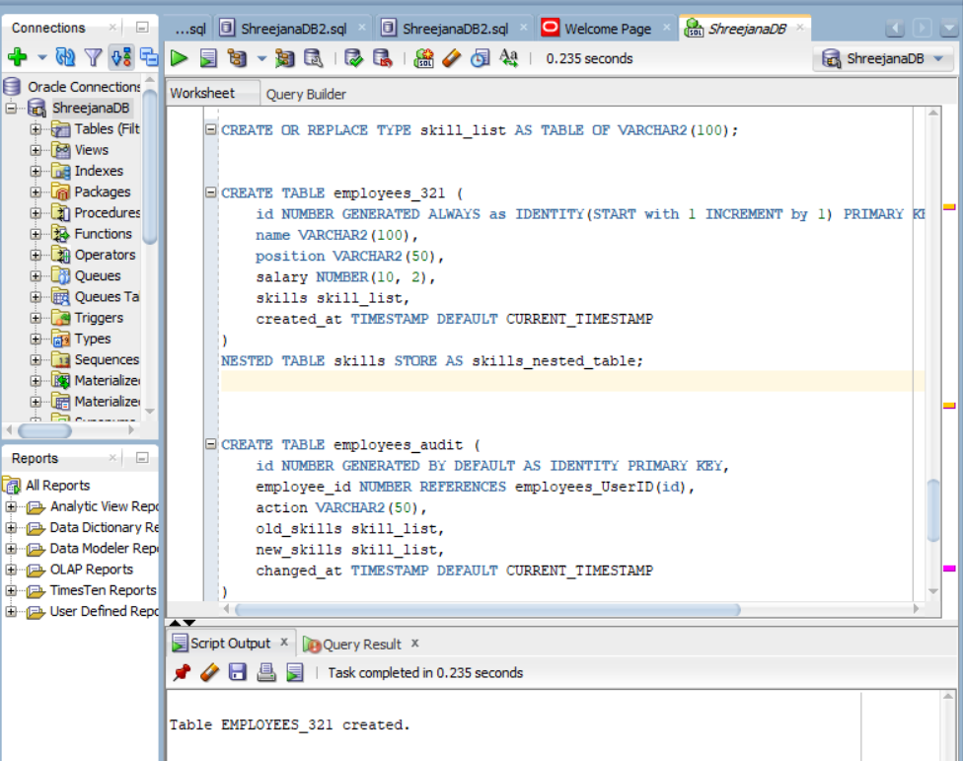

# Question 3: employees_audit table creation

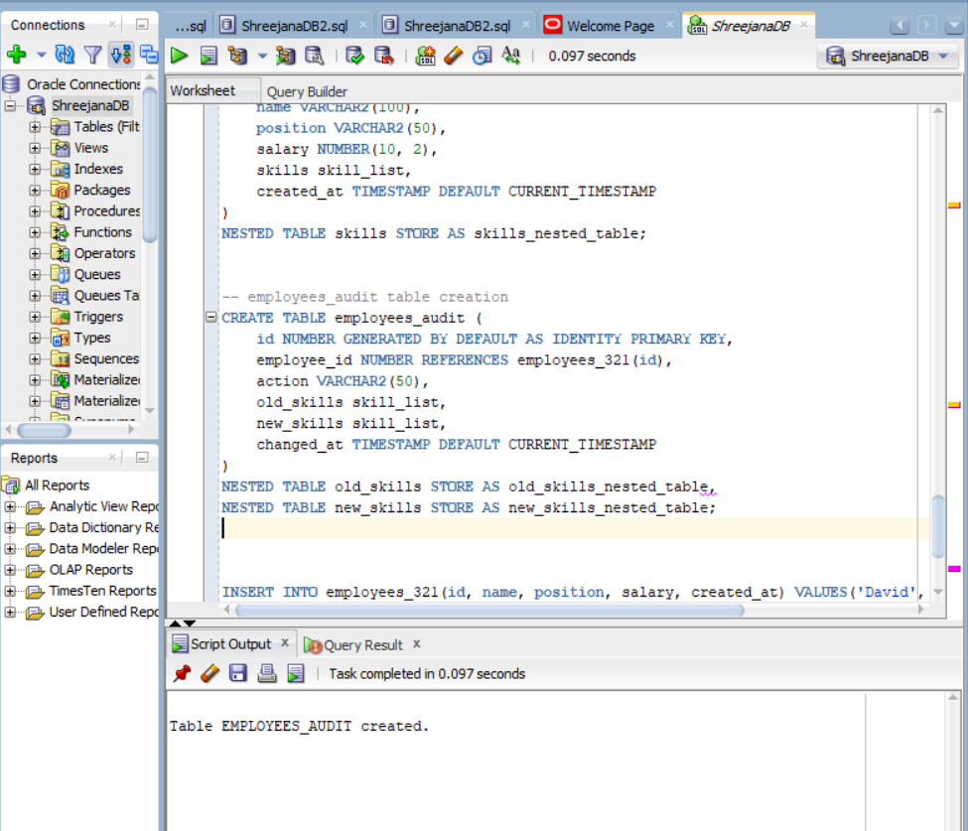

# Insertion of data for employees_321 table

# # Question 4: after_employee_update trigger creation

# # execution of trigger while doing update to the record

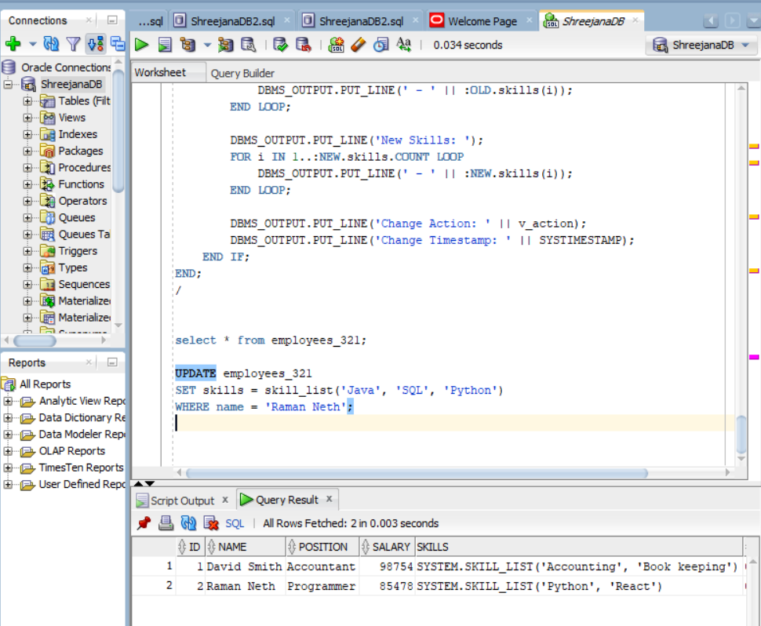



# # Output after the update of the record



