**CSD 4203 – Database Programming**

**Term : 2023S**

**Student ID : C0930321**

**Student Name : Shreejana Shrestha**

**Assignment # 9**

**----------------------------------------------------------------------------------------------------------------**

# # PL/ SQL – Package

## Package for Inventory Management

## # Creation of the package

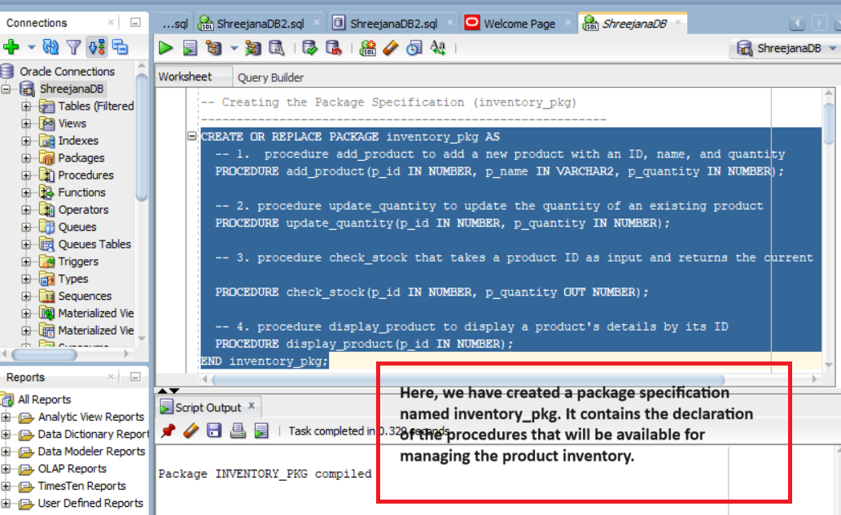

## # Creation of the products table

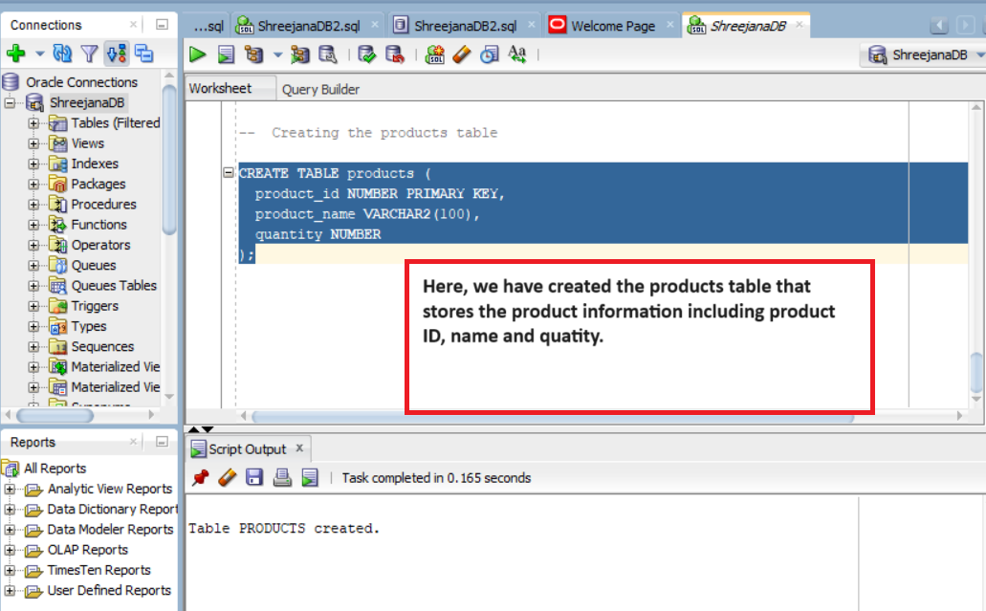

# Creation of package body with the logic to add/update/display the product records

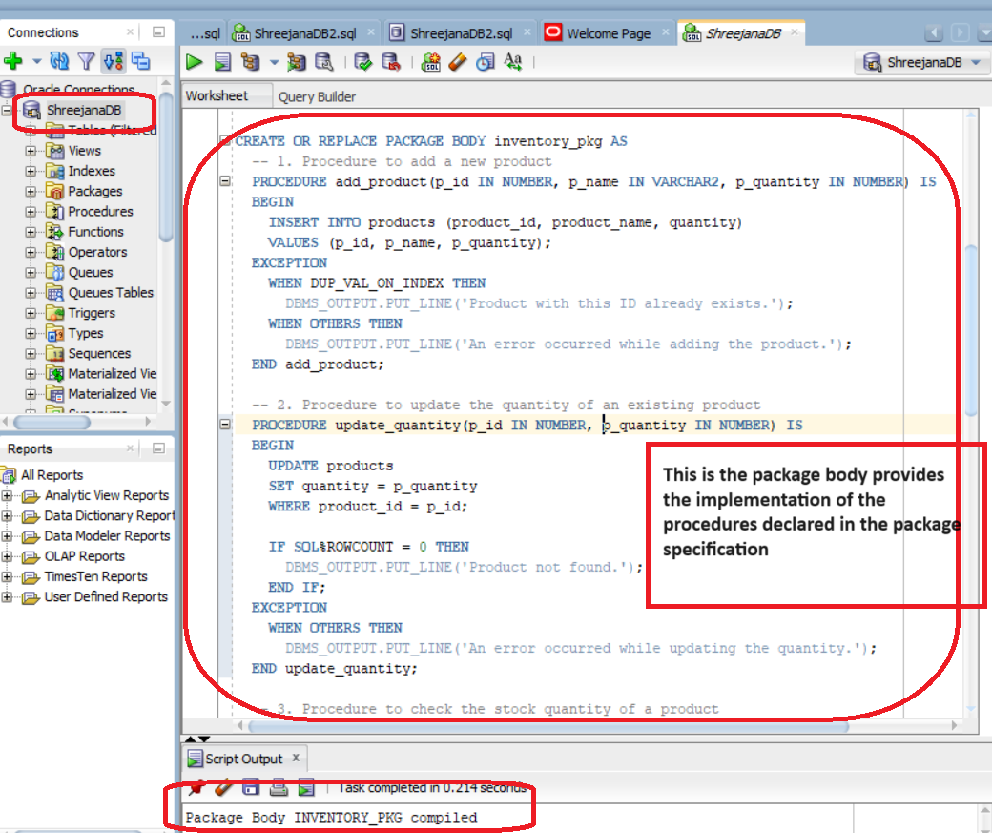

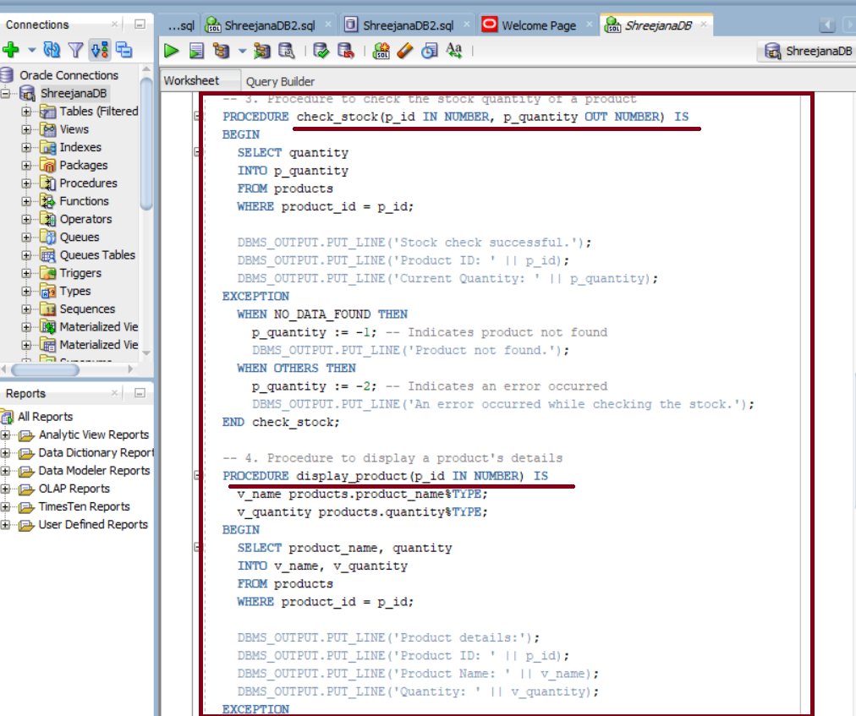

## # Implementation of the package

### # Inserting the product

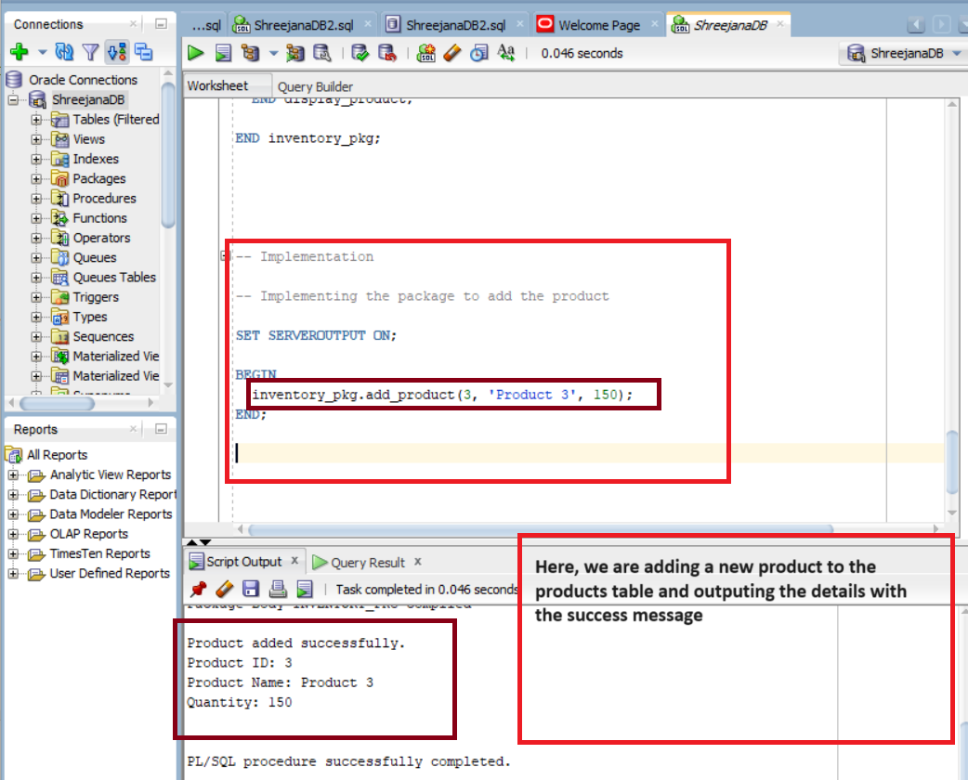

### # Updating the product

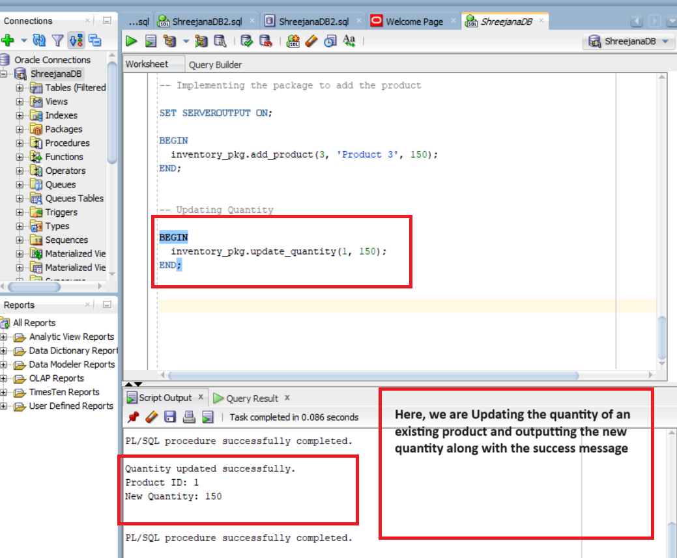

# Checking the stock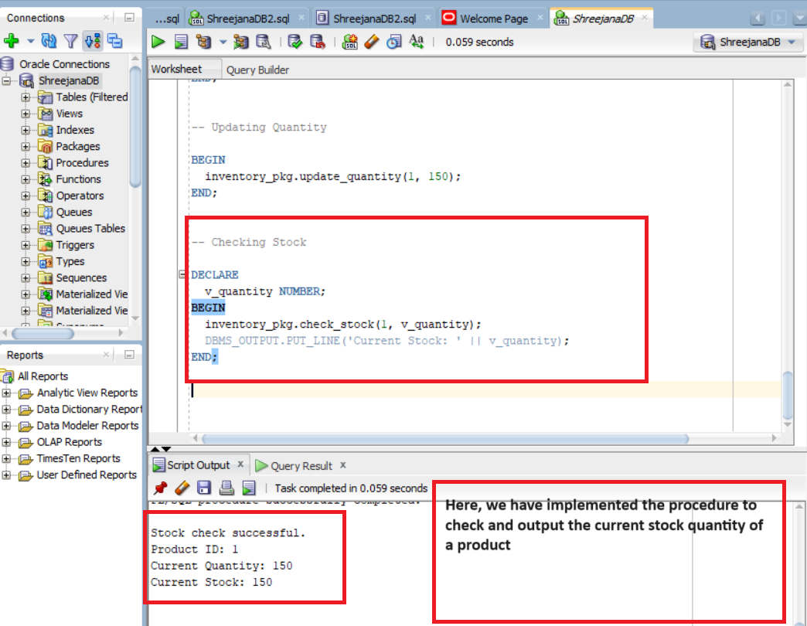

# Displaying the product

