**Web Technologies II**

**Student ID : c0930321**

**Student Name : Shreejana Shrestha**

**Assignment # 07**

**---------------------------------------------------------------------------------------------------------------------**

# #Screenshots of the output

## # Before jQuery DOM Manipulation

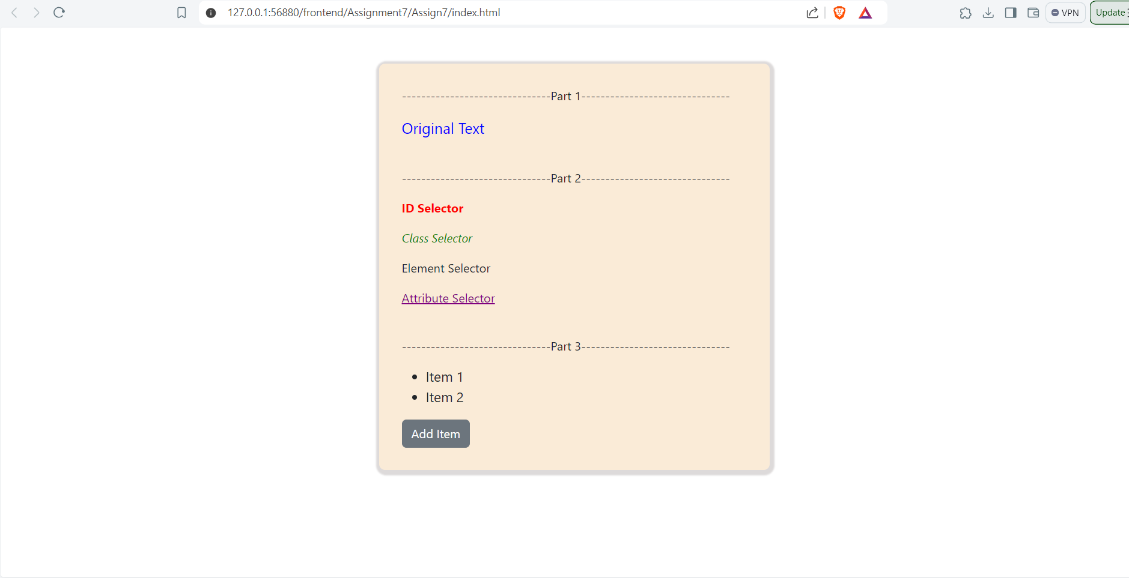

## # After jQuery DOM Manipulation

