**Web Technologies II**

**Student ID : C0930321**

**Student Name : Shreejana Shrestha**

**Assignment # 8**

---------------------------------------------------------------------------------------------------------------------

# # Screenshots of the output

1. **Part 1(Change Background Color on Click)**

*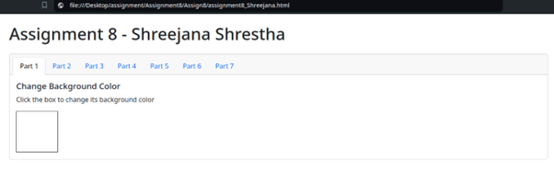   
Initial state without background change*

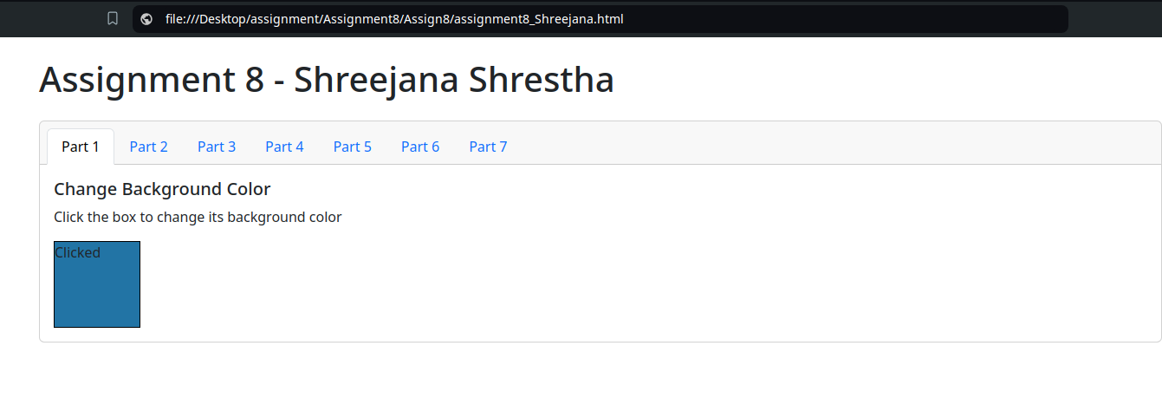

*Background changed on click*

1. **Part 2(Common Events)**
2. **Click**

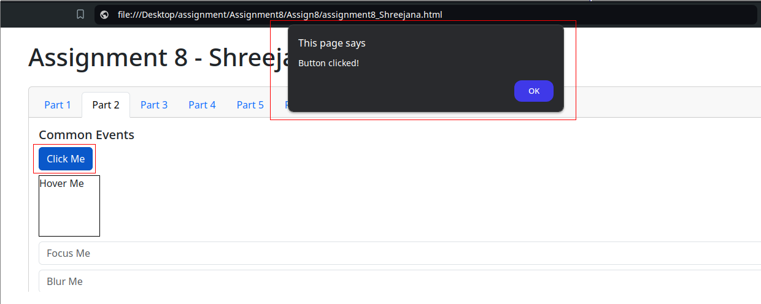

*Alert displayed on clicking the button*

1. **Hover**

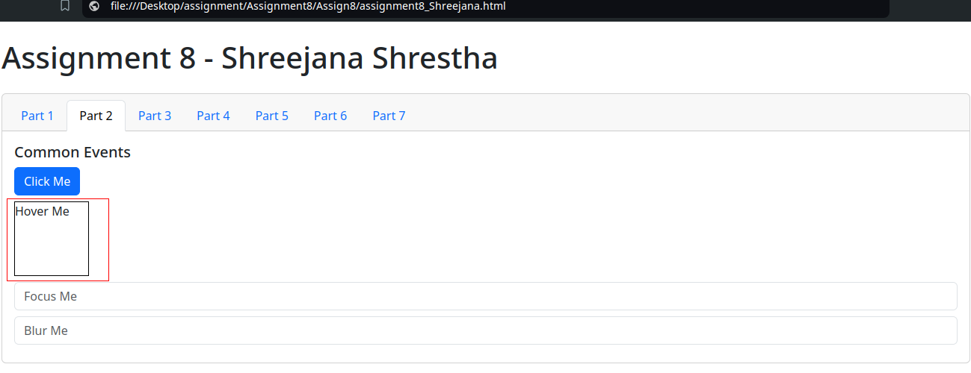

*Without Hover effect*

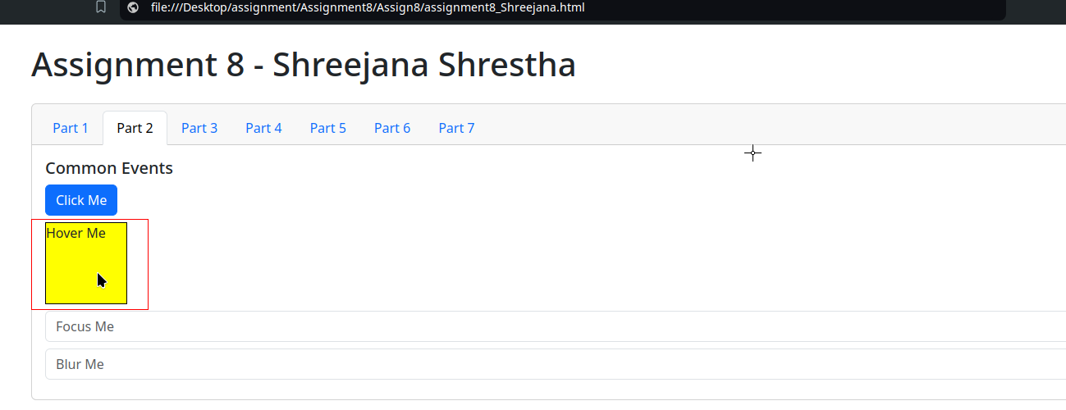

*After mouse hover*

1. **Focus**

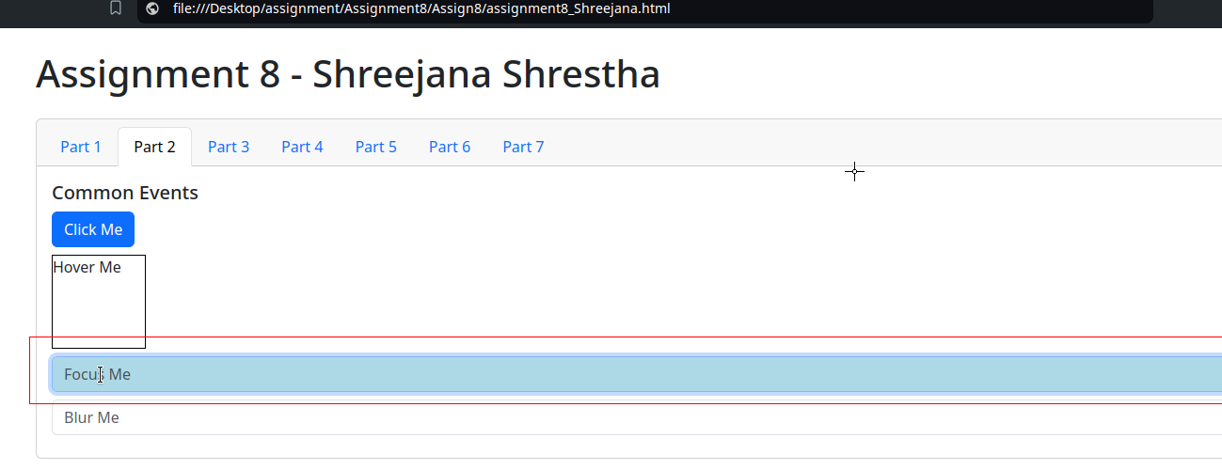

1. **Blur**

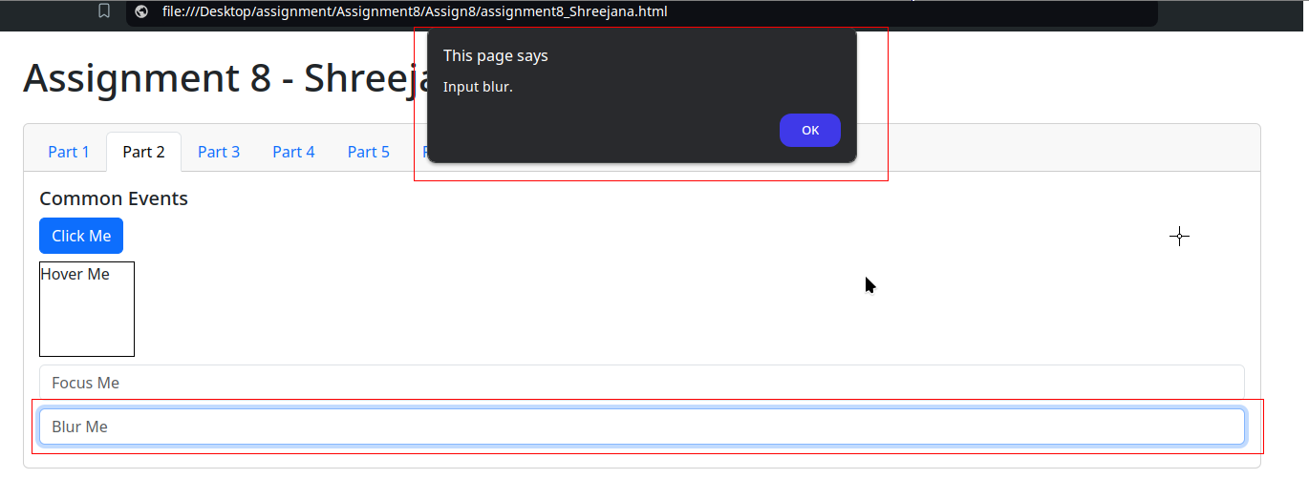

*Before Blur*

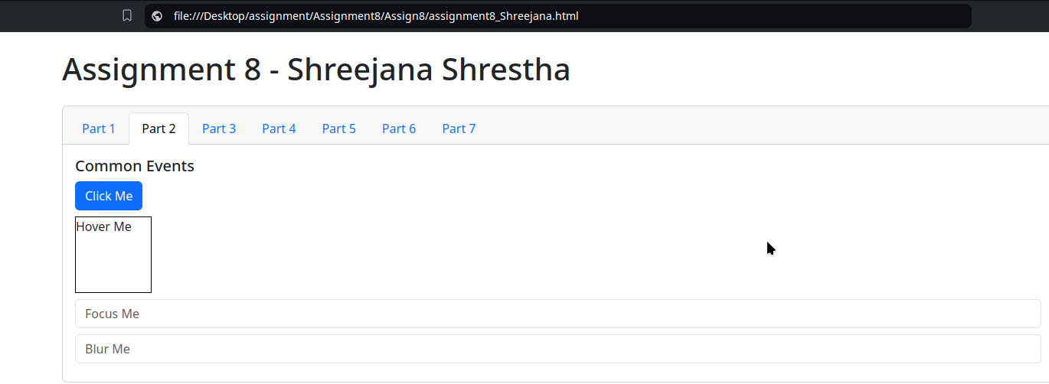

*After blur*

1. **Part 3(Show/Hide Content)**

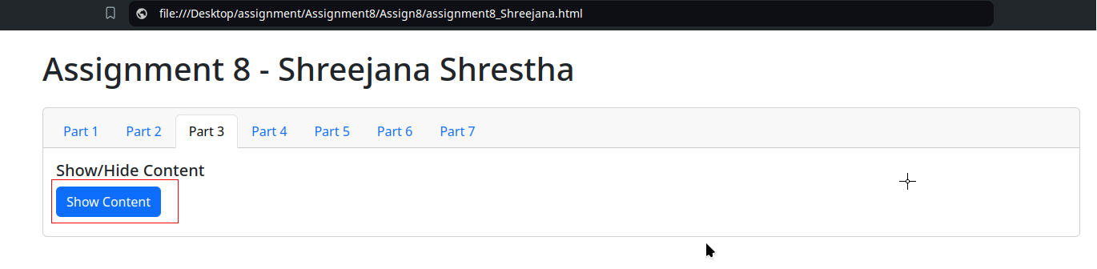

*Button to show content*

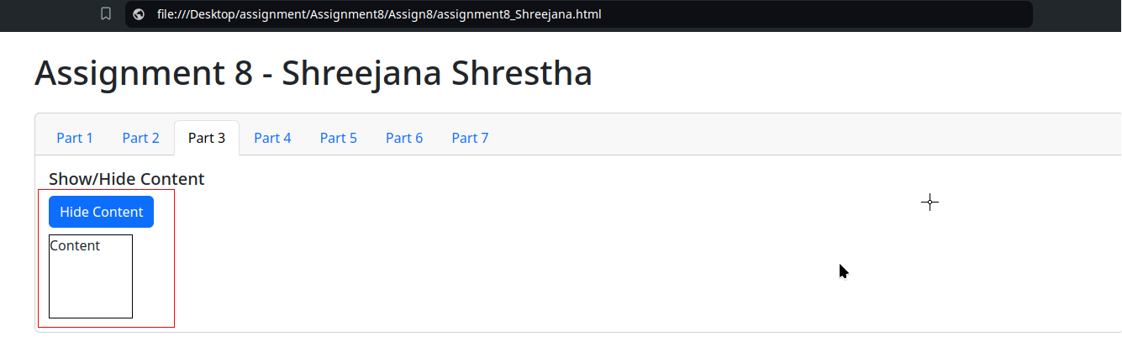

*Content Displayed and button changed to hide content*

1. **Part 4 (Fading Effects)**
2. **Fade In**

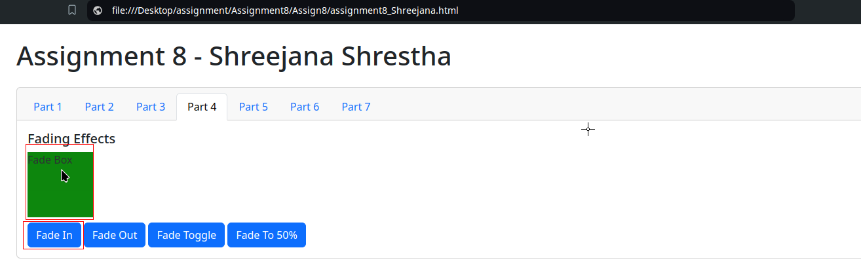

1. **Fade out**

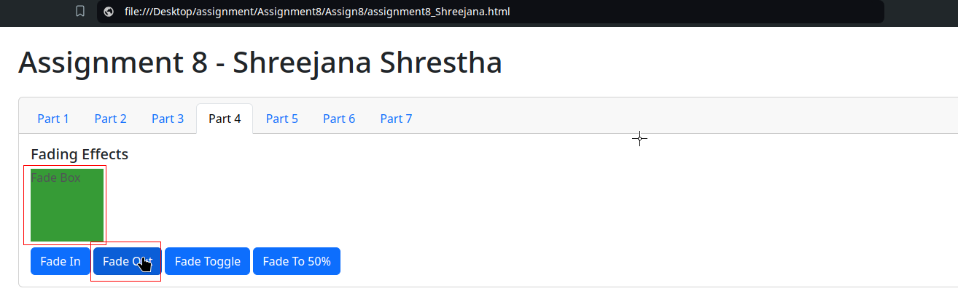

1. **Fade toggle**

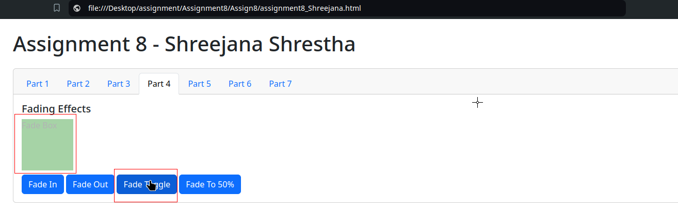

1. **Fade to 50%**

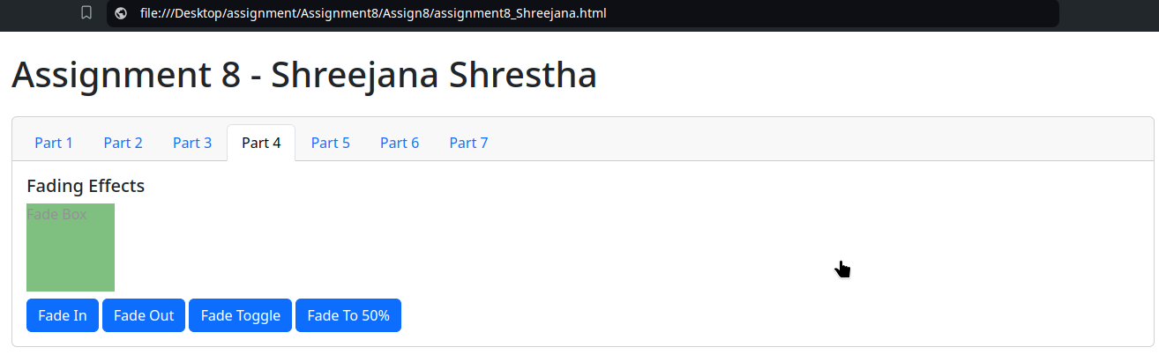

1. **Part 5 (Sliding Effects)**
2. **Slide Down**

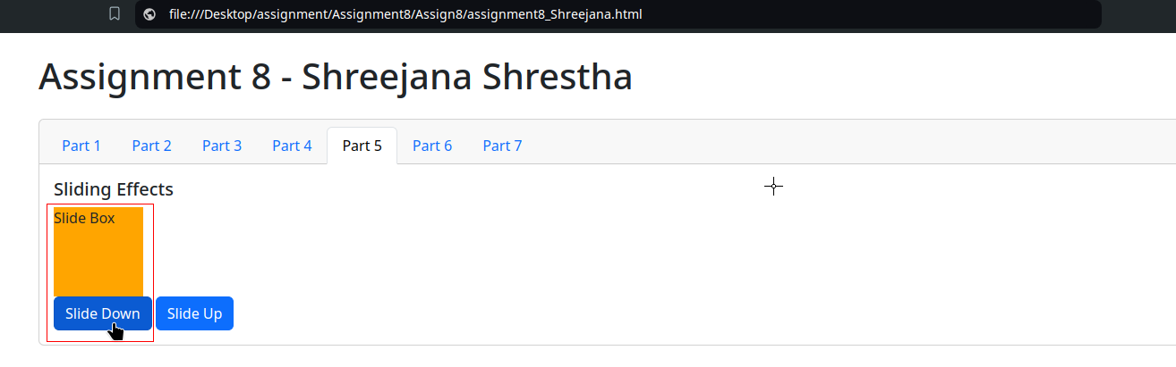

1. **Slide Up**

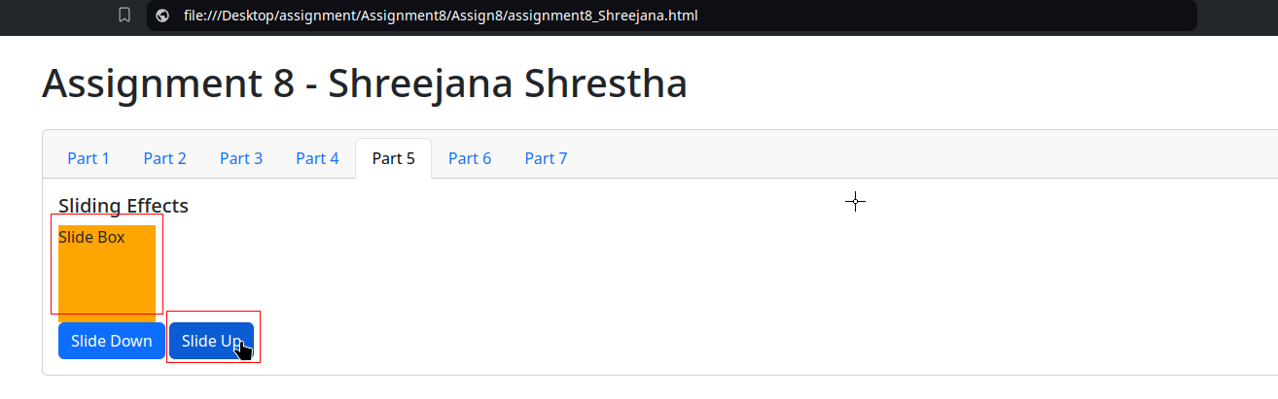

1. **Part 6 (Changing Image)**

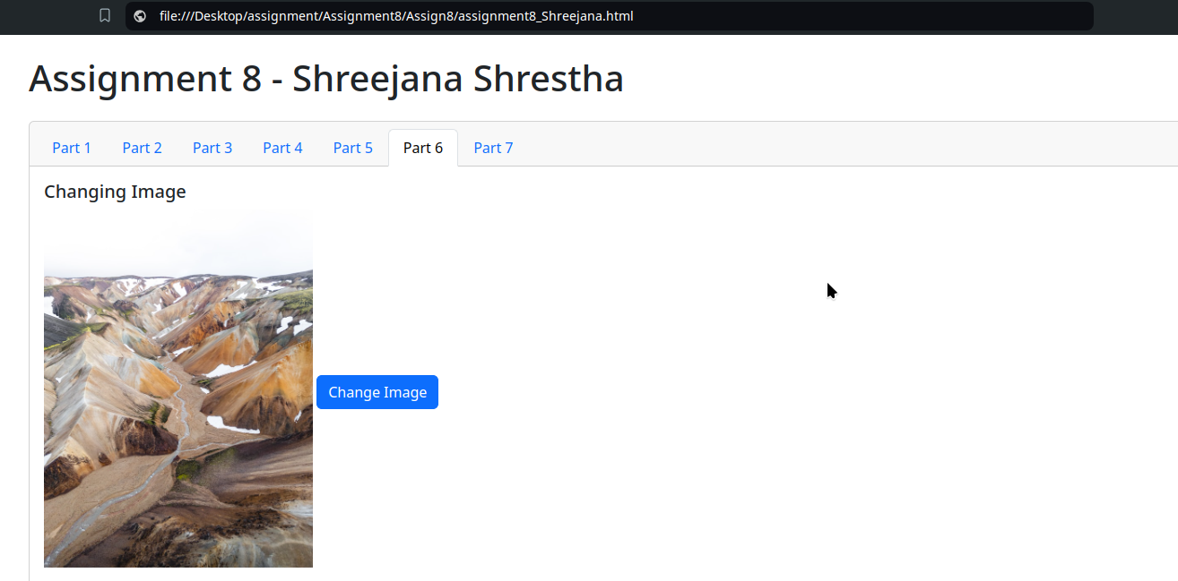

*Initial Image(before change)*

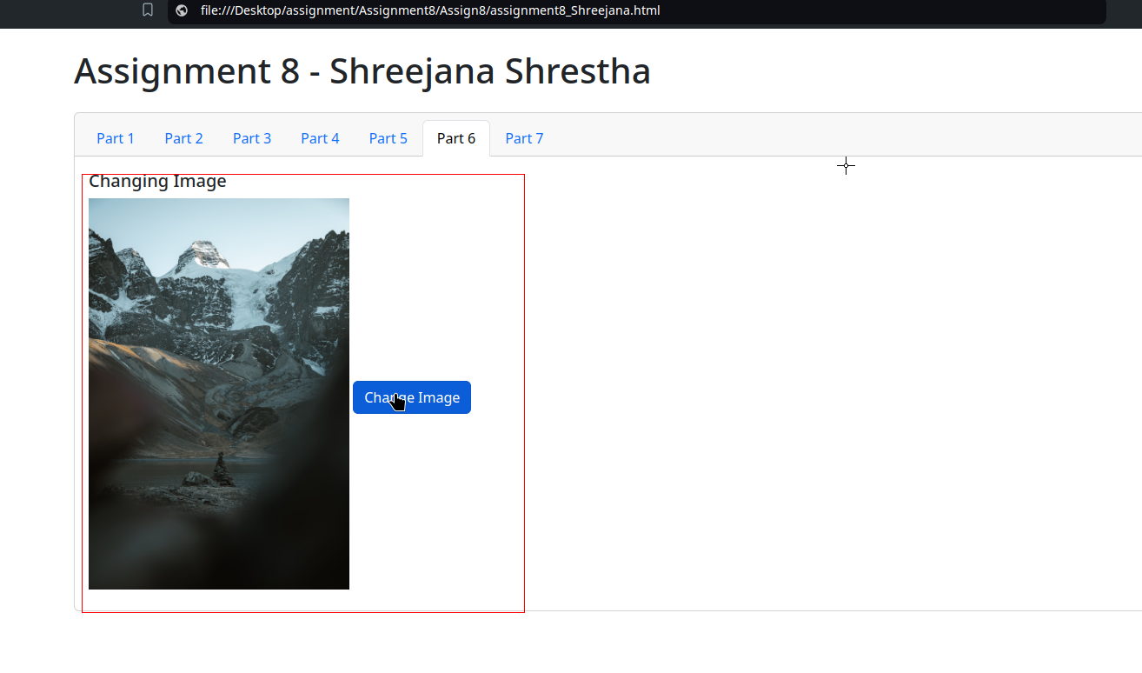

*After image change*

1. **Part 7(Changing text Style)**

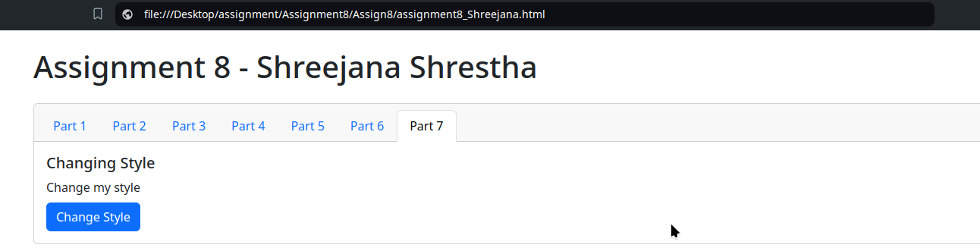

*Before text CSS change*

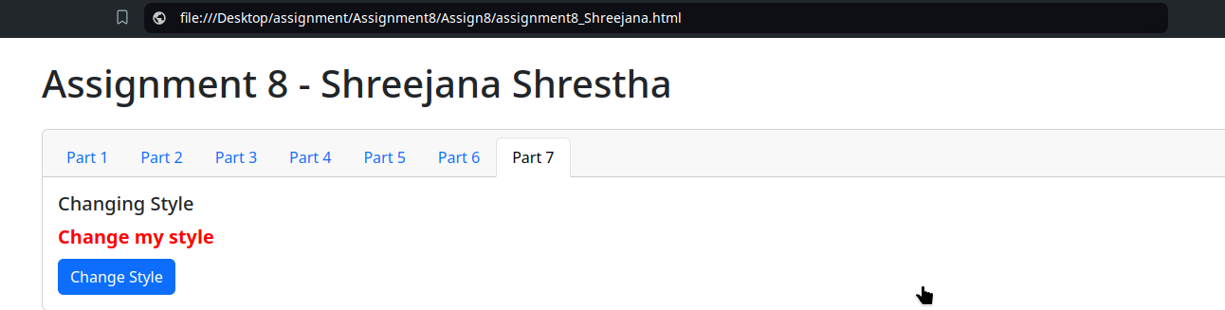

*After text CSS change*