**Assignment: 03**

**Student ID : C0930321**

**Student Name : Shreejana Shrestha**

**----------------------------------------------------------------------------------------------------------------**

# # Objects and methods

# # Class and Methods inside class

# # __init__ method

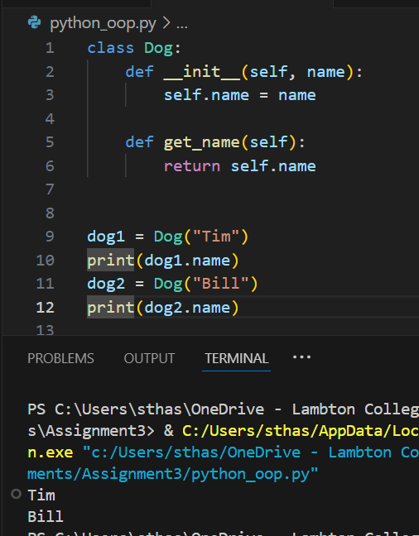

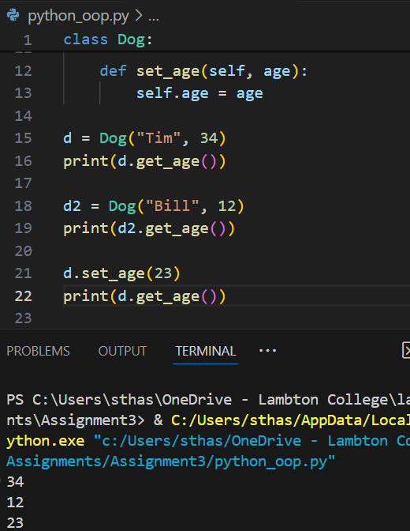

# # Multiple classes and adding students

## Output

# # Inheritance

## # Output

## # Output

# # Class attributes

# # Class methods

# # Static method

