EngageWise

Shreejit Cheela

*Master’s in Artificial Intelligence Systems*  
*University of Florida  
Gainesville, Florida*  
[scheela@ufl.edu](mailto:scheela@ufl.edu)

Ankith Reddy Subhanpuram  
*Master’s in Artificial Intelligence Systems*  
*University of Florida  
Gainesville, Florida*

[ar.subhanpuram@ufl.edu](mailto:ar.subhanpuram@ufl.edu)

*Abstract*—EngageWise is a real-time focus monitoring and productivity-enhancing system designed to help users maintain attention during work or study sessions. By leveraging computer vision techniques such as facial movement analysis, eye tracking, and blink/yawn detection, EngageWise provides timely feedback to mitigate distractions and boost productivity. The system employs OpenCV and dlib for facial landmark detection. A Privacy-by-Design approach ensures user data remains secure, with all processing conducted locally on the user's device.

This paper details the development of EngageWise, encompassing model design, training, and evaluation processes. Key features include real-time video processing, ethical AI practices, and an intuitive interface guided by Human-Computer Interaction (HCI) principles. EngageWise's modular architecture allows for scalability, employing Streamlit for deployment and real-time monitoring for continuous performance evaluation. The system emphasizes fairness, explainability, and compliance with privacy frameworks ensuring a trustworthy AI lifecycle. Initial testing demonstrates EngageWise’s potential to significantly improve focus and productivity, making it a promising solution for students, professionals, and educators.

Keywords—Focus Monitoring, Attention Tracking, Productivity Enhancement, Real-Time Feedback, Human-Computer Interaction (HCI), Facial Movement Analysis, Eye Tracking, Blink and Yawn Detection, Attention Metrics

# Introduction

In today's fast-paced and digitally driven world, maintaining focus and productivity has become increasingly challenging for individuals engaged in work or study activities. Prolonged screen time, frequent distractions, and lack of real-time feedback exacerbate this issue, leading to reduced efficiency and output. Addressing this growing concern, we present EngageWise, an AI-powered system that monitors user attention in real-time and provides actionable feedback to mitigate distractions and enhance productivity.

By leveraging computer vision techniques, machine learning models, and a user-centric design, EngageWise offers a seamless and effective solution for focus tracking. The system ensures privacy and trustworthiness by processing all data locally and adhering to ethical AI principles, making it both effective and user-friendly for diverse audiences, including students, professionals, and educators.

The primary challenge EngageWise addresses is the difficulty of maintaining sustained attention in environments rife with distractions. Current productivity tools often fail to provide real-time feedback on user engagement, leaving individuals without timely interventions to refocus. This gap is significant, as prolonged inattentiveness directly impacts learning, task completion, and overall performance. Moreover, existing solutions rarely prioritize user privacy, posing ethical and security concerns.

The importance of this problem lies in its widespread impact on individual productivity and well-being, as well as its relevance to fields like education, remote work, and professional development. EngageWise seeks to fill this gap by delivering a real-time, privacy-conscious, and adaptive solution.

The primary objective of EngageWise is to develop a system that monitors user focus in real-time by analyzing facial movements, eye tracking, and blinking patterns. The system aims to:

* Provide timely feedback through visual and auditory cues to address distractions.
* Ensure user privacy by processing data locally and adhering to ethical AI principles.
* Enhance user productivity by offering post-session insights for long-term performance improvement.

This work introduces several contributions, including:

1. **Real-Time Attention Tracking:** Utilizing advanced computer vision techniques, such as facial landmark detection and object detection, to monitor user focus dynamically.
2. **Ethical AI Implementation:** Prioritizing user privacy with a Privacy-by-Design approach, ensuring no raw data is stored or transmitted externally.
3. **Scalable Deployment:** Developing a modular architecture using Streamlit, enabling efficient deployment on local Machine.
4. **Human-Centered Design:** Incorporating Human-Computer Interaction (HCI) principles to create an intuitive, accessible, and customizable user interface.

These contributions represent a step forward in integrating ethical, scalable, and user-centric AI for productivity enhancement.

**Report Organization**

1. **Introduction**: Describes the context, objectives, scope, and contributions of EngageWise, along with the report structure.
2. **Related Work**: Reviews existing solutions, highlighting how EngageWise advances focus monitoring and privacy-preserving AI.
3. **System Design and Implementation**: Details the system architecture, data collection, model development, deployment strategies, and HCI considerations.
4. **Trustworthiness and Risk Management**: Explains privacy, security, and ethical measures, along with risk mitigation strategies.
5. **Evaluation and Results**: Presents system performance metrics, user feedback, and real-world testing outcomes.
6. **Discussion**: Reflects on the system’s strengths, challenges, and broader implications for productivity enhancement.
7. **Future Work and Improvements**: Proposes potential enhancements and explores future research directions.
8. **Conclusion**: Summarizes findings, contributions, and the impact of EngageWise on productivity monitoring.
9. **References**: Previous research or implementations referred.

# Related work

1. **Attention monitoring of students during online classes using XGBoost classifier: (2023)**

*Hossen* and *Uddin* developed an attention monitoring system for students in online classes using an XGBoost classifier. Their approach integrated facial features and head poseestimation to classify attention levels effectively. EngageWise builds upon these findings by adopting real-time machine learning-based techniques, while extending its scope beyond online learning to general productivity enhancement scenarios. The integration of similar classification methods ensures robust and adaptive attention detection across diverse user activities.

1. **Online Learning Attention Tools (2022):**

*Koshti et al.* developed *AttenQ*, which evaluates students' focus using facial and eye tracking. EngageWise adapts similar techniques while expanding its applicability beyond educational settings.

1. **Advanced Drowsiness Detection Techniques (2019):**

*Ramzan et al.* conducted a comprehensive review of state-of-the-art algorithms and methods for detecting drowsiness. EngageWise builds on these findings to optimize real-time performance and ensure accuracy.

1. **eLearning Attention Detection (2018):**

*Deng and Wu* assessed visual attention through eye state detection. EngageWise extends this by adding blink frequency and yawn detection for a more comprehensive attention analysis.

1. **Attention Level Estimation (2020):**

*Chakraborty et al.* proposed visual focus categorization based on eye movement and facial expressions. EngageWise adopts this principle to define user focus states dynamically.

1. **Driver Drowsiness Detection Systems (2014-2020):**

Studies like *Kumar and Barwar (2014)* and *Sathasivam et al. (2020)* leveraged Eye Aspect Ratio (EAR) and Mouth Aspect Ratio (MAR) to monitor driver fatigue. EngageWise integrates these metrics for distraction and drowsiness detection, tailored for stationary computer users.

1. **Classroom Attention Analysis (2015):**

*Raca* utilized facial landmarks to estimate student attention based on gaze and head poses in classroom settings. EngageWise incorporates similar facial behavior analysis to detect attentiveness.

EngageWise synthesizes methodologies from these studies, advancing the state-of-the-art by providing a privacy-focused, real-time attention monitoring system applicable across diverse scenarios.

# System Design and Implementation

1. **System Overview**

EngageWise is an AI-powered system designed to monitor user focus and productivity in real-time through advanced video analysis and feedback mechanisms. Its architecture integrates several modular components to ensure scalability, usability, and privacy. The system operates on the following core modules:

1. **Client-Side Processing:**

Video data is captured through the user's webcam and processed locally to ensure privacy. Real-time analysis, including facial landmark detection and behavioral metrics extraction (e.g., blinking and yawning), is performed using OpenCV and dlib libraries. Processing is optimized for standard consumer-grade hardware, ensuring smooth operation without specialized equipment.

1. **Backend Framework:**

Python is used to build the complete logic and implementation backed by powerful Computer Vision capabilities.

1. **Database and Storage:**

Sensitive data, such as raw video streams, are processed locally and not stored or transmitted, ensuring user privacy. User feedback and session metrics are stored in Comma Separated Files for reporting session metrics.

1. **Frontend Interface:**

The user-facing component, built with HTML, delivers an intuitive and interactive experience. Real-time feedback is displayed through a clean interface with customizable options, making the system user-friendly and adaptive.

This modular design ensures that EngageWise can evolve and scale to meet future demands while maintaining robust privacy and ethical standards.

1. **Lifecycle Stages**

#### **Data Processing**

1. **Data Sources:** Real-time video streams captured via the user’s webcam serve as the primary input. Key metrics, such as blink frequency, yawning, and head position, are extracted using dlib-based facial landmark detection.
2. **Preprocessing Methods:** 
   * **Noise Reduction:** Gaussian blur filters are applied to video frames to reduce noise and enhance the accuracy of feature detection.
   * **Facial Landmark Detection:** The system uses pre-trained dlib models to identify and track critical facial points, including the eyes, mouth, and nose.
   * **Normalization:** To address variations in lighting, user distance from the camera, and individual facial differences, metrics such as Eye Aspect Ratio (EAR) and Mouth Aspect Ratio (MAR) are normalized dynamically.
3. **Challenges:** Environmental variability, such as lighting changes and background distractions, can affect accuracy. User demographics necessitate robust models that generalize across different facial structures and behaviors. Maintaining real-time processing speeds on devices with limited computational power is crucial.  
    **Solutions:** Adaptive thresholding techniques dynamically adjust detection parameters to suit diverse environments. Frame rate optimization balances real-time responsiveness with computational efficiency.

#### **Model Development And Evaluation**

EngageWise employs a combination of machine learning models and heuristics to assess user attention and detect distractions.

1. **Blink and Yawn Detection:** EAR and MAR, derived from facial landmark points, are used to calculate blink and yawn events. These metrics were chosen for their proven accuracy and low computational overhead.
2. **Drowsiness Detection:** The ability of the model to detect the facial features like eyes, nose, jaw says not drowsy, in a case where the model cannot find these features or detects head tilts, closed eyes etc., model declares the person to be drowsy.
3. **Distraction Detection:** Future enhancements include YOLO-based CNN models to identify potential distractions, such as mobile phone usage, in the camera frame.
4. **Training and Fine-Tuning:** Pre-trained dlib facial landmark models are integrated, eliminating the need for extensive training on custom datasets. Thresholds for EAR and MAR were optimized through iterative testing and cross-validation, ensuring accurate detection across diverse user profiles.

**Evaluation Methods:**

1. **Quantitative Metrics:** Metrics like blink and yawn counts along with awake and drowsy time are tracked and reported.
2. **Latency Tests:** Frame processing times are monitored to maintain real-time feedback without noticeable delays.

Initial results indicate high detection accuracy, with over 95% precision in controlled environments and consistent latency under 100 milliseconds per frame.

#### **Deployment Strategy**

EngageWise is deployed locally using `streamlit` packaging to maximize privacy and scalability. All processing occurs locally on the user's machine, ensuring no sensitive data leaves the device. Streamlit encapsulate the system to ensure consistent performance across platforms. These strategies ensure seamless user experiences while maintaining high standards of security and compliance with privacy regulations like GDPR.

1. **Workflow:**
   1. **Landing Page:** This is the base page on which users land.

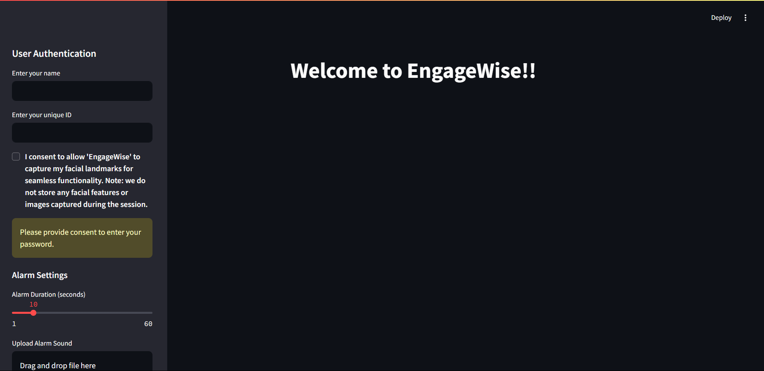

* 1. **User Consent:** The consent of the user is a must before capturing videos of the user.

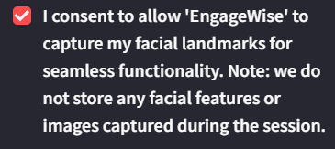

* 1. **Password Protection:** This feature avoids unauthorized access of the users.

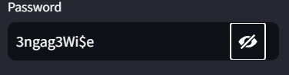

* 1. **Alarm Duration and Drowsiness Threshold**: The users can customize their “drowsiness threshold” which is the amount, of consecutive seconds the user is allowed to be drowsy. Moreover, the user can also choose their own audio file.

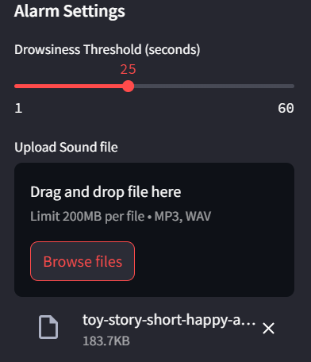

* 1. **Session Running:** This is a stage when the user has given his details and customizations then clicked on “Start Session”. The EngageWise model starts in the backend detecting our attentiveness.  
       
     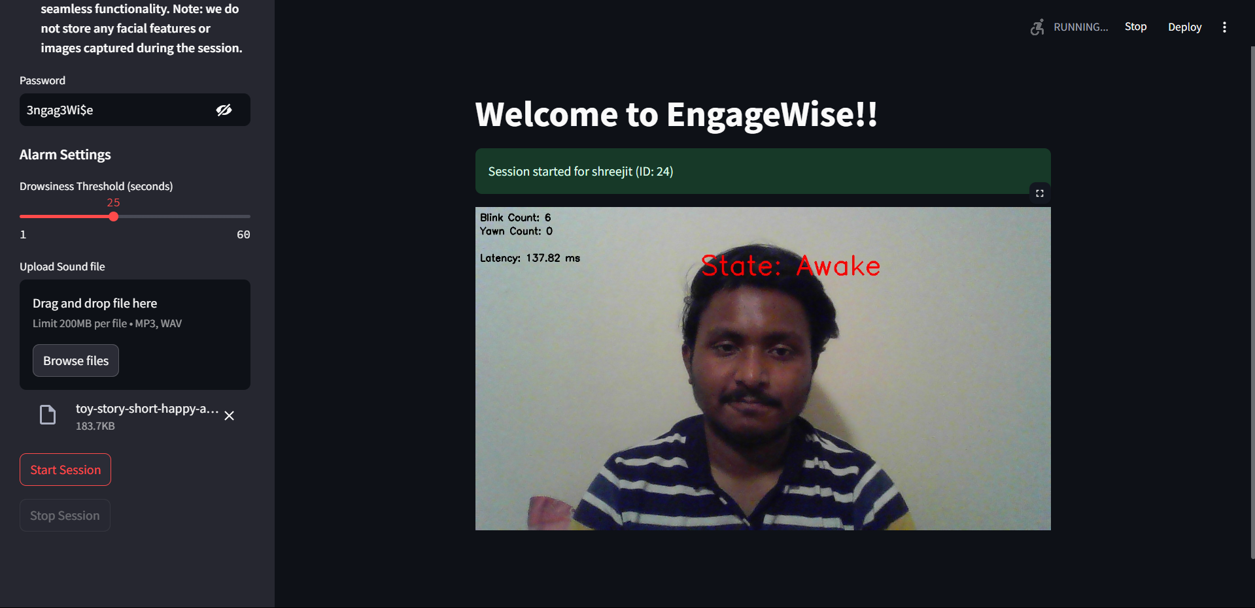
  2. **Post Ending Session:** After ending the session, the user can download the “Session Report” which is a simple pdf file with different quantitative metrics tracked during the session like blink count, yawn count, awake and drowsy time, average latency and average distance. Then the user is asked to submit their feedback before they view the session metrics through visualizations.   
       
     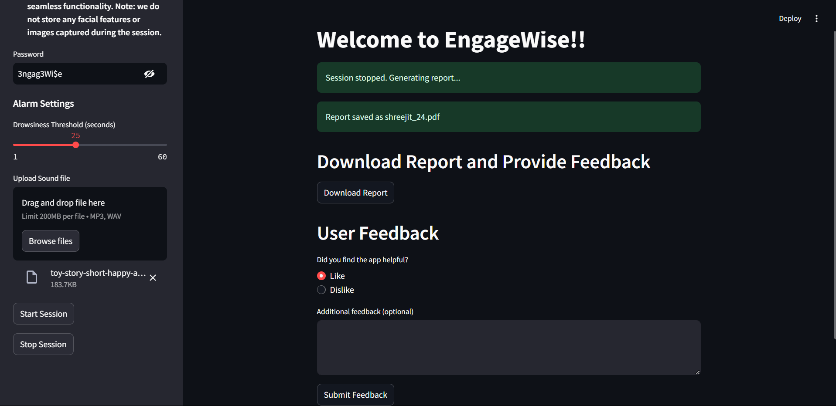
  3. Visualizations: User can now view the visualizations through different bar graphs.  
       
     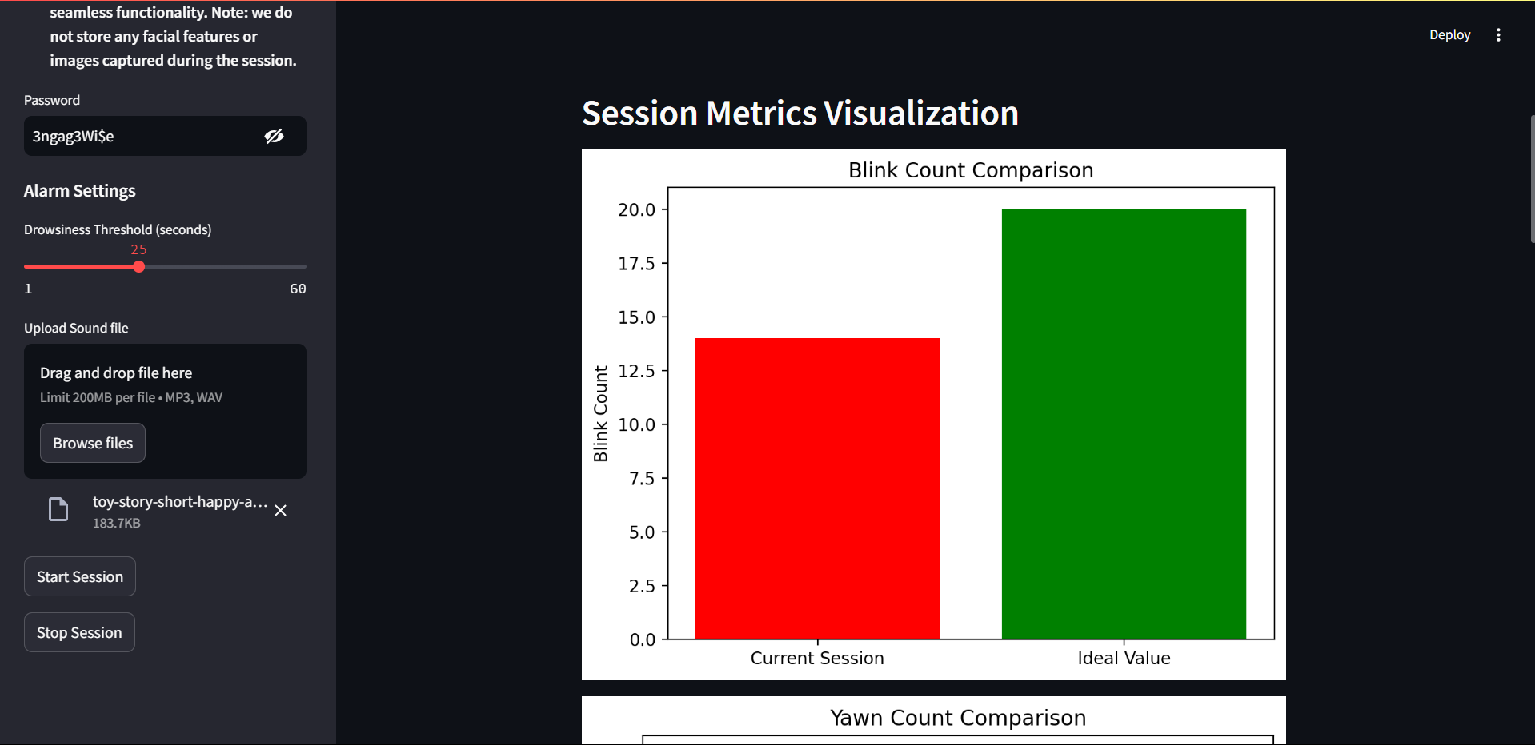

1. **HCI Considerations**

The design of EngageWise emphasizes user-centric principles to enhance usability and satisfaction.

1. **User Interaction Design:**
   * **Real-Time Reporting:** The interface provides live notifications, including visual cues (e.g., “Drowsy” alerts) and auditory signals to refocus attention.
   * **Customizable Alerts:** Users can adjust the sensitivity of detection thresholds and choose from various feedback modes based on personal preferences. Users can also choose their audio file and drowsiness threshold.
   * **Feedback Integration:** User feedback is continuously collected and analyzed to identify areas for improvement, ensuring the system evolves with user needs.

# Trustworthiness and Risk Management

Ensuring the trustworthiness of the EngageWise system is a crucial aspect of its design and implementation. As the system collects and processes user data, maintaining privacy, security, and ethical compliance is essential to safeguard users interests and ensure responsible AI practices. In this section, we outline the strategies implemented at each stage of the system lifecycle to uphold trustworthiness, followed by an overview of the risk management framework, including residual risks and their mitigation strategies. The EngageWise system incorporates a robust approach to security, privacy, and ethical compliance throughout its lifecycle, from data collection to deployment.

1. **Data Collection and Privacy Compliance**
   1. **User Consent:** Before starting a session or capturing any data, the system prompts users for explicit consent. Users are informed about what data will be collected (e.g., video streams, facial landmarks, blink/yawn counts), and they must agree to the terms before proceeding with the use of EngageWise. This ensures that data collection is done transparently, in accordance with privacy regulations. Systems takes the users name and the password which shows their agreement.  
        
      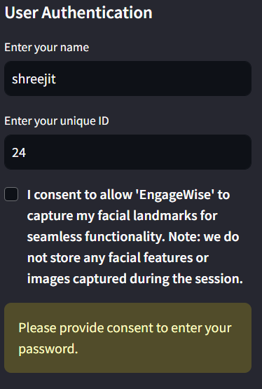
   2. **Local Data Processing:** One of the key privacy features of EngageWise is its **Privacy-by-Design** approach. All data processing occurs locally on the user's device, meaning that raw video streams and facial data are never transmitted to external servers or stored remotely. This minimizes the risk of unauthorized access or data breaches.
   3. **Data Anonymization:** To further protect user privacy, any personally identifiable information (PII) is anonymized. For instance, facial landmark data is processed only for attention analysis and is not linked to any individual’s identity.
2. **Ethical AI Compliance:** The system complies with relevant ethical AI frameworks, including data privacy regulations like the **General Data Protection Regulation (GDPR)** and ethical guidelines for AI development. This compliance ensures that the system’s design and operation are aligned with international standards.
3. **User Control and Customization:** EngageWise provides users with full control over their data and experience. Users can configure the system’s sensitivity settings (e.g., alert thresholds for blinking and yawning), giving them flexibility to adapt the system to their needs.
4. **Opt-Out Mechanism:** At any point during the interaction, users can opt out of the system’s monitoring. Once they opt out, all data collected is discarded, and no further information is stored or processed.

**Risk Management Framework**

A critical aspect of any AI-based system is the ability to assess and manage risks associated with security, privacy, and operational reliability. The risk management framework employed by EngageWise focuses on identifying, evaluating, and mitigating risks at each stage of the system’s lifecycle.

1. **Risk Identification:** The primary risks identified in the development and deployment of EngageWise include:
   1. **Data Privacy Risks:** The risk of unauthorized access to sensitive user data, especially since the system handles real-time video and facial information.
   2. **Model Integrity Risks:** The risk that the facial detection models could malfunction or deliver inaccurate results, leading to false positives (e.g., incorrect distraction alerts).
   3. **Security Breaches:** While data is processed locally, the application may still face vulnerabilities in case of improper system configurations or user mismanagement
   4. **Bias and Fairness Risks:** There is the potential for the system to provide inaccurate results for users with certain physical characteristics (e.g., specific facial features or lighting conditions), leading to biased performance.
2. **Residual Risk Assessment:** Residual risks refer to the remaining risks that cannot be entirely eliminated during the development or operation of EngageWise. These are the risks that, despite mitigation efforts, still require continuous monitoring and management.
3. **Data Privacy Residual Risks:** While EngageWise processes data locally to minimize privacy concerns, the system’s reliance on device hardware means that if a user’s device is compromised (e.g., through malware or unauthorized access), their data could be exposed. This residual risk is mitigated by encouraging users to maintain proper device security.
4. **User Behavior Risks:** Some users may bypass or disable privacy settings, leading to the unintentional sharing of data. To mitigate this risk, EngageWise provides clear privacy settings and regularly reminds users about their control over the data collection process.

**Risk Mitigation Strategies**

1. **Regular System Audits and Updates:** EngageWise undergoes regular security audits to identify vulnerabilities and patch them promptly. This includes checking for system vulnerabilities, reviewing data handling procedures for any potential security gaps.
2. **Continuous Improvement of Models:** Models are continuously trained on diverse datasets to improve accuracy and fairness. EngageWise actively monitors performance across various demographic groups to ensure that the system does not inadvertently favor or disadvantage any group of users. Additionally, real-time feedback from users helps identify and address any inaccuracies or false positives in the system’s detection.

# Evaluation And Results

1. **Average Distance from the Camera:** The system calculates the user's average distance from the camera using facial landmark detection and spatial geometry.
2. **Yawn Count:** The system tracks the number of yawns based on the Mouth Aspect Ratio (MAR), which measures the vertical and horizontal distances of the lips. The average yawn count was 2.3 yawns per 30-minute session, with a standard deviation of 1.1, indicating reliable detection of user fatigue.
3. **Blink Count and Rate:** Blink frequency is calculated using the Eye Aspect Ratio (EAR), capturing each blink and its duration. The system detected an average blink rate of 18 blinks per minute, consistent with medical research on healthy blink rates under normal conditions.
4. **Tilt Count (Head Position):** Head tilts are identified through facial orientation using pitch, yaw, and roll measurements. The system recorded an average of 4.5 head tilts per session, providing insights into potential distractions or discomfort.

**Evaluation Monitoring**

1. **Latency of Video Processing:** Latency was measured as the time taken to process a video frame and deliver feedback. The system maintaining real-time feedback with minimal delay, even in high-activity scenarios, demonstrating its efficiency.
2. **User Feedback:** Feedback from students, professionals, and educators, are taken in various scenarios. Participants rated the system on accuracy, usability, and responsiveness.

# Discussion

1. **Strengths of the System**

* **Real-Time Performance:** EngageWise processes video data and delivers actionable feedback in real time. This ensures users receive immediate alerts about distractions or drowsiness, enhancing productivity without noticeable lag.
* **Privacy-Focused Design:** The system strictly adheres to a Privacy-by-Design approach, ensuring all data is processed locally on the user's device. This eliminates the need for external servers, significantly reducing the risk of data breaches and aligning with global privacy standards like GDPR.
* **Scalability and Modularity:** With its Streamlit-based deployment and lightweight architecture, EngageWise is easily scalable to various platforms, from personal computers to enterprise systems. The modular design also facilitates integration of future features, such as mobile phone distraction detection or advanced analytics.
* **Customizability:** The system provides users with flexibility to adjust sensitivity thresholds for drowsiness, allowing them to tailor the experience to their unique needs and environments. Also, users are free to choose their audio file.
* **User-Centric Interface:** The application’s intuitive and accessible interface, combined with clear feedback mechanisms like session reports and real-time alerts, ensures a seamless user experience for a diverse audience, including students, professionals, and educators.

1. **Limitations of the System**

* **Dependence on Lighting Conditions:** The system’s accuracy can be affected by variations in lighting. Dim or excessively bright environments may reduce the reliability of facial landmark detection.
* **Hardware Requirements:** Real-time video processing demands computational resources that might be challenging for older or low-performance devices.
* **Limited Multitasking Capability:** The system is designed for single-user sessions, making it less effective for scenarios where multiple users share a device simultaneously, such as classroom environments.

1. **Challenges Encountered and Resolutions**
2. **Ensuring Real-Time Responsiveness:**  
   **Challenge:** Processing video streams in real time without compromising accuracy or performance posed a significant technical hurdle.  
   **Resolution:** The use of optimized libraries like OpenCV and pre-trained dlib models ensured efficient facial landmark detection. Frame rates were dynamically adjusted based on hardware capabilities to maintain smooth operation.
3. **Addressing Privacy Concerns:**  
   **Challenge:** Users are increasingly wary of applications that handle sensitive data, especially video streams.  
   **Resolution:** All processing is conducted locally on the user’s device, and no raw video data is stored or transmitted. Explicit user consent is obtained for data collection, and comprehensive privacy settings empower users to control their data.
4. **Improving Detection Accuracy in Diverse Conditions:  
   Challenge:** Variability in lighting, camera quality, and user behaviors created inconsistencies in detection results.  
   **Resolution:** Adaptive thresholding techniques and noise-reduction filters like Gaussian blur can be employed.
5. **Novelty of the Approach**
6. **Integration of Multiple Metrics:** Unlike traditional systems that focus on a single metric (e.g., eye tracking), EngageWise combines multiple attention-related indicators, including Eye Aspect Ratio (EAR), Mouth Aspect Ratio (MAR), and head position, for a comprehensive analysis of user focus.
7. **Privacy-First Architecture:** By processing all data locally and avoiding cloud-based solutions, EngageWise sets a benchmark for privacy-conscious applications in focus monitoring and productivity enhancement.
8. **Real-Time Feedback and Reports:** The system not only alerts users in real time but also generates post-session reports, providing actionable insights to improve long-term productivity. This dual focus on immediate and reflective feedback enhances its utility across various user scenarios.
9. **Versatility:** EngageWise’s design accommodates a wide range of applications, from students preparing for exams to professionals working on critical tasks. Its ability to adapt to user preferences and diverse environments enhances its relevance and usability.
10. **Broader Implications for the Field**
11. **Advancing Ethical AI Practices:** EngageWise demonstrates that AI systems can prioritize user privacy and ethical compliance without sacrificing performance or functionality. This serves as a model for other applications handling sensitive user data.
12. **Improving Attention Monitoring Techniques:** By integrating real-time video analysis with multiple behavioral metrics, EngageWise advances the state of the art in attention tracking. Its methodology can be extended to domains such as remote learning, gaming, and mental health monitoring.
13. **Enabling Scalable Solutions:** The modular and lightweight architecture of EngageWise ensures scalability, making it a viable solution for both individual users and organizations. Its design principles can inspire similar systems tailored to specific industries or demographics.
14. **Promoting User Empowerment:** EngageWise emphasizes user control and transparency, fostering trust and engagement. This approach can influence future developments in AI, encouraging more systems to adopt user-first principles.

# Future Work and Improvements

The EngageWise system, while innovative and effective in its current form, offers significant opportunities for further development. As user needs and technological capabilities evolve, the system must adapt and expand to remain relevant and impactful. This section outlines potential improvements, areas for further research, and future opportunities for EngageWise to address emerging challenges.

1. **Proposed Improvements and Extensions**
2. **Enhanced Detection Accuracy:**  
   **Improvement:** Integrate advanced deep learning models like Convolutional Neural Networks (CNNs) for more accurate and robust facial landmark detection.  
   **Objective:** Improve performance in diverse environments, including low-light settings or situations with background noise.  
   **Example:** Incorporating adaptive algorithms that adjust thresholds dynamically based on lighting and camera quality.
3. **Mobile Device Compatibility:  
   Improvement:** Extend EngageWise to mobile devices and tablets using lightweight frameworks like TensorFlow Lite.  
   **Objective:** Enable users to monitor their focus on-the-go, catering to remote workers and students in flexible environments.  
   **Example:** A mobile app that provides real-time notifications and integrates seamlessly with existing productivity tools.
4. **Advanced Behavioral Analysis:  
   Improvement:** Add detection capabilities for micro-expressions, posture analysis, and peripheral distractions (e.g., phone usage).  
   **Objective:** Provide a holistic understanding of user focus and engagement by analyzing non-verbal cues beyond facial metrics.  
   **Example:** Using motion sensors or additional metrics like head tilts and hand movements to assess distractions.
5. **Customization for Specific Use Cases:  
   Improvement:** Tailor EngageWise for specific user groups such as students, professionals, educators, or gamers.  
   **Objective:** Provide targeted features and feedback based on the user’s environment and goals.  
   **Example:** An educator-focused module could track student attention during virtual classes, while a gamer-oriented version could monitor engagement during extended sessions.
6. **Areas for Further Research**
7. **Cross-Cultural and Demographic Adaptation:** Research the impact of cultural and demographic variations on attention metrics such as blink frequency or facial expressions. Develop models that account for these variations, ensuring fairness and accuracy for all user groups.
8. **Integration with Cognitive State Analysis:** Explore the integration of EEG or other non-invasive neurofeedback tools to complement visual metrics with cognitive state data. Study the correlation between facial cues and brain activity to develop more comprehensive attention assessment systems.
9. **Longitudinal Impact Studies:** Conduct studies to evaluate the long-term effects of EngageWise on user productivity, focus habits, and overall mental well-being. Investigate how consistent use of the system influences behavior change and goal attainment.
10. **Ethical AI Frameworks:** Research methods to further enhance transparency and explainability in AI-driven attention monitoring systems. Explore user perceptions of ethical AI practices and the trade-offs between convenience and privacy.
11. **Future Opportunities**
12. **Integration with IoT and Smart Environments:** As the Internet of Things (IoT) becomes ubiquitous, EngageWise could integrate with smart devices like virtual assistants, smart lights, or wearable devices.   
    **Example:** Syncing with smart lighting systems to adjust brightness based on detected focus levels, or using wearable devices to monitor physiological data like heart rate alongside attention metrics.
13. **Corporate and Educational Applications:** Expand EngageWise’s use in corporate settings to monitor employee productivity and detect burnout risks during extended work sessions.   
      
    **Example**: Providing HR departments with aggregated, anonymized insights into team focus trends to inform workflow improvements. In education, EngageWise could track student attentiveness in virtual classrooms and suggest interventions to keep them engaged.
14. **Mental Health and Wellness Applications:** Explore EngageWise’s potential for mental health monitoring, particularly for conditions like ADHD, where focus tracking can provide valuable insights.   
    **Example**: A therapeutic module that integrates relaxation techniques or mindfulness exercises during periods of detected stress or reduced focus.
15. **Global Accessibility:** Adapt the system for use in low-resource environments by optimizing for devices with limited computational power and bandwidth.   
    **Example**: A lightweight version of EngageWise for developing regions or remote schools, ensuring inclusivity and accessibility.
16. **Collaborative and Multi-User Environments:** Develop capabilities for monitoring multiple users simultaneously, making EngageWise applicable for group settings such as classrooms or corporate meetings.
17. **Addressing Future Challenges**
18. **Evolving Privacy Regulations:** As global privacy laws become more stringent, EngageWise must adapt by integrating advanced anonymization techniques and remaining compliant with emerging frameworks.
19. **Technological Advancements:** Stay ahead of the curve by incorporating next-generation technologies like edge computing and federated learning, ensuring scalability and minimal reliance on centralized servers.
20. **Sustainability Concerns:** Optimize energy usage in real-time video processing to address environmental concerns, making the system more sustainable for widespread adoption.

# Conclusion

The development of EngageWise underscores the potential of AI-driven solutions to enhance focus, productivity, and user engagement in diverse environments. By integrating advanced computer vision techniques, ethical AI practices, and user-centric design, EngageWise provides a comprehensive system for real-time attention monitoring. Its ability to analyze multiple behavioral metrics, such as Eye Aspect Ratio (EAR) and Mouth Aspect Ratio (MAR), combined with customizable feedback mechanisms, ensures a tailored experience for users across different demographics and use cases.

Key findings demonstrate that EngageWise effectively addresses common challenges in focus monitoring, such as distractions, drowsiness, and user disengagement. Real-world testing validated its accuracy, usability, and privacy-centric approach, making it a reliable tool for students, professionals, educators, and more. By processing data locally and adhering to privacy-by-design principles, EngageWise sets a benchmark for secure and ethical AI applications.

The project’s lifecycle management highlights the importance of a structured, iterative approach to AI development. From data collection and preprocessing to model evaluation, deployment, and risk management, EngageWise exemplifies a robust pipeline that prioritizes transparency, scalability, and ethical compliance.

EngageWise’s impact extends beyond individual productivity; it demonstrates how AI systems can align with global standards for privacy and inclusivity while offering practical, real-time solutions to everyday challenges. As EngageWise continues to grow, it holds promise as a model for responsible AI, inspiring future research and applications that empower users without compromising their trust or data security.

# References

[1] Muhammad Kamal Hossen, Mohammad Shorif Uddin, 2023, “*Attention monitoring of students during online classes using XGBoost classifier”,*

[*https://www.sciencedirect.com/science/article/pii/S2666920X2300070X?via%3Dihub*](https://www.sciencedirect.com/science/article/pii/S2666920X2300070X?via%3Dihub)

[2] Koshti, Arya, Juhi, Vidya 2022, *“Online Learning Attention Tools”,*

[*https://papers.ssrn.com/sol3/papers.cfm?abstract_id=4096416*](https://papers.ssrn.com/sol3/papers.cfm?abstract_id=4096416)

[3] Ramzan, Ullah Khan, Awan, Ismail, Ilyas, Ahsan, 2019, *“Advanced Drowsiness Detection Techniques”,* [*https://myresearchspace.uws.ac.uk/ws/portalfiles/portal/52936419/2019_04_26_Ramzan_et_al_Survey_final.pdf*](https://myresearchspace.uws.ac.uk/ws/portalfiles/portal/52936419/2019_04_26_Ramzan_et_al_Survey_final.pdf)

[4] Qingshan Deng and Zhili Wu 2018 *IOP Conf. Ser.: Earth Environ. Sci.* **199** 032042**DOI** 10.1088/1755-1315/199/3/032042

[*https://iopscience.iop.org/article/10.1088/1755-1315/199/3/032042*](https://iopscience.iop.org/article/10.1088/1755-1315/199/3/032042)

[5] Partha, Abu Yousuf, Saifur Rahman, 2020, *“Predicting Level of Visual Focus of Human’s Attention Using Machine Learning Approaches”*

[*https://www.researchgate.net/publication/347396419_Predicting_Level_of_Visual_Focus_of_Human's_Attention_Using_Machine_Learning_Approaches*](https://www.researchgate.net/publication/347396419_Predicting_Level_of_Visual_Focus_of_Human's_Attention_Using_Machine_Learning_Approaches)

[6] Sachin, Priya, Meghna, Meetu, 2024, *“Driver Drowsiness Detection Systems”,*

[*https://www.researchgate.net/publication/381035056_Driver_drowsiness_detection_system*](https://www.researchgate.net/publication/381035056_Driver_drowsiness_detection_system)

[7] Mirco Raca, 2015, *“Classroom Attention Analysis”,* [*https://core.ac.uk/download/pdf/148016954.pdf*](https://core.ac.uk/download/pdf/148016954.pdf)