Client Report: Census Income Classification and Customer Segmentation

1. Executive Summary
This project built two production-oriented analytics solutions from Census data: (a) a binary classifier to predict whether annual income is above 50K, and (b) a customer segmentation model to create actionable groups for marketing strategy. The classification workflow prioritizes minority-class precision/recall trade-offs using PR-AUC and threshold tuning. The segmentation workflow applies PCA plus KMeans and translates clusters into business-friendly segment narratives.

2. Data Exploration and Pre-processing
Data exploration focused on shape, missingness, cardinality, and target imbalance. For classification, weak or sparse migration/origin administrative variables were removed, the target label was mapped to 0/1, education was ordinally encoded, selected categoricals were one-hot encoded, and high-cardinality fields were target-encoded after train/test split. For segmentation, a compact behavior-centric feature set was selected and transformed with ordinal mappings, binary behavioral flags, log transforms for skewed finance variables, and standard scaling.

3. Model Architecture and Training Algorithm
Classification compared Logistic Regression, Random Forest, XGBoost, LightGBM, XGBoost with SMOTE, and a second XGBoost variant with feature engineering and wider hyperparameter search. RandomizedSearchCV with stratified folds was used for robust tuning. Decision threshold optimization was performed using F1 over precision-recall thresholds, rather than fixed 0.5 cutoff. Segmentation used PCA for dimensionality reduction and KMeans clustering; elbow and silhouette analyses guided selecting k=6 for actionable granularity.

4. Evaluation Procedure
Classification evaluation used ROC-AUC, PR-AUC, and minority-class precision, recall, and F1 on a held-out test set. PR-AUC was prioritized because income >50K is the minority class and business action depends on positive-class quality. Segmentation evaluation used inertia (elbow behavior) and silhouette score, followed by profile validation through segment size and income-rate diagnostics.

5. Classification Results
Model | PR-AUC | ROC-AUC | F1 minority | Recall minority | Precision minority | Threshold
XGBoost | 0.6824 | 0.9531 | 0.6237 | 0.6288 | 0.6186 | 0.749
XGBoost V2 | 0.6801 | 0.9532 | 0.6272 | 0.6135 | 0.6415 | 0.869
XGBoost + SMOTE | 0.6701 | 0.9500 | 0.6097 | 0.5658 | 0.6608 | 0.426
Random Forest | 0.6267 | 0.9465 | 0.5874 | 0.6002 | 0.5751 | 0.774
Logistic Regression | 0.5861 | 0.9392 | 0.5572 | 0.5404 | 0.5750 | 0.879
LightGBM | 0.2169 | 0.8080 | 0.3043 | 0.4641 | 0.2264 | 0.025
Best model by PR-AUC: XGBoost. Recommended serving threshold: 0.749.

6. Segmentation Findings and Business Recommendations
The final segmentation uses six clusters and supports differentiated go-to-market actions: high-value premium campaigns for top-income segments, value-focused bundles for middle-income groups, and indirect household targeting for dependent-heavy segments. Recommendation is to operationalize segment-level marketing plays with controlled experiments and quarterly model refreshes.

7. Business Judgment and Decision Rationale
Key decisions included dropping administratively noisy fields, preserving interpretable transformations, prioritizing PR-AUC for imbalanced classification, using threshold tuning to align with campaign economics, and selecting six segments for actionability rather than maximum statistical granularity. Model usage recommendation: deploy the best PR-AUC classifier with calibrated threshold controls and use segment outputs as a campaign stratification layer.

8. Visualizations

Training Class Distribution
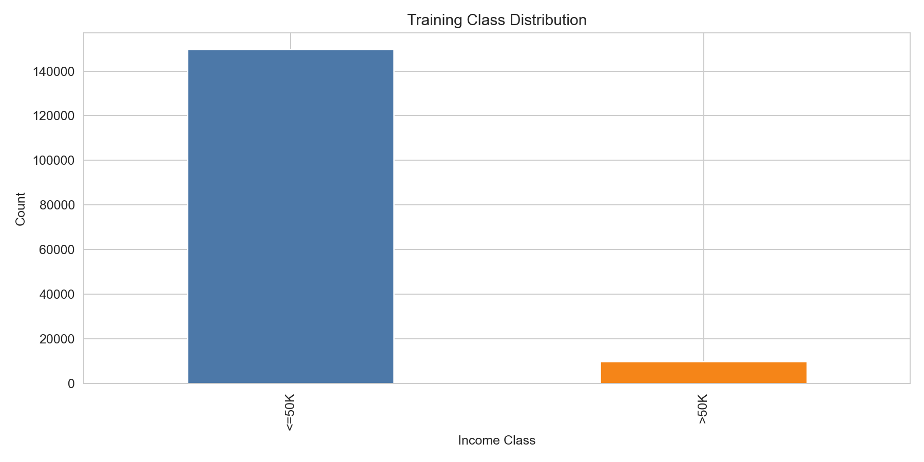
Figure: Training Class Distribution

Classification Model Comparison (PR-AUC)
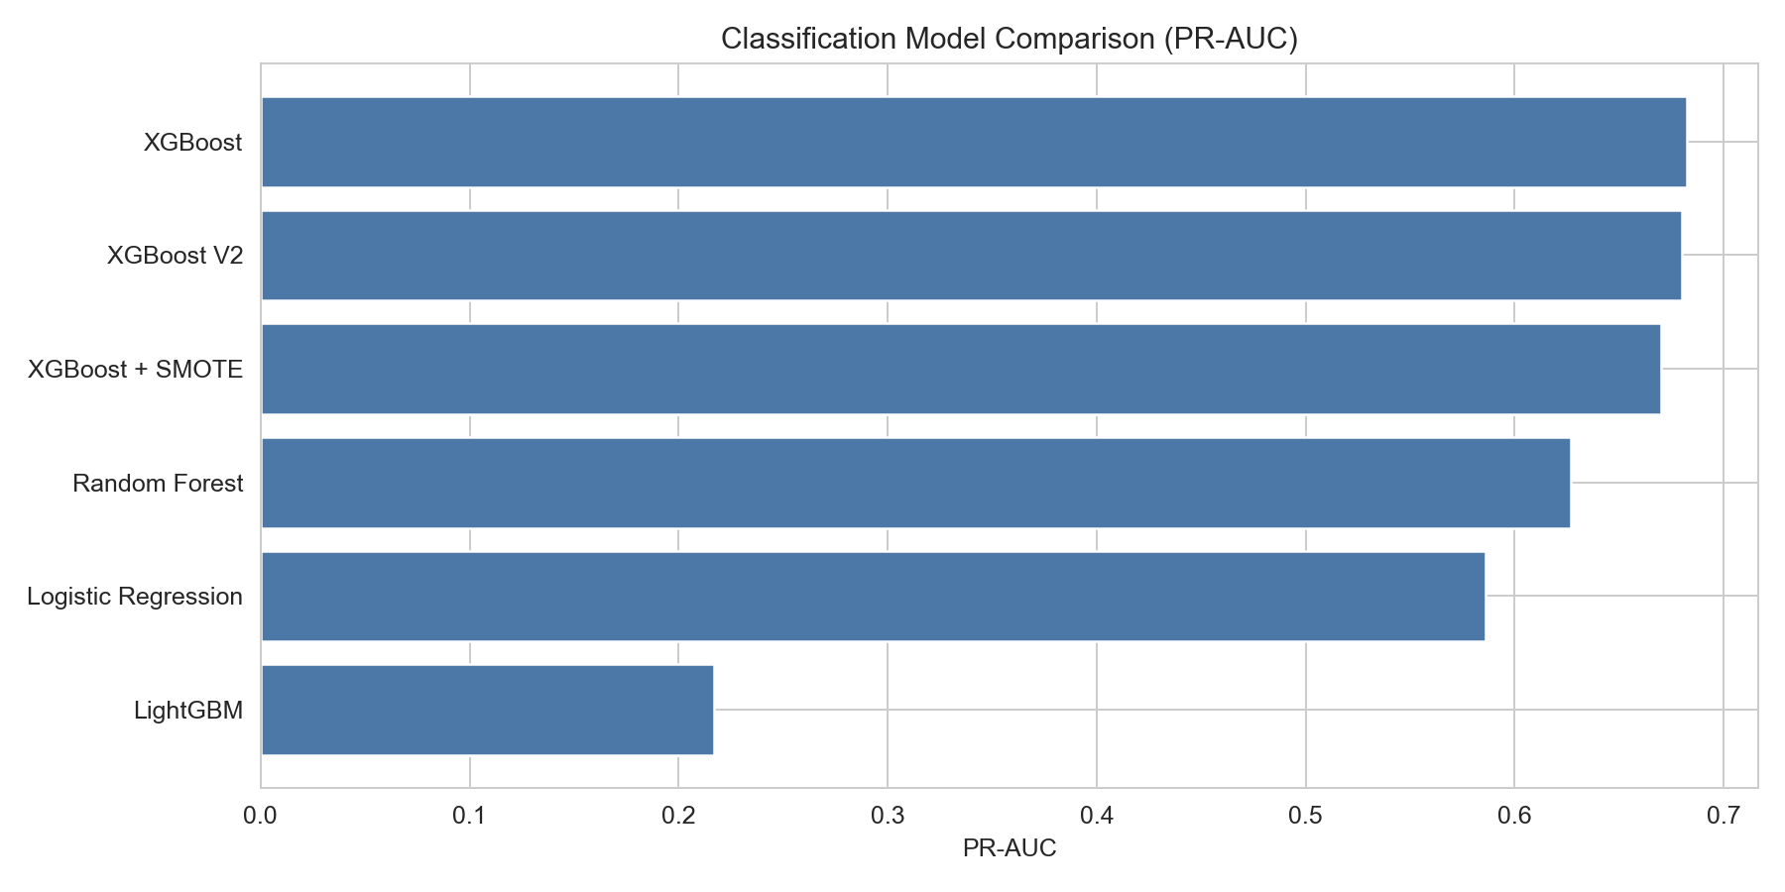
Figure: Classification Model Comparison (PR-AUC)

Best Model Confusion Matrix
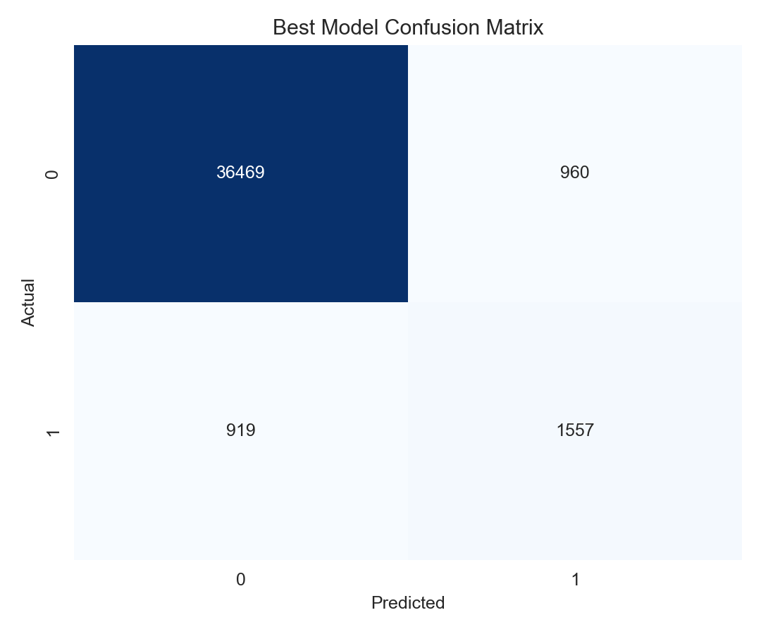
Figure: Best Model Confusion Matrix

Segment Sizes
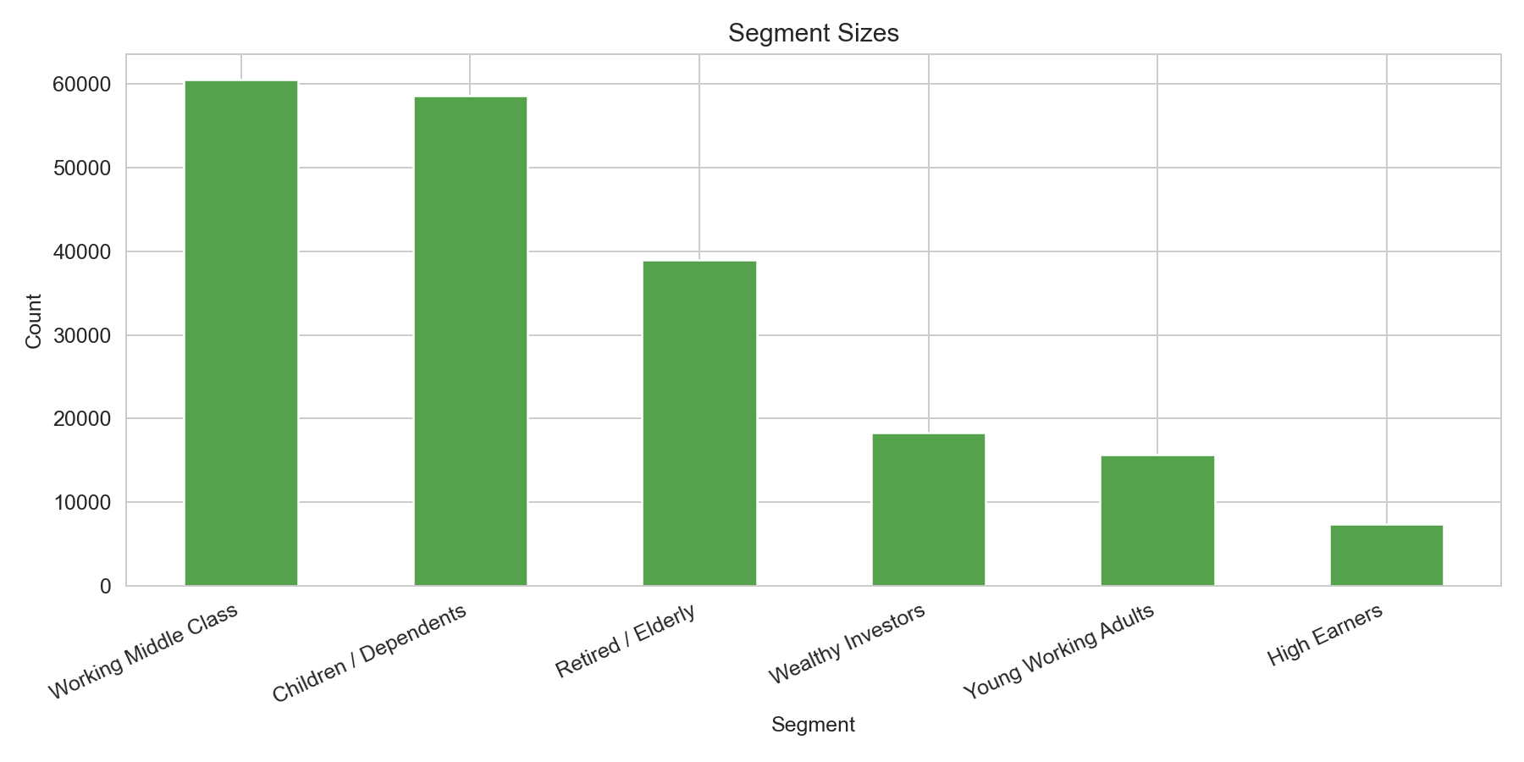
Figure: Segment Sizes

High-Income Rate by Segment
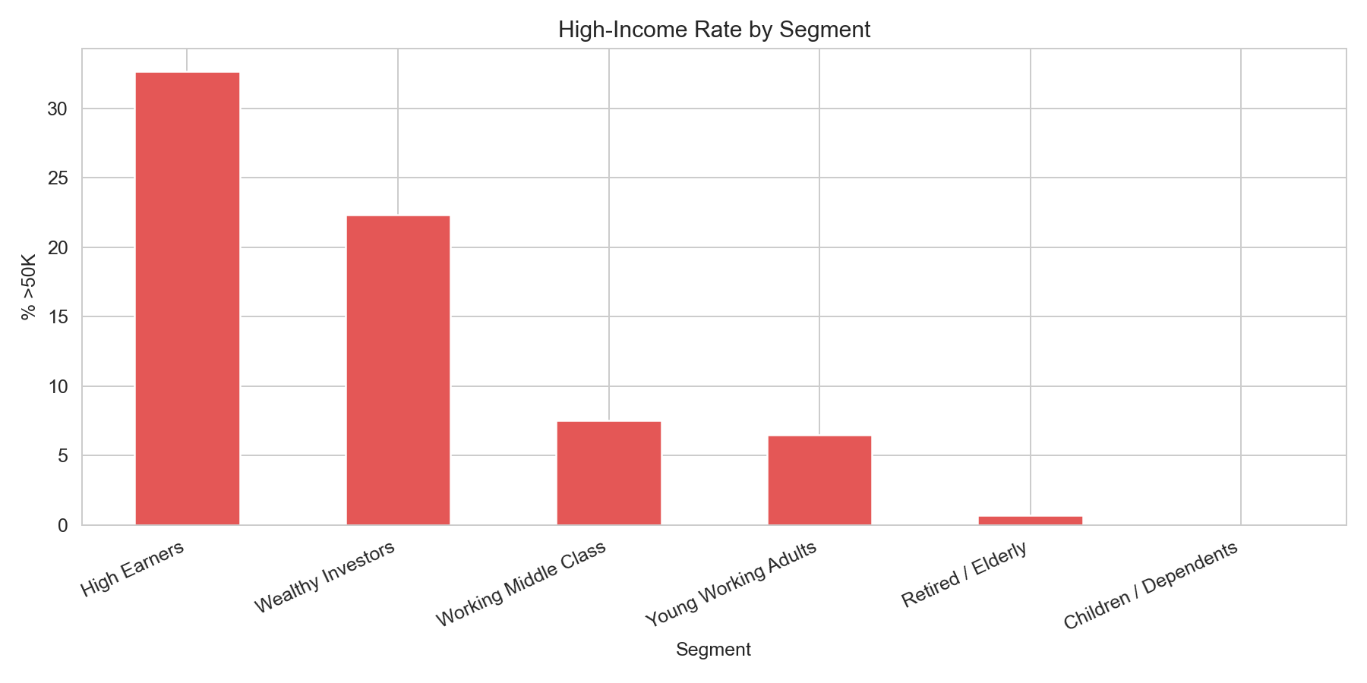
Figure: High-Income Rate by Segment

Segmentation in PCA Space
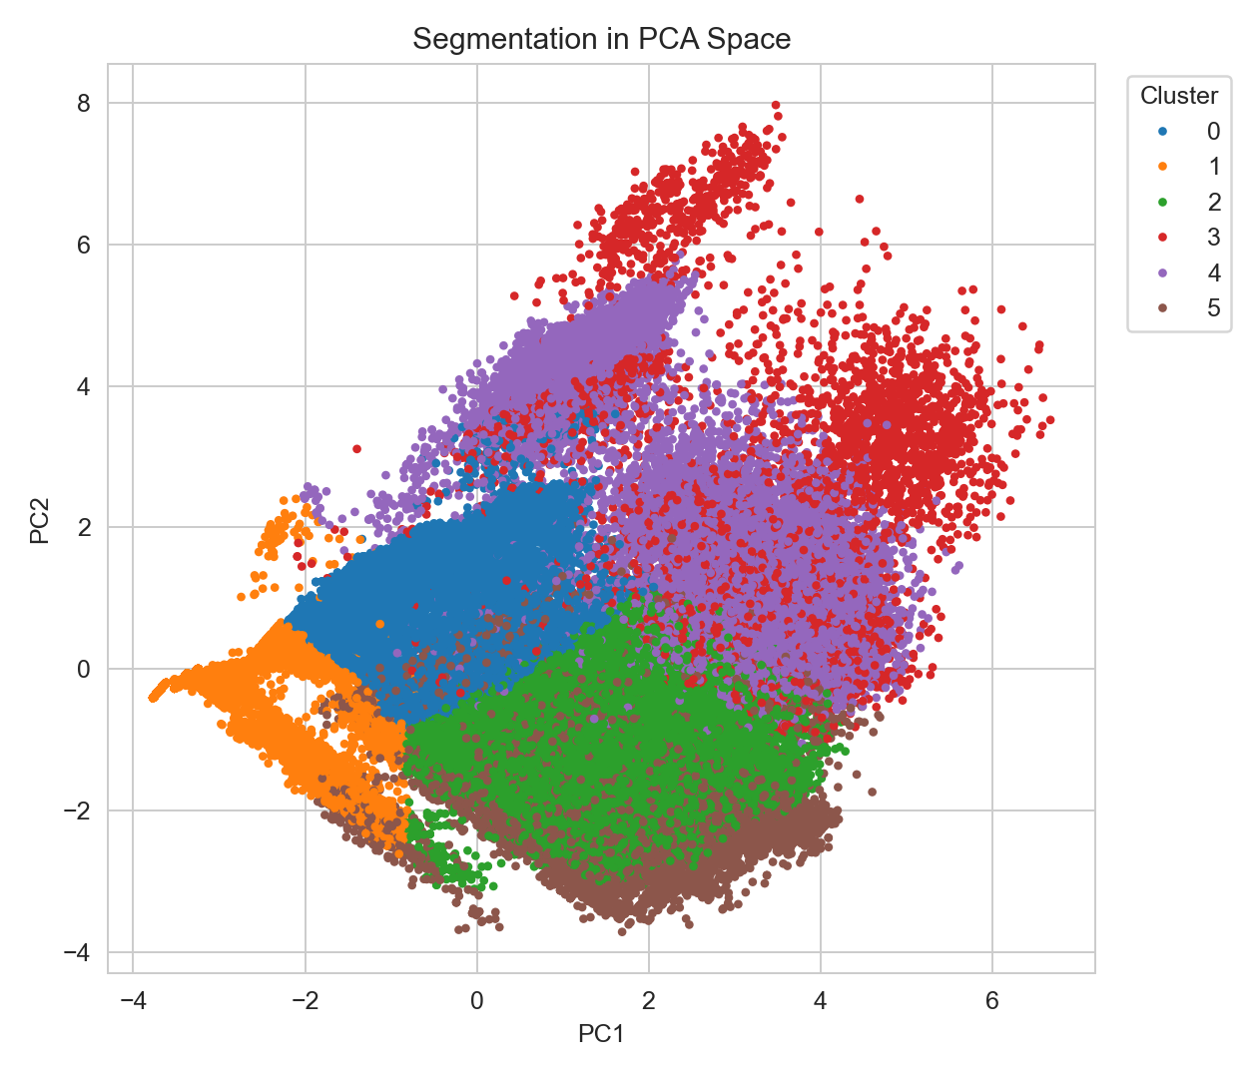
Figure: Segmentation in PCA Space

9. References
- Scikit-learn official documentation (model selection, metrics, PCA, KMeans).
- XGBoost documentation (classifier parameters and imbalance handling).
- LightGBM documentation (tree boosting and class weighting).
- CatBoost documentation (gradient boosting for structured data).
- Imbalanced-learn documentation (SMOTE strategy and caveats).
- Pandas and NumPy documentation for data processing operations.
- U.S. Census dataset documentation provided with the assignment files.

