Comprehensive Analysis Report: Classification and Segmentation

Project Scope
Objective 1: Income classification (>50K vs <=50K).
Objective 2: Customer segmentation for actionable marketing groups.

Data Exploration Summary
Raw data shape: 199523 rows x 42 columns. Categorical columns: 29, Numeric columns: 13.

Classification
This section documents preprocessing decisions, feature engineering, model selection, threshold tuning, and supporting evidence.

Table C1: Classification columns removed and rationale
column | decision | reason | missing_% | n_unique
year | removed | Dropped as temporal identifier with low direct predictive value in current setup | 0.0000 | 2
weight | removed | Sampling weight; not used as direct predictive feature in this modeling setup | 0.0000 | 99800
migration code-change in msa | removed | High missingness and weak business signal | 49.9700 | 9
migration code-change in reg | removed | High missingness and weak business signal | 49.9700 | 8
migration code-move within reg | removed | High missingness and weak business signal | 49.9700 | 9
migration prev res in sunbelt | removed | High missingness and weak business signal | 49.9700 | 3
country of birth father | removed | Sparse/high-cardinality; low incremental signal | 3.3600 | 42
country of birth mother | removed | Sparse/high-cardinality; low incremental signal | 3.0700 | 42
country of birth self | removed | Sparse/high-cardinality; partly captured by citizenship | 1.7000 | 42
state of previous residence | removed | Weak observed signal in notebook analysis | 0.3500 | 50
region of previous residence | removed | Weak observed signal in notebook analysis | 0.0000 | 6
fill inc questionnaire for veteran's admin | removed | Administrative field, low actionability | 0.0000 | 3
live in this house 1 year ago | removed | Weak observed signal in notebook analysis | 0.0000 | 3
hispanic origin | removed | Excluded in this project modeling choice to avoid direct sensitive-attribute usage | 0.4400 | 9
reason for unemployment | removed | Converted into binary signal and original dropped | 0.0000 | 6
enroll in edu inst last wk | removed | Converted into binary signal and original dropped | 0.0000 | 3
family members under 18 | removed | Converted into binary signal and original dropped | 0.0000 | 5

Table C2: Classification preprocessing and encoding decisions
step | implementation | why
Target mapping | label mapped {'- 50000.': 0, '50000+.': 1} | Model-ready binary target
Binary encoding | sex mapped Male/Female to 1/0 | Compact encoding for binary feature
Ordinal encoding | education converted using ordered scale | Preserves ordinal education progression
One-hot encoding | race, marital stat, tax filer stat, household summary, citizenship, union | Converts nominal categories without imposing order
Target encoding | class of worker, major industry code, major occupation code, full/part-time stat, detailed family stat | Controls cardinality while retaining signal
Train-test split | stratified split with test_size=0.2, random_state=2401 | Preserves class ratio for fair evaluation

Table C3: Classification model performance comparison
model | roc_auc | pr_auc | f1_minority | recall_minority | precision_minority | threshold
XGBoost | 0.9531 | 0.6824 | 0.6237 | 0.6288 | 0.6186 | 0.7494
XGBoost V2 | 0.9532 | 0.6801 | 0.6272 | 0.6135 | 0.6415 | 0.8690
XGBoost + SMOTE | 0.9500 | 0.6701 | 0.6097 | 0.5658 | 0.6608 | 0.4261
Random Forest | 0.9465 | 0.6267 | 0.5874 | 0.6002 | 0.5751 | 0.7735
Logistic Regression | 0.9392 | 0.5861 | 0.5572 | 0.5404 | 0.5750 | 0.8793
LightGBM | 0.8080 | 0.2169 | 0.3043 | 0.4641 | 0.2264 | 0.0255

Model | PR-AUC | ROC-AUC | F1 minority | Recall minority | Precision minority | Threshold
XGBoost | 0.6824 | 0.9531 | 0.6237 | 0.6288 | 0.6186 | 0.749
XGBoost V2 | 0.6801 | 0.9532 | 0.6272 | 0.6135 | 0.6415 | 0.869
XGBoost + SMOTE | 0.6701 | 0.9500 | 0.6097 | 0.5658 | 0.6608 | 0.426
Random Forest | 0.6267 | 0.9465 | 0.5874 | 0.6002 | 0.5751 | 0.774
Logistic Regression | 0.5861 | 0.9392 | 0.5572 | 0.5404 | 0.5750 | 0.879
LightGBM | 0.2169 | 0.8080 | 0.3043 | 0.4641 | 0.2264 | 0.025
Best model selected by PR-AUC: XGBoost. Recommended operating threshold: 0.749. This threshold was chosen by maximizing F1 on precision-recall tradeoff, aligning with minority-class performance goals.

Threshold Decision (Recorded from Classification Notebook)
In the classification notebook, a final operating threshold of 0.749 was explicitly used for final scoring. To provide factual proof, the table below compares default threshold 0.5, notebook threshold 0.749, and the F1-optimized threshold computed from precision-recall tradeoffs on the same test set.

Table C4: Threshold comparison with factual metrics
threshold | accuracy | precision_minority | recall_minority | f1_minority | tp | fp | fn | tn | source
0.5000 | 0.9190 | 0.4201 | 0.8053 | 0.5522 | 1994 | 2752 | 482 | 34677 | default
0.7490 | 0.9529 | 0.6181 | 0.6288 | 0.6234 | 1557 | 962 | 919 | 36467 | notebook_selected
0.7494 | 0.9529 | 0.6186 | 0.6288 | 0.6237 | 1557 | 960 | 919 | 36469 | f1_optimized
Interpretation: moving threshold upward generally improves precision while reducing recall. The selected threshold is justified by better minority-class tradeoff (F1 and business tolerance for false positives vs false negatives).

Classification Visual Evidence
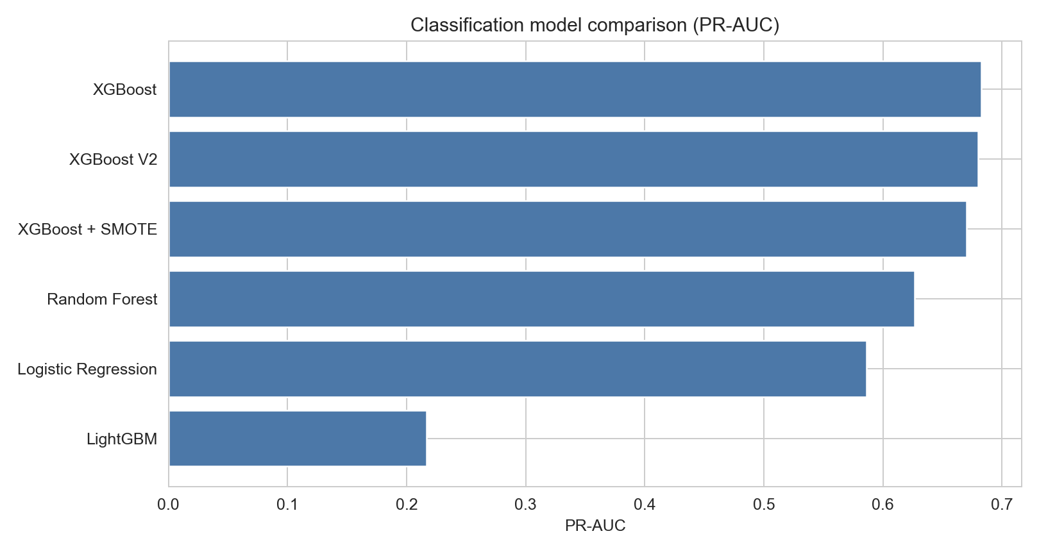
Figure C1: Model comparison by PR-AUC
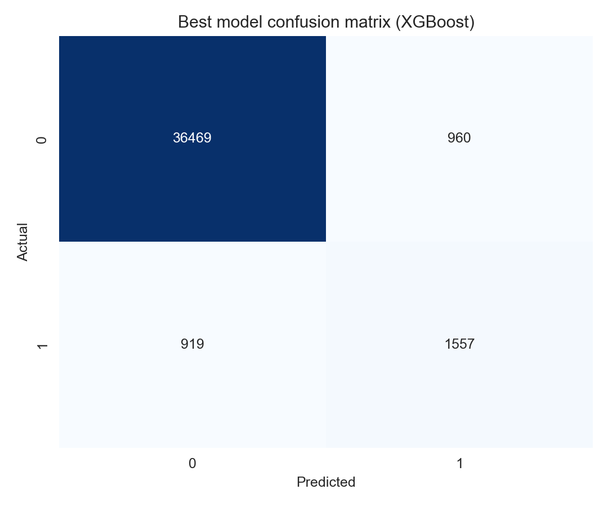
Figure C2: Confusion matrix for best classifier at optimized threshold
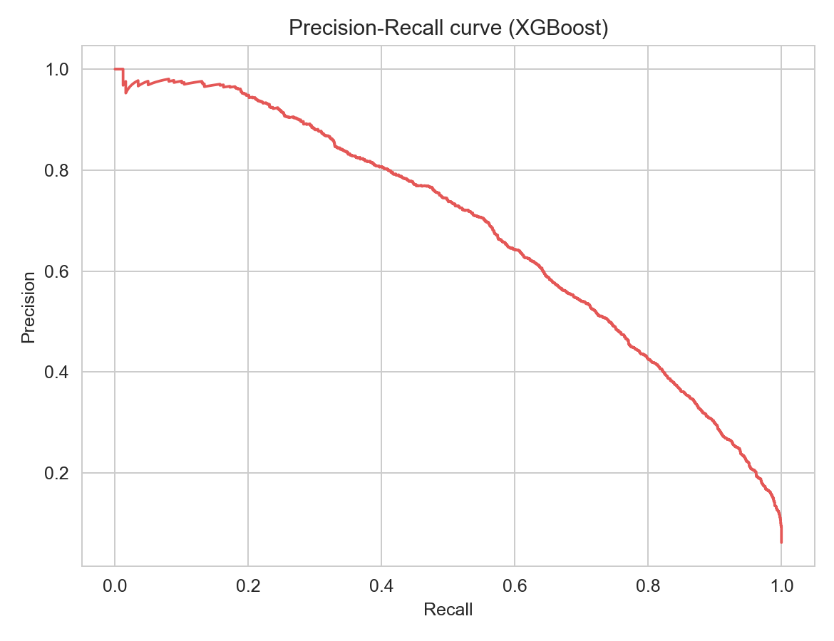
Figure C3: Precision-recall curve for best classifier
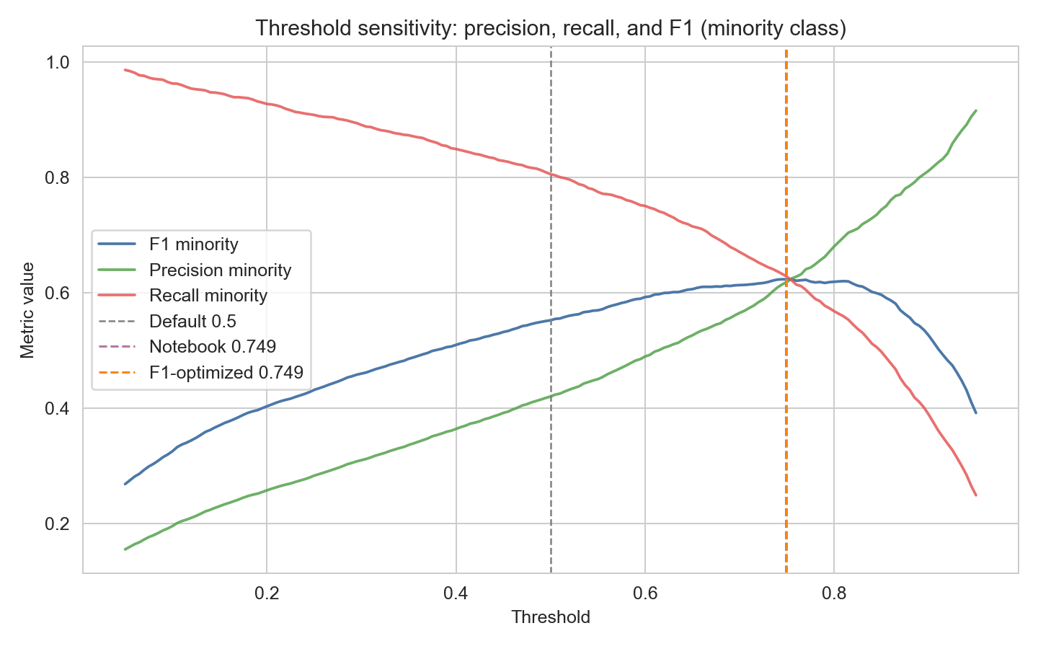
Figure C4: Threshold sensitivity curve with default, notebook, and optimized thresholds

Segmentation
This section documents feature selection, engineering, dimensionality reduction, k-selection evidence, and segment profiling.

Table S1: Segmentation feature selection and rationale
selected_feature | why_selected
age | Core demographic maturity proxy
education | Human capital
weeks worked in year | Work intensity
capital gains | Investment income behavior
dividends from stocks | Investment income behavior
family members under 18 | Household composition
own business or self employed | Entrepreneurship proxy
marital stat | Household stability/context
class of worker | Employment type
full or part time employment stat | Labor participation level
tax filer stat | Household tax profile
detailed household summary in household | Household role
major occupation code | Occupation group

Table S2: Segmentation transformations, engineered features, and pruning
feature_or_group | action | why
education | Ordinal mapping | To preserve education progression
marital stat | Ordinal/group mapping | To encode household-status gradient
class of worker | Ordinal/group mapping | To represent employment structure
full or part time employment stat | Ordinal mapping | To encode labor-force participation intensity
tax filer stat | Ordinal mapping | To encode filer complexity
detailed household summary in household | Ordinal mapping | To encode household role hierarchy
major occupation code | Ordinal mapping | To convert occupational groups for clustering
has_children | Engineered binary flag | Derived from family members under 18
has_capital_gains | Engineered binary flag | Captures non-zero gains behavior
has_dividends | Engineered binary flag | Captures non-zero dividends behavior
is_full_year_worker | Engineered binary flag | Captures 52-week work pattern
is_self_employed | Engineered binary flag | Captures entrepreneurship behavior
capital_gains_log | Log transform | Reduces right-skew
dividends_log | Log transform | Reduces right-skew
family members under 18, capital gains, dividends from stocks, own business or self employed | Dropped original columns after engineering | Avoid duplicate signal and collinearity with engineered features

Table S3: PCA components required by explained-variance threshold
threshold | components_needed
70% | 4
80% | 5
85% | 6
90% | 7

Table S4: k-selection evidence (inertia and silhouette)
k | inertia | silhouette
2.0000 | 1865292.79 | 0.3949
3.0000 | 1444619.81 | 0.4271
4.0000 | 1071751.16 | 0.4654
5.0000 | 807526.93 | 0.4992
6.0000 | 662772.21 | 0.5247
7.0000 | 578034.94 | 0.5155
8.0000 | 515158.47 | 0.5286
9.0000 | 462365.35 | 0.5353
10.0000 | 411415.17 | 0.5322
11.0000 | 378341.62 | 0.5309

Table S5: Final segment profile summary
segment | size | pct_of_population | pct_over_50k
High Earners | 7379 | 3.7000 | 32.6900
Wealthy Investors | 18319 | 9.1800 | 22.3400
Working Middle Class | 60558 | 30.3500 | 7.5700
Young Working Adults | 15704 | 7.8700 | 6.4800
Retired / Elderly | 39012 | 19.5500 | 0.7100
Children / Dependents | 58551 | 29.3500 | 0.0000
Decision proof for k=6: elbow-decay slows after mid-range k values and silhouette remains strong around k=6, providing a practical balance between separability and business actionability.

Segmentation Visual Evidence
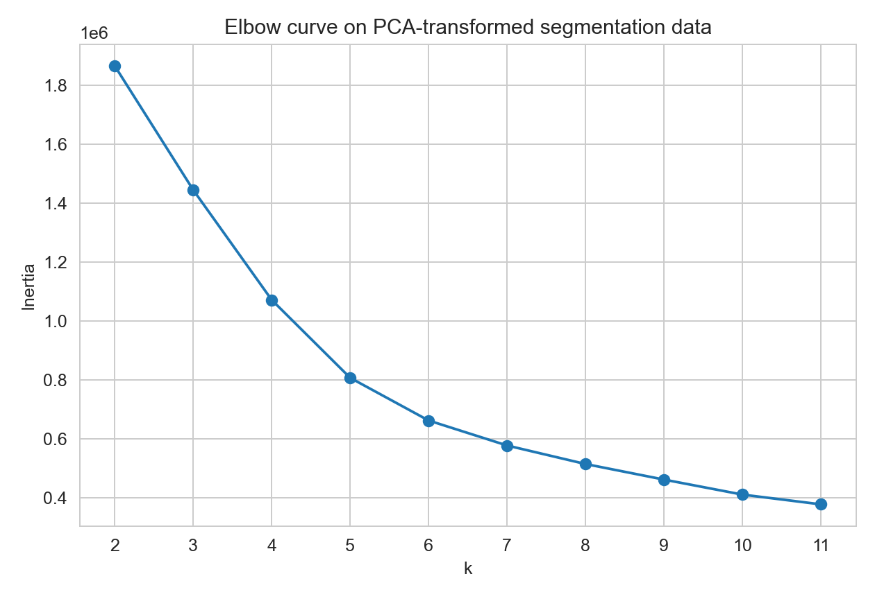
Figure S1: Elbow curve
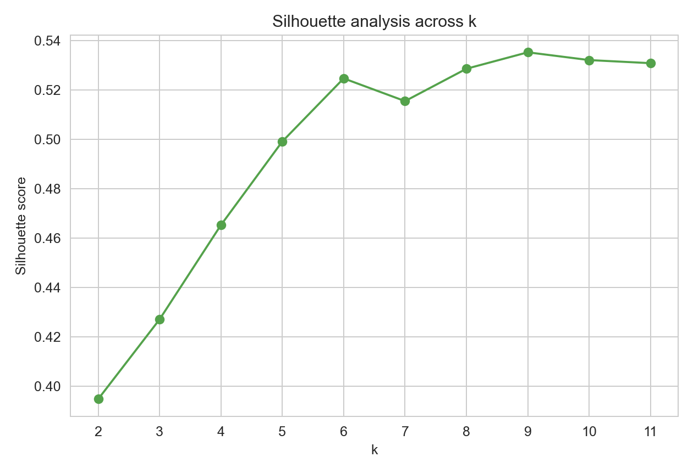
Figure S2: Silhouette curve
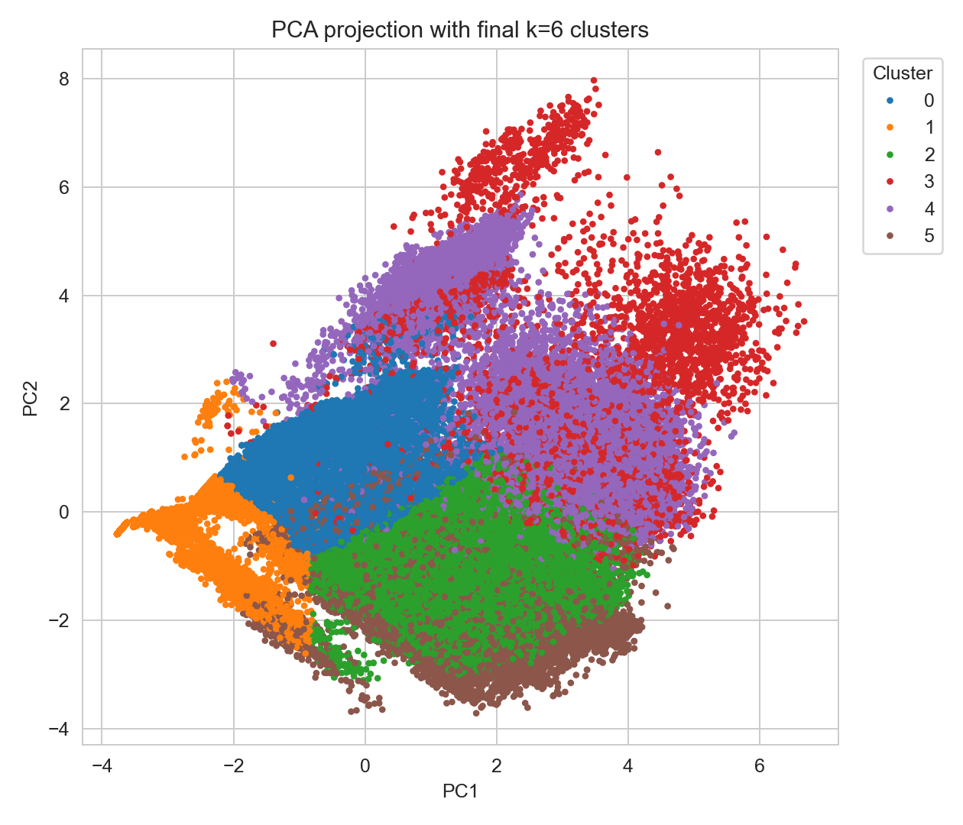
Figure S3: Final clusters in PCA space

Analysis Appendix
The following figures are extracted directly from notebook cell outputs to preserve full analysis traceability.

Figures from 01_eda.ipynb
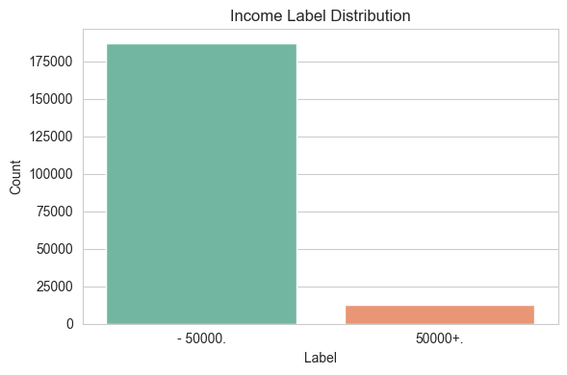
01_eda.ipynb - Cell 18 | Target Label Distribution
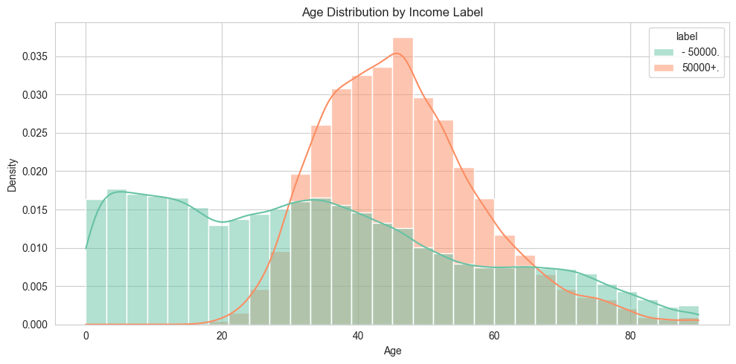
01_eda.ipynb - Cell 23 | Age v/s Income
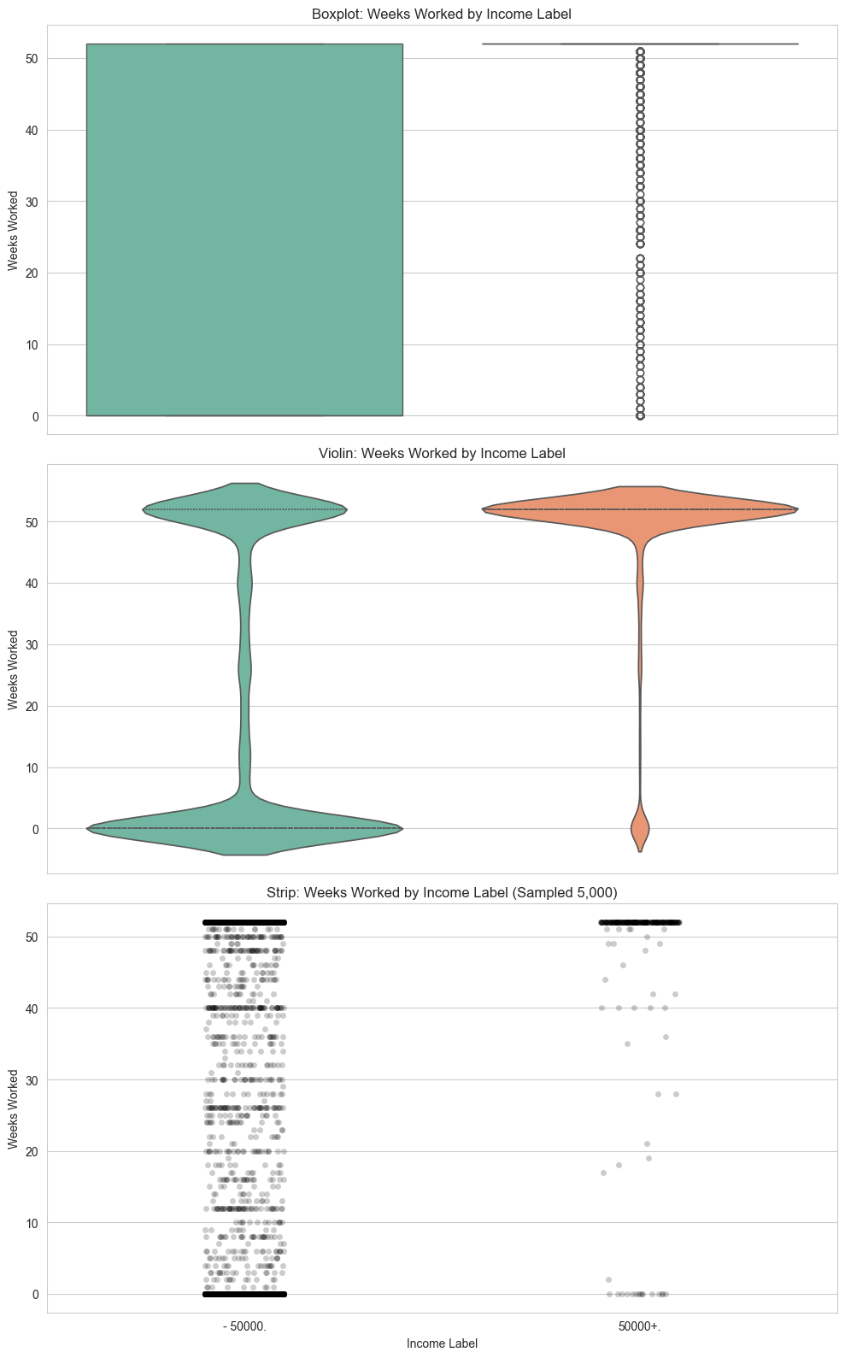
01_eda.ipynb - Cell 30 | Polishing the experimentation in the above code cell
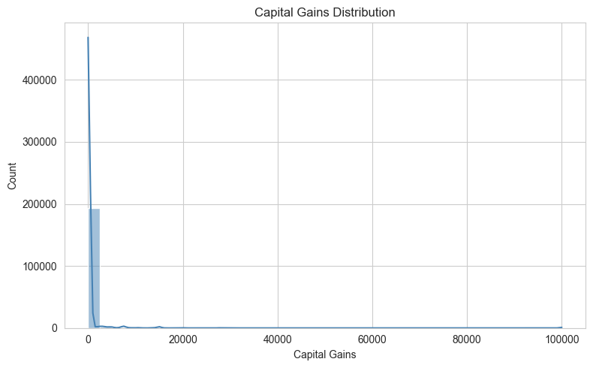
01_eda.ipynb - Cell 34 | Capital Gains
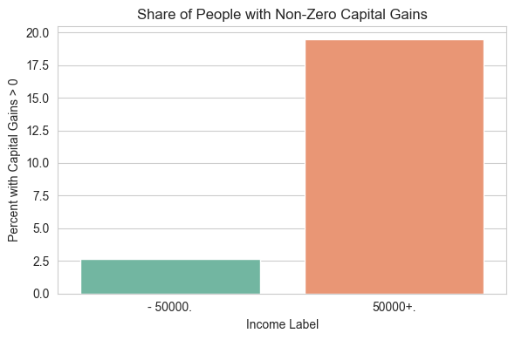
01_eda.ipynb - Cell 35 | Capital Gains
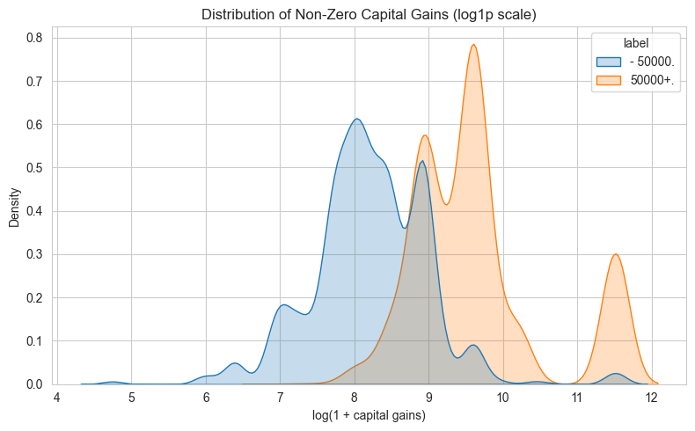
01_eda.ipynb - Cell 41 | Non-zero Capital Gains on a continuous projection to find Skewness
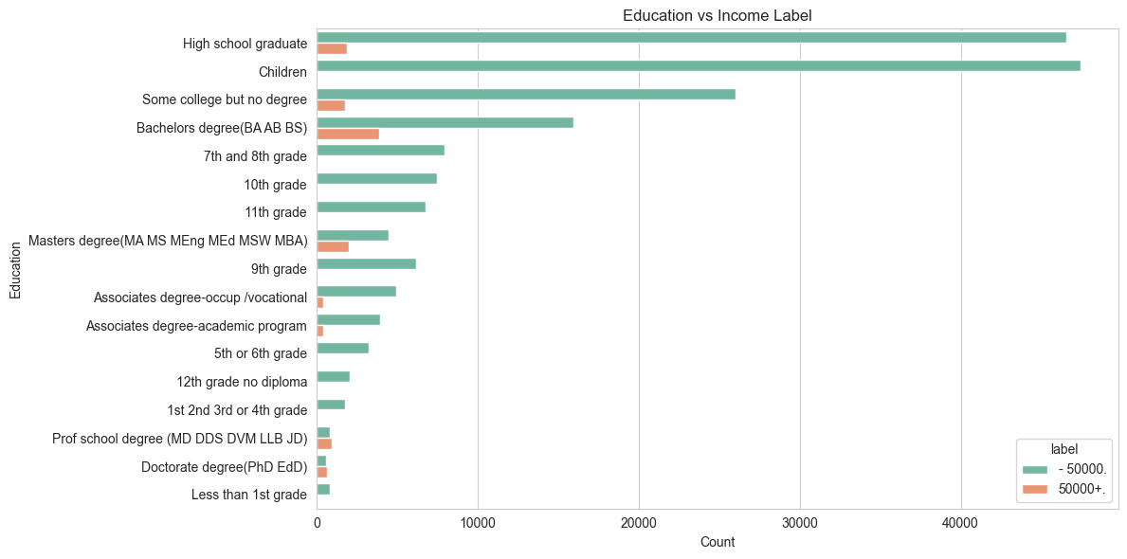
01_eda.ipynb - Cell 45 | Education v/s Income
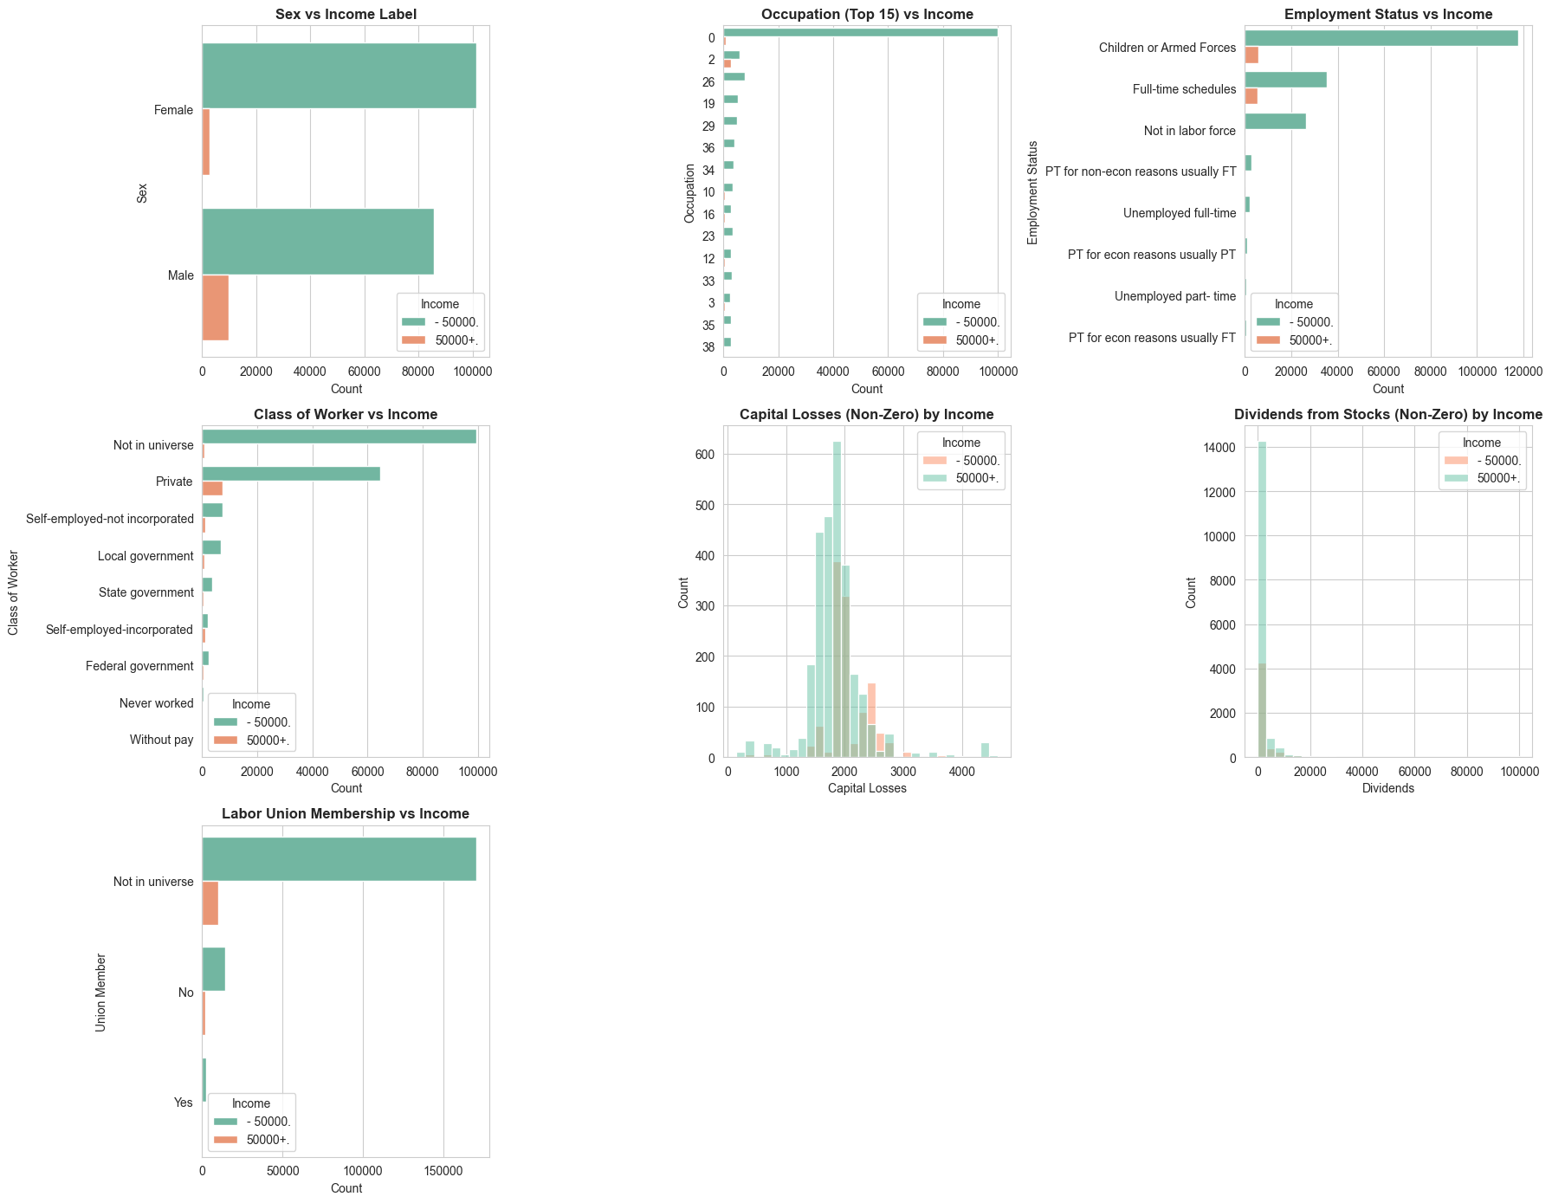
01_eda.ipynb - Cell 48 | Important Misc Plots
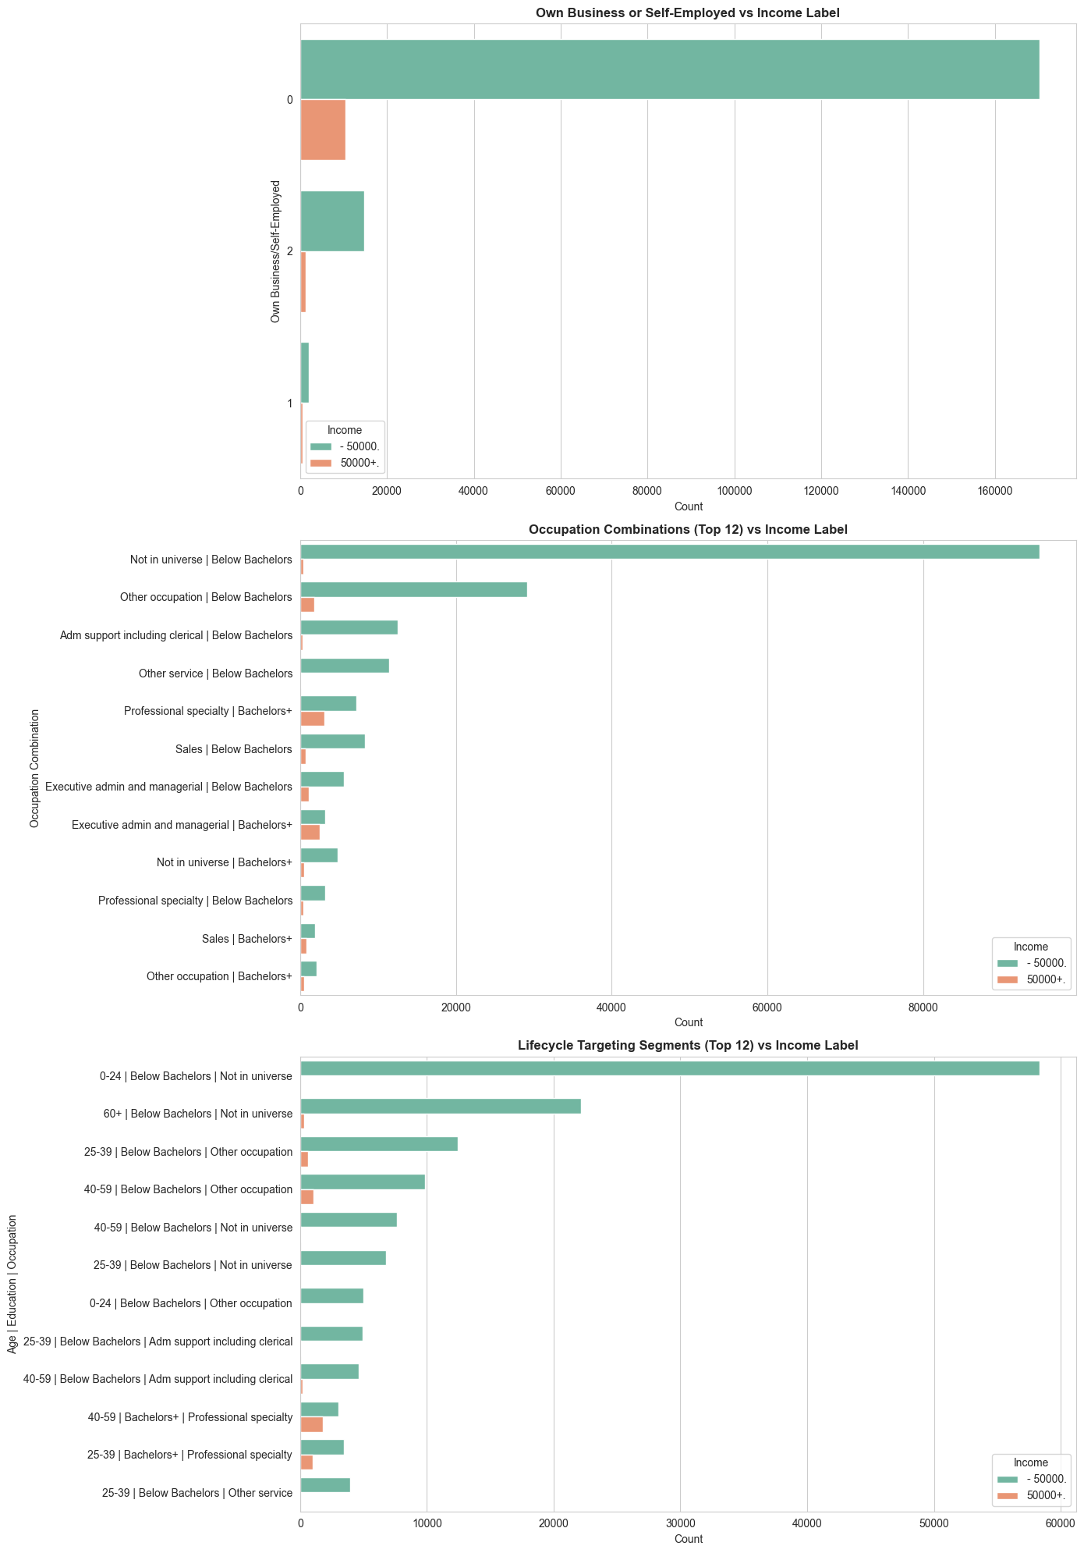
01_eda.ipynb - Cell 50 | Observation and Usability

Figures from 02_classification.ipynb
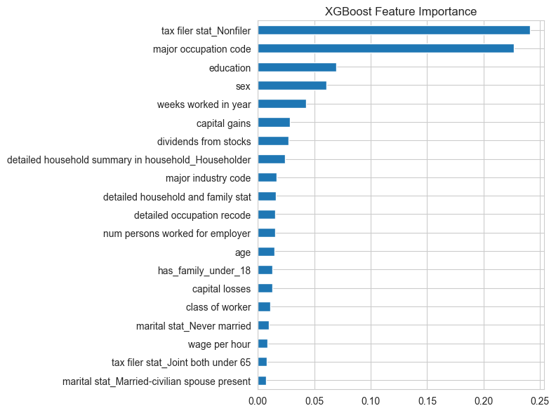
02_classification.ipynb - Cell 46 | Drop Noise Features

Figures from 03_segmentation.ipynb
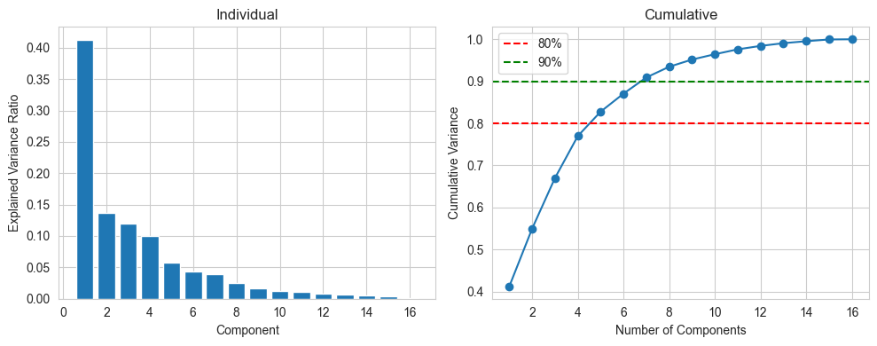
03_segmentation.ipynb - Cell 7 | Step 2: Determine Optimal Number of Clusters (Elbow Method using PCA)
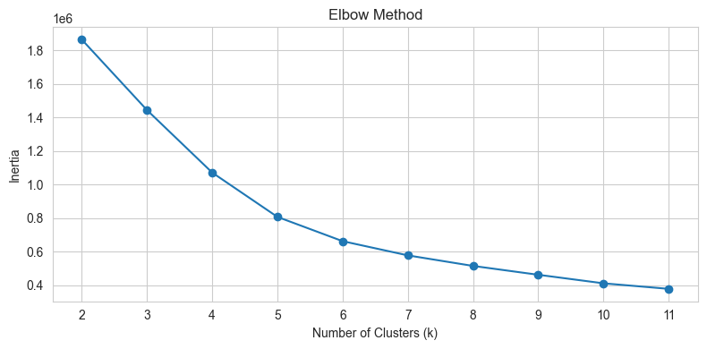
03_segmentation.ipynb - Cell 13 | Step 3: Train KMeans Model
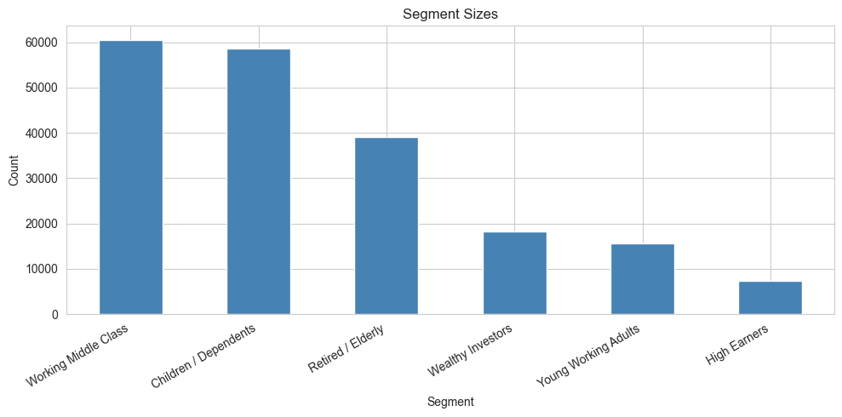
03_segmentation.ipynb - Cell 36 | Income Rate by Segment
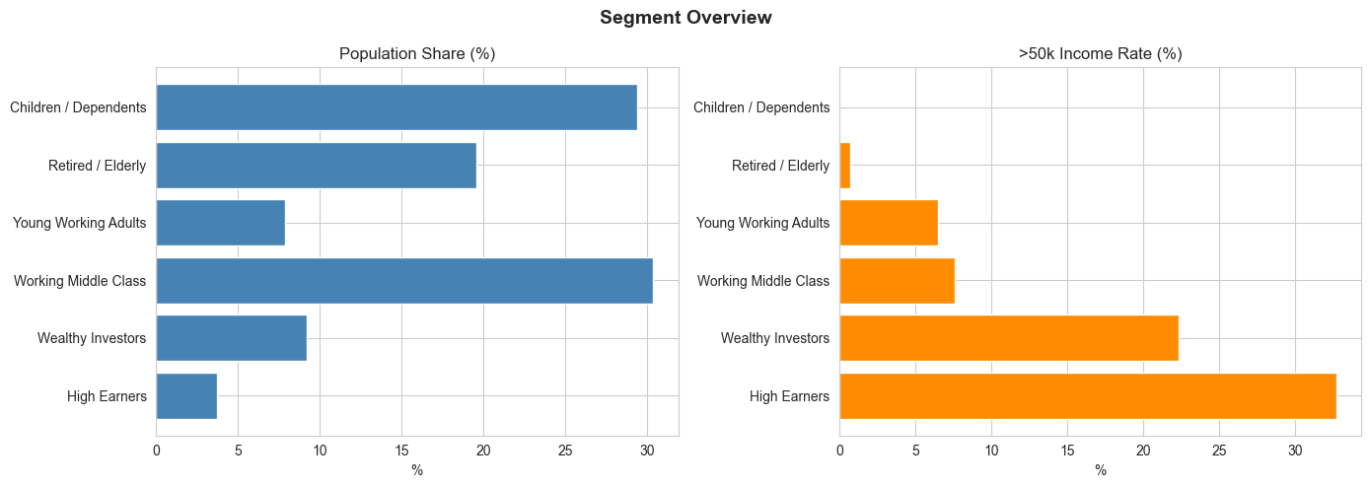
03_segmentation.ipynb - Cell 40 | Final Visualization
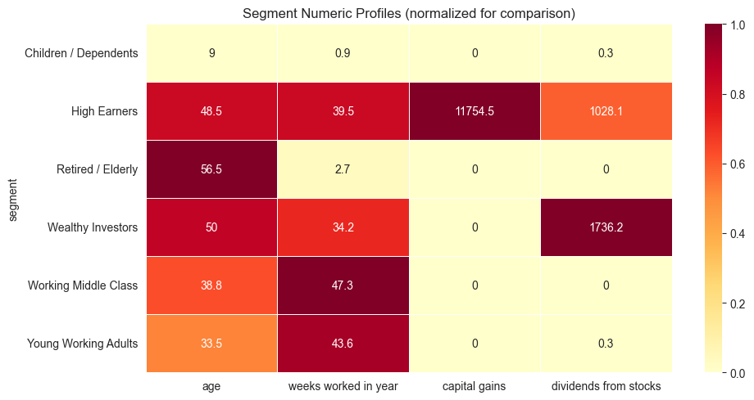
03_segmentation.ipynb - Cell 41 | Final Visualization
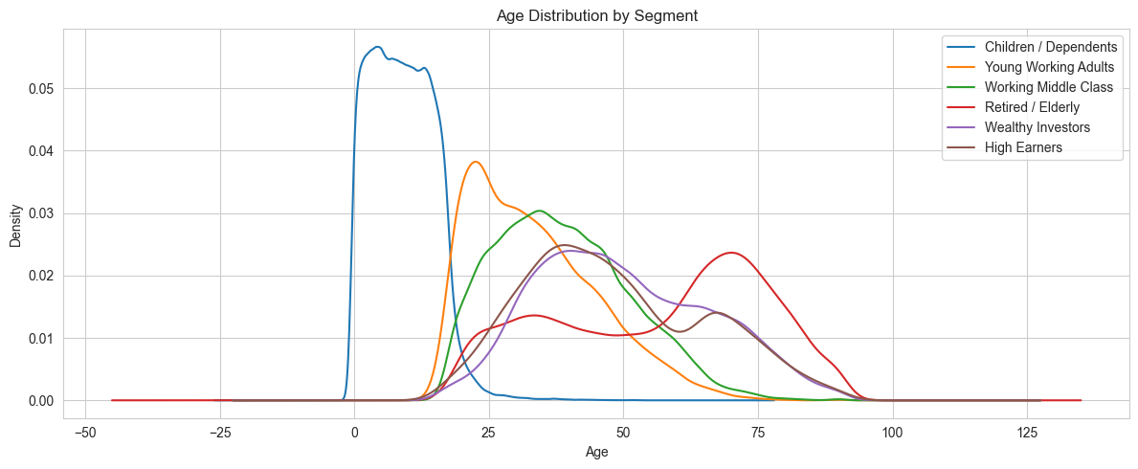
03_segmentation.ipynb - Cell 42 | Final Visualization
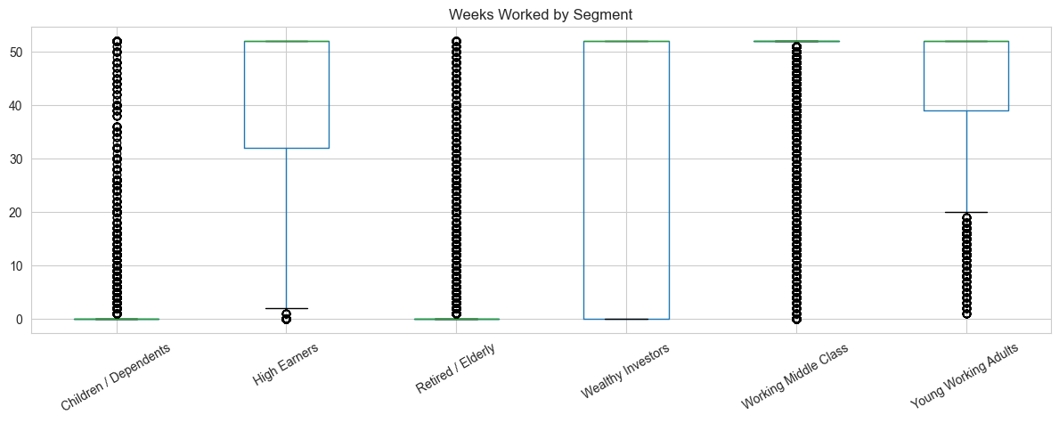
03_segmentation.ipynb - Cell 43 | Final Visualization
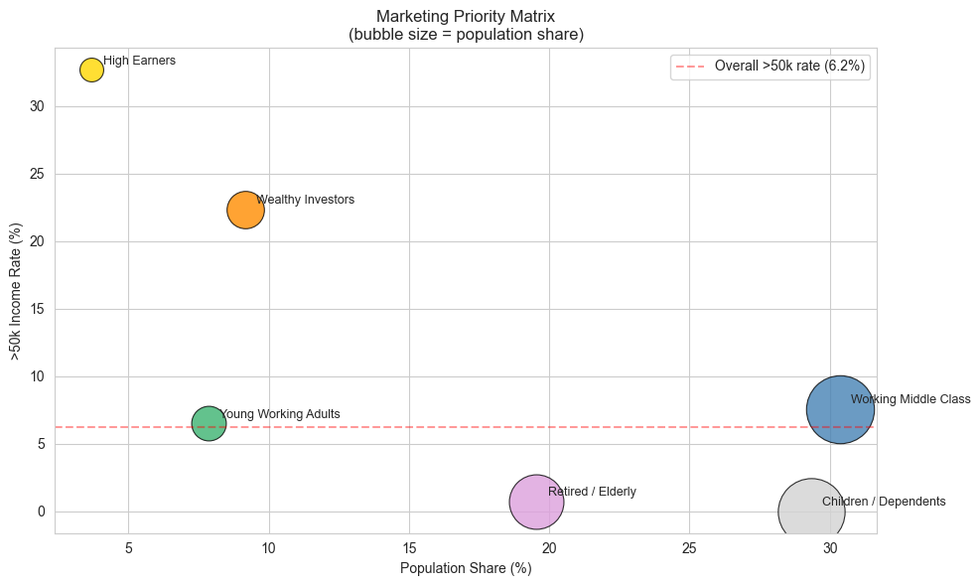
03_segmentation.ipynb - Cell 44 | Final Visualization

References
- Scikit-learn documentation: model selection, metrics, PCA, KMeans
- XGBoost documentation
- LightGBM documentation
- CatBoost documentation
- Imbalanced-learn documentation (SMOTE)
- Pandas and NumPy documentation
- Jupyter notebook outputs generated during project analysis

