**Online Retail Store Data Analysis Project Report**

**Table of Contents**

1. **Introduction**
   * Objectives
   * Tools Used
2. **Data Preparation and Cleanup**
   * Identified Issues
   * Cleanup Methods
3. **Analysis and Findings**
   * CEO-Focused Insights
     + Region-Based Revenue Analysis
     + Monthly Revenue Trends
     + Seasonality in Sales
     + Top Customers and Revenue Dependency
   * CMO-Focused Insights
     + Customer Retention and Repeat Purchases
     + Time Gap Between Purchases
     + Revenue from Repeat Customers
     + High-Frequency Customers and Revenue Contribution
4. **Visualizations**
   * Overview
   * Tabs and Their Content
5. **Conclusion and Recommendations**
6. **Appendices**
   * Raw Data Cleanup Example
   * Visuals and Files Information

**1. Introduction**

**Objectives**

This project focuses on analysing the operational performance, revenue generation, customer behaviour, and marketing strategies of an online retail store. The key stakeholders include the CEO and the CMO, whose questions guide the analysis.

**Tools Used**

* **Power BI**: For data visualization and interactive dashboards.
* **Excel**: For data cleaning, transformation, and preliminary analysis.

**2. Data Preparation and Cleanup**

**Identified Issues**

* **Negative Quantities**: Represent returns or erroneous data.
* **Invalid Unit Prices**: Unit prices below $0 are input errors.

**Cleanup Methods**

1. **Conditional Filtering**:
   * **Quantity**: Exclude data with quantities less than 1.
   * **Unit Price**: Exclude data with unit prices below $0.
2. **Data Transformation**:
   * Applied Excel formulas and Power BI transformations to ensure clean data for analysis.

**3. Analysis and Findings**

**CEO-Focused Insights**

**1. Region-Based Revenue Analysis**

**Question**: Which region is generating the highest and lowest revenue?

* **Findings**:
  + High-performing regions were identified.
  + Low-performing regions require strategic intervention.
* **Actions**:
  + Focus marketing and product strategies on underperforming regions.

**2. Monthly Revenue Trends**

**Question**: What is the monthly trend of revenue, and which months have experienced the biggest increase or decrease?

* **Findings**:
  + Clear seasonal peaks and dips identified.
  + Major growth or decline periods were highlighted.
* **Actions**:
  + Align marketing campaigns and stock availability with high-demand months.

**3. Seasonality in Sales**

**Question**: Which months generate the most revenue? Is there seasonality in sales?

* **Findings**:
  + Significant seasonality detected in sales trends.
* **Actions**:
  + Capitalize on peak periods through targeted promotions.

**4. Top Customers and Revenue Dependency**

**Question**: Who are the top customers, and how much do they contribute to total revenue?

* **Findings**:
  + High-revenue customers identified.
  + Revenue dependency analyzed.
* **Actions**:
  + Develop loyalty programs for top customers.
  + Diversify customer base.

**CMO-Focused Insights**

**1. Customer Retention and Repeat Purchases**

**Question**: What percentage of customers are repeat buyers? Are they ordering the same products or different ones?

* **Findings**:
  + High percentage of repeat customers ordering similar products.
* **Actions**:
  + Personalize marketing campaigns for repeat buyers.

**2. Time Gap Between Purchases**

**Question**: For repeat customers, how long does it take for them to place the next order after receiving their previous one?

* **Findings**:
  + Average time gap calculated.
* **Actions**:
  + Implement re-engagement campaigns at optimal intervals.

**3. Revenue from Repeat Customers**

**Question**: What revenue is being generated from customers who have ordered more than once?

* **Findings**:
  + Repeat customers contribute significantly to overall revenue.
* **Actions**:
  + Focus on retention strategies for high-value repeat customers.

**4. High-Frequency Customers**

**Question**: Who are the customers that have repeated the most, and how much are they contributing to revenue?

* **Findings**:
  + High-frequency, low-revenue customers identified.
  + High-revenue, infrequent buyers highlighted.
* **Actions**:
  + Optimize stock for high-frequency customers.

**4. Visualizations**

**Overview**

Each visual corresponds to a specific stakeholder question, providing actionable insights.

**Tabs and Their Content**

1. **Tab 1**: Monthly Revenue Trends (CEO Focused)

**Line chart**: The chart you provided represents the **Monthly Revenue Trends** for 2011 year, showing fluctuations in revenue generation across months

* + 1. The chart highlights the revenue performance for each month, with noticeable growth in revenue during the last quarter (October to November) and a sharp decline in December.
    2. The data indicates significant seasonality, with November having the highest revenue at approximately **1.51M**, suggesting peak sales during this period. December, despite being a festive month, shows a drastic revenue dip, likely due to reduced transactions or returns.
    3. There’s a gradual rise in revenue from July to November, indicating sustained business performance before the peak.

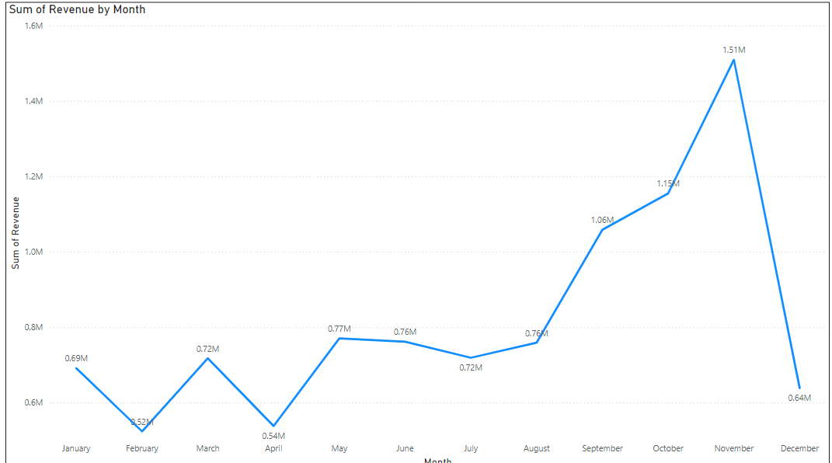

1. **Tab 2**: Top 10 Countries by Revenue (Excluding UK) (CMO Focused)

**Bar Chart:** This chart presents a comparison of the **Revenue** (light blue bars) and **Quantity** (dark blue bars) across different countries.

* + 1. The Netherlands and EIRE have the highest revenue (285K and 283K, respectively) and quantities sold (201K and 147K, respectively).
    2. Germany and France show strong revenue contributions (229K and 210K, respectively) but exhibit varying quantities sold (119K and 112K).
    3. Australia stands out with 139K revenue and 84K quantities sold, which may indicate a higher average price per unit.
    4. Countries such as Spain, Switzerland, Belgium, Sweden, and Japan generate lower revenue and quantities sold.

Insight:

Countries (e.g., Australia) have a notable difference between revenue and quantity sold, suggesting higher price points or premium product sales

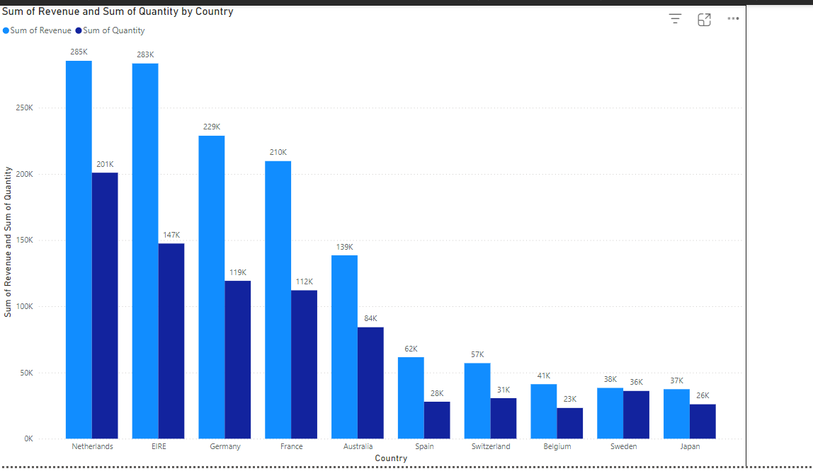

1. **Tab 3**: Top 10 Customers by Revenue (CMO Focused)

**Bar Chart:** The chart highlights the relationship between revenue (blue bars) and quantity sold (darker blue bars) across different countries

* + 1. Netherlands and EIRE lead in terms of both revenue and quantity, indicating strong sales and consistent demand.
    2. Germany and France also contribute significantly to revenue, though with slightly lower quantities compared to top performers.
    3. Australia and Spain show moderate performance with reasonable revenue but a drop in quantity.
    4. Countries like Sweden, Belgium, and Japan generate the lowest revenue and sell fewer quantities, indicating underperformance in these regions.
    5. Some countries have a higher revenue-to-quantity ratio (e.g., Germany and Australia), which is due high-value items being sold.

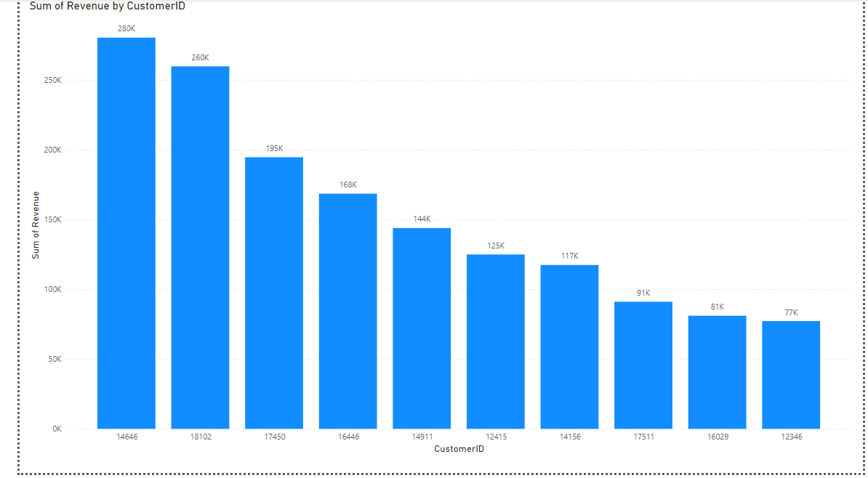

1. **Tab 4**: Regional Demand for Products (Excluding UK) (CEO Focused)

**Map**: The map showcases the geographical distribution of revenue, with bubble sizes representing revenue contribution from each region or country. Key insights:

1. **Europe** (e.g., France, Belgium) exhibits a concentration of high-revenue bubbles.
2. **Australia** is a notable contributor outside of Europe.
3. Smaller bubbles in **Canada, Singapore, and Japan** suggest emerging markets with potential for growth.

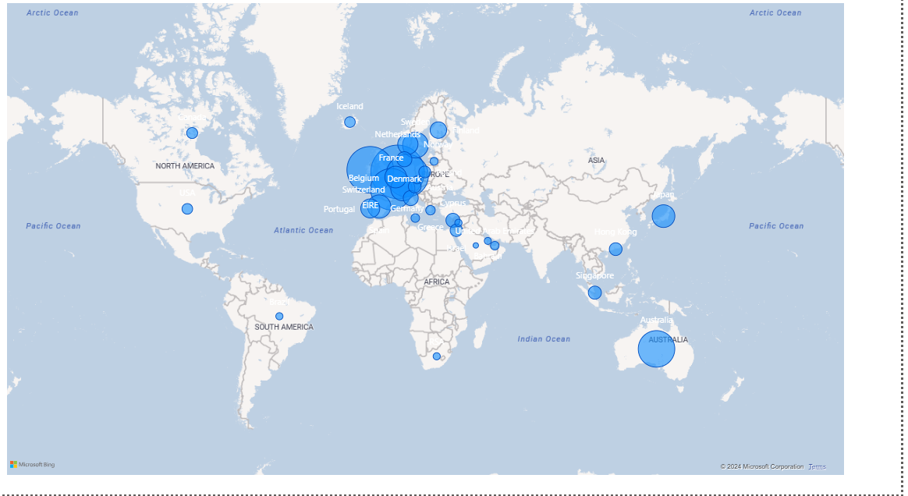

**5. Conclusion and Recommendations**

**Key Insights**

* Seasonal trends and high-revenue regions provide opportunities for growth.
* High repeat purchase rates underscore the importance of customer retention.

**Recommendations**

1. Strengthen marketing strategies in underperforming regions.
2. Align inventory management with seasonal peaks.
3. Develop personalized campaigns for top customers.
4. Leverage insights from repeat purchase patterns to enhance retention strategies.