Assignment - 1

Dheeraj Ippakayal 260240128013
Shree Koshti 260240128043

Folder created calc, added calc with addition then push to repo
then edited the calc in central repo with multiplication line there + commit
then edited the calc on local repo with subtraction line + commit + try push
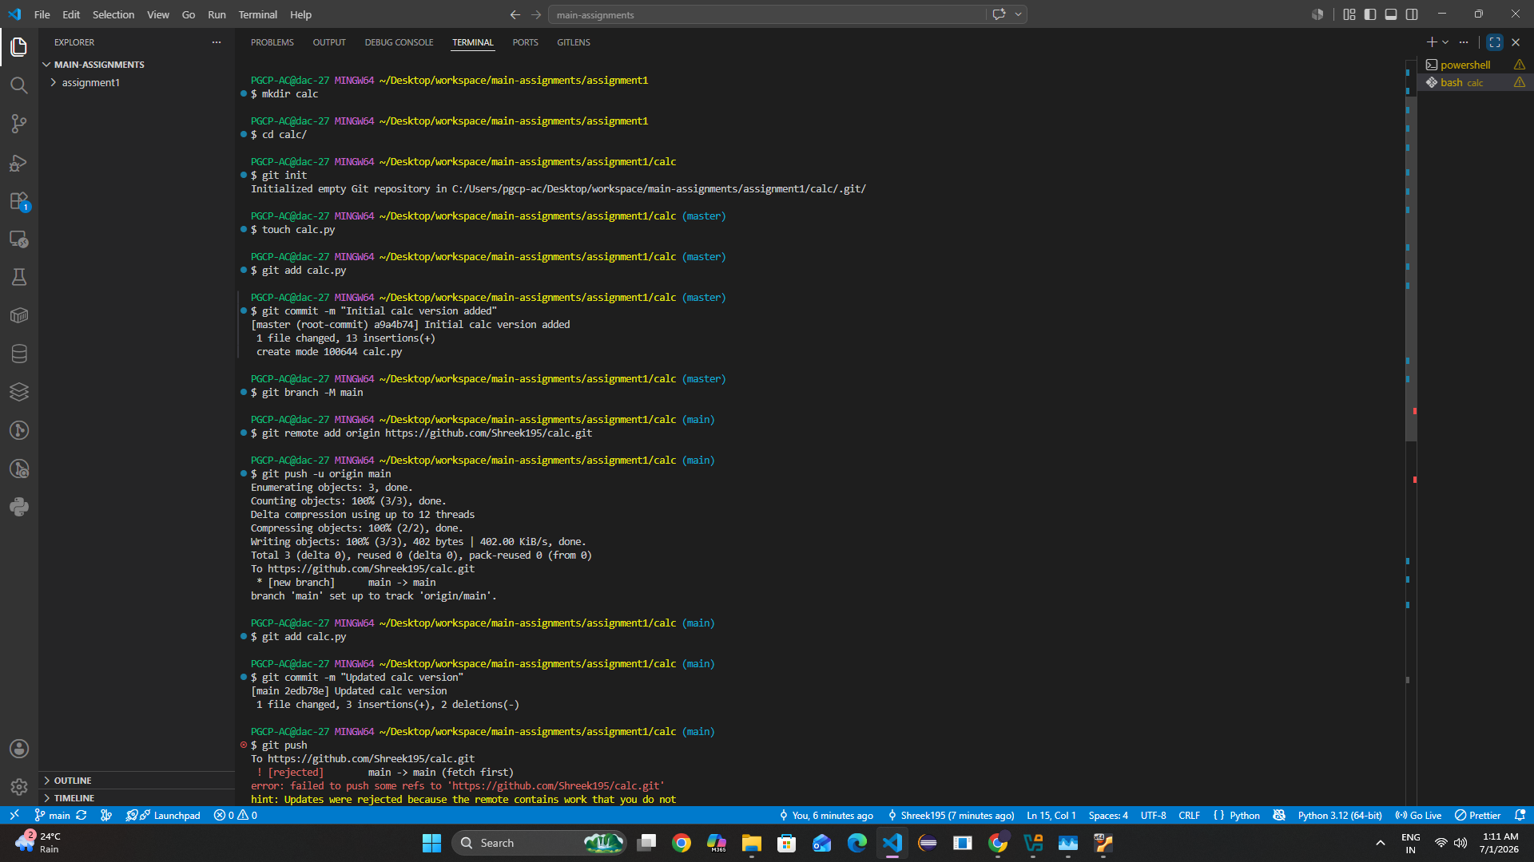

Git pull and accepted both the changes (local + central)
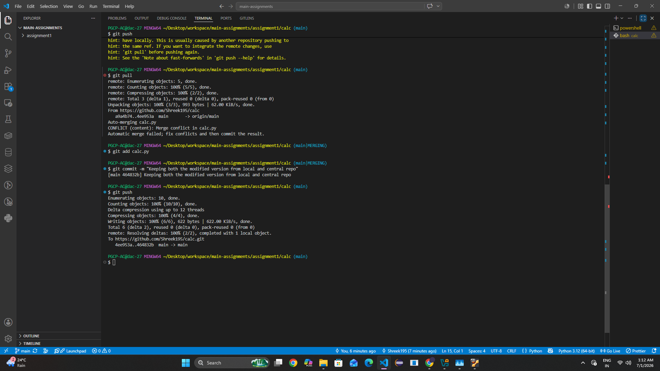

Accept both
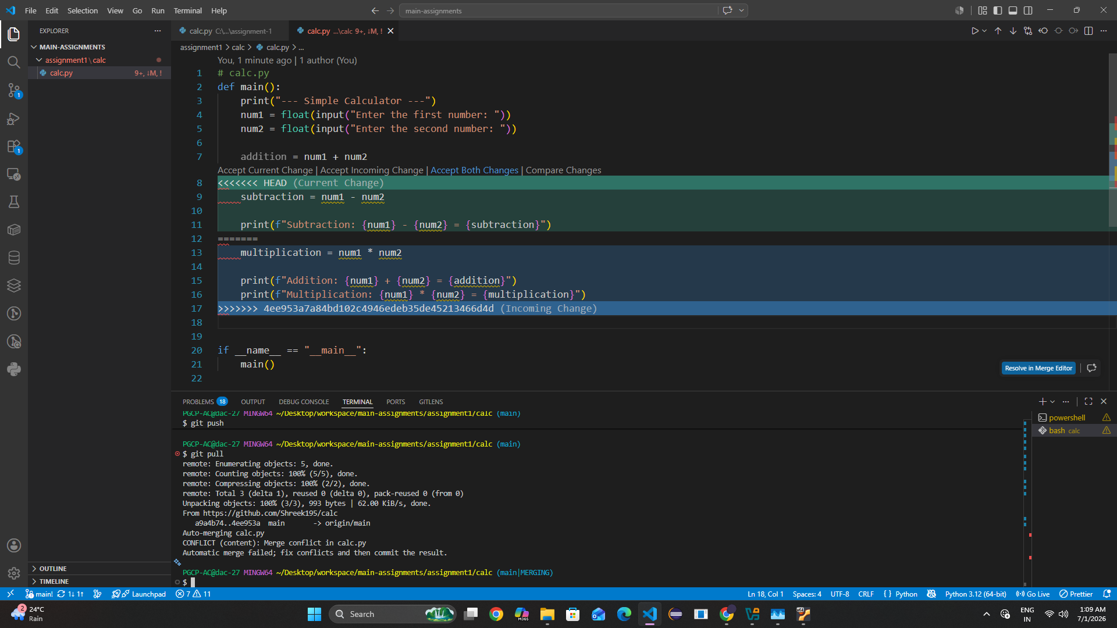

Git Hub final calc file
