Assignment - 3

Dheeraj Ippakayal 260240128013
Shree Koshti 260240128043

Part 1 (version 1):
Flask_app
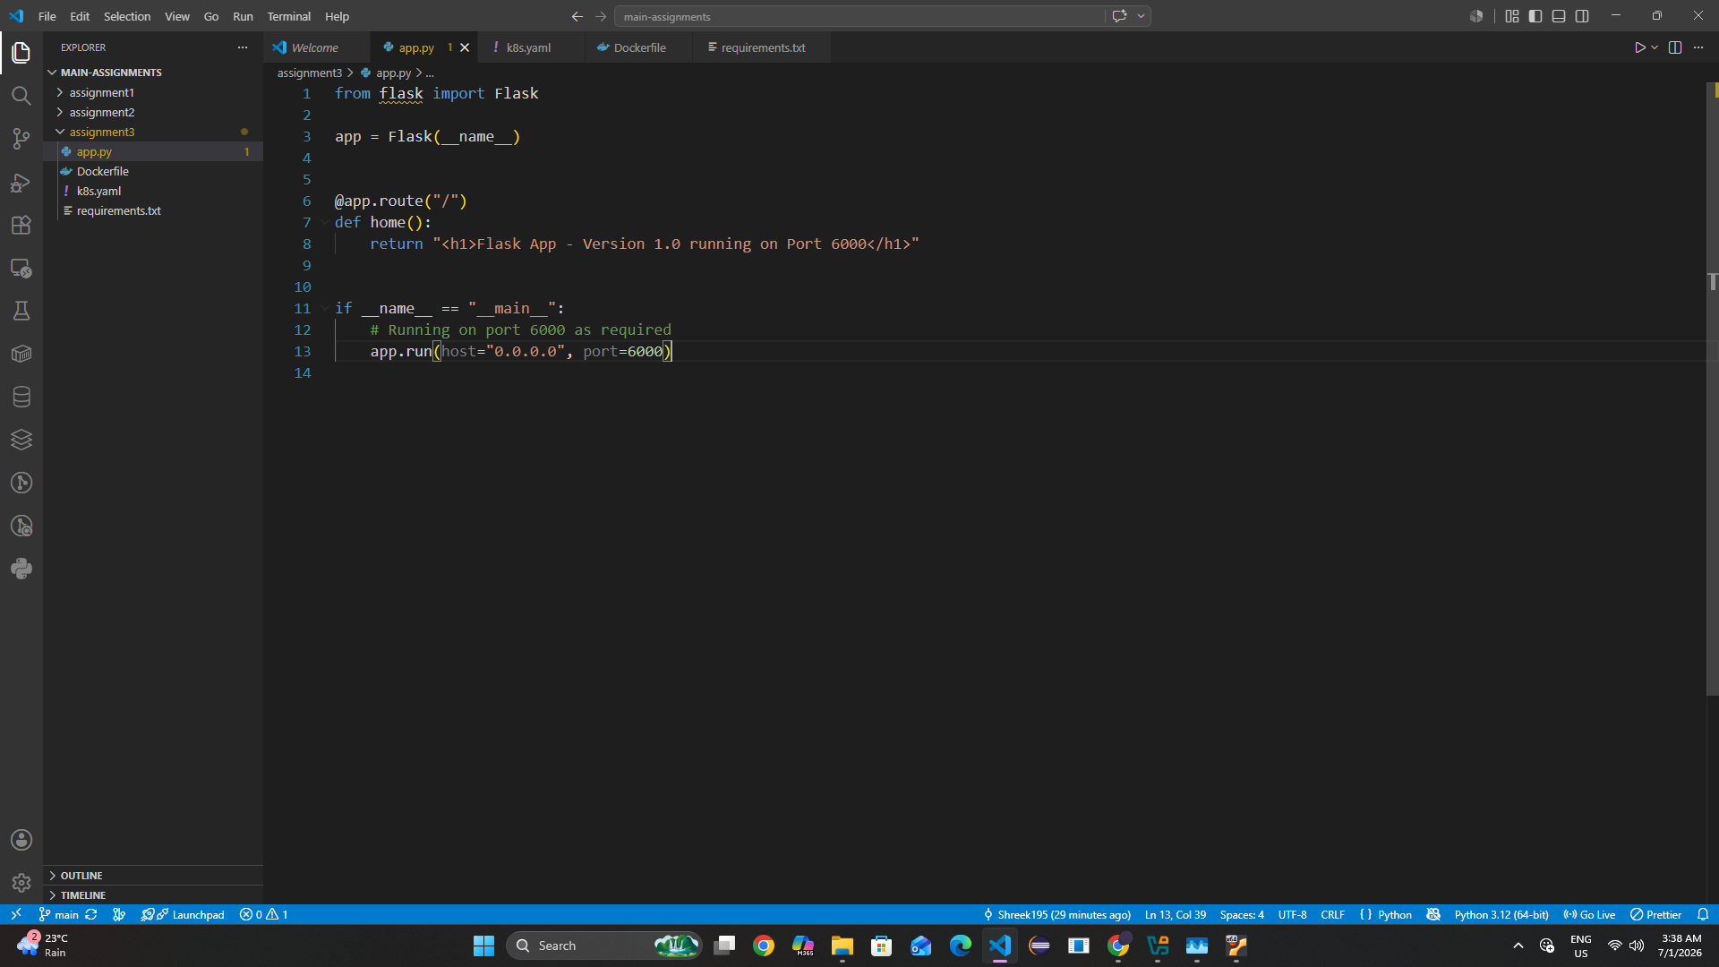

Dockerfile
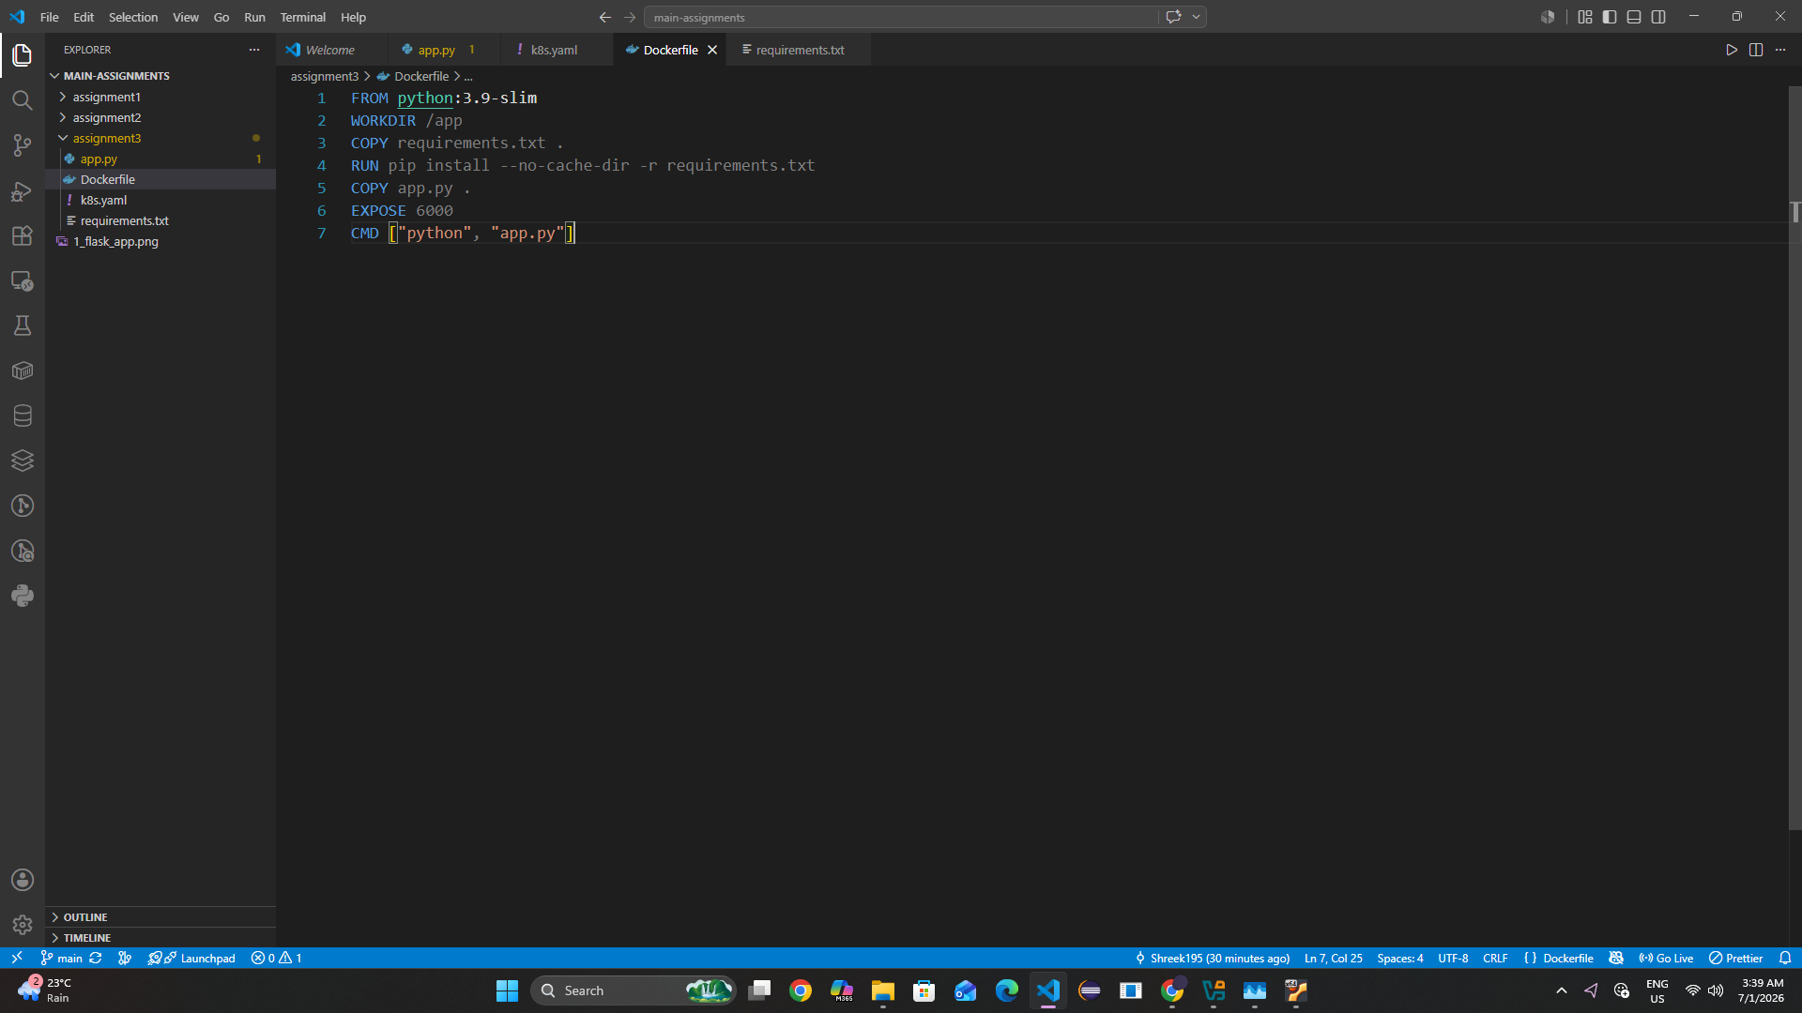

Requirements.txt
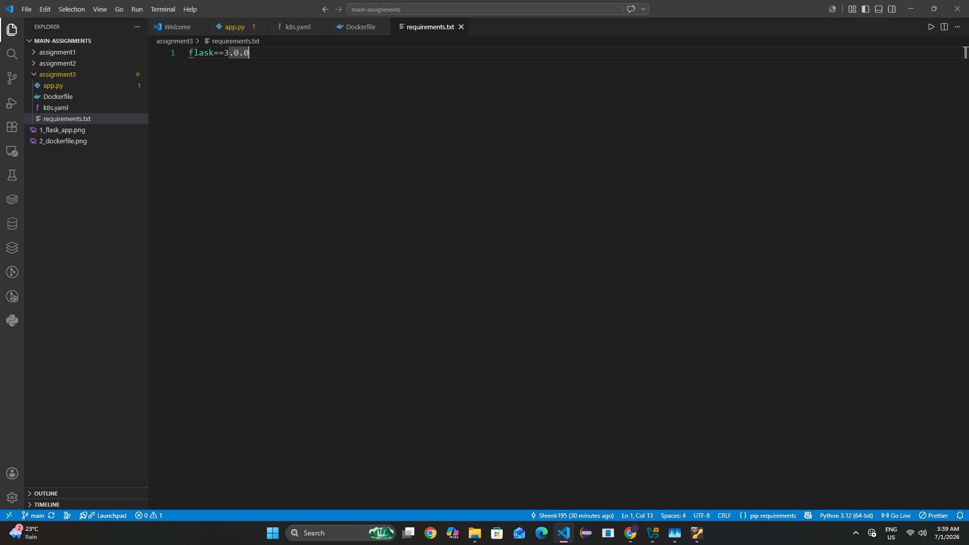

k8sFile.yaml <- contains all the kubernetes commands in single yaml file
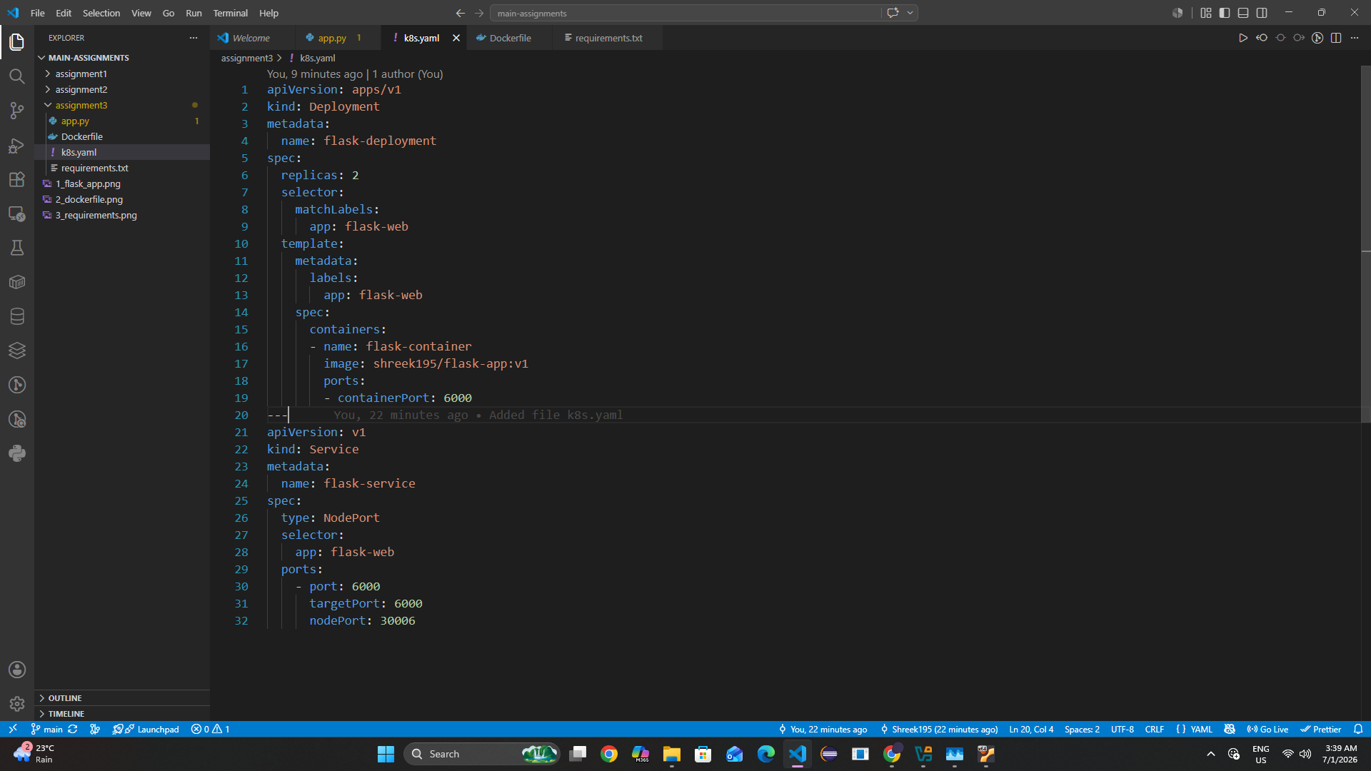

Starting the docker build, login, push
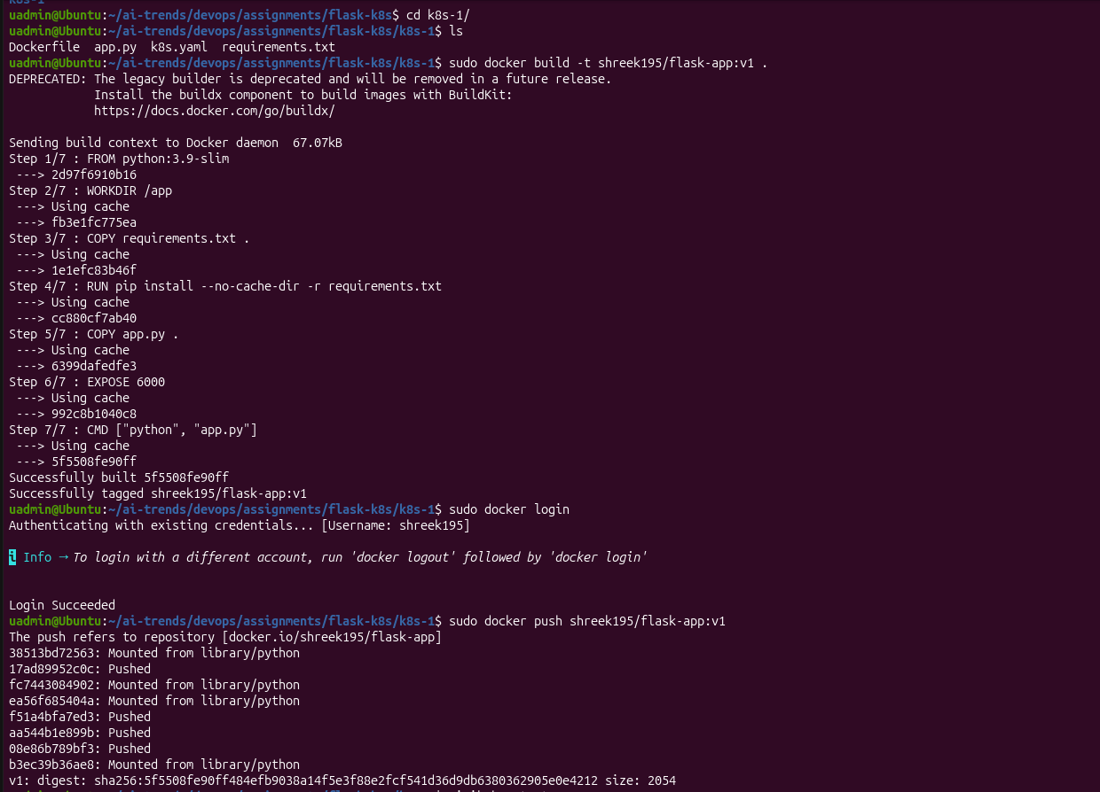

Starting the minikube and applying the yaml commands
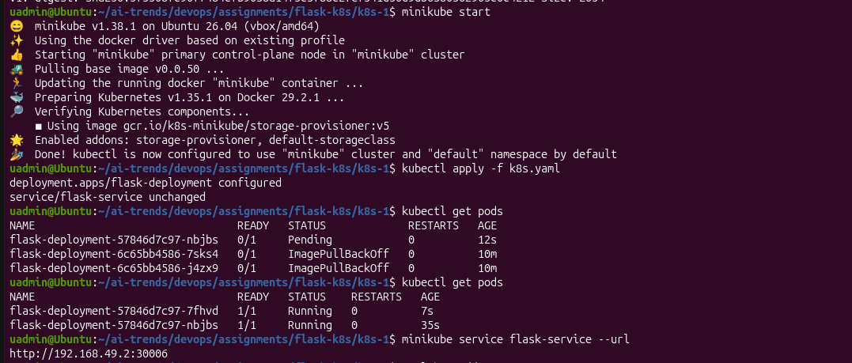

Flask-app version 1
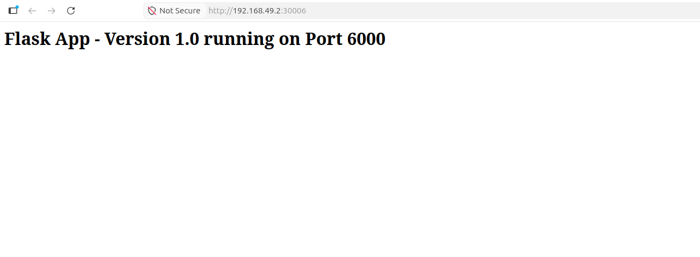

Part 2 (version 2):

Flask code updated v2
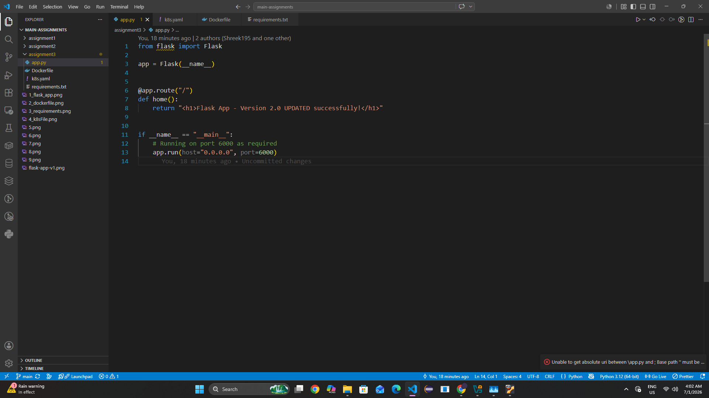

Dockerfile build and push
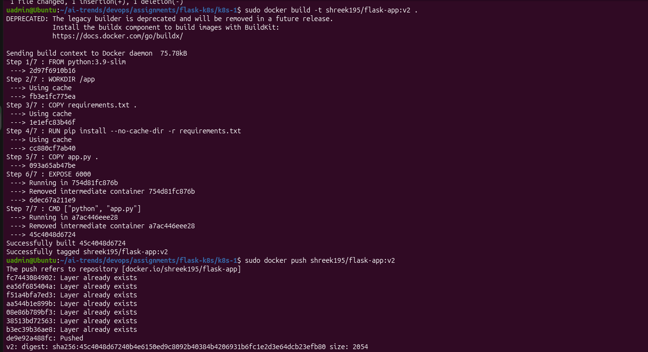

Set the new deployment and rollout previous from the workerNode


Flask-app version 2
