**Project Description:** In this project I’ve analysed the IMDB rating dataset for large no. of movies and found the insights as per requirements

**Approach:**

* Task 1: Cleaned the data means removed the columns that are not needed to solve the problem means they do not make any sense and also delete the rows with missing values
* Task 2: On a new worksheet created a column named Movie pasted all the movie names from the main sheet and then beside that created a column named profit which is difference between gross and budget and then sorted in descending order with respect to profit and made a chart that shows the movies with the profit greater than 20000000 because data is to large and difficult to show all on a single chart
* Task 3: Created a table that contain movie names IMDB rating and num_voted_users first sorted the table with IMDB rating and then sorted with the num_voted_users and then displayed top 250 movies and gave them a rank.

Then filtered the data with language to give non – English movies

* Task 4: Created a pivot table for directors names and their IMDB ratings and sorted the IMDB ratings then got the top 10 directors with highest IMDB ratings and then sorted with the directors name form A to Z and then made a pivot chart
* Task 5: Created a Pivot chart for the Genre and count of movies made in that genre sorted the count column and then took the top 10 genre to make a pivot chart
* Task 6: Created the columns as mentioned in the Question and then got the movies made by those actors and combined all the columns in one column named Combined. Created a pivot chart for the three actors and made the pivot chart to display the insights. Made a group of years with a stride of 10 and count of voted users in that decade and made a pivot chart.

**Tech-Stack Used:**

1. **MS Excel**
2. **MS Word**

**Insights:**

While doing this project I’ve got understanding about analysing of data creating a pivot table, charts and using some functions.

**Result:**

**1)Task 2:**

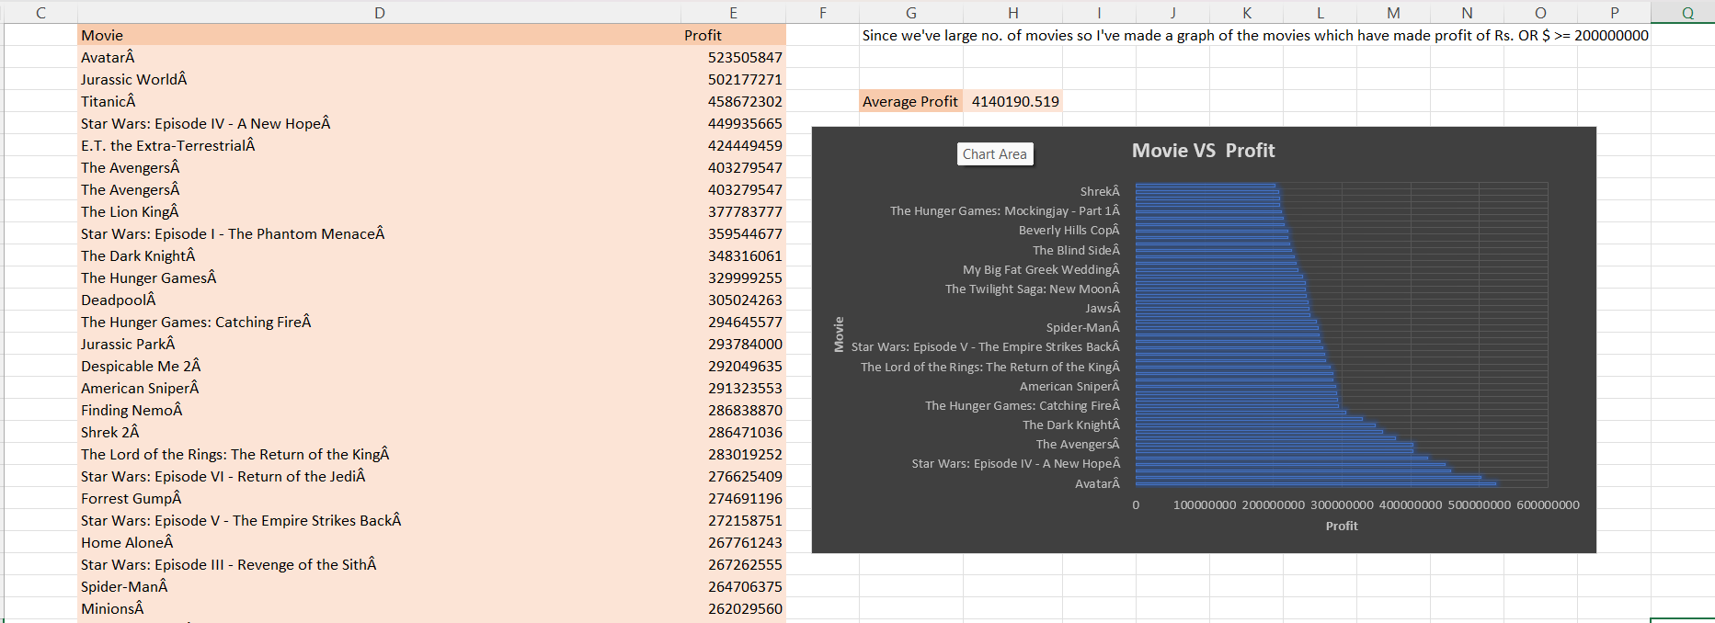

**2)Task 4:**

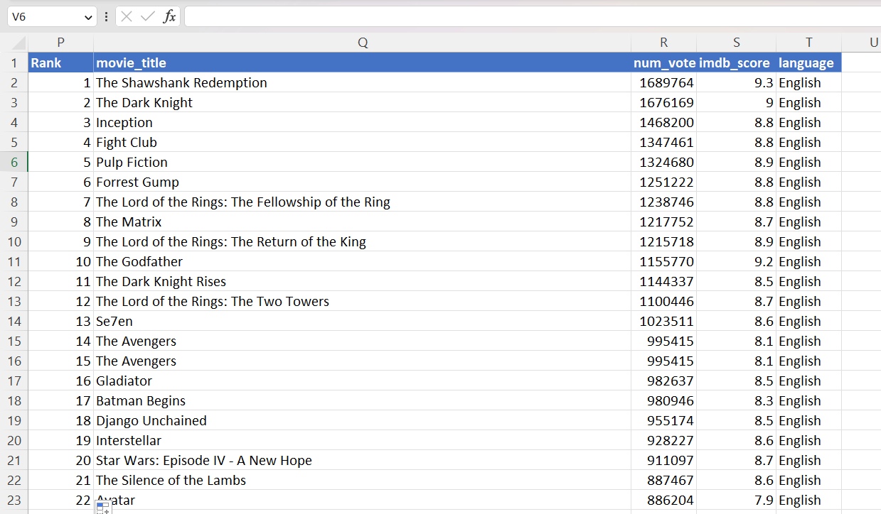

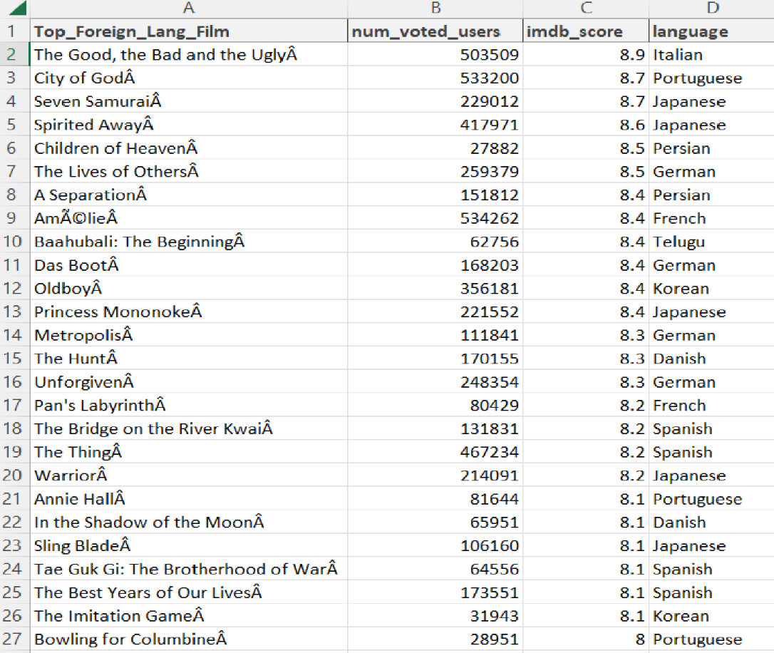

**3)Task 4:**

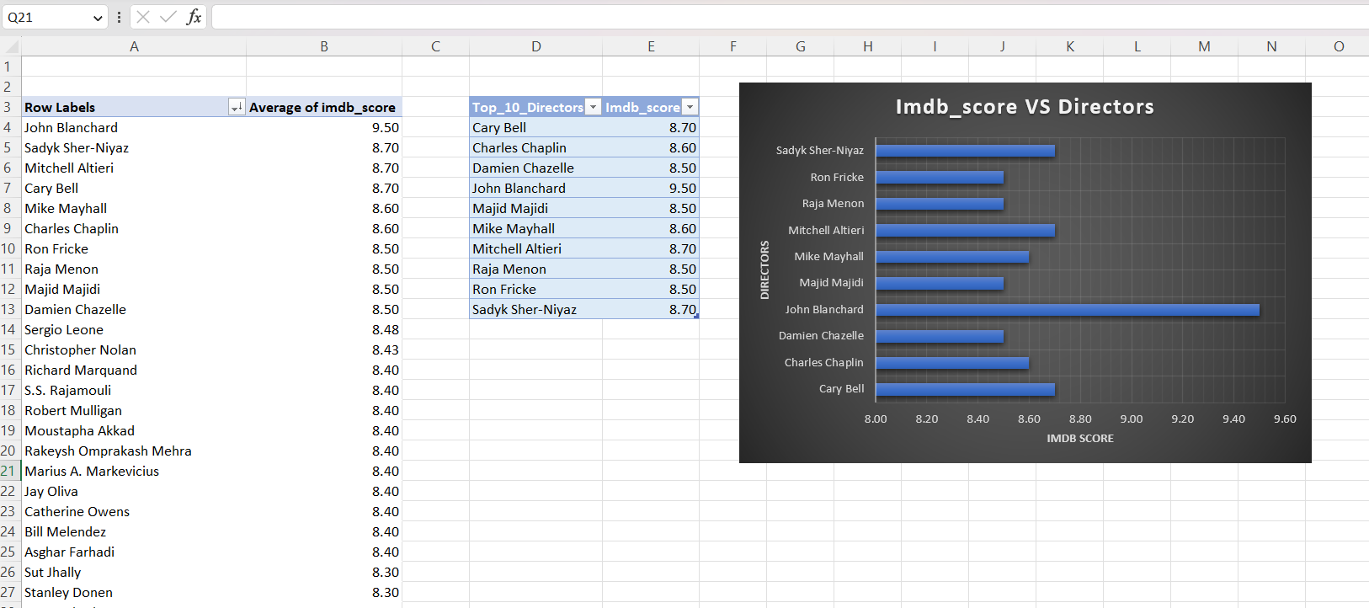

**4)Task 5:**

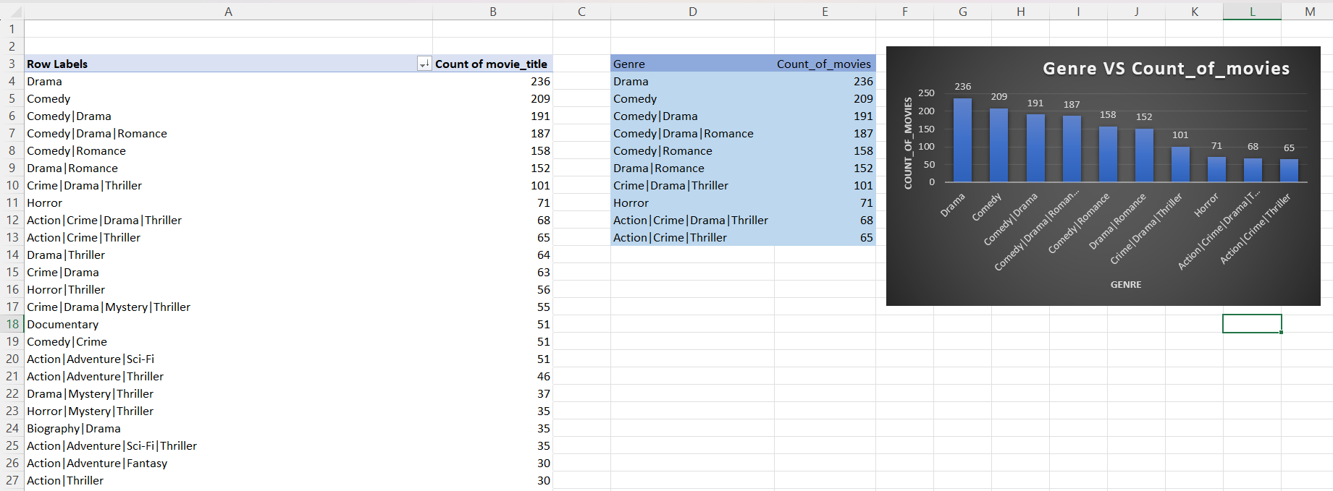

**5)Task 6:**

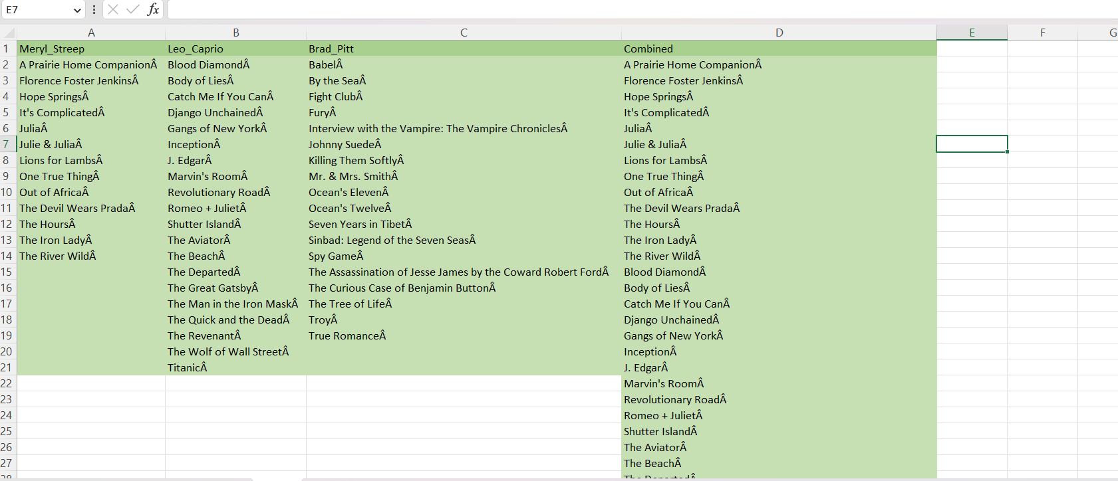

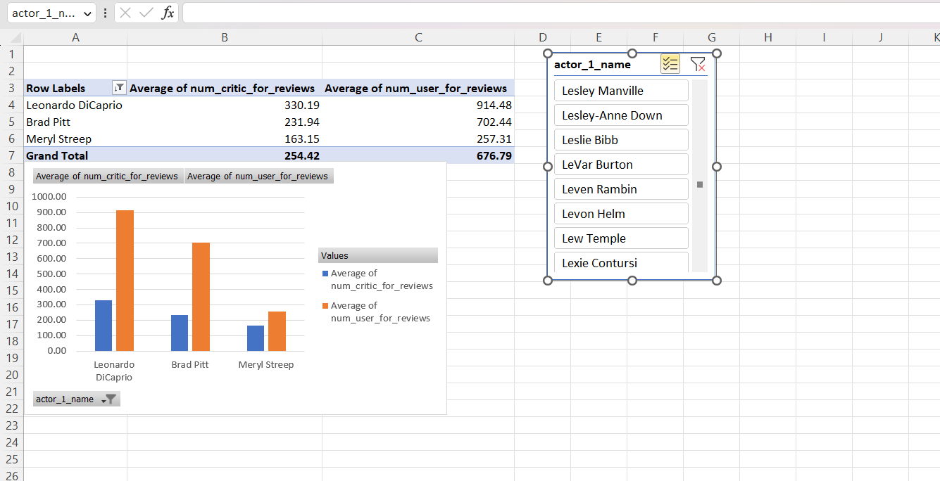

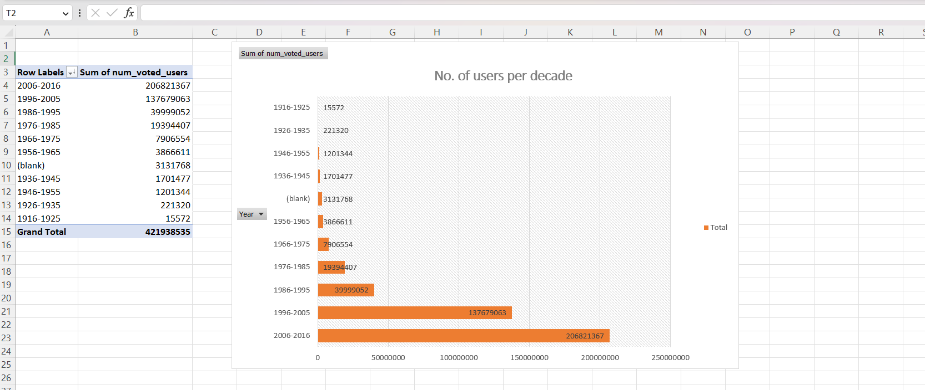

**Plagarism Report**

