**ES – II**

**FIELD WORK ACTIVITY REPORT**

**Group No.:** 4

**Group Members:**

|  |  |
| --- | --- |
| **Roll No.** | **Name** |
| 10564 | Aarya Badhe |
| 10565 | Kshitij Dhake |
| 10566 | Ameya Deshpande |

**Topic Name:** Visit to an area to document environmental assets; river/ forest/ flora/ fauna, etc.

**Name of place visited:** Taljai Hills

**Day & Date of visit:** Monday, 27 May 2023

**Time of visit:** 7 am to 9 am

***Introduction:***

Forests preserve nature in its realistic glory. Visiting forests helps us witness and appreciate the variety of flora and fauna that nature has bestowed upon us. It makes us realise the importance of natural resources and the need for their preservation.

***Taljai Hills:***

Taljai is a hill located in the heart of Pune, that has been designated as a wildlife reserve. The road to this hill passes through the Shivaji Maratha College campus with a picturesque mountain path, with sharp turns. Near the entrance of the forest is a temple to the hill's namesake Taljai Mata, a Hindu goddess. The reserve attracts migratory birds and is home to peacocks. The location is therefore popular with amateur bird watchers and ornithologists. Vehicles are prohibited in the area.

The highest point of this hill is located at the elevation of 2,000 ft (610 m). It provides a sweeping view of the Pune city. In the early morning or the late evening, one can enjoy a glorious sunrise or sunset. It takes about 2-3 hours to explore the entire area. For a relaxed visit, evenings are suitable and mornings for trekking all the way up to the summit.

***Purpose of the visit:***

The primary purpose of visiting Taljai hills is to enjoy nature, go for a hike, or engage in outdoor activities.

**Nature and Scenic View:** Taljai Hills provides a peaceful retreat from the bustling city life. We can enjoy the natural beauty, breathe in fresh air, and experience the tranquillity of the surroundings. The hill offers panoramic views of Pune city, especially during sunrise and sunset.

**Hiking and Walking Trails:** Taljai Hills has well-maintained trails that are perfect for hiking and walking enthusiasts. The paths wind through the forested area, allowing visitors to enjoy a leisurely stroll or engage in a challenging hike.

**Bird Watching:** The hill is home to a variety of bird species, making it a popular spot for bird watchers. You can spot numerous native and migratory birds in the area, providing an excellent opportunity for bird enthusiasts to indulge in their hobby.

**Flora and Fauna:** Taljai Hills boasts diverse flora and fauna. The hill is covered with dense vegetation, including various trees, shrubs, and medicinal plants. Wildlife enthusiasts can also spot different species of butterflies, insects, and small mammals during their visit.

**Exercise and Fitness:** The hill provides an excellent setting for outdoor exercise and fitness activities. Many people visit Taljai Hills for jogging, yoga, meditation, or other forms of physical fitness routines. The peaceful environment and pleasant weather make it an ideal place to rejuvenate and stay active.

***Details of Flora and Fauna:***

It is known for its rich biodiversity and serves as a habitat for various flora and fauna species. Here are some of the faunal species that can be found in the Taljai area:

**Birds:** Taljai Hill is a birdwatcher's paradise, attracting a wide variety of avian species. Some common bird species found in the area include Goose, Ducks, Indian Peafowl, Asian Paradise Flycatcher, Indian Grey Hornbill, Oriental Magpie-Robin, White-bellied Drongo, Indian Robin, Tickell's Blue Flycatcher, Common Iora, and Indian Roller. It is also home to many migratory birds during the winter months.

**Reptiles:** Several reptile species can be spotted in Taljai Hill. This includes the Indian Rock Python, Russell's Viper, Common Sand Boa, Indian Rat Snake, Common Wolf Snake, Indian Bronzeback, and various species of skinks, geckos, and lizards.

**Insects and Arachnids:** You can find species such as Praying Mantises, Grasshoppers, Beetles, Dragonflies, Orb-weaving Spiders, and Huntsman Spiders, among others.

**Amphibians:** Various amphibians inhabit the area, including species like Common Indian Toad, Common Tree Frog, Indian Bullfrog, and Marbled Balloon Frog.

**Small Mammals:** While large mammals are relatively rare in Taljai, you may come across small mammal species such as Indian Palm Civet, Indian Hare, Indian Grey Mongoose, and Indian Porcupine.

**Butterflies:** The hill is a haven for butterfly enthusiasts, with a diverse range of butterfly species fluttering around. You can spot butterflies like Common Mormon, Blue Mormon, Clouded Yellow Butterfly, Common Emigrant, Common Jezebel, Plain Tiger, Common Rose, Oriental Plains Cupid, and many more.

**Flowers and Trees:** It boasts wide variety of local trees and flowers such as Bougainvillea, Gokarna, Yellow Cotton Tree, Flame Tree, Shivala, Karvi, Kanwel, White musli and Van haldi.

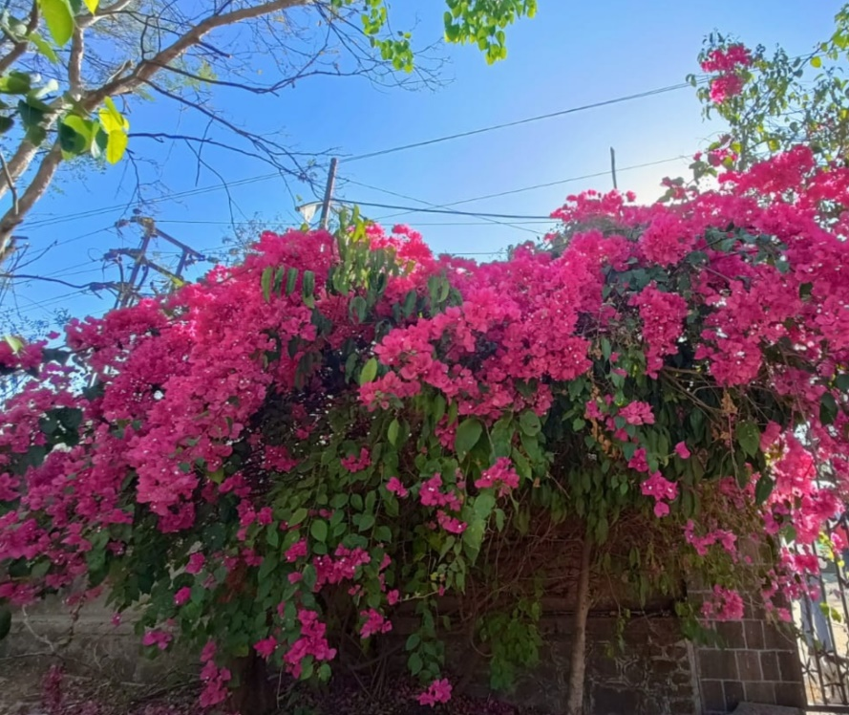 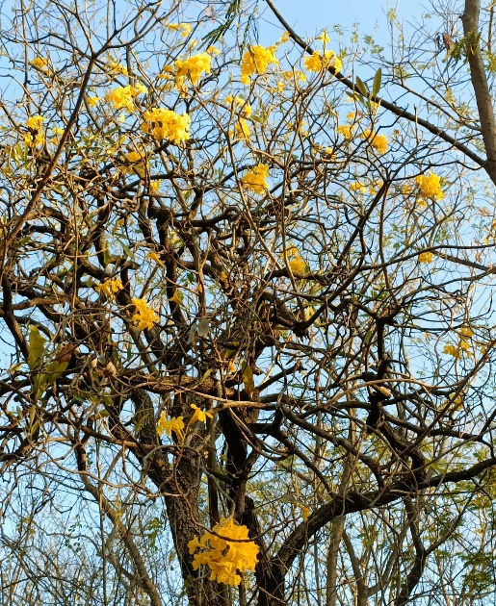

**Bougainvillea**   **Yellow Cotton Tree**

**Caterpillar**

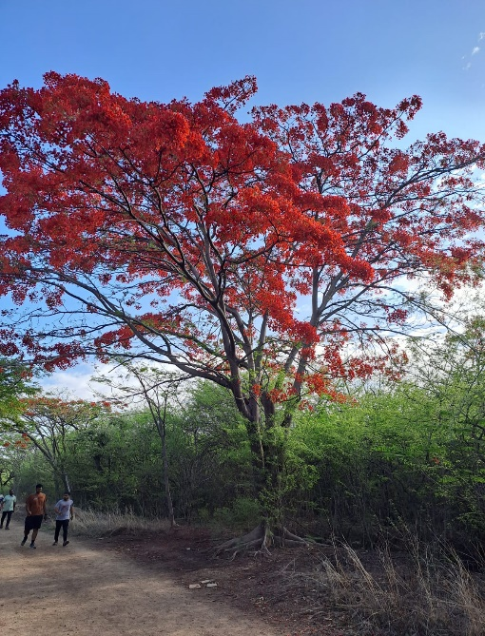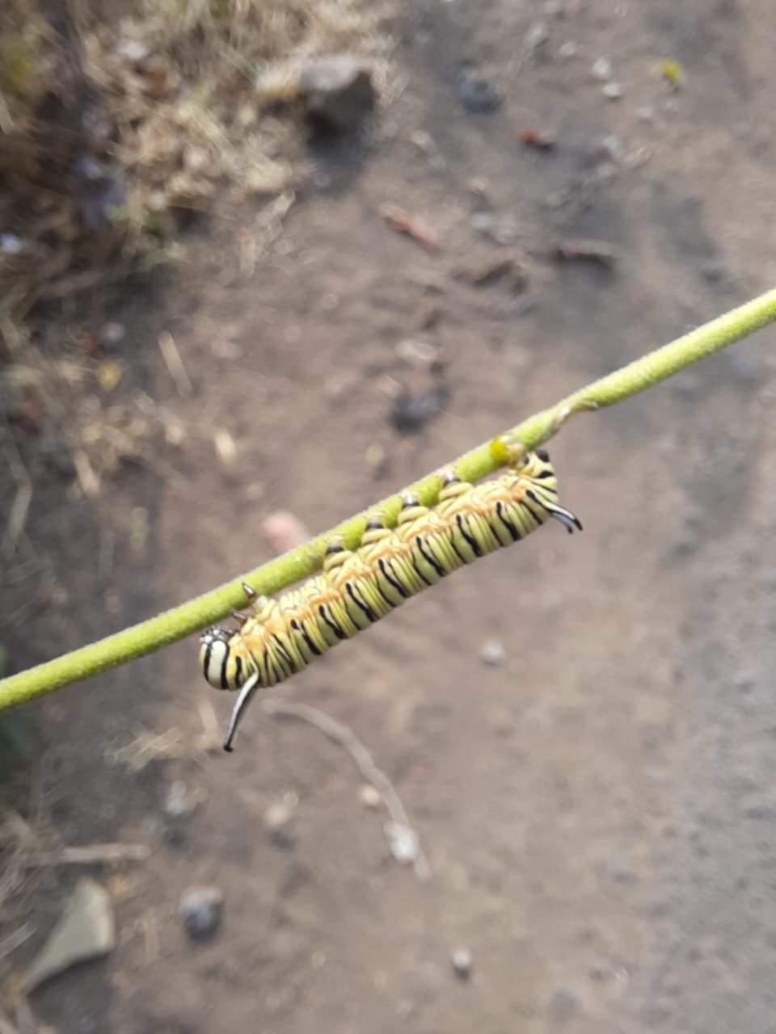 **Royal Poinciana**

It is worth noting that the presence and abundance of these fauna species may vary throughout the year, and some sightings may require careful observation and patience. Additionally, the local ecosystem is subject to changes and the introduction of new species over time.

***Conclusion:***

During the visit we witnessed one of the most beautiful natural views. The visit helped us to know more about the flora and fauna and experience the peace in nature away from the clamour of the city. It helped in finding more information about the various types of trees, ayurvedic plants and other different species of flora and fauna. It made us realize the urgent need to take steps that can help to preserve the local species and the Taljai hill itself. Several organizations are running campaigns to raise the issue.

***Group Photos:***