Abstract:
The purpose of this document is to share with you some code to achieve provisioning integration with Satellite6 via Ansible/Ansible Tower. The code works over Satellite6's API and makes use of compute resources and profiles for provisioning Virtual Hosts. The code also allows you to provision bare-metal hosts in Satellite6 by providing a MAC address, which in turn sets the host up for kickstarting once it is powered on.

Repositories:
The relevant Ansible Roles can be downloaded from Ansible Galaxy here:
- Ansible Galaxy - ahuffman.sat6_create_hosts
- Ansible Galaxy - ahuffman.api (dependency which is installed with ahuffman.sat6-create-hosts)
Example Use Case Diagram:
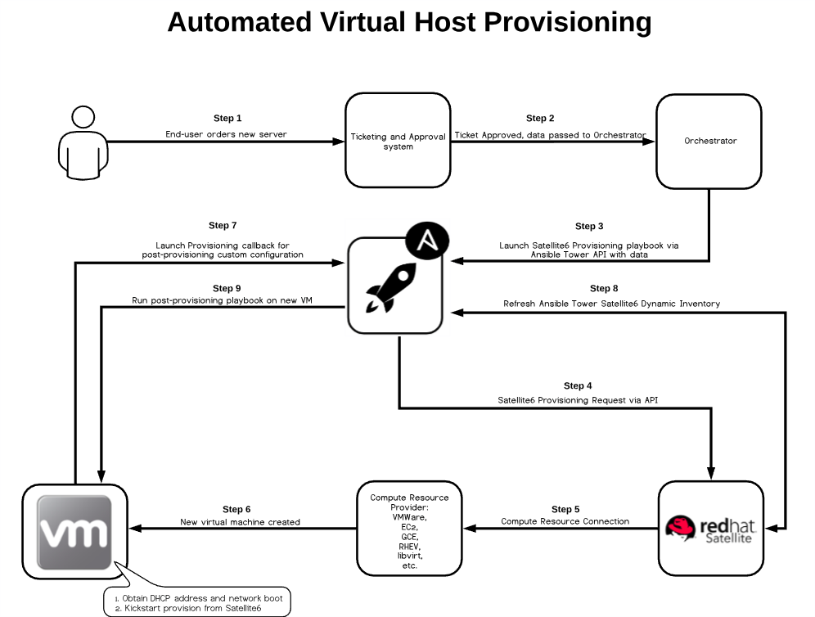

Setup/Configure Code:
To use this code in an Ansible Tower project we'll need to setup our repository structure. You'll need a new playbook called "satellite6-provisioning.yml". You'll also need a "roles" and "vars" directory.

Contents of satellite6-provisioning.yml:
---
- hosts: "localhost"
vars_files:
- "vars/provisioning-secrets.yml"

tasks:
- name: "Create Satellite 6 Hosts"
include_role:
name: "ahuffman.sat6_create_hosts"
vars:
sat6_fqdn: "yoursat6server.yourdomain.com"
sat6_user: "userwithadminrights"
sat6_organization: "ORG NAME HERE"
sat6_fail_on_existing: True #Optional, causes playbook to fail if a host exists

Contents of vars/provisioning-secrets.yml:
You'll need to generate an Ansible Vault to store your Satellite6 admin user password in:
cd vars

ansible-vault create provisioning-secrets.yml
---
sat6_pass: "yourpasswordhere"

If using Ansible Tower:
Contents of roles/requirements.yml:
---
- src: "ahuffman.sat6_create_hosts"

If using Ansible Core/Engine:
Install the Roles:
From the root of your repository/directory:

ansible-galaxy install ahuffman.sat6_create_hosts -p ./roles/

Setup Summary:
Your directory/project structure is now ready to go. You should now add, commit everything, and push it up to your repository.

Ansible Tower Setup:
I'm assuming you have some Tower knowledge here, so I'll only provide the high-level steps to get provisioning.

- Create a new vault credential with the password you used to store the sat6_pass variable.
- Create a new Source Control credential to access the repository we setup earlier
- Create a new Machine credential for a user that has access to your Tower server. This can be root or a user with sudo rights.
- Create a new project with the repository we setup earlier and attach the Source Control credential
- Synchronize the project you created (if Tower didn't already do so automatically for some reason. Check your job log)
- Create a new inventory with the host localhost
- Create a new Job Template
  - Give the template a name like: "Satellite6 Provisioning"
  - Select the project you created
  - Select the "satellite6-provisioning.yml" playbook
  - Attach the machine credential for localhost you created
  - Attach the vault credential you created for accessing provisioning-secrets.yml
  - Choose prompt on launch for extra_vars
  - (optional) Choose allow concurrent jobs
  - Click save
  - Assign "Execute" permissions to a any user that you want to be able to use the job template via the UI or API of Tower

Testing:
Click the launch button next to the Tower job template.
You'll be prompted for extra_vars. You'll be entering information for the variable "sat6_hosts".
You'll need a bit of information from your Satellite6 environment to provision a host:

Virtual Host:
You'll need the compute resource name, compute_profile name (if not set in the host group), host group name, and location name.

You can provision a single host or many, as the sat6_hosts variable was designed as a list. Your extra_vars for the job template should look something like this:

---
sat6_hosts:
- name: "myshorthostname"
domain: "mydomainname.com" #optional if a default is set in the host group
ipv4: "192.168.122.83" #optional if the satellite6 subnet suggests via dhcp or ipam
subnet: "Subnet Name" #optional if the subnet is set in the host group
location: "Raleigh"
compute_resource: "my compute resource"
compute_profile: "1-little" #optional if a default is set in the host group
comment: "an optional comment about what the server does"
parameters: #optional host specific parameters that you could potentially use in post provisioning callbacks to tower
- name: "build_type"
value: "httpd"
- name: "rinseandrepeat"

...

Bare-metal:
Refer to the virtual host section for all of the other fields you'll need. The only difference with bare-metal hosts is that we don't provide the compute_resource and compute_profile fields, but do provide the mac field.

---
sat6_hosts
- name: "myshorthostname"
domain: "mydomainname.com" #optional if a default is set in the host group
ipv4: "192.168.122.83" #optional if the satellite6 subnet suggests via dhcp or ipam
subnet: "Subnet Name" #optional if the subnet is set in the host group
location: "Raleigh"
mac: "01:23:45:67:89:10"
comment: "an optional comment about what the server does"

parameters: #optional host specific parameters that you could potentially use in post provisioning callbacks to tower
- name: "build_type"
value: "httpd"
- name: "rinseandrepeat"
...

Summary:
You now saw how easy it is to provision hosts via Ansible and Satellite6 (granted you've already got Satellite6 fully configured for provisioning purposes.) The nice thing about this is that you can now hook external systems to this over the Ansible Tower API for fully integrated provisioning. Finally, you can configure your Satellite6 host groups for provisioning callbacks to Ansible Tower when they come online, with Ansible Tower both initiating and finalizing the provisioning cycle.

Please contribute to the projects on Github if you have improvements or more features you would like to add in. I tried to think of most common use-cases, but I'm sure there's some interesting ones out there.

Repositories:
GitHub - ahuffman/sat6-create-hosts: An Ansible role to create new virtual and bare-metal hosts in Satellite 6.x. v2 of …
GitHub - ahuffman/api: An Ansible role to avoid having to fill in repetitive parameters when writing a playbook with mul…

