POWER-BI

Week 1- Assignment

(Sreekrishna Bigala)

The process through which I had completed my week 1 assessment is explained in following points:

* The POWER-BI interface after opening it is shown in the below image where we’ve opened the blank report

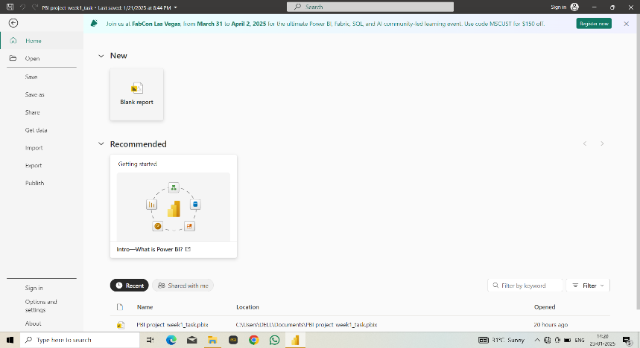

* Now to obtain the data we have used the “get data” option in Home tab.

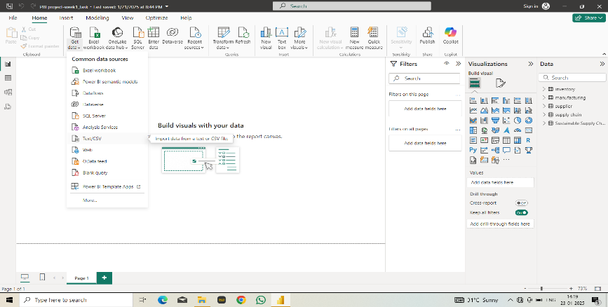

* After obtaining the data we have completed one of the **ETL** [Extract, Transform, Load] task which is **Extracting.**
* Now we’ll be transforming the data by clicking on “Transform data” from home tab where the data extracted will be available in the table format which was required for applying the changes

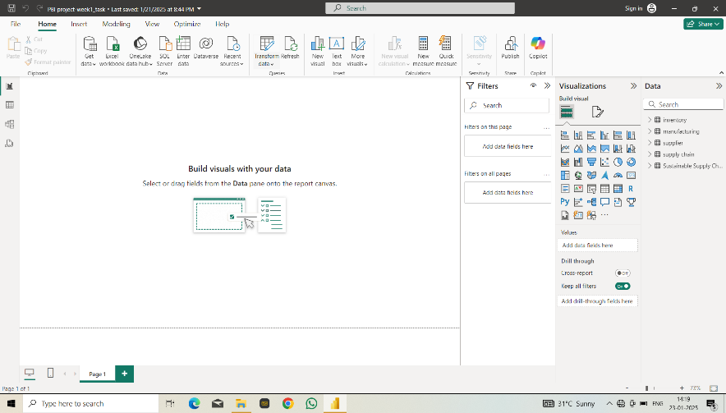

* Now as per the requirements we can make the changes in the table as per requirements.
* As per my requirements I have removed few columns from the table after duplicating the table 3-4 times providing with the names as “**inventory**”, “**manufacturer**”, “**supplier**”, “**supply** **chain**” keeping the original table as it is (**sustainable** **supply** **chain**).

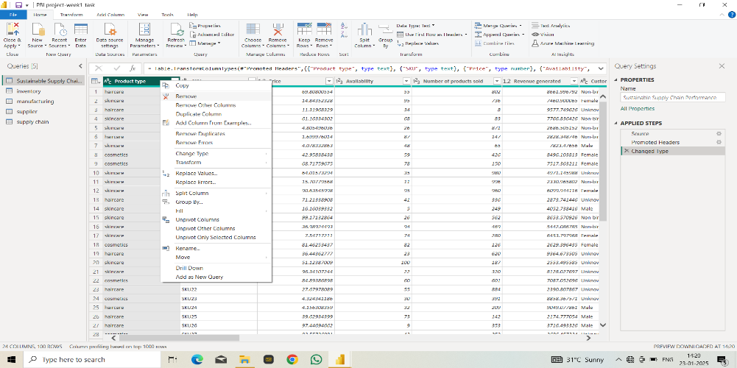

* However, all the changes are applicable only if we save them, and to do so we use close and apply in **Home** tab of “transform data” interface.

