**Dr. Sunil K. PARAMESWARAN**

**E-mail:** [**tarheeltraining2022@gmail.com**](mailto:tarheeltraining2022@gmail.com)

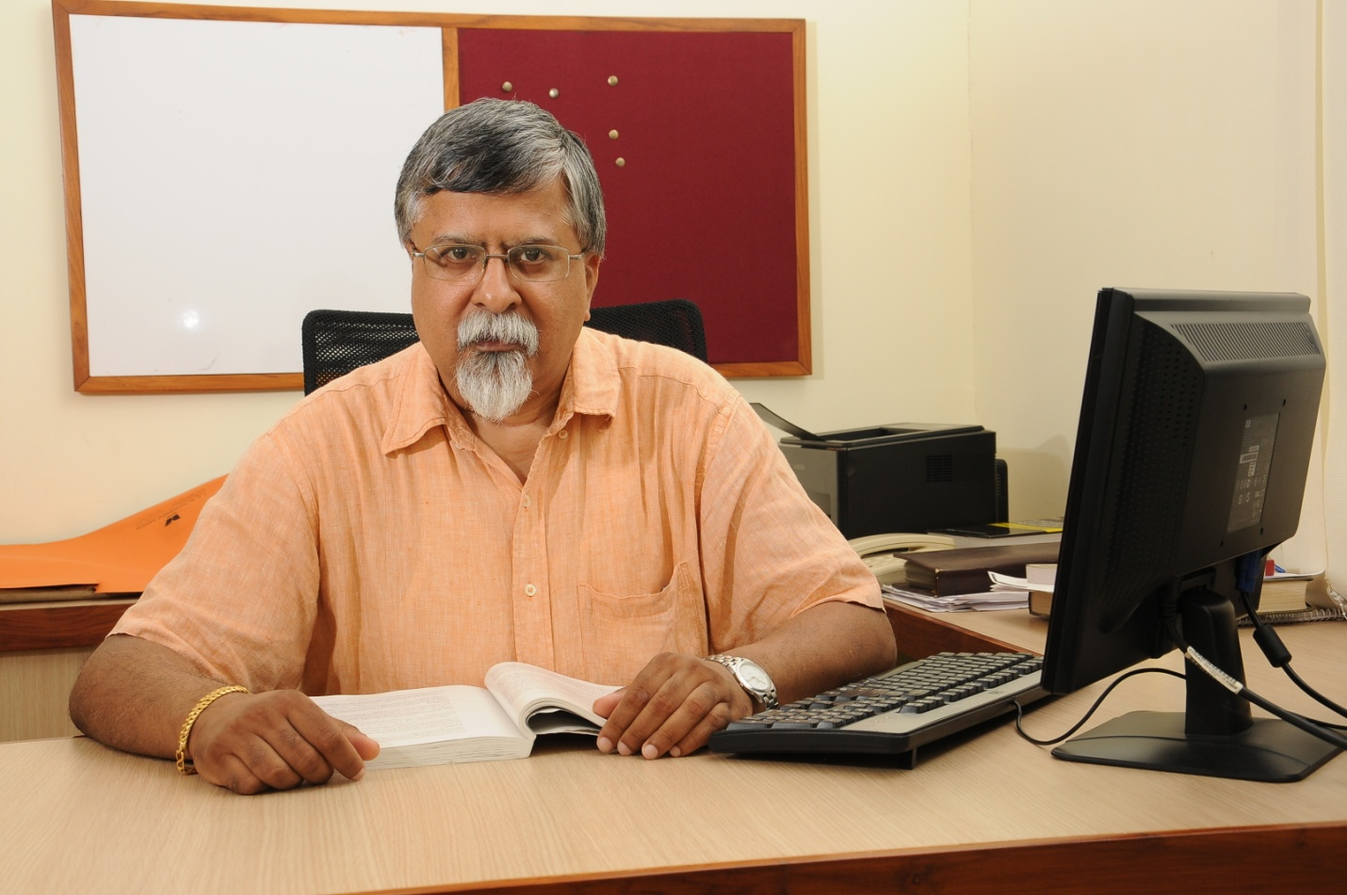

Sunil K. Parameswaran is the Director & CEO of Tarheel Consultancy Services, Manipal, a corporate training and management consultancy firm set up by him in 2004. For the past 20 years Sunil has been active as a corporate trainer and management consultant. He has delivered training programs on Global Securities Markets and Global Banking to some of the multinational IT firms located in India. Sunil also has over 30 years of teaching experience and has taught at leading business schools in the U.S. (University of Iowa), Singapore (National University of Singapore), Australia (La Trobe University), IIM Bangalore and IIM Calcutta. His past clients include WIPRO Technologies, HCL, Capgemini, Accenture, Microland, and JPMC.

Sunil obtained his Ph.D in Finance from the Fuqua School of Business at Duke University U.S.A, and his M.B.A from IIM Bangalore, and holds a degree in Chemistry from St. Stephen’s College, New Delhi.

**Workshop on Professional Career Enhancement Skills**

This is a one-month workshop with 12 contact sessions of 90 minutes each. There will be a maximum of 12 students in a batch, and only two batches a week. Thus, there are only 24 available seats.

The workshop will use a Group Discussion cum Group Interview format, which was introduced by IIM Bangalore, among others, many years ago. Participants will get the opportunity to improve their oral presentation skills and learn from the other members in the group. This exposure will be invaluable for competitive entrance exams and career interviews.

We will meet on Mondays, Wednesdays, and Fridays for four weeks. The first batch will be from 2:00 to 3:30 PM and the second from 4:00 to 5:30 PM. Interested candidates can send an Email to the address given above. If selected, you will be informed, and can then make a payment by scanning the QR Code given below. The fee is Rs. 7,500 plus 18% GST per participant.