**Karjat**

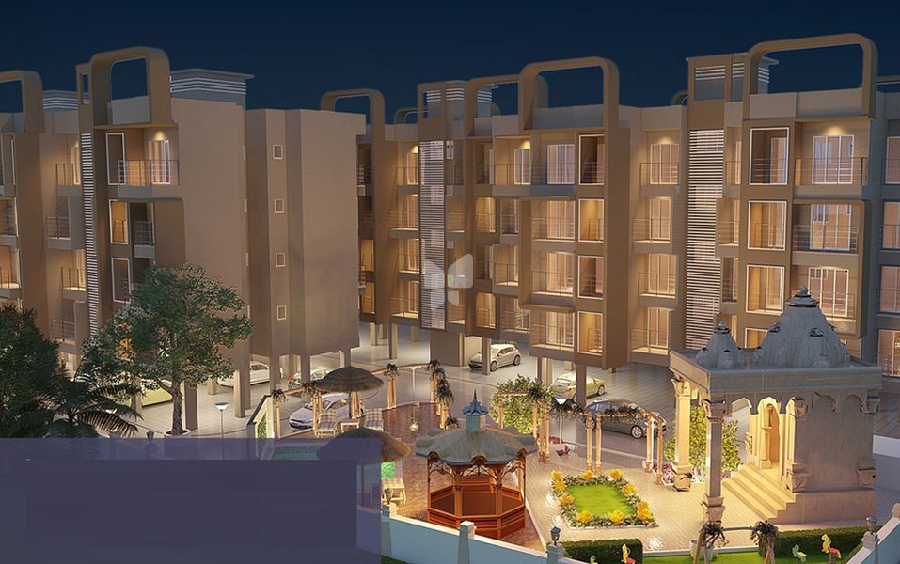

Karjat is a Pleasant climate consists of evergreen and healthily environmental town in Raigad district which is located in state Maharashtra, India. This region is located approximately at distance 70km away from Mumbai and 100km from Pune. It is one of the best and ideal locations for living and working with multiple choices in improvement of better lifestyle. The location has huge number of population in the regions, as most of the people from Metropolitican cities are nowadays prefer to move towards karjat side region in the search of propery, education and Bussiness related work. Because of increasing property value, the people choose to move to karjat due to affordable price range of property within the region. Featured with great facilities include Schools, Colleges, grocery market, Restaurants,Mall.It is also an ideal place for weekend destination which is easy access to various point of attraction such as Lonavala, Khandala and Malshej Ghat and many more in Karjat. As it is located closeness to Mumbai Metropolitan Region’ there will be no issue related to travel transport facilities. You can find various options for travelling with the region as well as outside the region.

**Transport:-**

The Karjat is a pleasant climate region with pollution free facilitated well transport connectivity to all major cities and small regions. The Karjat is a region which is accessible via NH17, NH4 and NH3 highways. The extensive roadway networks connected to localities like Murbad, Kaiyanpur, Kasar Ghat, Khapoli, Khalapur, Neral, Badlapur, Ambernath, Pen, Panvel, etc.For moving from one region to other people can use their private four wheelers or two wheelers facilities. There is also a mixture of service in the region, comprising of MSRTC buses, 6-seater mindors, 3-seater auto rickshaws and 6-seater vans. To travel towards metropolitan cities like Mumbai and Pune, there are rail service is available within the region, the nearest railway station for moving towards Mumbai and Pune is Karjat railway station which is also a junction where you can find an express train as well as local trains. This station is a last station of Thane district to move towards Mumbai region. There is also an Airline facility such as Chhatrapati Shivaji International Airport and the Navi Mumbai International Airport is the nearest airport.

**Real Estate Developments in Karjat:-**

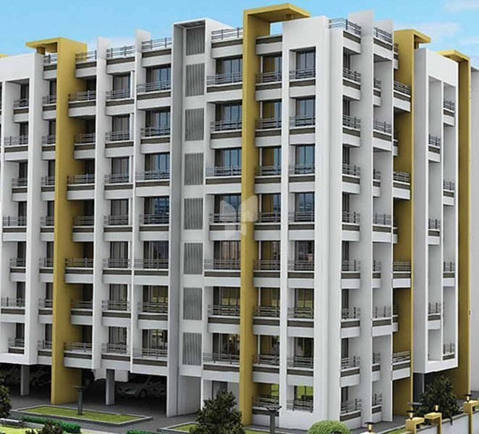

Over the last few years, the Karjat has become a housing destination for people to live in a pleasant climate with evergreen environment. There are also several industrial hubs and holiday spots that makes it a good area of investment in a residential properties. As this location is outskirts from Mumbai, so it has huge scope for development and increases in prices.

There are newly and upcoming development projects are building within the karjat. The people who are wants to move from crowd metropolitan city to pleasant environment region like karjat, they have a wonderful choice to live in a desire home in healthy lifestyle. The newly developed projects constructed by well-known developers with high-tech materials include 1BHK, 2BHK, 3BHK and villas with full-equipped amenities and facilities.

One of the most famous project Eco Greens is a rapport to the ever increasing individual world.Eco-Greens Phase-1 is one of the first IGBC green rated projects within karjat with deplorable green in feature such as Solar Street Lights, Solar Water Heater, Eco friendly Wetland Sewerage Treatment system, Herbal Garden and over hundreds trees are surrounded around the locality. These is the perfectly encapsulated modern living and offers luxury apartments ranging from 1-2 bedrooms designed with complementary architectural interiors with high quality finishing and meticulous attentions at every residential homes. This is centrally located project which is proximate to all important locations, thus adding the functional value to your homes. For increasing the comfort and value enormously, there is a Hypermarket-D mart situated within the premises. For lifestyle, project is constructed with amenities such as Cricket Pitch, Children’s play area, Jogging track, Tennis & Basketball Court, Fully Equipped Gym, Multipurpose Court, Swimming Pool, and Club House. This project is ready to move in condition starting at Rs. 20.77 lacs onwards with No GST & Stamp Duty.

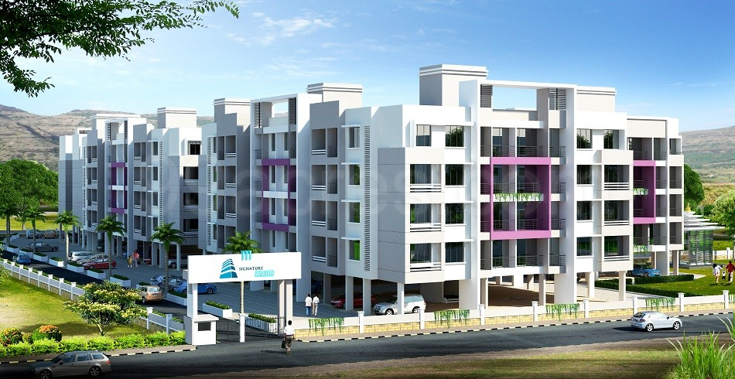

Other than these, there are lots of new projects are constructed with your needs and requirements in a more affordable prices with healthily and comfort lifestyle. Some of the projects name includes Unimont Aurum build by Unimont Group located in Dahivali Karjat. The projects offers 1RK, studio, 1, 2, 3 BHK home in an affordable prices, starting at Rs. 10.0Lac- Rs27.0 Lac onwards. This projects is ready to move till may 2024.Bright Florance Town build by Bright Developers located in Bhivpuri Karjat starting at Rs. 8.81L-Rs.20.32 Lac.This project offers 1RK,1,1.5,2 BHK apartments and the possession Date on Dec 2021.Arihant Aloki Phase I developed by Arihant Superstructures Limited located at Bhisegaon, Karjat. It offers 1, 2, 3 BHK apartments starting at Rs. 25L-50L.There are many more projects are been developed and under constructions. They are built with many amenities and facilities which full-fill the daily requirements to live healthily and comfortable lifestyle in a greenery area. The various amenities and facilities such as Parking slot, Rainwater harvesting, children’s play area with various gaming zone for any age group, Relaxation Park, jogging track, securities etc. There are many supermarkets and small markets to buy daily requirements grocery, well connected transport facilities within the region and outside the region to connect various others.

**Karjat is Best for Real estate Investments:-**

Karjat is well-known for holiday destination which is now transforming into popular real estate hub. It is a tiny hill station with a pleasant climate, scenic natural vistas, fast-developing industries, boom in housing sector and connectivity to Mumbai and Pune makes karjat a potential investment with valuable high returns. Some of the reasons buying a flat in Karjat will be a good investment, such as:



1. Ideal Place for Investment :-

Buying a flat is considered to be good investment ideal for the investors to invest in Karjat like location where can get high returns. If you are planning for investing in flat near Mumbai- Pune, then karjat will be the right choice! Real estate properties in Karjat is growing rapidly high due to it convenient location between Mumbai and Pune. Mumbai and Pune are the two metro cities which are nearer to the Karjat. People from these cities attracts towards Karjat in the search of properties because of its affordable range and evergreen environment and pleasant climate.In Upcoming years, value of the flats will be definitely increases and gets high benefits in the future. So, people who are investing in Karjat will be beneficial.

1. Affordable range Price:-

Karjat is appearing as a popular residential hub among common people because of it affordable price. As the normal rates of flats in Mumbai are out of reach for the common people, Karjat as very low rate of flats compared to Mumbai. The buying flats in Karjat are the good option for the common people in a reasonable and affordable price with various modern facilities and amenities. Within a convenient price range starting from 10Lac onwards and move, you will find 1BHK, 2BHK ,3BHK and studio apartment .Social amenities such as well constructed in fracture of School for the childrens, for health related issues there are hospitals and clinics are available, for grocery shopping there are small markets are available with the residential area.



1. Transport Connectivity :-

Transportation within Karjat is well constructed and connected to various small region and other areas mainly two metropolitan area such as Mumbai and Pune.

Mumbai is about 100km distance away from Mumbai and 92 km way from Pune. The town makes a good connectivity via road and railways. In terms of road connectivity, Karjat is linked to Mumbai-Pune Expressway, Pune highways, Nasik Highways, Goa Highways and state highways. This makes the people to connect to various routes by using their private vehicles or public transportation. In the form of public transportation, there are various options for the people such as Buses, auto and many more as per convenient. In terms of railway station, Karjat is served as railway station which connects the Mumbai metropolitan city. There are two nearest airport, Chhatrapati Shivaji International Airport and Navi Mumbai International Airport.

1. Huge Demand for Rental Flats:-

There is Huge Demand for Rental flats, as karjat is famous for Educational Institutes and situated between financial capital of Maharashtra, Mumbai, Pune and IT hub. There are various Educational institutes that students search for the rental apartment nearer to their college. Same goes for the employees who migrate to city because of work, they also search for flats in rent. If you are planning to give a flat for rent, then you can easily get tenants in Karjat. There is a huge demand for rental flats among migrants, students and employees. This will be good side business and can start generating rental income almost immediately after taking possession. This will give a good earning income from it.

1. Beauty of Karjat :-

One of reasons to move to karjat is live in a pleasant climate having a beautiful scenery, mountains, ancient caves and forts. It is famous for adventure sports like trekking, waterfall climbing, rappelling and river rafting. The people who planning to spend weekends and enjoy holidays can plan to visit the karjat for gaining the wonderful experiences. There are beautiful place to visit within karjat includes Kondana Caves, Peth fort,Jain Temple,UlhasValley,Kondeshwar temple,Bhor Ghat,Bahiri cave,ND Studio,Blackwaters of Pali Bhutivali Dam,Bhivpuri waterfall. This all makes the karjat one of the favorite holiday destinations for the peoples. There are various restaurants, hotel rooms with delicious food cuisines and many more options. The town provides peaceful and beautiful place to spend some time away from our bust scheduled life.

**Upcoming new Projects in Karjat :-**

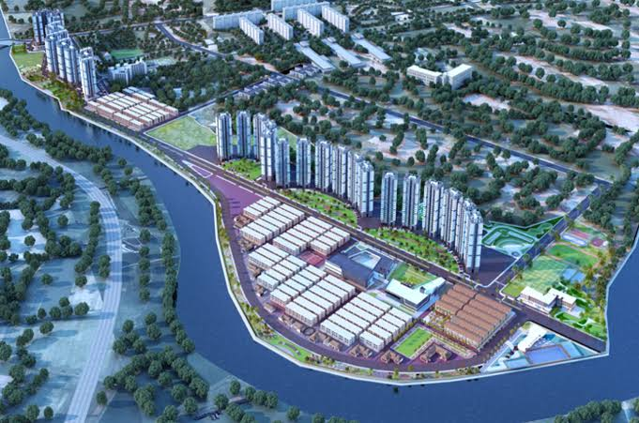

Karjat is a point of attraction for the people to move to towards it from Mumbai- Pune like metro cities. Because of it massive development within the region in the form of real estate projects in an affordable price range. The prices for residential property within the karjat region are presently affordable i.e. 2,500-3,000 per sq ft. There is ample scope for appreciation since Thane, Kalyan-Dombivli and Ulhasnagar are inching towards saturation. People working in this area are now looking to buy houses at affordable rates. This extends a huge opportunity for developers to invest in real estate properties who can expect high returns after re-selling within five years. There are number of new real estate projects are developing in a most reasonable and attractive place where the rate of the apartments are in affordable, starting from least rate of apartments to high rated apartments according to customer requirements.

Since Karjat is a tourist destination place, were people attracts towards it because of it pleasant climate and evergreen environmental views to see. There are most famous places are available within the regions that people can spend their weekends with their love once in a luxurious and comfortable rooms. There are studio apartments facility with all required amenities, are most popular configuration among weekend homebuyers. This increasing interest in the market from small-scale investors, the sales of 1BHK and 3BHK has also increases from last two years.

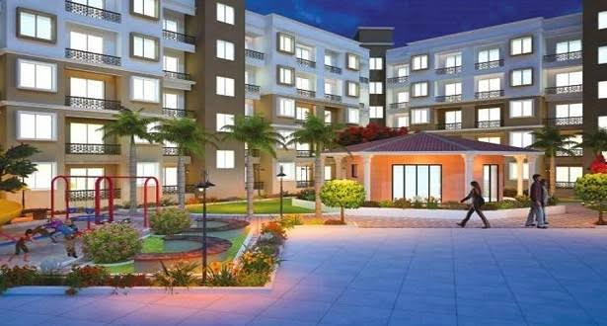

Karjat is easily accessible from Pune(92km),Mumbai(90km),Thane(60km) and Navi Mumbai(40km).It has a huge potential for development and price appreciation, particularly once the four-lane state highways 38 becomes operational which will substantially reduce the travel time between Karjat and Mumbai.

There is Upcoming development projects in MMR that reduce the distance between the cities and improve their connectivity to Karjat. This Trans Harbor link between Sewri, Mumbai and Navi Mumbai reduce the distance between the cities. Additionally, two-lane and four-lane highways between Badlapur-Neral-Karjat roads will boost the connectivity of the area to commercial and industrial area of the MMR region. This improved connectivity and development attracts the foreign investor to invest within the region in the upcoming years, is expected.

**Proximity and Landmarks near Karjat:-**

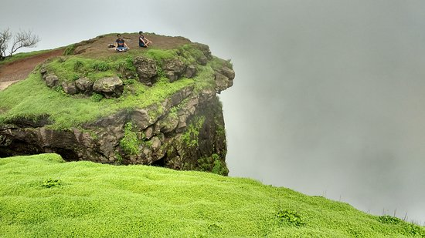

Karjat is an evergreen town facility with all amenities to fulfill the basic needs which are necessary for living happy life. The amenities like various schools and institutes within the localities that a resident of area has no problems related to their children’s education. Some of the schools such as DAV Public school, St Joseph’s High School, India First Global School, New Horizon Public School, Biotech Research Institute, Dhirubhai Ambani School Lodhivali, etc.For healthcare related issues, residents doesn’t have to move to Mumbai for checkup, there are number of major health institution such as Raigad Hospital and Research Center, Madhavbaug Hospital,etc.There are also various Banks, ATM, Shopping centers and many more for residents without moving to metro Politian city, you can find all within the locality of Karjat.

Karjat is also a well-known tourist place for the visitors to enjoy their weekends with their love once. You can find many eye-catching attractive places to do picnics, river rafting, trekking and hiking. It is a favorite destination during rainy season. It is famous for mountain climbing because of its undulating hilly terrain and lofty slopes make it ideal spot for it. It is best for friends, family and couples from within the region and outside the region comes spend weekend holidays by staying 1-2 days in nearby hotel. The hotels have regional favor’s cuisines. This type of cuisines are most of the peoples are enjoyed because of its remembering the flavor of hometown. Apart from cusines, Management and services are also well served. The people around the region are also very friendly and helpful that doesn’t make you feel like visitors. For moving towards the destination from railway station, you have many transport facilities like buses, autorikshaw in an affordable price range.

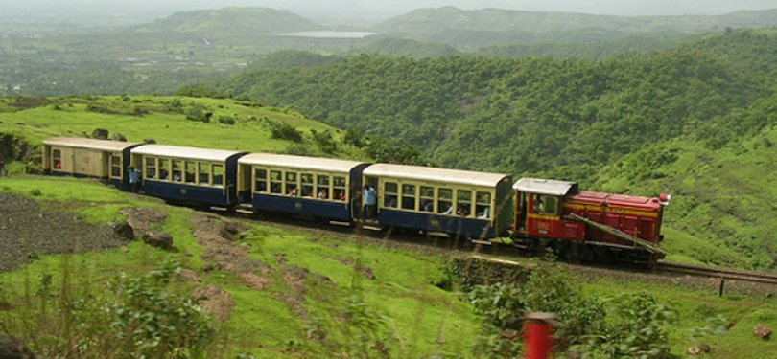

Some of the best sights and landmarks within karjat are as follows:

* Kothaligad(Peth)Fort :

Kothaligad is a small fort which is situated near karjat-murbad Raod to the east of Karjat.It is famous for treking because of its small height and easy climbing.It is also known as the fort Peth because of its base starts from peth village. There is a small temple and large cave at the base and a chimney like tunnel to the top of the fort. This pinnacle is curved from inside forming a staircase reaching the top. There is water fall at some distance from the cave and another one at the top of the fort.

Kothaligad is a small fort which is situated near karjat-murbad Raod to the east of Karjat.It is famous for treking because of its small height and easy climbing.It is also known as the fort Peth because of its base starts from peth village. There is a small temple and large cave at the base and a chimney like tunnel to the top of the fort. This pinnacle is curved from inside forming a staircase reaching the top. There is water fall at some distance from the cave and another one at the top of the fort.

* Bhimashankar Temple:

Bhimashankar Temple is a jyotirlinga shrine which is located in khed over 50km northwest near Pune.It is located 127 km from shivajinagar in the Ghat region of the Sahyadri Mountains.This temple is also famous for knowing river Bhima which flows southeast and merges with the Krishna River near Raichur. Other than these, there Trimbakeshwar jyotirlinga shrines is located near Nashik and Grishneshwar in Maharashtra.

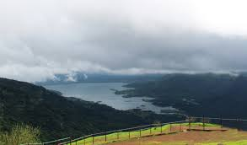

* Rambagh Point:

Rambagh Point is the most famous picnic spot that provides spectacular view of the karjat and khandal of the region. This is located locate nearby to the town. It makes a weekend perfect destination for a great time with your dear ones.

* Shri Bal Digambar Ganesh Mandir:

Shri Bal Digambar Ganesh Mandir is located in kadav Karjat Town. It is a very spiritual place located in a quiet and peaceful location. Nice and simple place. There seems to be historic semblance to it’s given that there are 2/3 very old carved lying near the premise.

* Panorama Point:

For adventure seekers and photo enthusiasts, the panorama points are most attractive place in Matheran. It provides stunning view of Western Ghats and nearby towns and villages is completely breathtaking. This tranquility of the place adds the overall appeal of this site which also doubles up as an idyllic picnic spot.

* Lousia Point:

Lousia Point is one of the significant touring attractions of the goal, which gives perspectives of lovely environment. It offers wonderful perspective of old landmarks which incorporate fortresses of vishalgad and prabal. There is frequented by nature sweethearts to locate nightfall. This place is also known as photographer’s paradise in matheran, as it is famous for offers panoramic views of mountains, peaks, valleys, lake and waterfalls.

* Mountain Top Camping:

Mountain Top Camping is located at-Pavanalake, near Lonavala, Dist-Pune, Khandala, and Lonavala. Mountain Top Camping is located in Pavanalake which is nearer to Lonavala. This place one of the best places to spend weekend with friends for camping. It is an amazing to out with friends in both rainy and winter season. The waterfalls were the highlight in the monsoon and star gazing was highlight in winter. It is a bit tough but the wonderful view at the top of the fort is worth all the efforts. Also, the village food was finger licking.

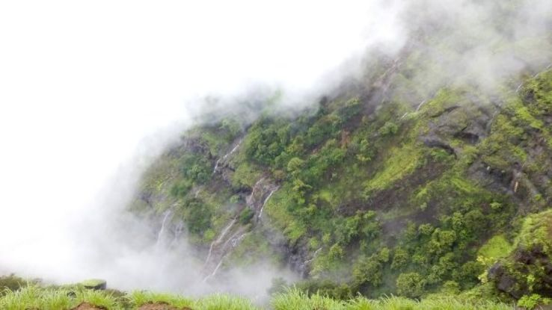

* Irshalgad Fort:

Irshalgad Fort is best place for trekking with friends which is about 3700 feet above sea level situated on a hill. It is a difficult to climb up through Irshalagad Fort trek. It takes one hour from Irshalwadi village to reach fort. The trek had been from Base Village Irshalwadi. It is located in between Matheran and Panvel in Maharashtra.

* Hart Point:

One of the famous points of interest in Matheran offers majestic views of the low lying lush plains and the greenish quite villages it is located at a distance of 2.5 km from Matheran hill station, Hart Point or Heart Point is situated on the north-western edge of the Matheran hill station. This point is surrounded by dense green woods; offer a cool, calm and unspoiled spot for taking meditation and relaxation techniques. It is also a favorite point of the visitor to view a beautiful sunrise from the location. The site is popular among tourists as well as locals and is a paradise for nature lovers.

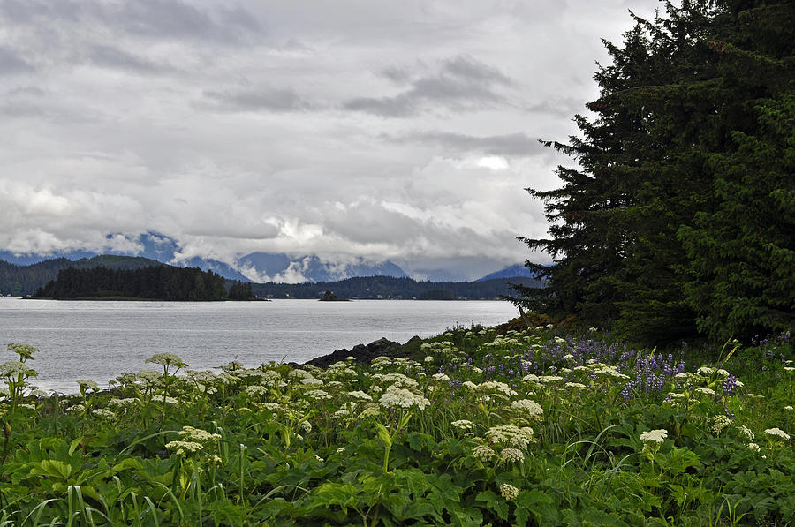

* Narayani Dham Temple:

It is religious place located in Dhankawadi area of Lonavala at a distance of 2 km from Lonavala Railway Station. This temple is dedicated to Goddness Narayani and is one of the famous places of sightseeing in Lonavala. The people from local areas and as well as tourists visit everyday owing to its famous path Dadi Mangal and bhajans that fill the air with spirituality. The temple is famous for celebrating Ganesh Chathurdi, Janmashtami and Diwali festivals with much enthusiasm. The temple has a hall huge enough to host more than 15,000 devotees. It also has a lodging facility where devotees coming from long distance can easy stay and take rest.

**Connectivity to karjat and new Developments:-**

Karjat has huge population as compared to other cities within the localities in Raigad district. There are number of various development areas and number of hotels, schools, banks and hospitals within the localities which makes an excellent network of roadways and railway stations. There are various schools are constructed for the children’s within the localities. Parents, within the localities don’t have to worry about their children’s education. Apart from these there are banks, hospitals and many more are available in a residential area. Weekend holidays, residents can enjoy their happy day by visit the nearby attractive location of the city.

All these network connectivity within the karjat location, there is an excellent network of roadways and railways stations facilities are available to reduce the time travelling from one place to other. The extensive network of roadways connected to localities like Murbad, Kaiyanpur, Kasara Ghat on oneside and Kapolei, Sholapur, Neral, Badlapur, Ambernath, Pen Panvel on another side. More over karjat is accessible via NH17, NH4 and NH3 highways. This road connectivity makes fastest route to connect to various other accessible regions. Travelling via railway, Karjat has well connectivity towards Mumbai from karjat railway station that connects Mumbai and Karjat. This railway station is also junctions were local and express train is halt. If residents are planning to go for hometown, then it could be easy for them to catch express train. Train for travelling towards Southside, express train is passing through the karjat station. Another connectivity option for the residents to travel is through airline service such as Chatrapati Shivaji international Airport and the Navi Mumbai International Airport. These two airports are the nearest airport from the karjat.

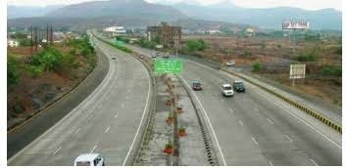

In Upcoming year, there are planning and implementing by Mumbai Metropolitan region development authority and City and Industrial Development Corporation (CIDCO).Firstly, the area has been given minimal FSI of 1.0. Within the area there is recreation centre is also proposed to be developed, along with a 20-20 league playground and a golf course.

To boost connectivity to the commercial and industrial pockets of the region, government has recently approved for development for Neral-Bhimashankar highways. Infrastructure is expected to improve the roadway which connects to Navi Mumbai Airport, expansion of JNPT and the proposed Mumbai Trans-Harbour Link. To reduce the distance between Mumbai and Karjat there are planning to develop four-lane state highway 38 from chowk to karjat and State Highway 54.In addition to these projects, newly four-lane highway is being built between Badlapur and Karjat location which reduces time travelling and distance.

The real estate development within the region acts as catalyst.”Residential, Commercial and large self-sustained townships’ have launched in these locations. The four mode of transport connectivity such as rail network, state highways and the upcoming airport and water transport facilities will boost and improve the standard of living of the people in the region.