**Practical no 01:Demonstrate Simple Hello Word program using Angular.**

<html>

<head><title>hello angular</title></head>

<script src="https://ajax.googleapis.com/ajax/libs/angularjs/1.8.2/angular.min.js">

</script>

<div>

<h1>{{'hello world'}}</h1>

</div>

</html>

Output:

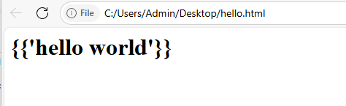

**Practical no 02:Demonstrate angular js script to implement Built-in Directives.**

<html>

<head><title>hello angular</title></head>

<script src="https://ajax.googleapis.com/ajax/libs/angularjs/1.8.2/angular.min.js">

</script>

<div>

{(10+20)}

</div>

<div body ng-app="">

{{10+20}}

<h1>{{'hello world'}}</h1>

<p>first number:

<input type="number" ng-model="a"/>

</p>

<p>second number:

<input type="number" ng-model="b"/>

</p>

<p>sum:{{ a+b }}</p>

</div>

</body>

</html>

Output:

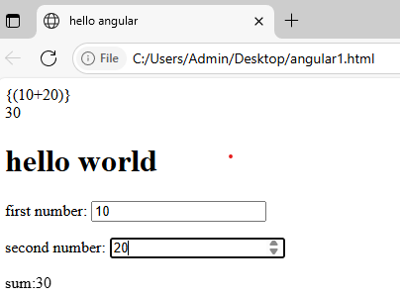

**Practical no 03: Demonstrate angular js script to add modules and controller.**

<html>

<script src="https://ajax.googleapis.com/ajax/libs/angularjs/1.8.2/angular.min.js"></script>

<body>

<div ng-app="myApp" ng-controller="myCtrl">

{{firstname+""+lastname}}

</div>

<script>

var app=angular.module("myApp",[]);

app.controller("myCtrl",function($scope){

$scope.firstname="prachi";

$scope.lastname="take";

});

</script>

</body>

</html>

Output:]



**Practical no 05:Demonstrate number,currency,uppercase and lowercase filters.**

<html>

<script src="https://ajax.googleapis.com/ajax/libs/angularjs/1.8.2/angular.min.js"></script>

<body>

<div ng-app="myApp" ng-controller="personCtrl">

<p>The name is {{firstname | uppercase}}</p>

<h1>price:{{price | currency}}</h1>

<p>The name is {{college |lowercase}}</p>

</div>

<script>

angular.module('myApp',[]).controller('personCtrl',function($scope){

$scope.firstname="prachi"

$scope.lastname="Take",

$scope.price=96;

$scope.college= "G.H.Raisoni"

});

</script>

</body>

</html>

Output:

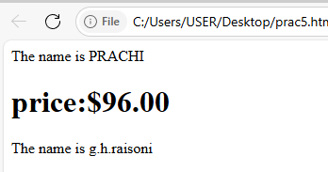

**Practical no 06: Write angular js app for displaying current date in 10 different format using date filter.**

<!DOCTYPE html>

<html>

<head>

<meta charset="utf-8">

<title>AngularJS Date Formats</title>

<script src="https://ajax.googleapis.com/ajax/libs/angularjs/1.8.2/angular.min.js"></script>

</head>

<body ng-app="dateApp" ng-controller="dateController">

<h1>Current Date in Different Formats</h1>

<p><strong>Default:</strong> {{ currentDate | date }}</p>

<p><strong>Short:</strong> {{ currentDate | date:'short' }}</p>

<p><strong>Medium:</strong> {{ currentDate | date:'medium' }}</p>

<p><strong>Full Date:</strong> {{ currentDate | date:'fullDate' }}</p>

<p><strong>Long Date:</strong> {{ currentDate | date:'longDate' }}</p>

<p><strong>Short Time:</strong> {{ currentDate | date:'shortTime' }}</p>

<p><strong>Medium Time:</strong> {{ currentDate | date:'mediumTime' }}</p>

<p><strong>Custom (DD/MM/YYYY):</strong> {{ currentDate | date:'dd/MM/yyyy' }}</p>

<p><strong>Custom (MMMM dd, yyyyHH:mm:ss):</strong> {{ currentDate | date:'MMMMdd, yyyyHH:mm:ss' }}</p>

<p><strong>Custom (EEE, MMM d, yyyy):</strong> {{ currentDate | date:'EEE, MMM d, yyyy' }}</p>

<script>

var app = angular.module('dateApp', []);

app.controller('dateController', function ($scope) {

$scope.currentDate = new Date();

});

</script>

</body>

</html>

Output:

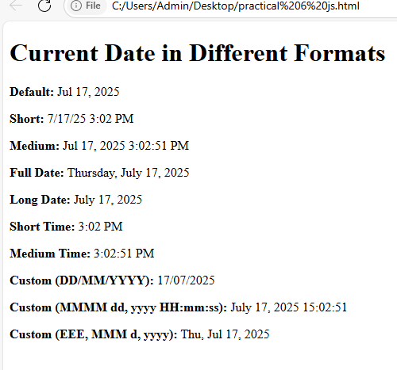

**Practical no 07:Write angular js app whch sort array object data in ascending and decending by using orderby filter.**

<!DOCTYPE html>

<html>

<head>

<script src="https://ajax.googleapis.com/ajax/libs/angularjs/1.8.2/angular.min.js"></script>

</head>

<body ng-app="myApp" ng-controller="nameCtrl">

<p>Looping with object:</p>

<ul>

<li ng-repeat="x in names | orderBy:'country'">

{{x.names + ', ' + x.country}}

</li>

</ul>

<script>

angular.module('myApp', []).controller('nameCtrl', function($scope) {

$scope.names = [

{names:'jani', country:'USA'},

{names:'carl', country:'eng'},

{names:'mahesh', country:'india'},

{names:'hege', country:'norway'},

{names:'joe', country:'UAE'},

{names:'gustay', country:'eng'},

{names:'birgit', country:'india'},

{names:'prachu', country:'eng'},

{names:'pooja', country:'USA'}

];

});

</script>

</body>

</html>

Output:

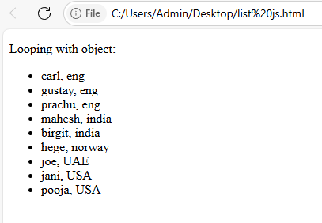

**Practical no 08:Demonstrate simple form using angular js script.**

<html ng-app>

<head>

<script src="https://ajax.googleapis.com/ajax/libs/angularjs/1.8.2/angular.min.js"></script>

</head>

<body>

<h2>angular js simple form</h2>

<div ng-init="name=''; output=''">

<input type="text" ng-model="name" placeholder="enter name"><br><br>

<button ng-click="name=''">reset</button>

<button ng-click="output = name">display</button>

<p><strong>output:</strong> {{output}}</p>

</div>

</body>

</html>

Output:

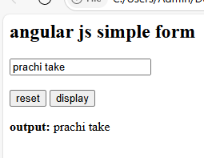

**Practical no 10: Implement a simple Angular Calculator application that can perform basic**

**Mathematical operations (addition,subtraction,multiplication,division) based on user input.**

<html>

<html ng-app="calculatorApp">

<head>

<title>Simple AngularJS Calculator</title>

<script src="https://ajax.googleapis.com/ajax/libs/angularjs/1.8.2/angular.min.js"></script>

<style>

body {

font-family: Arial;

padding: 30px;

}

input {

margin: 5px;

padding: 5px;

}

button {

margin: 5px;

padding: 8px 12px;

}

</style>

</head>

<body ng-controller="calculatorcontroller">

<h2>AngularJS Calculator</h2>

<label>Enter first number:</label>

<input type="number" ng-model="num1"><br>

<label>Enter second number:</label>

<input type="number" ng-model="num2"><br>

<button ng-click="add()">Add (+)</button>

<button ng-click="subtract()">Subtract (-)</button>

<button ng-click="multiply()">Multiply (×)</button>

<button ng-click="divide()">Divide (/)</button>

<h3>Result: {{ result }}</h3>

<script>

var app = angular.module('calculatorApp', []);

app.controller('calculatorcontroller', function($scope) {

$scope.num1 = 0;

$scope.num2 = 0;

$scope.result = 0;

$scope.add = function() {

$scope.result = $scope.num1 + $scope.num2;

};

$scope.subtract = function() {

$scope.result = $scope.num1 - $scope.num2;

};

$scope.multiply = function() {

$scope.result = $scope.num1 * $scope.num2;

};

$scope.divide = function() {

if ($scope.num2 !== 0) {

$scope.result = $scope.num1 / $scope.num2;

} else {

$scope.result = "Cannot divide by zero!";

}

};

});

</script>

</body>

</html>

**Output:**

