ACTIVITY

Software as a Service – SaaS

* SaaS is also known as "**On-Demand Software**". It is a software distribution model in which services are hosted by a cloud service provider.
* These services are available to end-users over the internet so, the end-users do not need to install any software on their devices to access these services.
* In this model, an independent software vendor (ISV) may contract a third-party cloud provider to host the application.

**Features of SaaS**

* Multi-tenancy model.
* Automated provisioning.
* Single Sign On.
* Subscription based billing.
* High availability.
* Elastic Infrastructure.
* Data Security.
* Application Security.

**BENEFITS OF SAAS**

## Reduced time to benefit

## Lower costs

## Scalability and integration

## New releases (upgrades)

## Easy to use and perform proof-of-concepts

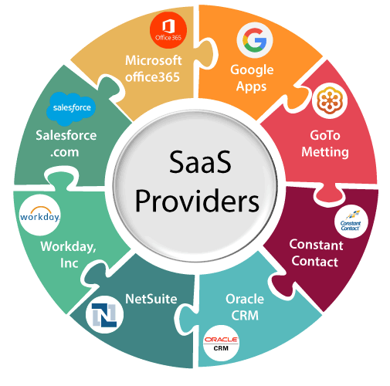

SAAS DAILY OPERATION IN DT3

* Customer Relationship Management (CRM).
* Web hosting and E-commerce.
* Communication platforms.
* Accounting and invoicing.
* Payment gateways.
* Project management.
* Enterprise resource planning (ERP)