NAME : Shreemayi Katakam
ROLL NO: 2503B05124
BRANCH: M-TECH(CSE)

Set 4
7. Q1. Create a function to reverse a list in Python. Use an AI tool to suggest alternative
implementations. Test and compare the performance of each version.
(Each question carries 5 marks)
PROMPT: Create a Python function to reverse a list. Then suggest 2–3 alternative implementations to reverse a list (e.g., slicing, recursion, using loops). Test and compare the performance of each version. And take input from the user.
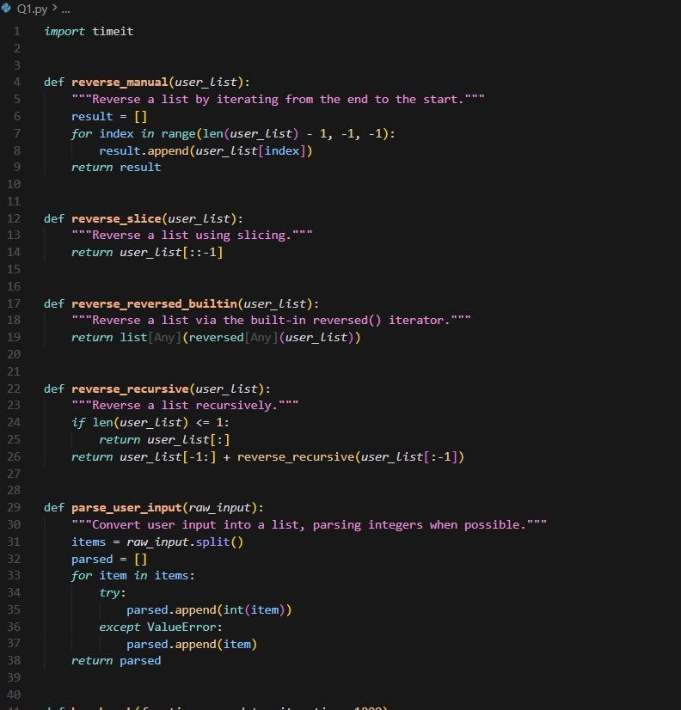
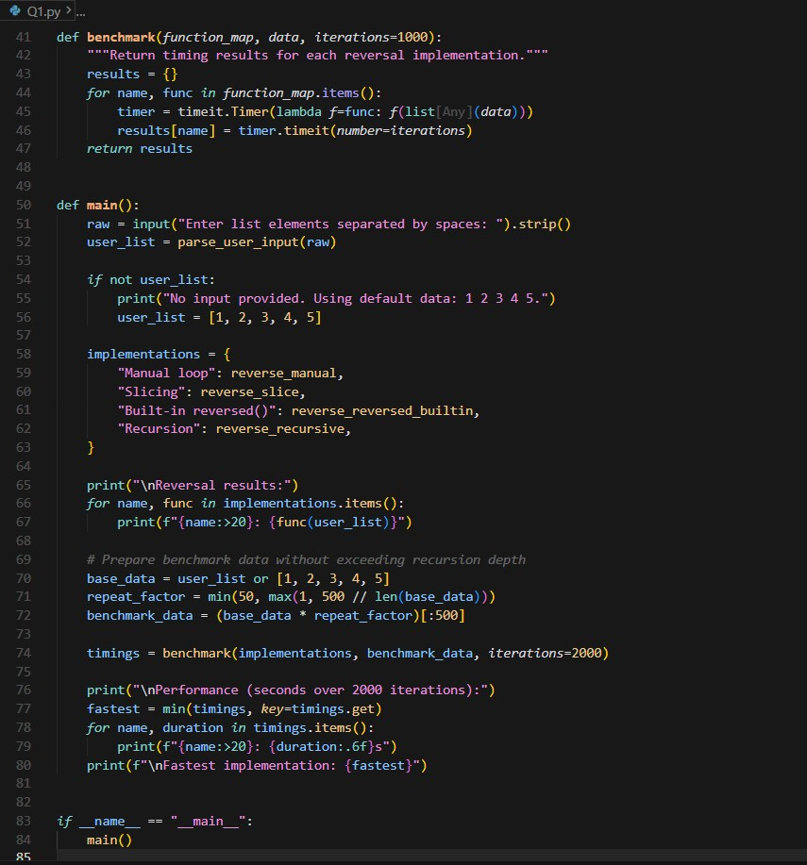
Output:
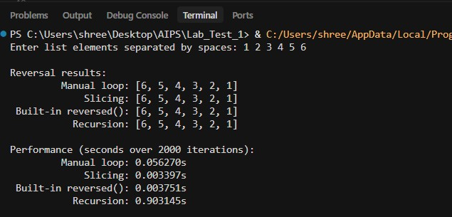
Slicing is fastest because Python handles it internally .
Loop is slower since it handles elements one-by-one in Python.
Recursion repeatedly creates new lists very slow
8. Q2. Design a few-shot prompt to guide an AI tool in writing code for a basic linked list
with methods for insert and delete. Analyze the resulting code for correctness and
completeness.
(Each question carries 5 marks)
PROMPT: Design a few-shot prompt to guide an AI tool and write a Python program for a Singly Linked List with basic methods to insert and delete .And take input from the user.

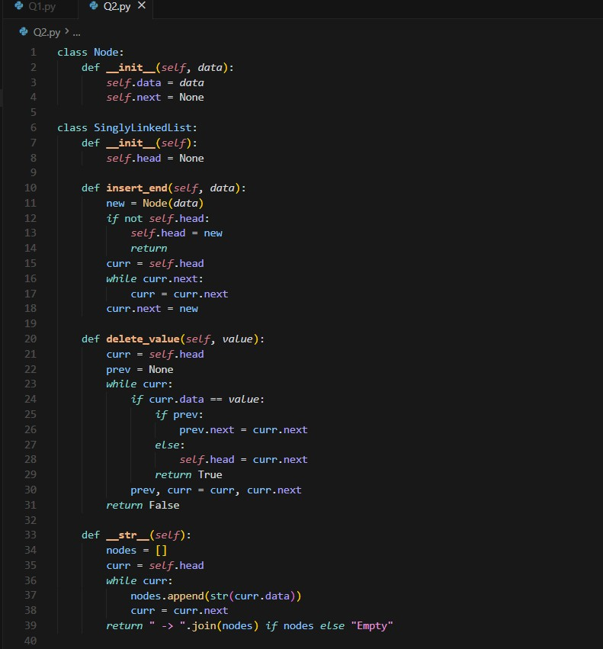
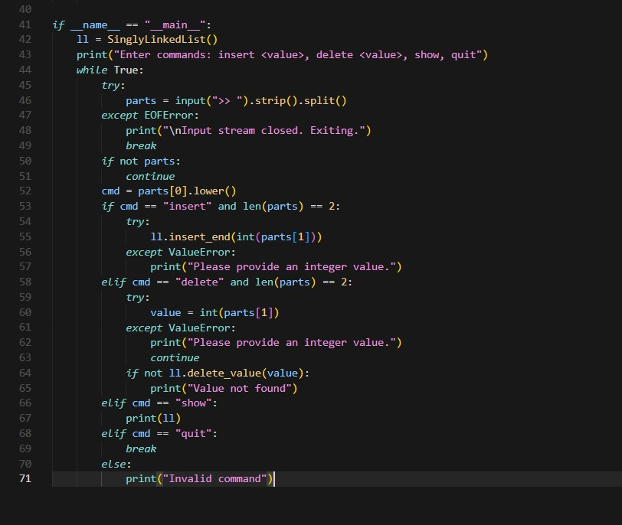

Output:
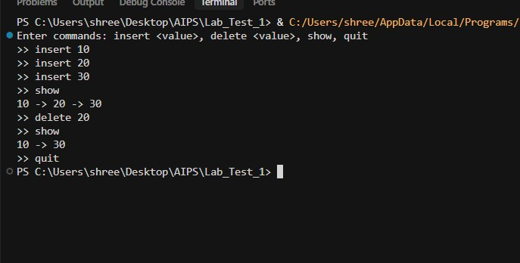
It includes a Node class, a LinkedList class, and properly implemented insert() and delete() methods

