Investigating Smart Home Security: Is Blockchain the Answer?
Smart Home Automation gaining popularity because of remote home monitoring or access of home appliances with the help of IOT (internet of things) sensors. IOT can utilize internet connection to accept commands such as Bulb ON or OFF from users and then execute those commands. IOT devices ease user works but raise risk of security as malicious users can eavesdrop with malicious command to disturb services. IOT devices are small in size and processing so traditional security algorithms cannot be employed so author of this paper aim to investigate Blockchain technology to secured smart home devices.
In existing application all IOT sensors were using traditional centralized cloud server for data storage, if this server crash o hacked then all data and services will be lost but Blockchain can be the solution as its store data in decentralized manner so if one node down then Blockchain can access data from other working nodes.
Blockchain store data as Block/transaction and associate each node with unique hashcode and this hashcode will get verify for subsequent block storage, if data tamper at any node then hashcode will get mismatch and data tamper will get detected and this verification process makes Blockchain secured and tamper proof storage.
Above advantages of Blockchain can be the solution for all the security issues faces by IOT sensors in traditional cloud storage and network access.
In propose work author has used real IOT sensors for door locked or bulb on/off and then perform simulation using mobile application and Blockchain storage. In propose simulation sensors (SEN) are used as NODES and Super Node (SN) is used as communication between nodes and users. SN will accept commands from user and then send to SEN for execution, SEN will authenticate user with previous 5 blocks hashcode and upon successful authentication SEN will execute command send result back to SN. SEN will store all executed commands and user request verification data to Blockchain with the help of SN node.
SEN will authenticate users with the help of REST API by checking user IP is exists in Blockchain whitelist database, user request gap is above 1 minute and hashcode of 5 previous blocked successfully matched. SEN also checked each request must be AES encrypted.
Malicious attacker need to update hashcode of all blocks in Blockchain for successful verification which is not possible so IOT can be successfully secured with the help of Blockchain.
In propose work author has used Consortium Blockchain which allow only a pre-chosen set of nodes are pledged for validating the block and there is no single point left for the attacker to eavesdrop sensor which are running on Blockchain. Using Blockchain IOT command execution response time will be little high and costly but security will be fully achieved.
Blockchain can store and retrieve data using SMART Contracts which can be designed using SOLIDITY programming and this contracts contains functions which can be called using any programming language. In propose work to manage IOT sensor data we have designed following contract.
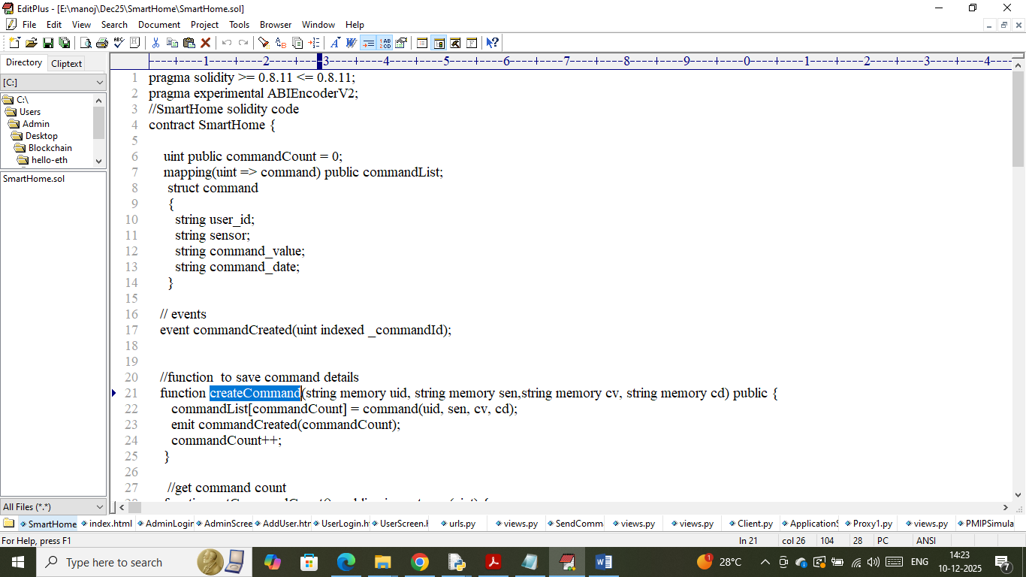
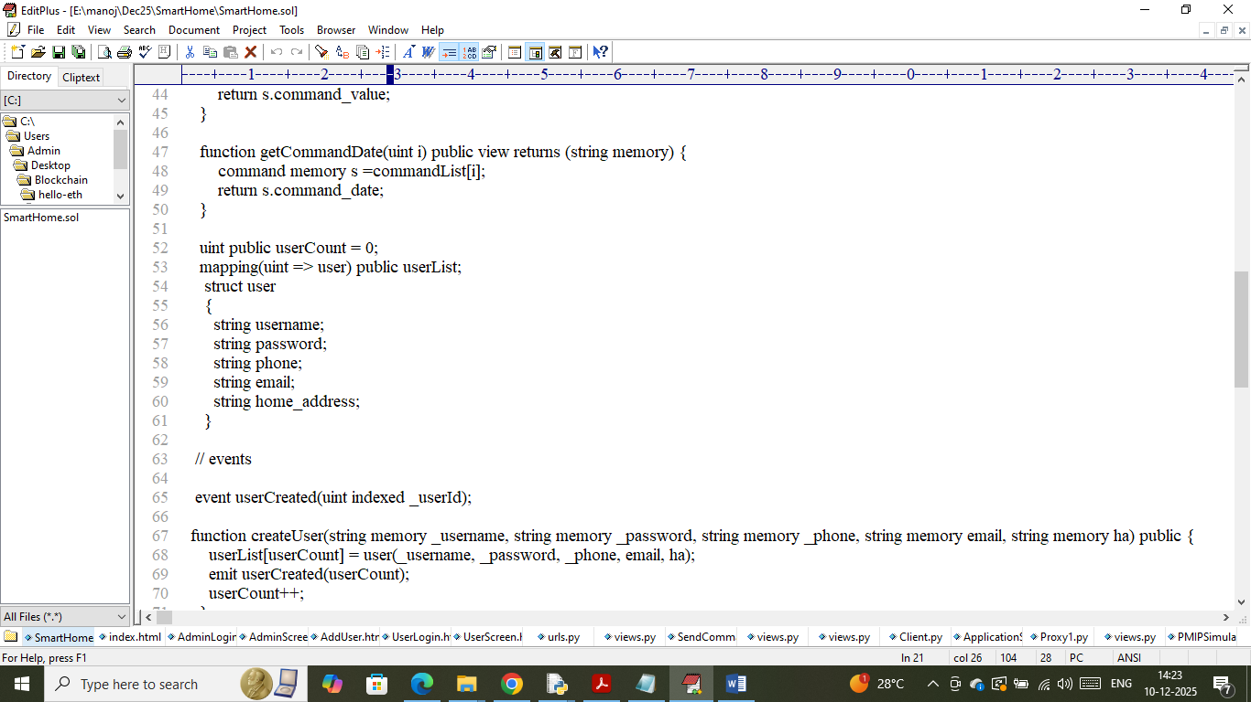
In above contract we have defined function to manage users and sensor commands and now we need to deploy above contract to Blockchain Ethereum using below steps
- First go inside ‘hello-eth/node-modules/bin’ folder and then look and double click on ‘runBlockchain.bat’ file to get below page
- 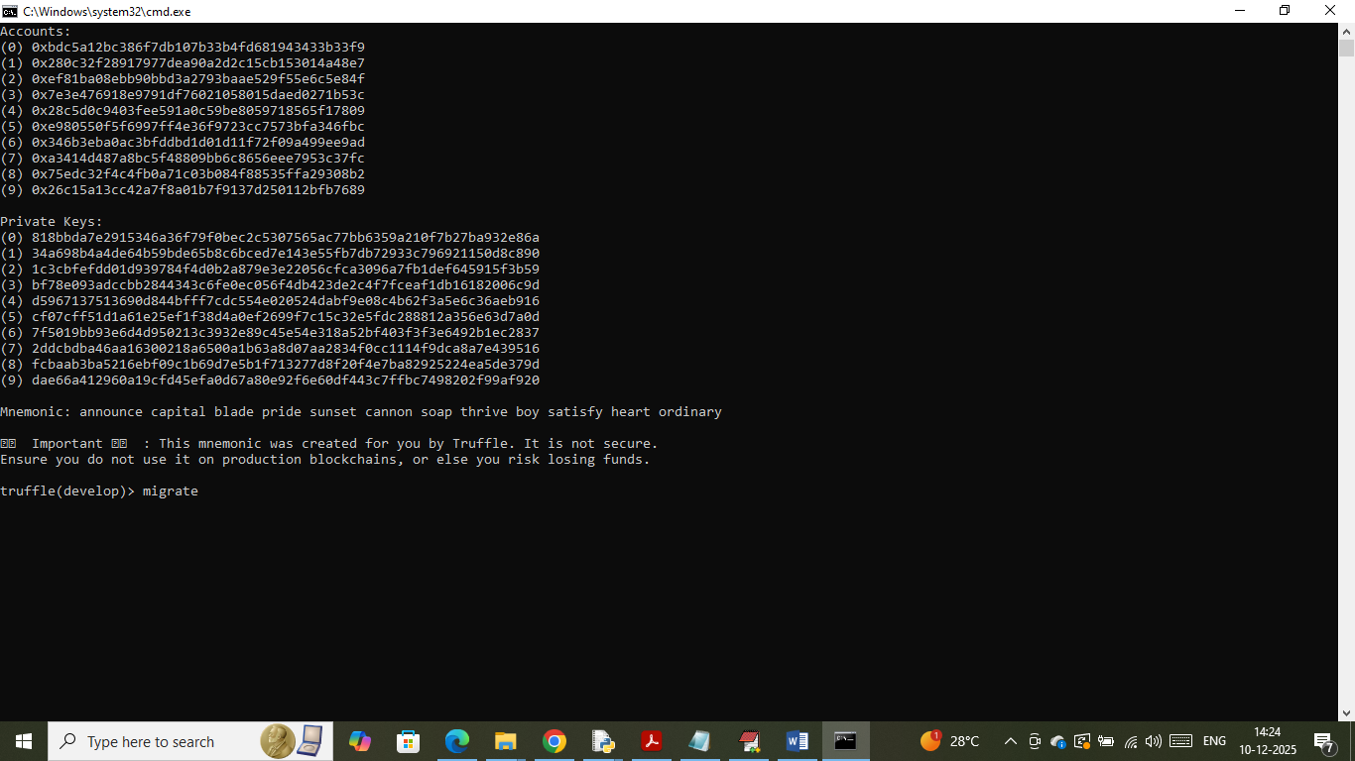
- In above screen Ethereum started with default accounts and private keys and now type command as ‘migrate’ and then press enter key to deploy contract and then will get below page
- 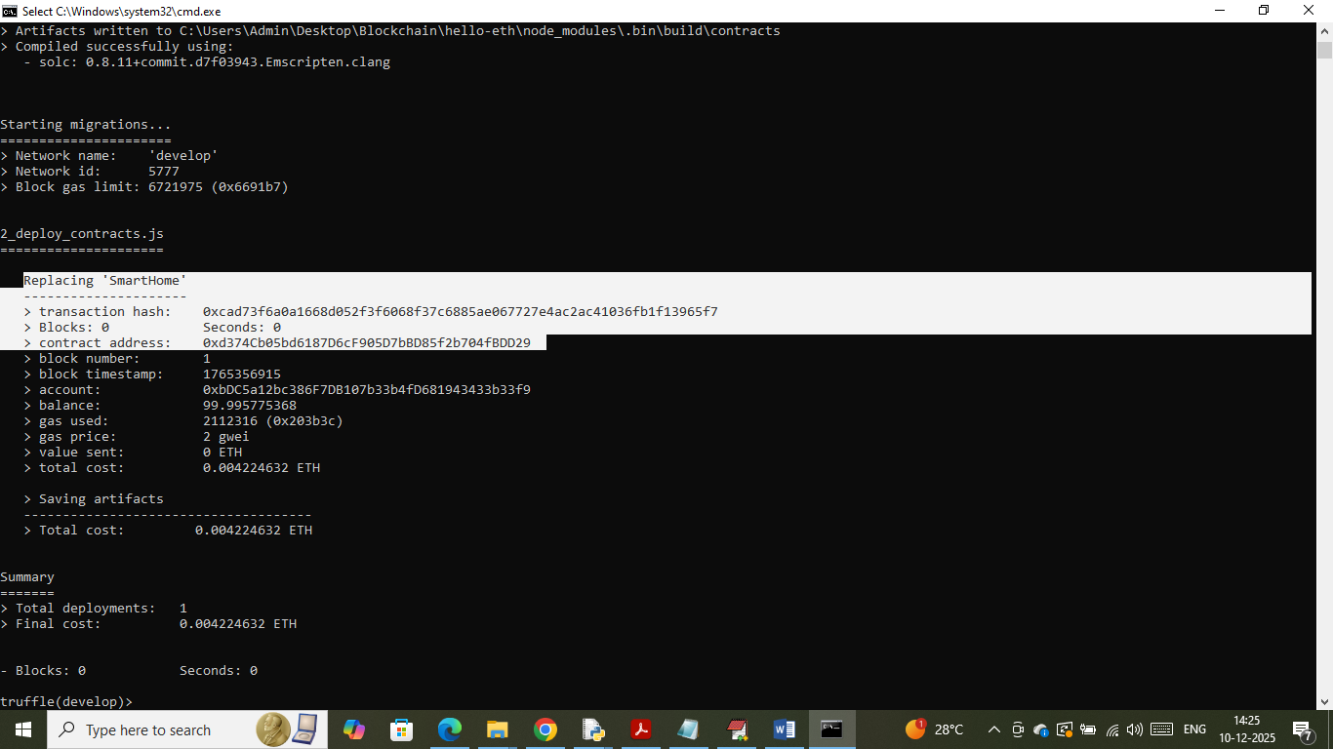
- In above screen in white text can see ‘Smart Home’ contract deployed and got contract address and this address can be specified in python program to call above contract. In below screen showing python code calling above contract using address
- 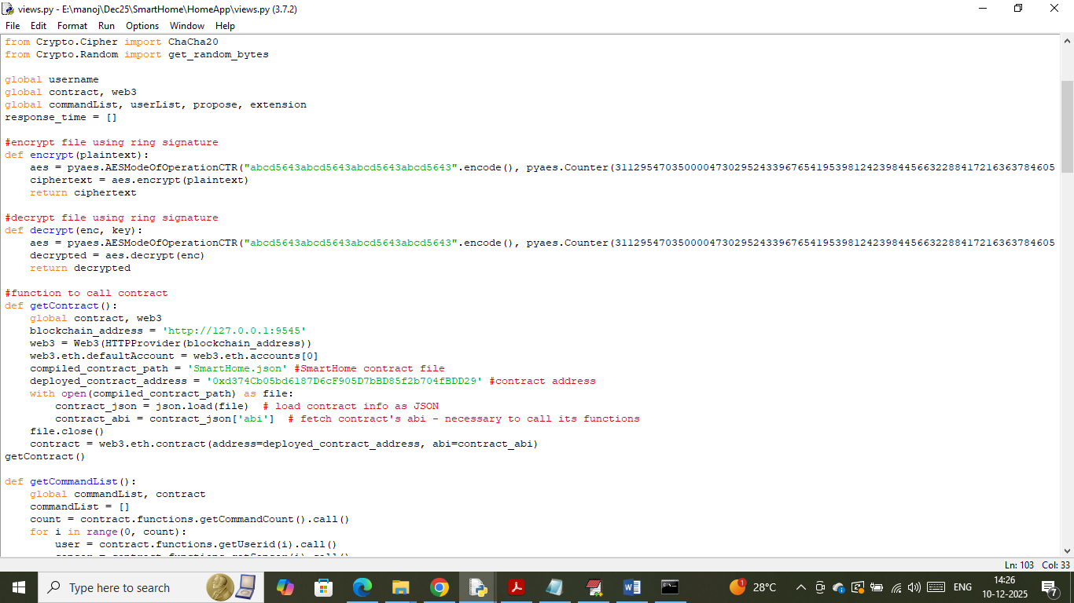
- In above screen read red colour comments to know about contract calling using address. In above screen we have successfully deployed contract and let it run till you execute project.
Extension Concept: In propose work author has used AES algorithm for messages transfer between user and IOT sensor but decrypting and verifying messages at IOT using AES will be more time consuming. To reduce time as extension we have experimented with advanced and more secured algorithm like CHACHA20 which is 30% faster and more secured than AES.

Modules Information
To developed above project we have designed IOT simulation and web based user command application which can run in mobile also and this project contains following modules
- Admin: admin can login to system using username and password as ‘admin and admin’. After login admin will “ADD New User” to Blockchain who can access own IOT sensors and each sensor will verify and mine user command by inspecting Blockchain database with the help of SUPER-NODE. Admin will give login details to each user
- User Login: user can login to system by taking login details from Admin and then perform below operations
- Send Command: user will choose any sensor IOT and then send command as ON or OFF. This commands will be publish to IOT simulation with the help of REST API. SEN will accept command with the help of SUPER NODE and then execute all verification process and upon successful verification command will get executed.
- View History: user can view list of commands executed in the past along with verification hashcode
- Blockchain Response Time: using this module will plot response time graph taken by each transaction
- Propose AES & Extension CHACHA Graph: using this module will plot computation graph between AES and CHACHA20.
- IOT Simulation: you can run this module by double click on ‘runSimulation.bat’ file which will accept REST APPI request from user and then execute command and saved data in Blockchain for future access.
SCREEN SHOTS
To run simulation double click on ‘runSimulation.bat’ file to start simulation and then will get below page
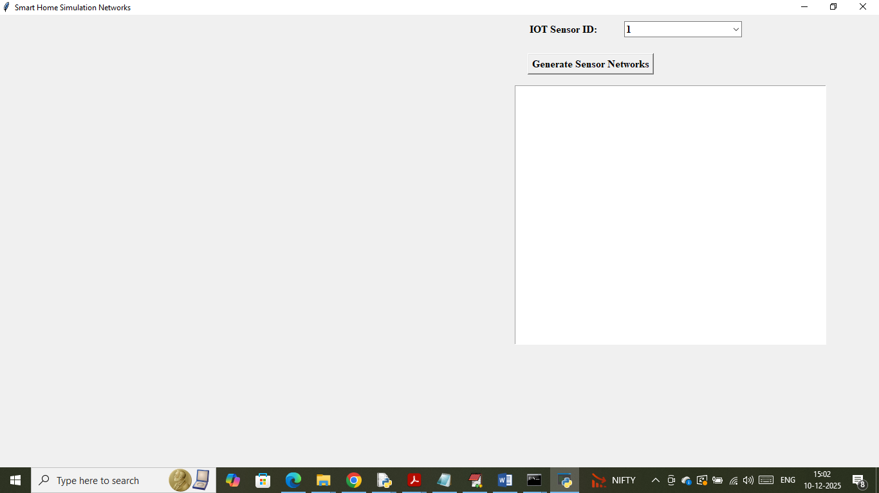
In above screen click on ‘Generate Sensor Network’ button to create simulation and then will get below page
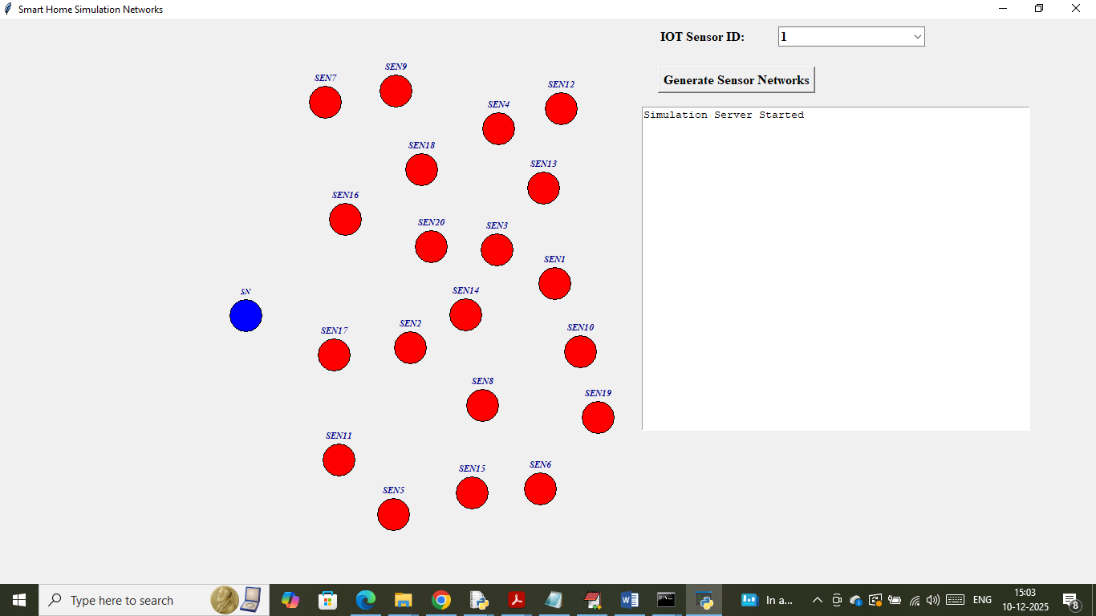
In above screen red colour nodes are the sensors and blue colour node is the ‘Super Node’ which receive command from USER and then send to red colour IOT sensors nodes for verification and to mine command execution transaction. So let the above simulation running and now double click on ‘run.bat’ file to start python web server and then will get below page
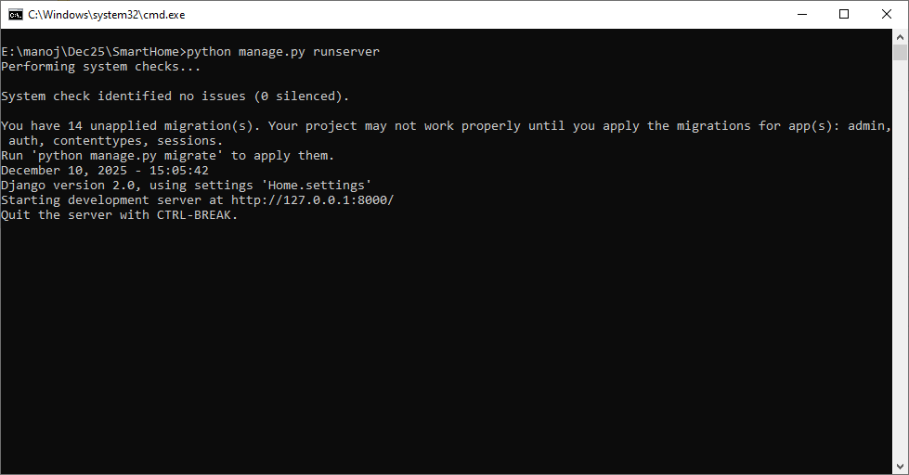
In above screen python web server started and now open browser and enter URL as http://127.0.0.1:8000/index.html and then press enter key to get below page
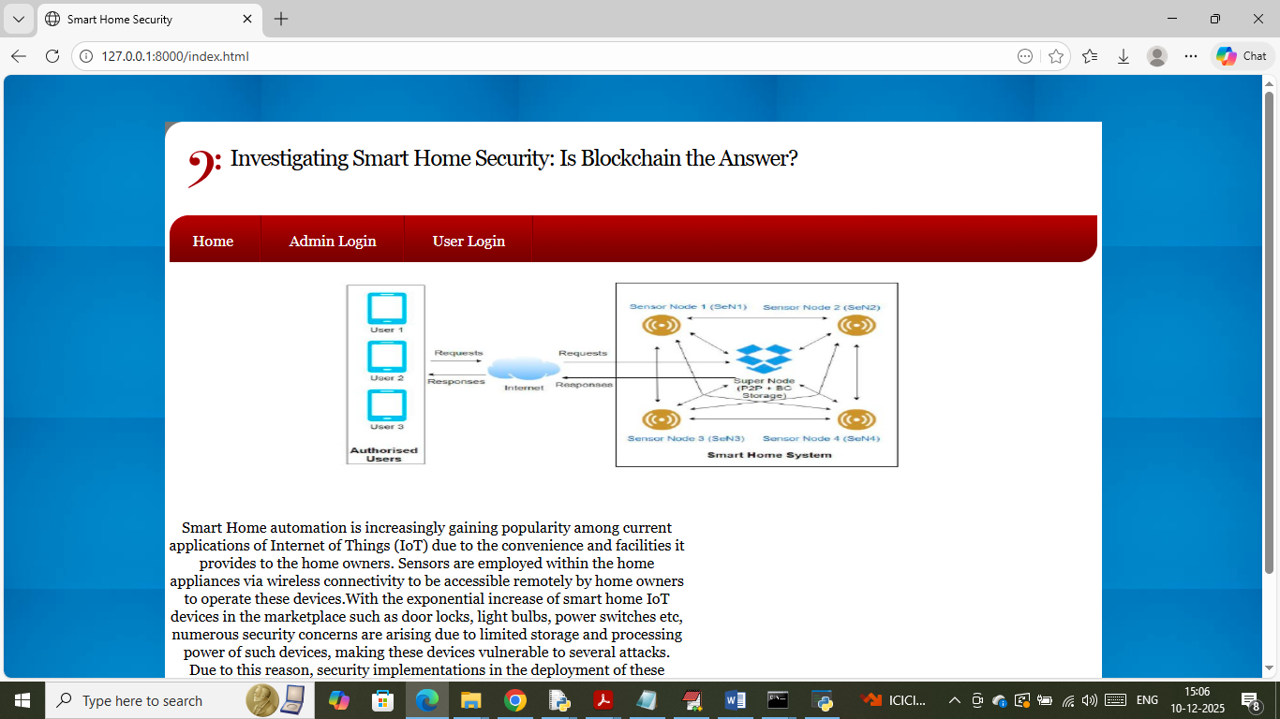
In above screen click on ‘Admin Login’ link to get below page
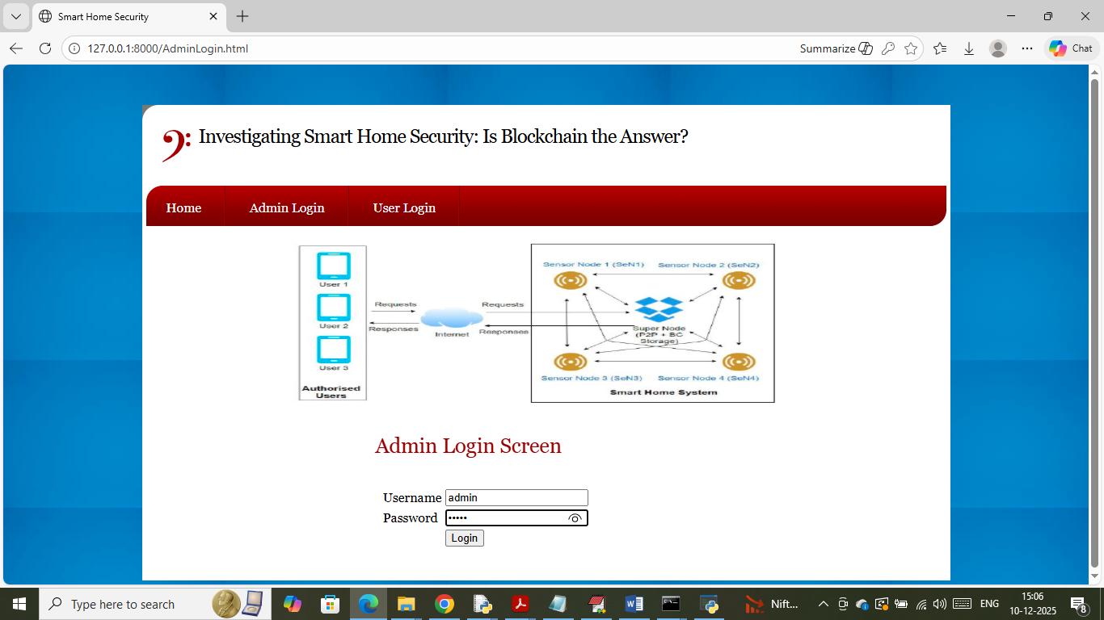
In above screen admin is login and after login will get below page
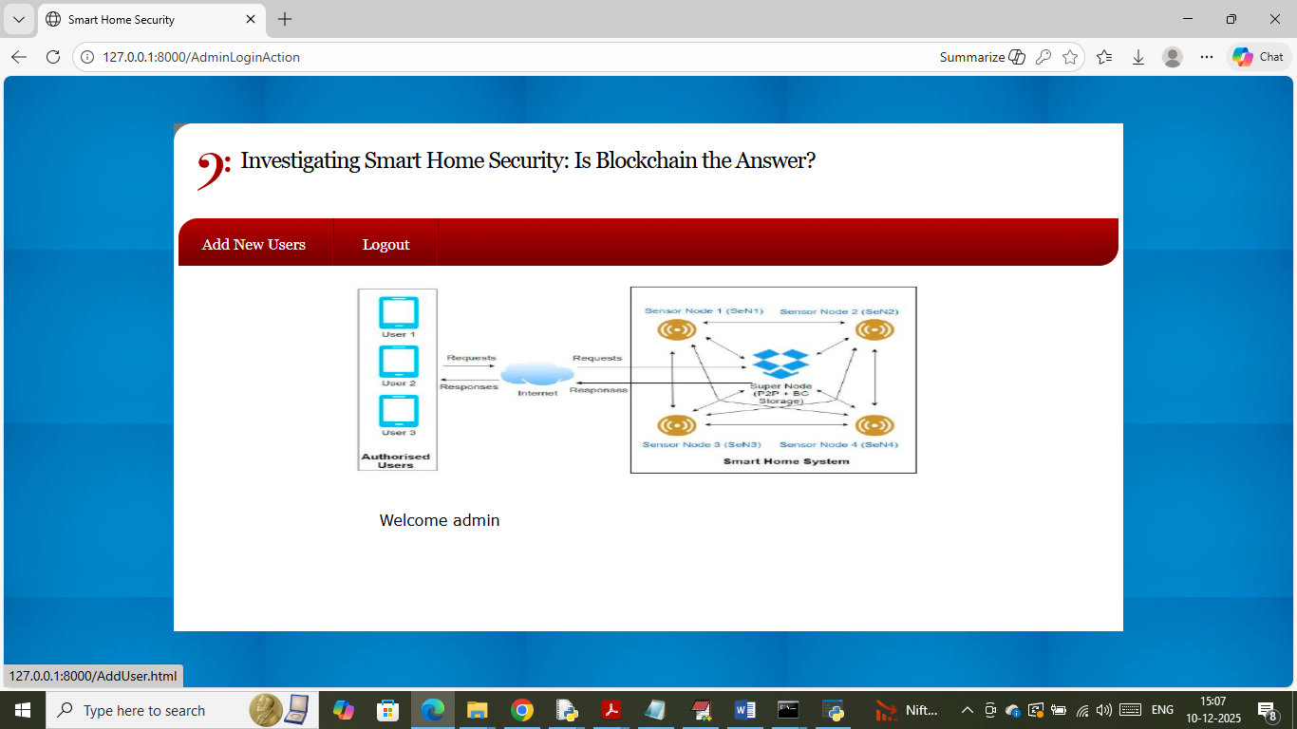
In above screen admin can click on ‘Add New User’ link to get below page
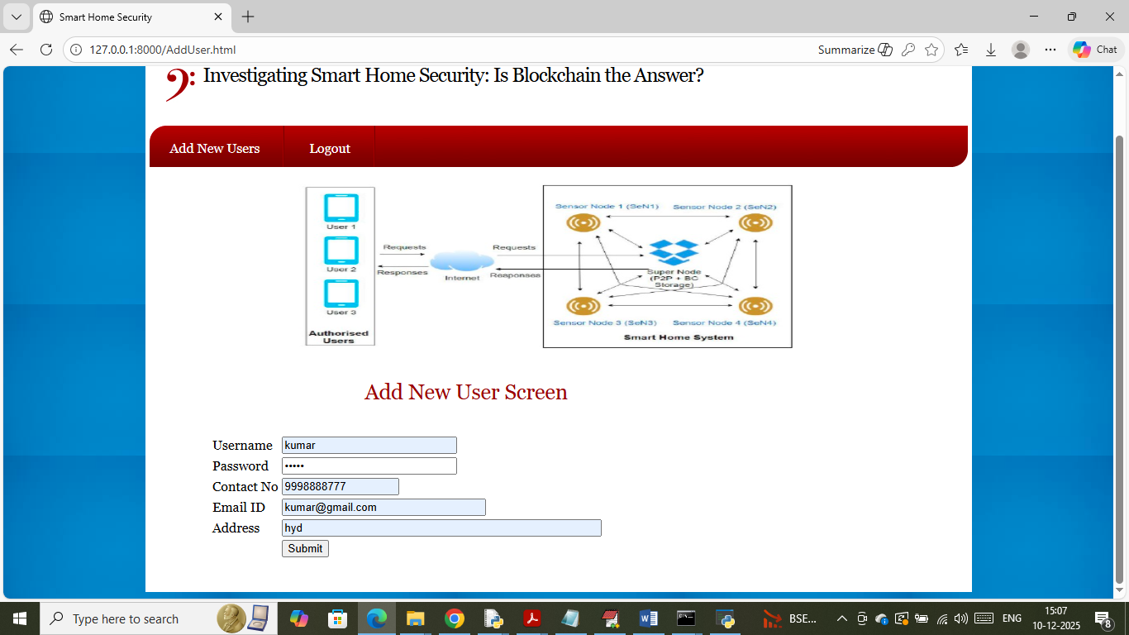
In above screen admin is adding new user details and now click on button to get below page
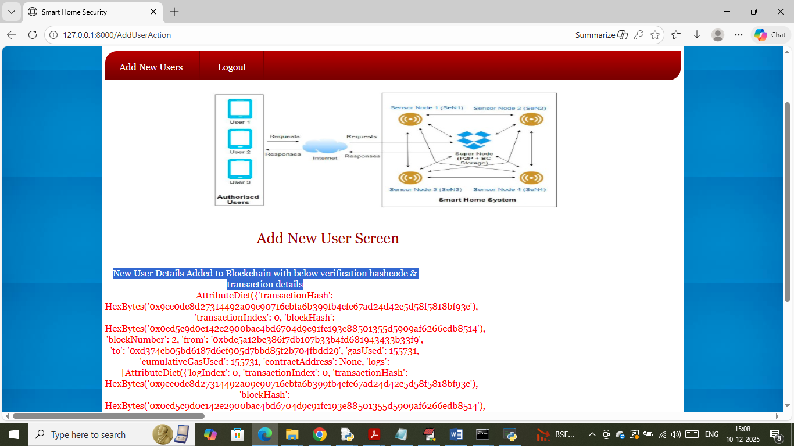
In above screen can see new user details added to Blockchain and then I am displaying entire log obtained from Blockchain which contains details like Transaction, no, block no, hashcode and many other details. Similarly you can add as many users as you want. Now logout and login as user to send commands
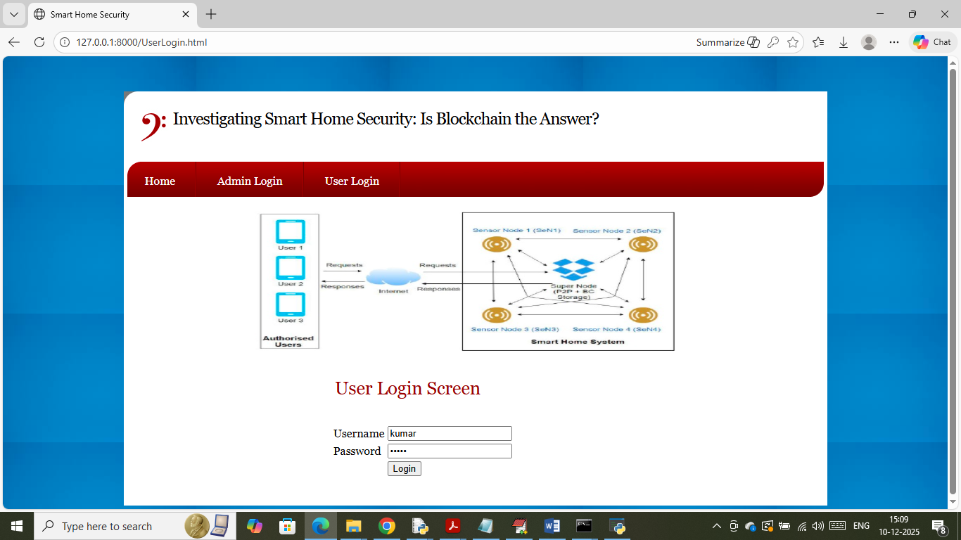
In above screen user is login and after login will get below page
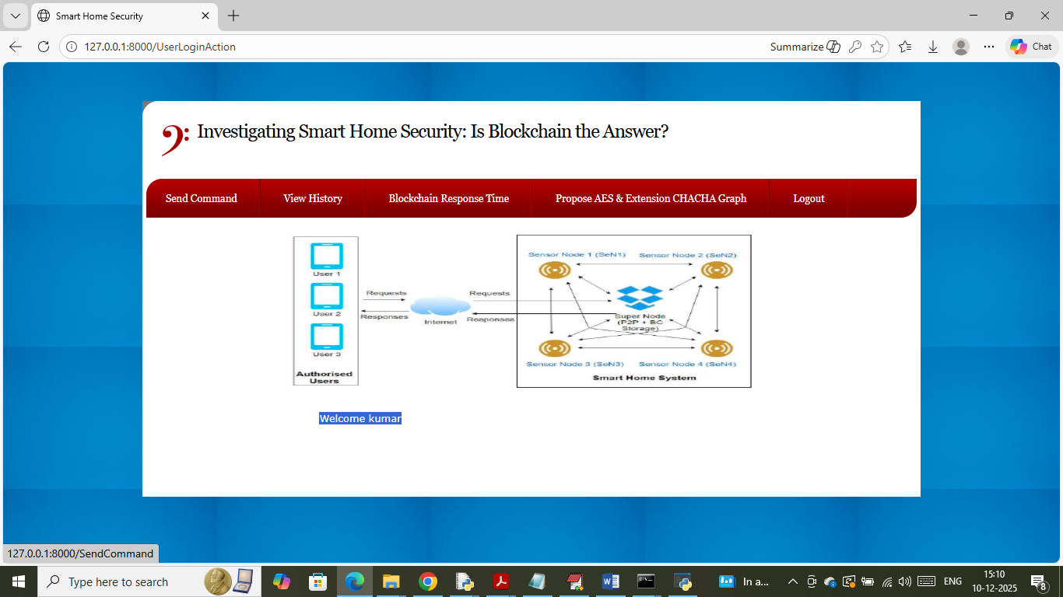
In above screen user can click on ‘Send Command’ link to get below page
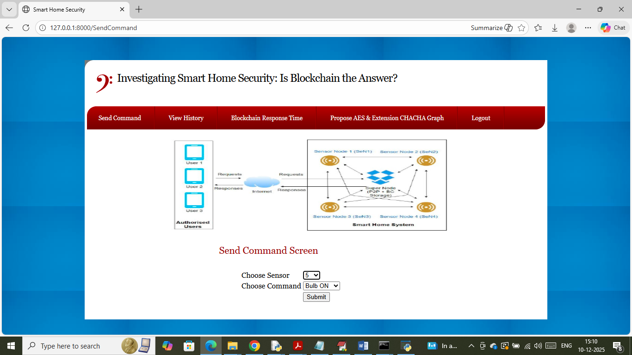
In above screen I am selecting sensor ID as 5 and then selecting command as ‘Bulb ON’ and then press button to send command to simulation and then will get below page
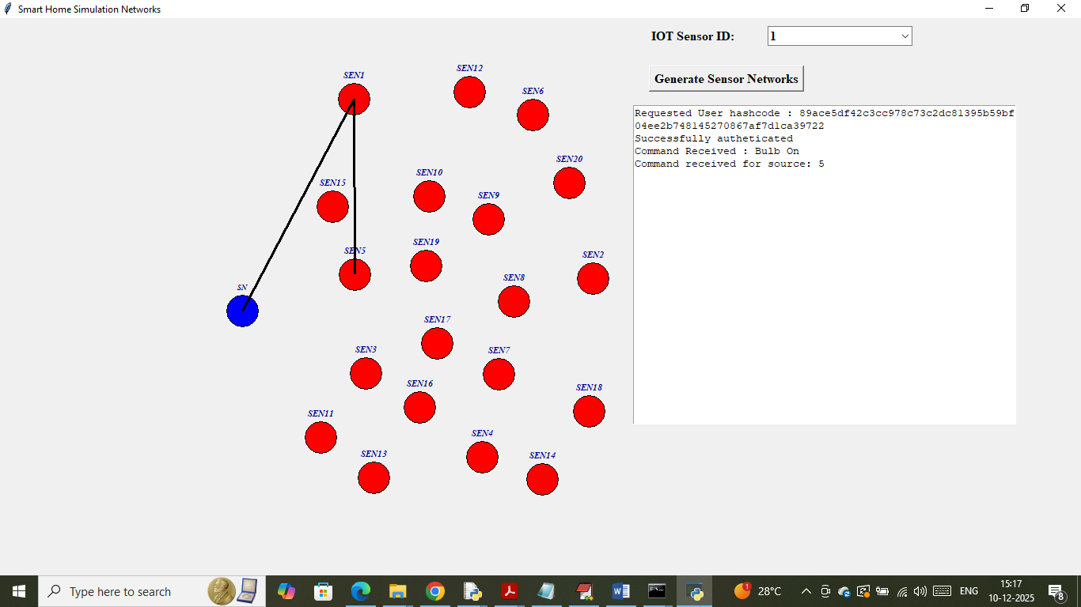
In above screen simulation Super Node receive REST request from user and then sending to sensor node 5 which is marking with black line communication link and then node 5 performing all verification process and then storing data in Blockchain. In text area we can see all verification details and similarly from web user can send command to any node. In below screen executing another request
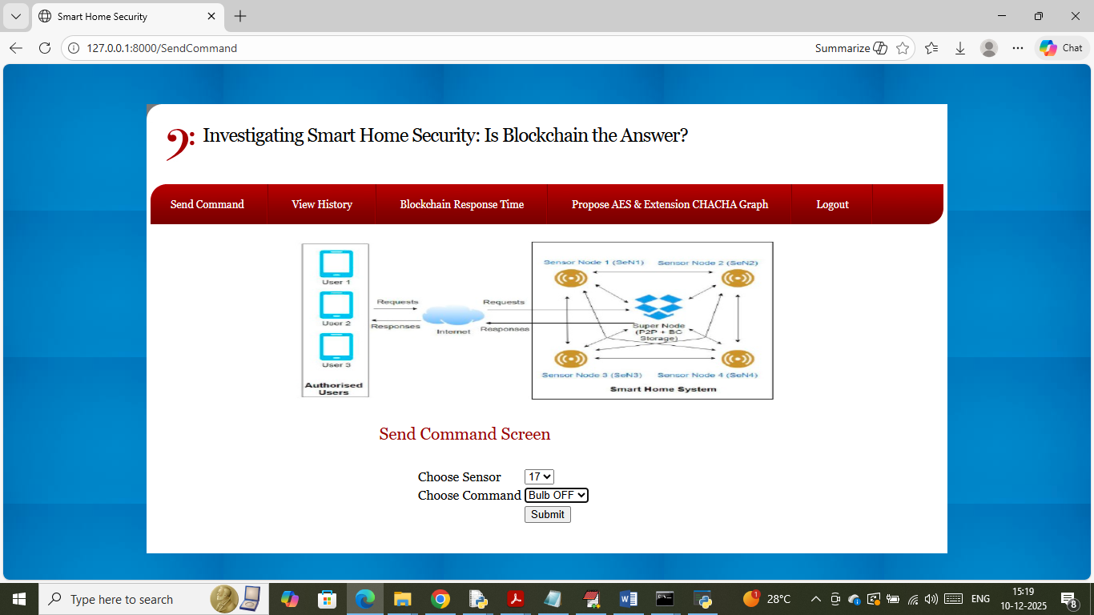
In above screen sending BULB OFF request to node 17 and press button to get below page
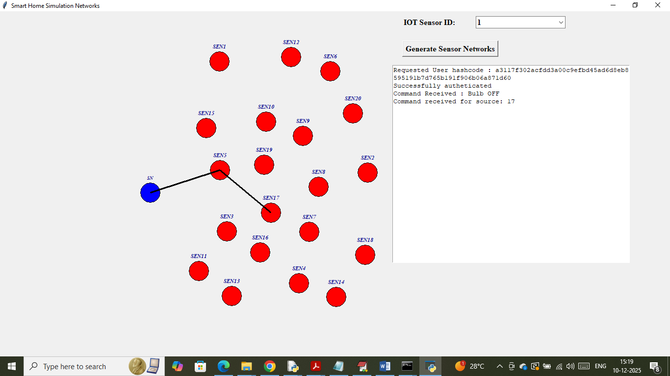
In above screen now Super node sending command to sensor 17 and after executing command will get below page
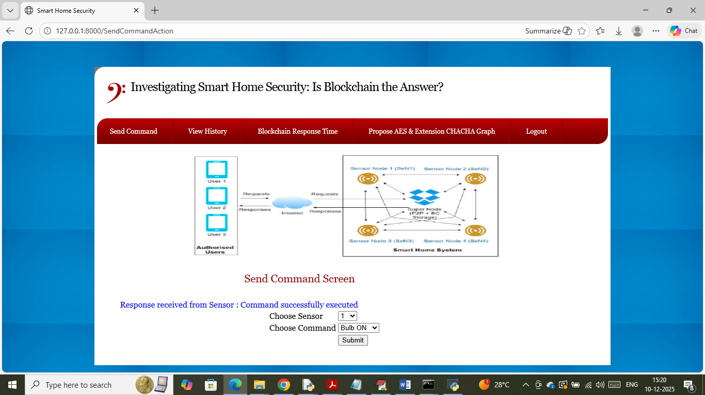
In above screen in blue text can see command successfully executed and now click on ‘View History’ link to view all executed command details
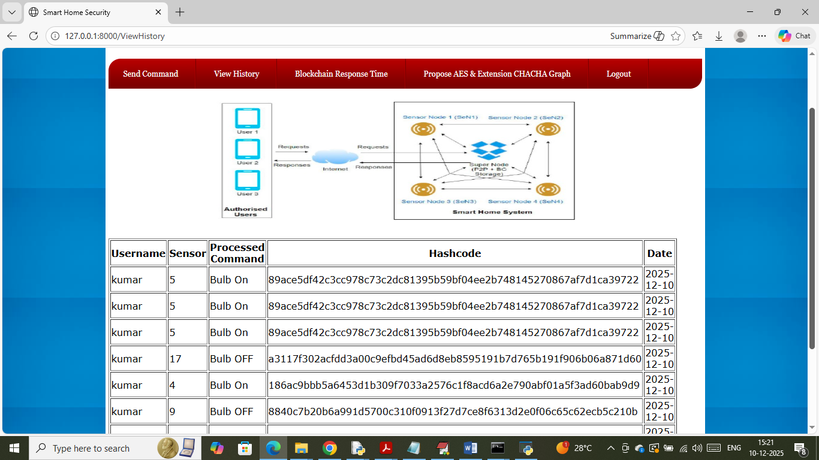
In above screen user can view all commands which are executed in the past along with verification hashcode and now click on ‘Blockchain Response Time’ link to get below graph
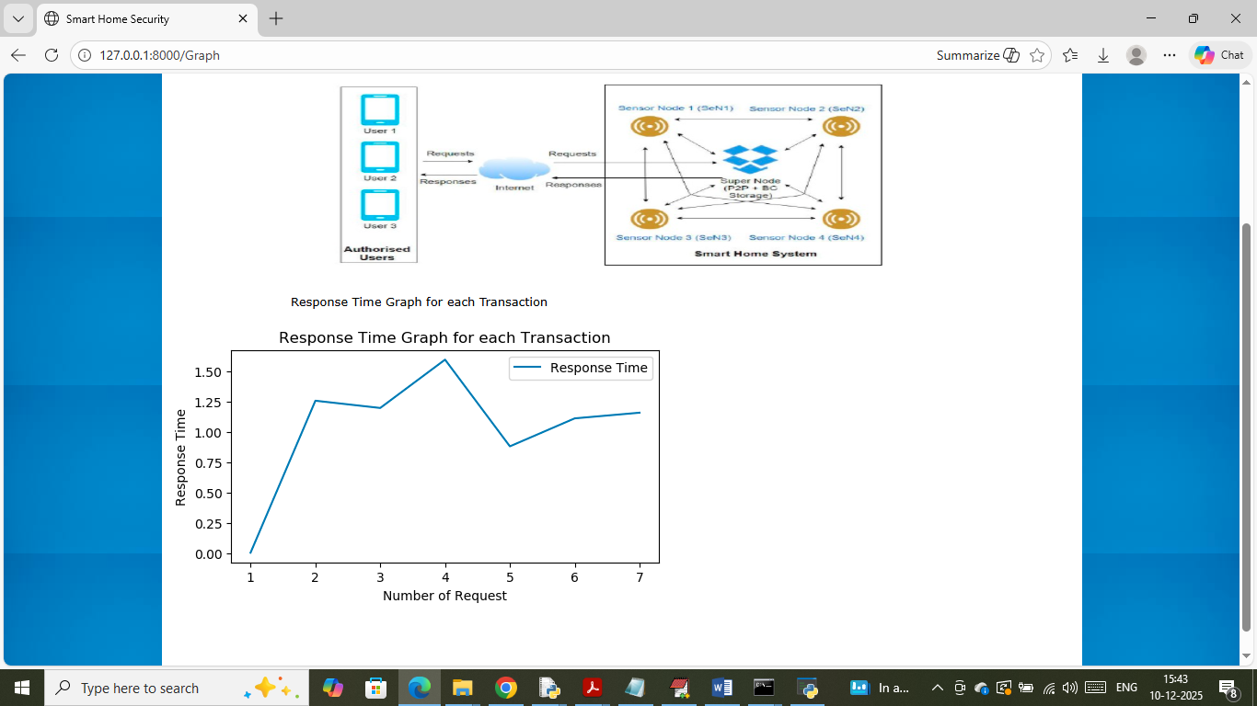
In above graph x-axis represents ‘Number of Transaction’ and y-axis represents response time in seconds. Now click on ‘Propose AES & Extension CHACHA Graph’ link to get below propose and extension comparison graph
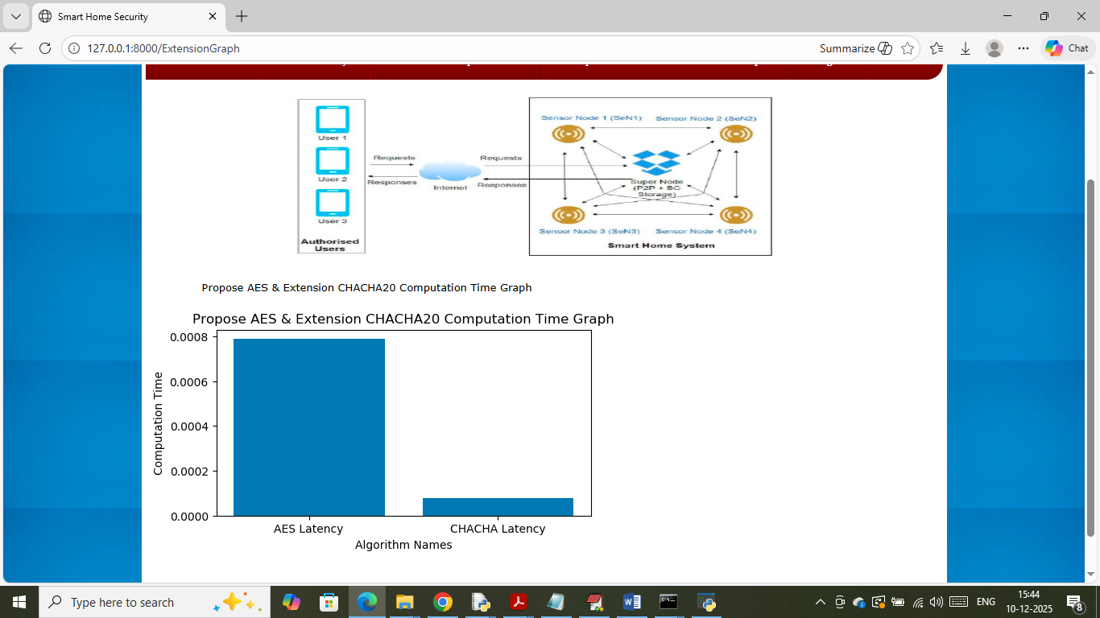
In above graph x-axis represents algorithm names and y-axis represents computation time between propose AES and extension CHACHA20 and in both algorithms extension taking less computation time.

