## 

**TABLE OF CONTENTS**

**1. INTRODUCTION**

1.1 Aim of the Project ----------------------------------------------------------------------2

1.2 Overview of the Project ---------------------------------------------------------------2

1.3 Outcome of the Project ----------------------------------------------------------------2

**2. REQUIREMENTS**

2.1 Software Requirements---------------------------------------------------------------3-4

2.3 Hardware Requirements--------------------------------------------------------------4

**3. SYSTEM ANALYSIS AND DESIGN**

3.1System Analysis -----------------------------------------------------------------------5

3.2 Module ---------------------------------------------------------------------------------5-6

**4. IMPLEMENTATION**

4.1 Front End Implementations ----------------------------------------------------------7-8

**5. RESULT ANALYSIS**

5.1 Snap Shots -----------------------------------------------------------------------------9

**6. CONCLUSION AND FUTURE WORK**

6.1 Conclusion -----------------------------------------------------------------------------10

6.2 Future Enhancement -----------------------------------------------------------------10-11

**7. REFERENCES** --------------------------------------------------------------------------12

**CHAPTER-01**

**INTRODUCTION**

* 1. **AIM OF THE PROJECT**

The aim of a Django project for an online fire reporting system is to establish a comprehensive platform that facilitates efficient and timely reporting, management, and response to fire incidents. Such a system would enable users, including citizens and emergency responders, to quickly submit detailed reports on fire incidents through a user-friendly interface. Key objectives include integrating mapping capabilities to visualize incident locations, implementing real-time updates and notifications to relevant stakeholders, and ensuring robust security measures for sensitive data handling. Additionally, the system would support analytics and reporting functionalities to analyze trends and optimize resource allocation.

* 1. **OVERVIEW OF THE PROJECT**

The Django project for an online fire reporting system aims to provide a centralized and efficient platform for reporting and managing fire incidents. This system will allow users, such as citizens and emergency responders, to easily submit detailed reports about fire emergencies through a user-friendly web interface. Key features include real-time incident updates, integration with mapping services for visualizing incident locations, and notification systems to alert stakeholders promptly. The project will prioritize secure user authentication and authorization to control access to sensitive information, ensuring compliance with privacy regulations.

**1.3 OUTCOME OF THE PROJECT**

The outcome of the Django project for an online fire reporting system aims to achieve a transformative impact on emergency response capabilities and public safety. By implementing this system, communities will benefit from streamlined and efficient reporting of fire incidents, facilitating quicker response times and more effective allocation of resources. Citizens will have a user-friendly platform to report emergencies promptly, ensuring that critical information reaches emergency services in real-time.

**CHAPTER-02**

**REQUIREMENTS**

**2.1 SOFTWARE REQUIREMENTS**

• **Python**: Django is a Python web framework, so Python must be installed. Django typically supports Python versions 3.6 and higher.

• **Django**: Install Django framework using pip, which manages Python packages. This can be done using the command pip install django.

• **Database:** Django supports multiple databases such as PostgreSQL, MySQL, SQLite, and others. Choose and install one that fits your project's needs. For development, SQLite comes pre-configured.

**• Integrated Development Environment (IDE)**: Choose an IDE or text editor for Python development. Popular choices include PyCharm, Visual Studio Code, Sublime Text, and Atom.

• **Web Server**: While Django has a built-in development server (manage.py runserver), for production, consider deploying on web servers like Apache or Nginx, possibly with Gunicorn or uWSGI as the application server.

• **Version Control**: Use a version control system like Git for managing codebase versions and collaboration.

• **Dependencies and Packages**: Depending on your project's requirements, you may need additional Python packages beyond Django itself. Use pip to install these packages as needed, and maintain a requirements.txt file listing all dependencies.

• **Frontend Frameworks**: Decide on frontend technologies like HTML, CSS, JavaScript, and potentially frontend frameworks/libraries such as Bootstrap, React, or Vue.js for building user interfaces.

• **APIs and Services**: If integrating with external services (like mapping APIs for visualizing incident locations), ensure necessary API keys and credentials are obtained and managed securely.

• **Operating System**: Django and Python are compatible with Windows, macOS, and Linux operating systems. Choose based on your development environment preferences.

• **Testing Frameworks**: While not mandatory, using testing frameworks like Django's built-in testing tools, pytest, or unittest can help ensure the reliability of your application.

**2.3 HARDWARE REQUIREMENTS**

1. **Web Server:**
   * **CPU:** Intel Core i5 or equivalent
   * **RAM:** 2GB+
   * **Storage:** SSD preferred, with adequate capacity for application files and logs
2. **Database Server:**
   * **CPU:** Intel Core i5 or equivalent
   * **RAM:** 4GB+
   * **Storage:** SSD preferred, with adequate capacity for database files and backups

**Scaling Considerations:**

* **Vertical Scaling:** Upgrade CPU, RAM, and storage as needed based on application load and performance metrics.
* **Horizontal Scaling:** Consider load balancing and database replication for handling increased traffic and ensuring high availability.

**CHAPTER-03**

**SYSTEM ANALYSIS AND DESIGN**

**3.1 SYSTEM ANALYSIS**

System analysis for a Django project involves a comprehensive evaluation of its functional and non-functional requirements to ensure the successful development and deployment of the application. This process begins with defining the project scope, including its objectives, core features, and key modules. Stakeholders, such as users and clients, are identified to understand their roles and expectations within the system. Functional requirements are meticulously detailed through use cases, workflows, and data flow diagrams, outlining how users interact with and manipulate data within the application. Non-functional requirements encompass aspects like performance, reliability, security, usability, and compatibility, setting benchmarks for system behavior under various conditions. Constraints, including technological choices, budget, and timeline, are considered to guide development decisions and resource allocation effectively. Risk assessment identifies potential challenges and mitigation strategies, while system design considerations encompass architecture, database schema, APIs, and integration points. Testing methodologies are planned to validate each feature, ensuring they meet acceptance criteria before deployment. An implementation plan outlines development phases, milestones, and resource allocation, while provisions for maintenance and support post-deployment ensure ongoing functionality and user satisfaction. Through systematic analysis and planning, a Django project can be structured to meet both immediate needs and future scalability requirements, fostering efficient development and operational excellence.

* 1. **MODULES**

For a Django project focused on an online fire reporting system, here are the essential modules:

1. **Authentication and Authorization:**
   * User registration, login, and role management.
   * Secure access control for different user types (e.g., admin, firefighter, public).
2. **Incident Reporting:**
   * Form for submitting fire incident details.
   * Attachment uploads for photos or documents.
   * Geolocation integration for incident location tracking.
3. **Dashboard and Reporting:**
   * Overview of reported incidents with statistics.
   * Search, filter, and report generation functionalities.
4. **Notification:**
   * Email and SMS alerts for new incidents.
   * Real-time notifications for stakeholders.
5. **GIS Integration:**
   * Mapping incidents geographically.
   * Overlay with additional data layers (e.g., fire risk zones).
6. **Admin and Management:**
   * Admin dashboard for system configuration.
   * User management and audit logs.
7. **Communication:**
   * Internal messaging system.
   * Public announcements or alerts.
8. **Analytics and Reporting:**
   * Data visualization tools for incident trends.
   * Predictive analytics for fire risk assessment.
9. **Integration and API:**
   * RESTful APIs for external system integration.
   * Webhooks for real-time updates.
10. **Documentation and Help:**
    * FAQs, knowledge base, and user guides.
    * Help desk or support ticket system.

**CHAPTER-04**

**IMPLEMENTATION**

**4.1 CODE**

**Views.py**

import datetime

from django.db.models import Q

from django.shortcuts import render,redirect

from .models import *

from datetime import date

from datetime import datetime

from django.contrib.auth.models import User

from django.contrib.auth import login,logout,authenticate

**Manage.py**

#!/usr/bin/env python

"""Django's command-line utility for administrative tasks."""

import os

import sys

def main():

"""Run administrative tasks."""

os.environ.setdefault('DJANGO_SETTINGS_MODULE', ' OnlineFire_ReportingSystem.settings')

try:

from django.core.management import execute_from_command_line

except ImportError as exc:

raise ImportError(

"Couldn't import Django. Are you sure it's installed and "

"available on your PYTHONPATH environment variable? Did you "

"forget to activate a virtual environment?"

) from exc

execute_from_command_line(sys.argv)

if __name__ == '__main__': main()

**Urls.py**

from django.contrib import admin

from django.urls import path

from firereport.views import *

from django.conf import settings

from django.conf.urls.static import static

urlpatterns = [

path('admin/', admin.site.urls),

path('', index, name='index'),

path('reporting', reporting, name='reporting'),

path('viewStatus', viewStatus, name='viewStatus'),

path('viewStatusDetails/<int:pid>', viewStatusDetails, name='viewStatusDetails'),

path('admin_login', admin_login, name='admin_login'),

path('dashboard', dashboard, name='dashboard'),

path('addTeam', addTeam, name='addTeam'),

path('manageTeam', manageTeam, name='manageTeam'),

path('editTeam/<int:pid>', editTeam, name='editTeam'),

path('deleteTeam/<int:pid>', deleteTeam, name='deleteTeam'),

path('newRequest', newRequest, name='newRequest'),

path('assignRequest', assignRequest, name='assignRequest'),

path('teamontheway', teamontheway, name='teamontheway'),

path('workinprogress', workinprogress, name='workinprogress'),

path('completeRequest', completeRequest, name='completeRequest'),

path('allRequest', allRequest, name='allRequest'),

path('dateReport', dateReport, name='dateReport'),

path('changePassword', changePassword, name='changePassword'),

path('logout/', Logout, name='logout'

]+static(settings.MEDIA_URL,document_root=settings.MEDIA_ROOT)

**RESULTS**

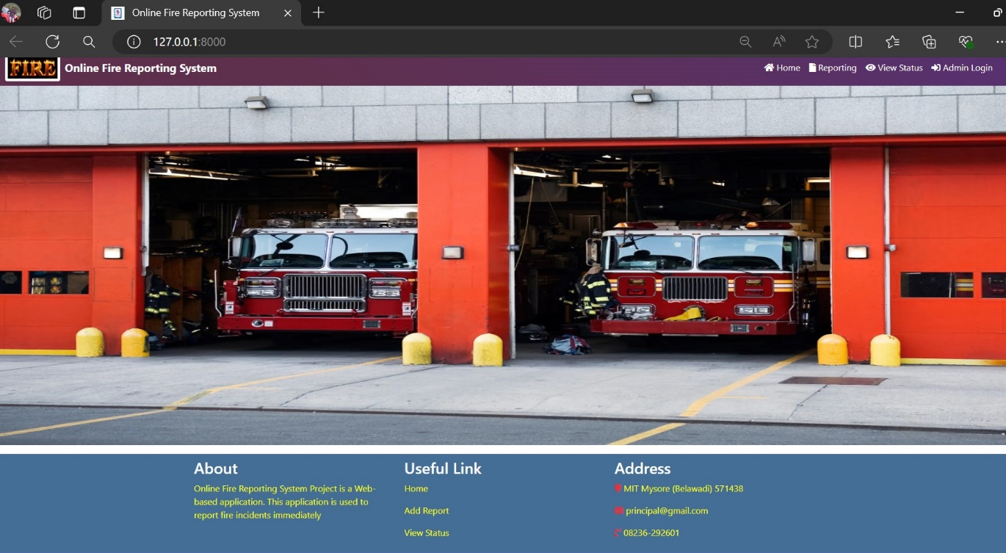**5.1 SNAP SHOTS**

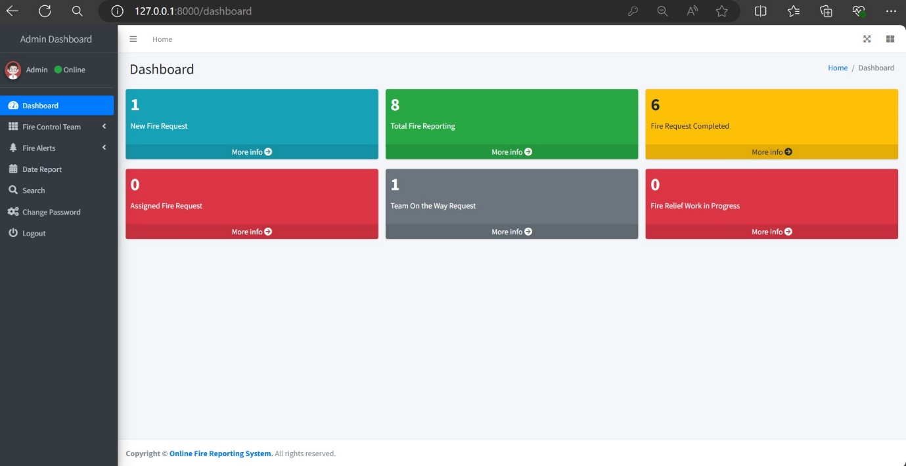**Fig:Home page**

**Fig:Admin Interface**

**CHAPTER-06**

**CONCLUSION AND FUTURE WORK**

**6.1 CONCLUSION**

In conclusion, the Django-based online fire reporting system offers a robust platform for efficient management of fire incidents. Key features like user authentication, incident reporting, real-time notifications, and GIS mapping ensure timely and accurate response capabilities. The system prioritizes usability, security, and scalability, with ongoing improvements guided by user feedback. Looking ahead, potential enhancements include advanced analytics for fire risk assessment, integration with emergency response systems, and further customization options. Continual adaptation to technological advancements and user needs will ensure the system remains effective in supporting communities and promoting public safety.

**6.2 FUTURE ENHANCEMENT**

Future enhancements for this Django-based online fire reporting system could focus on several key areas to further improve functionality, user experience, and overall effectiveness:

1. **Advanced Analytics and Predictive Modeling:**
   * Implement algorithms to analyze historical fire incident data for predictive modeling.
   * Develop tools to forecast fire risks based on various factors such as weather conditions, historical trends, and geographic data.
   * Provide actionable insights to aid in proactive fire prevention and resource allocation.
2. **Integration with Emergency Response Systems:**
   * Enhance integration capabilities with local emergency services and dispatch systems.
   * Facilitate seamless communication and data sharing during incident response to improve coordination and efficiency.
3. **Enhanced Geolocation and Mapping Features:**
   * Expand GIS capabilities to include more detailed mapping of fire incidents and surrounding infrastructure.
   * Integrate with geographic information layers such as building layouts, road networks, and evacuation routes.
   * Provide interactive maps with overlays for fire risk zones, hazardous materials locations, and critical infrastructure.
4. **User Interface and Accessibility Improvements:**
   * Conduct usability studies and incorporate user feedback to refine the interface design.
   * Ensure accessibility standards compliance to accommodate users with disabilities.
   * Enhance mobile responsiveness for seamless access and usability across different devices and screen sizes.
5. **Community Engagement and Public Awareness:**
   * Develop features to engage the community in fire safety education and awareness campaigns.
   * Implement public information portals with fire prevention tips, emergency procedures, and community resources.
6. **Scalability and Performance Optimization:**
   * Architect the system to scale efficiently with growing data volumes and user traffic.
   * Implement caching strategies and database optimizations to improve performance during peak usage periods.
7. **Continuous Security Enhancements:**
   * Strengthen security measures with regular audits and updates to protect user data and system integrity.
   * Implement multi-factor authentication (MFA), encryption protocols, and secure API endpoints.
   * Provide user education on best practices for maintaining security and privacy within the system.

**REFERENCES**

[1].HTML Tutorial - https://www.w3schools.com/html

[2].CSS Tutorial - <https://www.w3schools.com/Css>

[3].Google and You tube videos

[4]. https://www.youtube.com/watch?v=0QOYRkl2C1o&t=302s