**0**

Software Requirements Specification

for

"VR Data Trek: Exploring Data Structures Beyond Reality"

Version 1.0 approved

**Prepared by**

**SARVESH S M**

**SHREENA S**

**SHRUTHI R A**

**PSG INSTITUTE OF TECHNOLOGY AND APPLIED RESEARCH**

**20-02-24**

**Table of Contents**

**Table of Contents ii**

**Revision History ii**

**1. Introduction 3**

1.1 Purpose 3

1.2 Document Conventions 3

1.3 Intended Audience and Reading Suggestions 3

1.4 Product Scope 3

**2. Overall Description 4**

2.1 Product Perspective 4

2.2 Product Functions 4

2.3 User Classes and Characteristics 5

2.4 Operating Environment 5

2.5 Design and Implementation Constraints 6

2.6 User Documentation 6

2.7 Assumptions and Dependencies 6

**3. External Interface Requirements 7**

3.1 User Interfaces 7

3.2 Hardware Interfaces 8

3.3 Software Interfaces 9

3.4 Communications Interfaces 9

**4. System Features 10**

4.1 Virtual Environment 10

4.2 Interaction 10

4.3 Training Content 11

4.4 Workflow Path 11

**5. Other Nonfunctional Requirements 12**

5.1 Performance Requirements 12

5.2 Safety Requirements 12

5.3 Security Requirements 13

5.4 Software Quality Attributes 13

5.5 Business Rules 14

**Appendix A: Analysis Models 14**

**Revision History**

| **Name** | **Date** | **Reason For Changes** | **Version** |
| --- | --- | --- | --- |
|  |  |  |  |
|  |  |  |  |

# Introduction

## Purpose

The objective of this initiative is to develop a virtual reality (VR) application intended to facilitate the comprehension and mastery of data structures. This application seeks to offer an immersive learning experience, fostering collaboration, comprehension, and knowledge retention through the utilization of VR technology. Ultimately, the aim is to revolutionize the learning process and interaction with technology, empowering students to cultivate proficiency in computer science.

## Document Conventions

Throughout the document:

- Main headings: Bold, Times New Roman, size 18.

- Subheadings: Bold, Times New Roman, size 14.

- Body text: Times New Roman, size 12.

## Intended Audience and Reading Suggestions

This idea has a wide reach for audience. The audience this idea is intended to reach out are:

1. Students: Especially those studying computer science, software engineering or other fields who want to have a deep understanding of data structure in a comprehensive and comprehensive way.

2. Educators: Educators who are looking for new teaching tools to supplement learning materials in the classroom or online courses.

3. Professionals: Developers, programmers, and software engineers who want to improve their knowledge of data structures or explore new learning opportunities.

4. VR Enthusiast: A person who is interested in virtual technology and its applications in education, especially computer science and software development.

## Product Scope

The software being specified is a Virtual Reality (VR) application designed to enhance learning and understanding of data structures. Its purpose is to provide an immersive and interactive learning experience, allowing users to visualize, manipulate, and interact with various data structures in a virtual environment.

# Overall Description

## Product Perspective

The VR Data Trek project represents a pioneering endeavor in the realm of virtual reality educational tools, offering a unique and unparalleled experience in the exploration of data structures. Unlike existing applications or extensions, VR Data Trek stands out as the first-of-its-kind immersive learning platform tailored specifically for data structures education. By leveraging virtual reality technology, VR Data Trek transports users into a dynamic and visually captivating environment where they can interact with various data structures in ways previously unimaginable. From traversing linked lists in a virtual landscape to manipulating binary trees in a three-dimensional space, the possibilities for experiential learning are boundless.

## Product Functions

1. Continuous exploration: Users can explore various data structures such as links, categories, columns, trees and images in a beautiful virtual environment. They can visualize abstract concepts in a visual and interactive way, thus improving comprehension and memory.

2. Interactive operation: Users can work and interact with the data structure in real time. They can add, remove, and replace elements in the model, track changes instantly, and try different scenarios to understand them more deeply.

3. Tutorials: This platform offers tutorials and exercises for different skill levels, guiding users to understand the basics of each data model. Interactive lessons and step-by-step instructions provide a stimulating learning experience.

4. Research Analysis: Users can track their progress and performance while analyzing different models and exercises. Progress indicators, tests, and assessments help users track learning results and identify areas for improvement.

5. Personalization options: The platform offers customization options that allow users to customize the learning experience according to their personal preferences. Users can adjust settings such as difficulty level, perspective, and preferred language to suit their needs.

6. Feedback: The platform has a feedback mechanism where users can provide comments, suggestions and opinions to improve the overall user experience. An ongoing feedback system ensures that the platform continues to evolve to meet the changing needs and expectations of its user base.

Together, these features enable users to work with data structures in a dynamic, immersive, and personal way, promoting effective learning and intellectual development in computer science and software engineering.

## User Classes and Characteristics

1. Teachers and Educators:

- Educators who incorporate technology into their teaching methods and curriculum. They use VR Data Trek as a supplementary tool to enhance their lessons on data structures, allowing students to engage with concepts in a more interactive and immersive manner. Teachers can track students' progress and use the platform to facilitate discussions on the legal and ethical implications of data usage.

2. Students:

- Students frequently utilize web browsers for educational and research purposes. They encounter terms and conditions agreements on websites but may often skip reading them, potentially missing important warnings or information. VR Data Trek provides a solution by automatically summarizing the agreements, ensuring that students can grasp crucial details without spending excessive time reading lengthy documents..

3. Developers and Software Engineers:

- Professionals involved in developing websites, applications, and digital platforms. They utilize VR Data Trek to analyze terms and conditions agreements related to third-party APIs, libraries, and services integrated into their projects. Developers can ensure compliance with legal requirements and assess potential risks associated with using external resources in their software development endeavors.

## Operating Environment

The VR Data Trek project is designed with extensive versatility to ensure accessibility across multiple platforms and devices. Its operating environment encompasses:

1. Cross-Platform Compatibility:

Leveraging the architecture of Chrome extension, VR Data Trek seamlessly operates across various operating systems like Windows, macOS, Linux, iOS, and Android. Users can access the application on desktops, laptops, tablets, or smartphones, ensuring widespread availability and convenience.

2. Internet Connectivity:

VR Data Trek relies on internet connectivity for real-time analysis of terms and conditions agreements from online sources. A stable internet connection is essential for users to effectively utilize the extension and receive timely summaries and evaluations of website agreements.

By offering compatibility with desktop and mobile browsers, VR Data Trek ensures accessibility and functionality across diverse operating environments, empowering users to make informed decisions about online activities, irrespective of their device choices.

## Design and Implementation Constraints

1. VR Hardware Compatibility: Ensure seamless functionality across various VR headsets and platforms to enhance accessibility for users.

2. Graphics Optimization: Optimize visual elements to maintain smooth frame rates and minimize motion sickness, improving the overall immersive experience.

3. Intuitive Interaction Design: Design user interfaces and interaction mechanics that are intuitive and easy to navigate, enhancing engagement with data structure concepts in the VR environment.

4. Learning Content Integration: Integrate educational content such as tutorials, visualizations, and interactive exercises to effectively teach data structures and promote active learning.

5. Quality Assurance Testing: Conduct comprehensive testing for functionality, performance, and user experience to deliver a reliable and polished VR learning application tailored to the needs of learners.

## User Documentation

1. Introduction to VR Data Structures Learning Tool:

- The VR Data Structures Learning Tool is an immersive educational application designed to help users learn data structures through virtual reality technology.

2. Getting Started:

- This section provides step-by-step instructions on how to use the VR Data Structures Learning Tool.

3. Using the Tool:

- Learn how to navigate through the VR environment, interact with data structures, access tutorials and exercises, and track progress.

4. YouTube Tutorial:

- Refer to our YouTube tutorial video demonstrating how to use the VR Data Structures Learning Tool effectively. The video showcases key features and provides visual guidance for users.

## Assumptions and Dependencies

1. VR environment development:

- The VR learning environment will be created using Next.js and appropriate VR development libraries and frameworks such as React 360 or A-Frame.

2. Front-end development:

- The front-end interface in the VR environment will be developed using Next.js components to provide interactive content and user interface.

3. Backend development:

- Backend logic and server side functions such as user authentication and progress tracking will be implemented using Next.js API routing and serverless functionality.

4. Data processing and analysis:

- Data processing, compilation and analysis of conceptual data presented in the VR environment will be done using Python and Libraries such as SpaCy or NLTK integrated with Next.js backend.

5. Integration with VR Hardware:

- VR education apps built with Next.js will work well with a variety of VR hardware, including VR headsets and controllers.

# External Interface Requirements

## User Interfaces

1. Simple VR Interface:

- The VR interface is designed to be intuitive and easy to use, with easy navigation and minimal distractions. Users use VR headsets and controllers to interact with data models and learning materials in a virtual environment.

2. Main menu:

- The VR interface includes a main menu accessible in the virtual environment and allows users to navigate between tutorials on different devices, such as instruction, exercise and progress.

3. Search function:

- Users can use the search function integrated in the VR interface to quickly find specific information content or areas of interest in the virtual environment. These features support easy access and effective search of educational materials.

4. Settings Menu:

- In the VR interface, users can access the Settings Menu to adjust various aspects of their experience, such as preferred language, lighting, and User information. This allows users to customize the VR experience according to their preferences and needs.

5. Help and Support:

- The VR interface provides users with a help and support system that provides access to resources, FAQs, and support. Users can find help or advice on all aspects of VR Information Technology directly from the virtual environment.

6. Feedback:

- The VR interface includes a feedback feature where users can provide feedback, suggestions or special requests. This encourages user participation and allows developers to gather insights to improve VR learning tools.

7. Knowledge Panel:

- The Knowledge Panel in the VR interface provides users with more information about VR Information Technology, including its purpose, functionality, and development team. Users can place themselves in a virtual environment and access relevant information.

## Hardware Interfaces

1. VR Headsets and Controllers:

- Users engage with the VR learning environment utilizing VR headsets offering optimal visibility and spatial tracking. The controller facilitates interaction with virtual objects and content navigation.

2. Headphone Screens:

- VR headset screens display the virtual environment, showcasing data models, tutorials, and interactive sessions with high-resolution clarity and detail.

3. Controller Input:

- Controllers enable users to interact within the VR environment, navigating menus and managing data structures using intuitive tooltips and input buttons.

4. Sound Output:

- VR headsets provide audio output or support external headphones for high-quality sound, enhancing the learning experience with suggestions, prompts, and explanations integrated with visual materials.

5. Connectivity:

- VR headsets connect to compatible computers or game consoles via wired or wireless connections, while controllers communicate wirelessly with the VR system, enabling unique interactions within the virtual environment.

6. Setup and Calibration:

- VR hardware necessitates initialization and calibration for optimal functionality. Users should follow setup instructions to test parameters, configure the headset, and install drivers before utilizing the VR learning device.

## Software Interfaces

1. VR Software Platform:

- The VR software platform serves as the interface between the VR hardware and the VR learning environment. It manages rendering, input processing, and interaction mechanics to create a seamless VR experience.

2. Tutorial Modules:

- Tutorial modules within the VR software interface guide users through learning materials, presenting explanations, examples, and interactive exercises. Users navigate between different tutorial modules to explore various data structure topics.

3. Navigation Controls:

- Navigation controls within the VR software interface enable users to move within the virtual environment, select options, and interact with virtual objects. Users use controllers or headset gestures to navigate menus and explore learning materials.

4. Settings and Preferences:

- Settings and preferences menus allow users to customize aspects of their VR learning experience, such as language settings, visual preferences, and user profiles. These menus provide flexibility and personalization options for users.

5. Integration with Backend Services:

- Backend services interface with the VR software platform to provide data storage, user authentication, and progress tracking functionalities. This integration enables seamless communication between the VR interface and backend systems.

## Communications Interfaces

1. Controller Inputs:

- Users interact with virtual objects and menus using controller buttons and gestures, enabling navigation and interaction within the VR environment.

2. Haptic Feedback:

- Haptic feedback in controllers provides tactile sensations, enhancing immersion by simulating the sense of touch when interacting with virtual objects.

3. Text Input:

- Users can input text using virtual keyboards or voice-to-text features, facilitating tasks such as searching for specific concepts or entering text for exercises.

4. Menu Navigation:

- Menu interfaces allow users to navigate through options and settings within the VR environment using controllers or gestures.

5. Remote Collaboration:

- Multiple users can engage in collaborative learning experiences within the VR environment, interacting with each other and learning materials in real-time from different locations.

# System Features

**4.1 Virtual Environment**

**4.1.1 Definition and Importance**

This feature is more important. It involves creating a 3D environment to represent various devices.

**4.1.2 Stimulus/Response Sequence**

The user selects the data model from the menu.

The loading system corresponds to the 3D environment.

The user selects the data model from the menu.

The loading system corresponds to the 3D environment.

Users can interact with the data model using VR controls.

**4.1.3 Functional Requirements**

**REQ-1**: The application must provide 3D models and textures for arrays, linked lists, groups, lines, trees, and images.

**REQ-2:** Users must be able to navigate the 3D environment using VR controls.

**REQ-3**: There should be a content dialog that allows users to manage the data model (e.g. add/delete content).

**4.2 Interaction**

**4.2.1 Description and importance**

These features are more important. It allows users to control the contents of the data model and get a real-time view of how the model is changing.

**4.2.2 Stimulus/Response Sequences**

Users select interactive displays for specific information.

This tutorial provides step-by-step instructions for working with data structures.

Users use VR controllers to manipulate data models.

The system instantly adjusts visibility to reflect changes

.

**4.2.3 Functional Requirements**

**REQ-1**: The application must have an interactive interface for each data model.

**REQ-2**: In order to work properly, the instruction must have a set of instructions (e.g. insert, delete, search).

**REQ-3**: The system should immediately update the view to reflect changes made by the user.

**4.3 Training Content**

**4.3.1 Description and Importance**

These features are more important. It includes detailed explanations, examples, and tests to help users understand the concepts behind each data model.

**4.3.2 Stimulus/Response Sequence**

The user selects the learning module for a particular data model.

This model provides a description of the model and usage.

Users complete quizzes and interactive exercises to test their understanding.

**4.3.3 Functional Requirements**

**REQ-1**: The implementation should provide explanations and robustness

**REQ-2**: Examples explaining the process using each data model in a real situation should be provided.

**REQ-3**: Questions and discussions should be provided to assess user understanding.

**4.4 Workflow Path**

**4.4.1 Description and Importance**

This feature holds medium importance as it enables users to monitor their progress and accomplishments within the application.

**4.4.2 Stimulus/Response Sequences**

- The user initiates the monitoring function from the main menu.

- The system presents details of the support/response thread and tracks user progression, providing comprehensive instructions and questions.

- Users can access detailed information for each achievement.

**4.4.3 Business Requirements**

REQ-1: The application must log users' educational achievements during training and testing completion.

# Other Nonfunctional Requirements

## Performance Requirements

1. Loading Time:

- Ensure quick loading of the VR learning environment upon launch to provide users with immediate access to educational content and minimize waiting times.

2. Responsiveness:

- The VR interface should respond promptly to user interactions, such as selecting options and interacting with virtual objects, to maintain a fluid and immersive learning experience without delays or lag.

3. Rendering Efficiency:

- Optimize rendering performance to maintain consistent frame rates and visual quality, reducing stuttering and motion sickness for users interacting with complex data structures.

4. Memory Management:

- Implement efficient memory management strategies to optimize memory usage and prevent memory leaks, ensuring stability and preventing performance degradation over time.

5. Network Efficiency:

- Minimize network requests and optimize data transfer to reduce latency and bandwidth usage, enhancing performance and reducing dependence on network connectivity for accessing educational resources.

## Safety Requirements

1. Motion Sickness Prevention:

- Optimize VR experience to minimize motion sickness.

- Implement smooth movement, and avoid sudden movements and excessive rotation.

- Follow VR industry standards for motion sickness mitigation.

2. User Awareness of Surroundings:

- Ensure users are aware of physical surroundings.

- Provide reminders to check surroundings and clear obstacles.

- Design clear boundaries in the VR environment.

3. Hardware Maintenance and Care:

- Ensure proper maintenance of VR hardware.

- Warn against using damaged hardware.

- Follow manufacturer guidelines for maintenance.

4. Content Safety and Appropriateness:

- Ensure educational content is safe and appropriate.

- Curate content and provide warnings.

- Regularly review and update content.

## Security Requirements

1. Secure communication:

- All communication between the VR application and external servers uses HTTPS to ensure data confidentiality and integrity.

2. Authentication and authorization:

- Implement effective authentication and authorization processes to identify users and effectively manage access.

3. Security Third Party Integration:

- Check the authenticity and reputation of third party websites and services before integration to avoid management deference or leakage.

4. Access authentication:

- Use common sense techniques to prevent vulnerabilities such as SQL injection and cross-site scripting (XSS) attacks.

## Software Quality Attributes

1. Interoperability:

- Compatibility tests with other VR applications and technologies commonly used in the industry to ensure seamless integration and interaction with external devices and services.

2. Portability:

- Ensures compatibility with various VR hardware and operating systems, allowing users to access the VR learning environment on various platforms.

3. Flexibility:

- Allows users to customize their VR learning environment by providing customization options and options in the VR learning environment. information and tailoring it to their specific interests and needs.

## Business Rules

1. User Authentication: Only registered and authenticated users can access premium features and personalized content.

2. Content Access Control: Access to advanced tutorials or exercises is restricted based on user proficiency levels or subscription plans.

3. Progress Tracking: Users can monitor their learning progress and performance through personalized reports and analytics.

4. Feedback Mechanism: Users can provide feedback for continuous improvement of the VR learning experience.

**Appendix A: Glossary**

SRS**:** Software Requirements Specification:A document that outlines the requirements, features, and scope of a software project.

VR: Virtual Reality: It is a computer-generated environment with scenes and objects that appear to be real, making the user feel they are immersed in their surroundings.

API: Application Programming Interface:A set of rules and protocols that allows different software applications to communicate with each other.

NLTK: [Natural Language Toolkit](https://www.nltk.org/):Natural Language Processing with Python provides a practical introduction to programming for language processing.

FAQ: Frequently Asked Question:A question in a list of questions and answers intended to help people understand a particular subject.

3D: Three Dimensional: It refers to the three spatial dimensions of width, height and depth.

SQL: Structured Query LanguageSQL is a program created and formulated in the Relational Database Management System to handle structured data.

HTTPS: Hyper Text Transfer Protocol Secure:It is a secure way to send data between a web server and a web browser.

XSS:Cross-Site Scripting: It is an attack in which an attacker injects malicious executable scripts into the code of a trusted application or website.

**Appendix B: Analysis Models**

**Workflow diagram:**

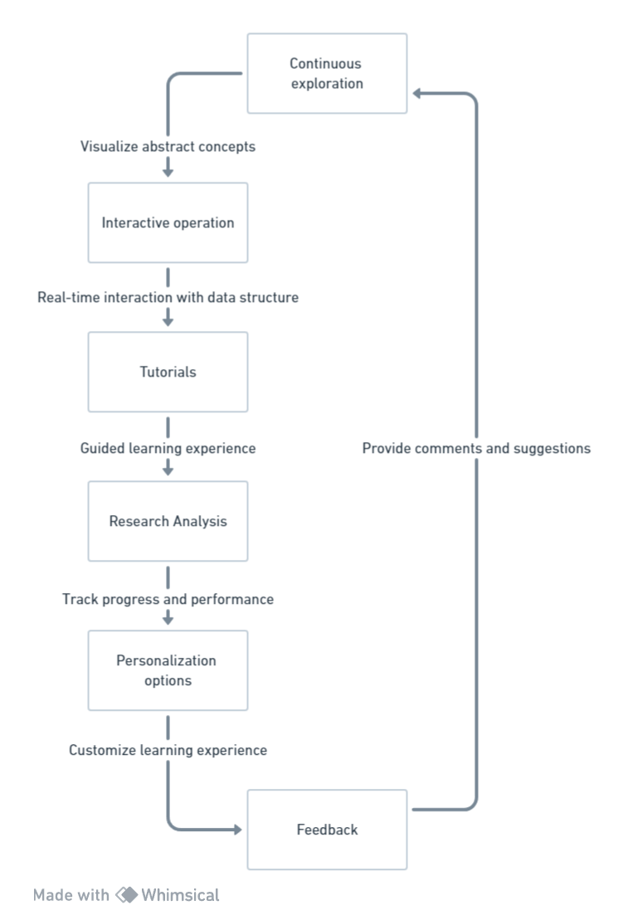

**Module Flow diagram:**

