**date_format() with different formats are:**

1. **format %j - It shows day of the year out of 365/366 days.**

select date_format("2021/09/16 11:59:59","%j"); or

select hire_date,date_format(hire_date,"%j") Days from employees;

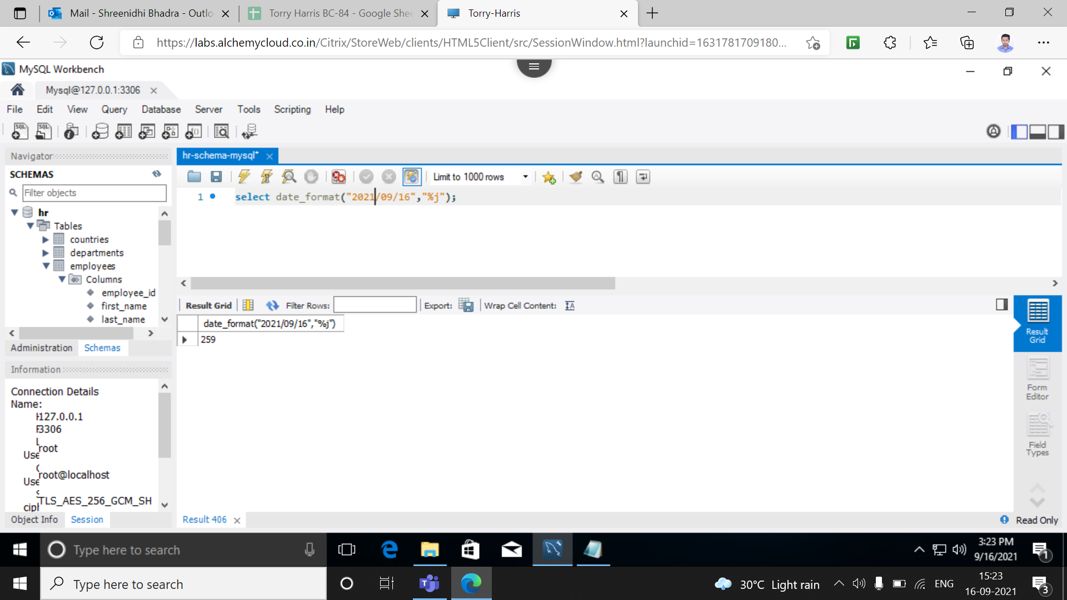

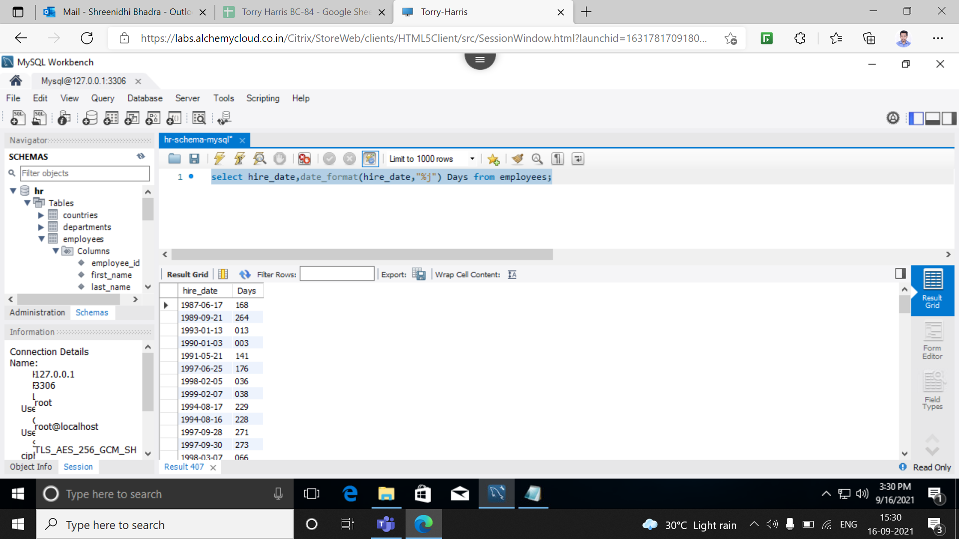

1. **format %M - It shows full month name of the year from January to December.**

select date_format("2021/09/16 11:59:59","%M"); or

select hire_date,date_format(hire_date,"%M") Days from employees;

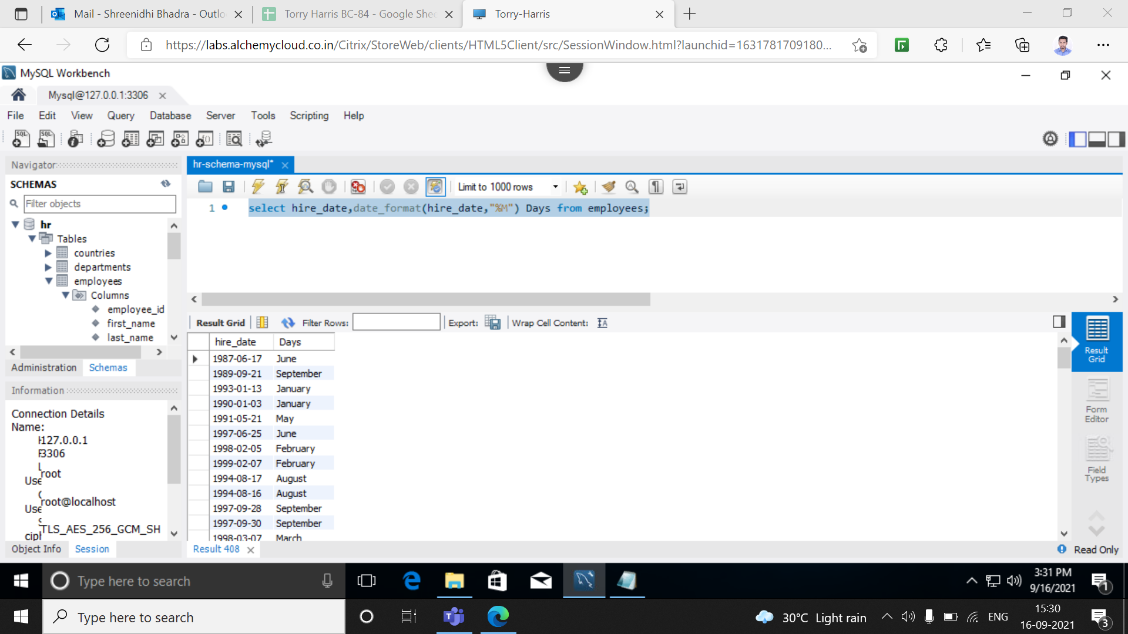

1. **format %p - It returns whether the time is AM or PM;**

select date_format("2021/09/16 11:59:59","%p");

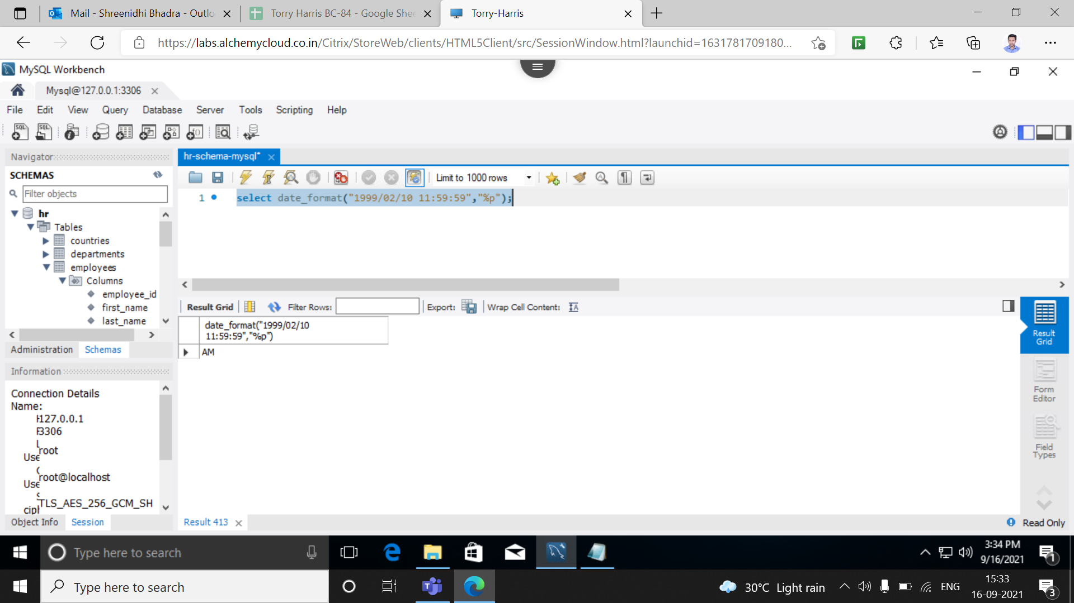

1. **format %S - It returns seconds using given date and time**

select date_format("2021/09/16 11:59:59","%S");

