**Topics: Descriptive Statistics and Probability**

1. Look at the data given below. Plot the data, find the outliers and find out $μ, σ, σ^{2}$

|  |  |
| --- | --- |
| **Name of company** | **Measure X** |
| Allied Signal | 24.23% |
| Bankers Trust | 25.53% |
| General Mills | 25.41% |
| ITT Industries | 24.14% |
| J.P.Morgan & Co. | 29.62% |
| Lehman Brothers | 28.25% |
| Marriott | 25.81% |
| MCI | 24.39% |
| Merrill Lynch | 40.26% |
| Microsoft | 32.95% |
| Morgan Stanley | 91.36% |
| Sun Microsystems | 25.99% |
| Travelers | 39.42% |
| US Airways | 26.71% |
| Warner-Lambert | 35.00% |

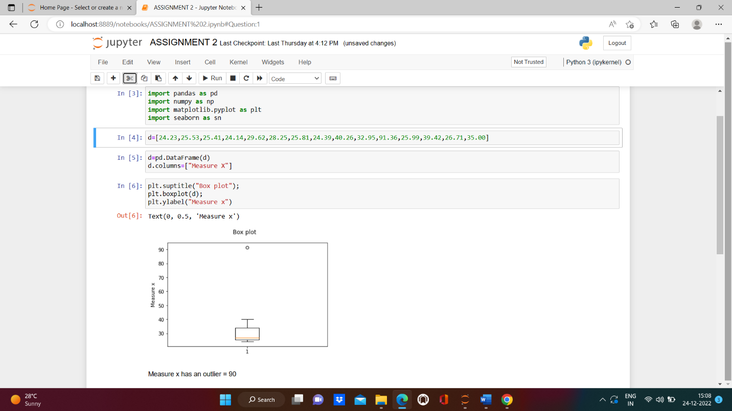

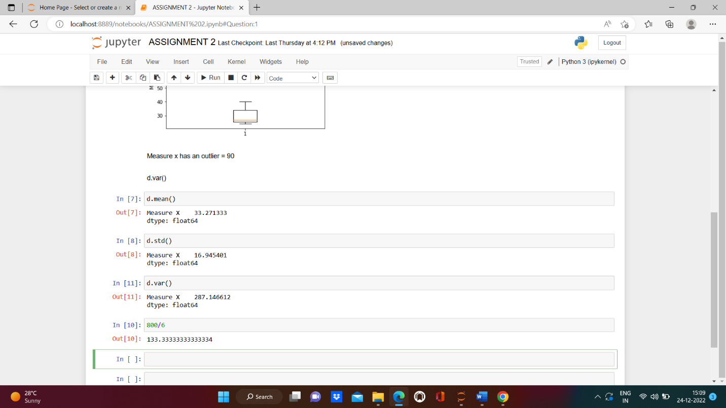



Answer the following three questions based on the box-plot above.

1. What is inter-quartile range of this dataset? (please approximate the numbers) In one line, explain what this value implies.

* **INTERQUARTILE RANGE IS: 5 to 12. It is the middle 50% of our data. i.e first 25% and last 25 percentile of our data is excluded in this range.**

1. What can we say about the skewness of this dataset?

* **Since the outlier is present is on the right side and the distribution is right tailed, hence it is positively skewed.**

1. If it was found that the data point with the value 25 is actually 2.5, how would the new box-plot be affected?

* **There may be no outlier anymore. Mean value will be nearer to median and positive skewness may decrease to almost zero**



Answer the following three questions based on the histogram above.

1. Where would the mode of this dataset lie?

**Mode lies between 4 to 8.**

1. Comment on the skewness of the dataset.

**Data is positive skewed as it is right tailed with an outlier around 25(on the right side).**

1. Suppose that the above histogram and the box-plot in question 2 are plotted for the same dataset. Explain how these graphs complement each other in providing information about any dataset.

* **Boxplot plotted on a data set shows the presence of outlier and helps to identify it.**
* **Smoothening of the histogram gives distribution of our data.**
* **When our data is positively or negatively skewed, Boxplot tells it is because of presence of an outlier and histogram tells about the distribution of the data.**

1. AT&T was running commercials in 1990 aimed at luring back customers who had switched to one of the other long-distance phone service providers. One such commercial shows a businessman trying to reach Phoenix and mistakenly getting Fiji, where a half-naked native on a beach responds incomprehensibly in Polynesian. When asked about this advertisement, AT&T admitted that the portrayed incident did not actually take place but added that this was an enactment of something that “could happen.” Suppose that one in 200 long-distance telephone calls is misdirected. What is the probability that at least one in five attempted telephone calls reaches the wrong number? (Assume independence of attempts.)

**ANS: Probability a calls reaches the wrong number = 199/200**

**Probability of all calls in five attempted telephone calls reaches the wrong number = (199/200)5**

**(Because all 5 attempts are independent events.)**

**Therefore, probability that at least one in five attempted telephone calls**

**reaches the wrong number = 1- (199/200)5**

**= 0.02475 (2.475%).**

1. Returns on a certain business venture, to the nearest $1,000, are known to follow the following probability distribution

|  |  |
| --- | --- |
| x | P(x) |
| -2,000 | 0.1 |
| -1,000 | 0.1 |
| 0 | 0.2 |
| 1000 | 0.2 |
| 2000 | 0.3 |
| 3000 | 0.1 |

1. What is the most likely monetary outcome of the business venture?

**ANS: 2000** **(Because the probability of return of 3000 is more(30%) than others.)**

1. Is the venture likely to be successful? Explain

* **The probability of the business to get positive return is 0.6 (60%) and that of loss is 0.2 (20%). So, the business is likely to be successful.**

1. What is the long-term average earning of business ventures of this kind? Explain

* **The long term average=**

**((-2000*0.1)+(-1000*0.1)+(0*0.2)+(1000*0.2)+(2000*0.3)+(3000*0.1))= 800$**

1. What is the good measure of the risk involved in a venture of this kind? Compute this measure

**The average return of venture is = 800$.**

**The variance is = 3500000$**

**The standard deviation is = 1870$**

**Compared to mean, the variance and standard deviation is much more. That means the risk in the business is also very high.**